GPON OLT USER MANUAL
(WEB Management)

Version V2.0.1
Release Date 2017-08-08
Contents
Chapter 1 System Description 5
1.1 Overview 5
1.1.1 OLT Introduction 5
1.1.2 PC System Requirement 6
1.2 Connection 7
Chapter 2 OLT Information 8
2.1 Login 8
2.2 Device Information 8
Chapter 3 OLT Configuration 10
3.1 VLAN 10
3.1.1 Create VLAN 11
3.1.2 VLAN Port 11
3.1.3 QinQ/Translation 12
3.2 Uplink Port 13
3.2.1 Information 13
3.2.2 Configuration 14
3.3 PON 15
3.3.1 Information 15
3.3.2 Configuration 16
3.4 MAC 17
3.4.1 MAC Table 17
3.4.2 Configuration 18
3.5 LACP 19
3.6 QOS 20
3.7 ACL 21
3.7.1 IP Filter 21
3.7.2 MAC Filter 22
3.7.3 IP/MAC Filter 23
3.7.4 Effect Filter 23
3.8 IGMP 24
3.8.1 Group Member 24
3.8.2 Global 25
3.8.3 Port 26
3.8.4 Port User VLAN 26
3.8.5 Port Mrouter 27
3.8.6 Mvlan 28
3.8.7 Static Group 29
3.9 RSTP 30
3.9.1 Information 30
3.9.2 Global 30
3.9.3 Port 31
3.10 DHCP 32
3.10.1DHCP Server 33
3.10.2 DHCP Relay 34
3.10.3 DHCP Snooping 35
3.11 IP Route 39
3.11.1 VLAN IP 39
3.11.2 ARP Proxy 40
3.11.3 Static Route 41
Chapter 4 ONU Configuration 43
4.1 ONU AuthList 43
4.1.1 ONU Status 43
4.1.2 ONU List 44
4.1.3 ONU Manual Add 54
4.2 ONU AutoFind 55
4.3 ONU AutoLearn 56
4.3.1 ONU AutoLearn 56
4.3.2 ONU AutoBind 57
4.4 ONU Upgrade 57
4.4.1 Upload Image 57
4.4.2 Manual Upgrade 58
4.4.3 Upgrade Status 59
4.3.4 Auto Upgrade 60
4.5 Rogue ONU 60
Chapter 5 Profile Configuration 62
5.1 ONU Profile 62
5.1.1 Information 62
5.1.2 Add profile 63
5.2 DBA Profile 64
5.2.1 DBA profiles 64
5.1.2 Add profile 65
5.3 Traffic Profile 66
5.3.1 Traffic profiles 66
5.2.2 Add profile 67
5.4 Line Profile 68
5.3.1 Line profile 68
5.3.2 Add profile 69
5.5 Service Profile 73
5.3.1 Line profile 73
5.3.2 Add profile 74
5.6 Alarm Profile 76
5.4.1 profile info 76
5.4.2 Add profile 77
5.7 Bind Profile 77
Chapter 6 System Configuration 79
6.1 System Log 79
6.1.1 System Log 79
6.1.2 Alarm 79
6.1.3 Threshold Alarm 80
6.1.4 Syslog Server 81
6.2 Device Management 82
6.2.1 Firmware Upgrade 82
6.2.2 Device Reboot 82
6.2.3 Config File 83
6.3 User Management 84
6.4 SNMP 84
6.4.1 SNMP V1/V2 84
6.4.2 SNMP V3 85
6.4.3 SMNP V3 Trap 86
6.5 AUX IP 87
6.6 System Time 87
6.6.1 RTC 87
6.6.2 NTP 88
6.7 FAN 89
6.8 Mirror 89

Chapter 1 System Description

Overview

1.1.1 OLT Introduction
The Web management user manual is for the OLTs listed in Table 1-1.
After you have completed installation, connection and commissioning of the equipment, you can start on configuring various services and functions for the equipment.
Table 1-1 OLT interfaces
Products |  | 8 ports GPON OLT
Chassis | Rack | 1U 19 inch standard box
1000M  Uplink Port | QTY | 14
 | Copper | 8*10/100/1000M auto-negotiation
 | SFP  (Independent) | 6*SFP
10000M  Uplink Port | QTY | 2
 | SFP  (Independent) | 2*SFP+ (SFP+ is compatible with 10GE)
GPON Port | QTY | 8
 | Physical Interface | SFP Slots
Management Ports |  | 1*10/100BASE-T out-band port(AUX), 1*CONSOLE port
Management Mode |  | SNMP, WEB, Telnet and CLI

1.1.2 PC System Requirement
Table 1-2 PC System requirement
CPU | Memory | DISK | Video Card | Operating System
Frequency above 2GHz | 2GB  Or above | 10GB  disk space | 65000 color  resolving  capability  1024*768  and above | Windows2008  Windows XP  Windows 7  Windows 8  Windows 10

1.2 Connection
Connect the OLT AUX port to IP network. The OLT default management IP is 192.168.8.200.
Please set your PC IP to192.168.8.XXX (e.g.192.168.8.123).
AUX
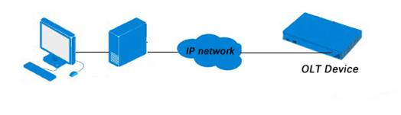

Chapter 2 OLT Information

2.1 Login
Followthe steps to login:
1. Conform “1.2 Connection” to connect;
2. The device default IP address is 192.168.8.200;
3. Open your web browser, type the device IP in address bar;
4. Entry of the username and password will be prompted. Enter the default login User Name and Password. Both the username and password are "admin" by default.
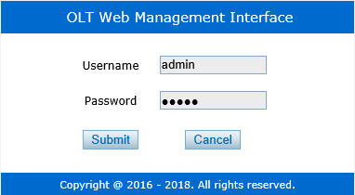
Figure 2-1: Login

2.2 Device Information
The OLT ports connection status are shown in the top of the interface, and about the OLT basic information.
OLT InformationDevice Information
This part shows the OLT information such as system name, serialnumber, hardwareversion, firmwareversion, MAC address and system time.The system name can be modified if need.
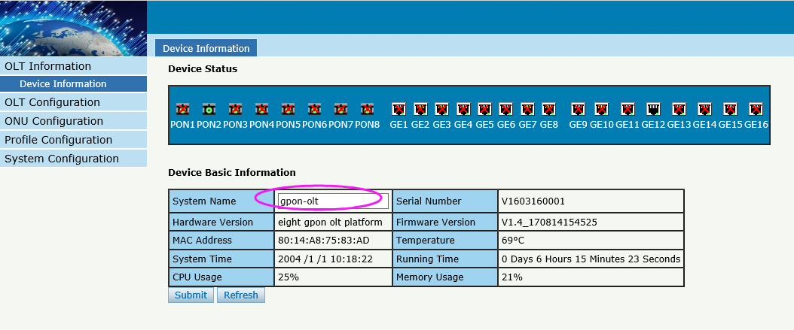
Figure 2-2: Device Information

Chapter 3 OLT Configuration
This section is about the basic service of OLT configuration.

3.1 VLAN
OLT equipment switch engine is fully compliant with the IEEE802.1Q VLAN standard and has the following main features:
- Support Port-based VLAN and IEEE802.1Q VLAN.
- Support full 4K VLAN group, VID range 1~4095.
All switch ports, including uplink ports and downlink ports, support VLAN partition.
VLAN 1 is the system reserved VLAN, it includes all switch ports which are UNTAG mode.
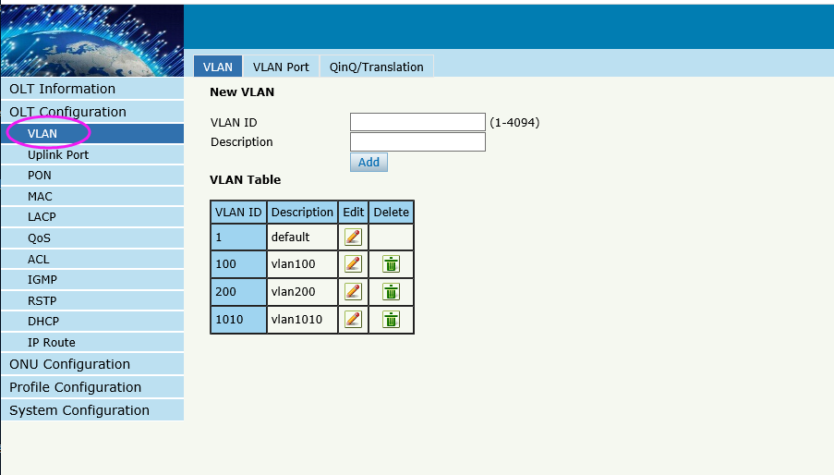

3.1.1 Create VLAN
OLT ConfigurationVLAN
In this user interface, can be create new VLAN.
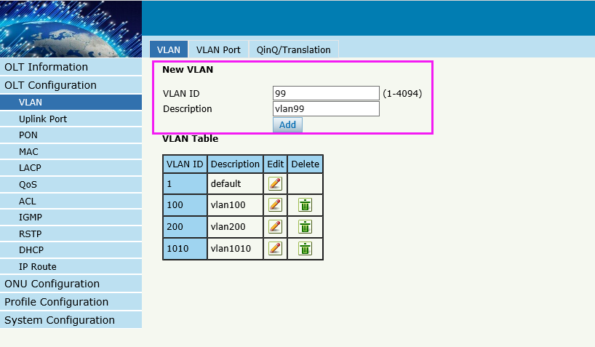
Figure 3-1: Create New VLAN

3.1.2 VLAN Port
OLT ConfigurationVLANVALN Port.
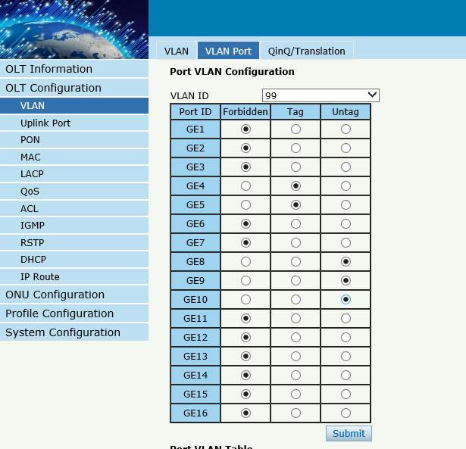
Figure 3-2: Add VLAN Port

3.1.3 QinQ/Translation
OLT ConfigurationVLANQinQ/Translation
In this user interface, VLAN QinQ and VLAN translation can be configured. VLAN QinQ and translation are effective for ingress.

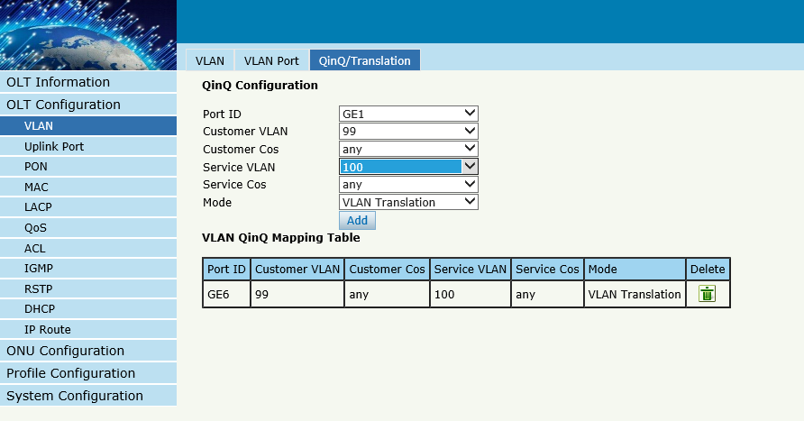
Figure 3-3: QinQ/Translation Configuration

3.2 Uplink Port
GE portstraffic statistics and basic configuration setting.

3.2.1 Information
OLT ConfigurationUplink PortInformation
This user interface displays traffic statistics of uplink ports.

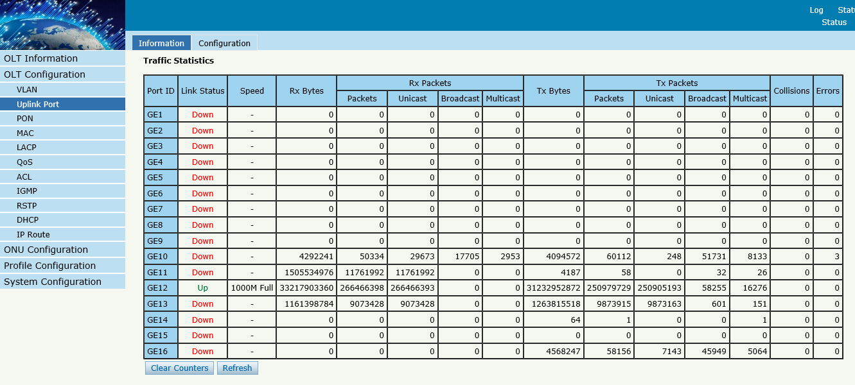
Figure3-4 : GETraffic Statistcs

3.2.2 Configuration
OLT ConfigurationUplink PortInformation
This user interface is used to configure port related functions and characteristic parameters of uplink port, such as port attributes, PVID, flow control, rate limit, storm inhibition, port isolation and so on.
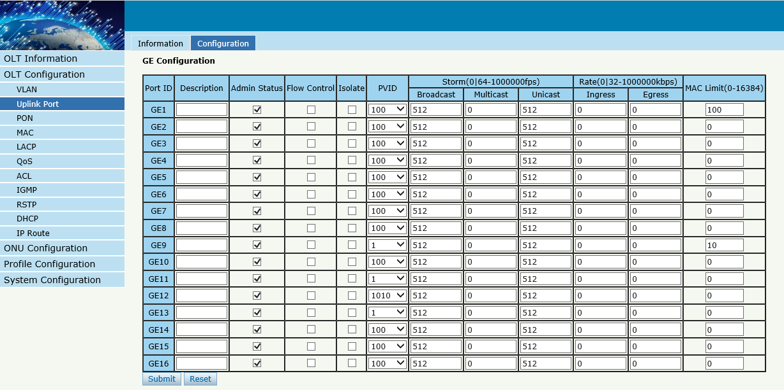
Figure3-5: Uplink Ports Configuration
Illustrations of each parameter:
Parameters | Illustration
Port ID | GE port has two types, fiber SFP(GE1 to GE8) and copper(GE9 to GE16).
Description | Descriptions or remarks of port.
Admin Status | Active or inactive status of port. It is "Enable" by default.
Flow Control | Enable or disable flow control function of uplink port to control congestion. It is "disable" by default.
Isolate | Port isolation with each other.
PVID | Default VLAN ID of the port.
Broadcast | Broadcast storm inhibition.
Multicast | Multicast storm inhibition.
Unknown Unicast | Unknown unicast storm inhibition.
Ingress Rate | Port ingress rate.
Egress Rate | Port egress rate.
MAC limit | Number of mac

3.3 PON

3.3.1 Information
OLT ConfigurationPONInformation
This user interface is used to displays parameters of PON port, such as PON module port current temperature, Voltage,current, transmit power and the traffic statistics.
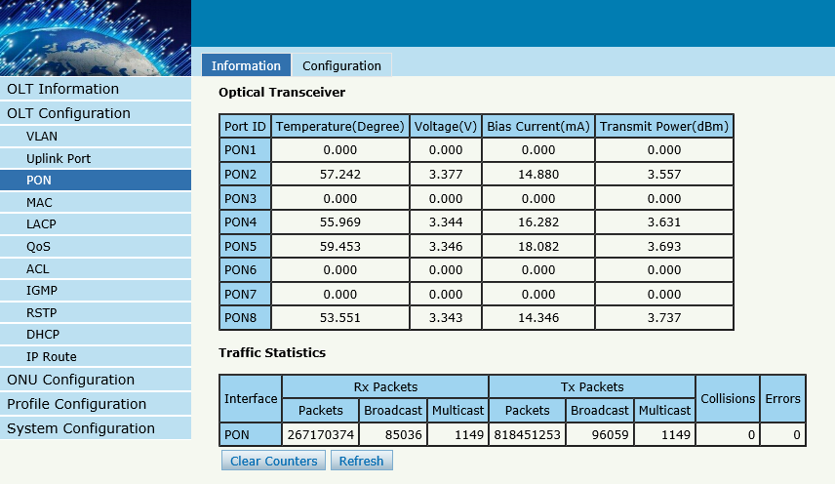
Figure3-6: PON Information

3.3.2 Configuration
OLT ConfigurationPONConfiguration
This user interface is used to configure port status
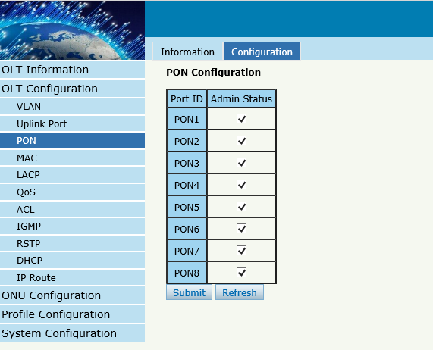
Figure3-7: PON configuration

3.4 MAC
In this section, you can check MAC address table of OLT, set MAC aging time and MAC limit of the ports.

3.4.1 MAC Table
OLT ConfigurationMACMAC Table
This table displays MAC addresses that OLT has learnt at PON port and GE port.

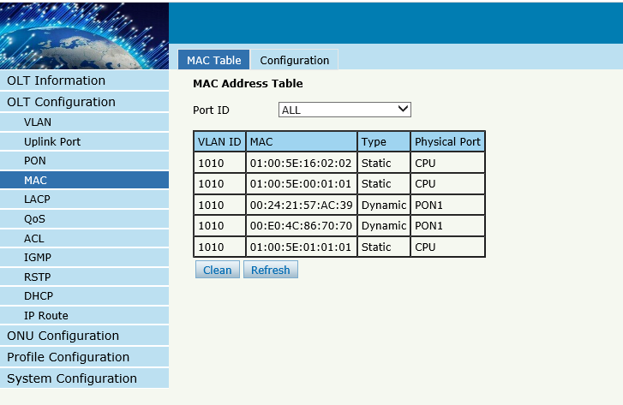
Figure3-8: MAC Address Table

3.4.2 Configuration
OLT ConfigurationMACConfiguration
The default MAC aging time of OLT is 300s, user can change the value between 10~1000000s. Also, user can add the MAC to the OLT manually.

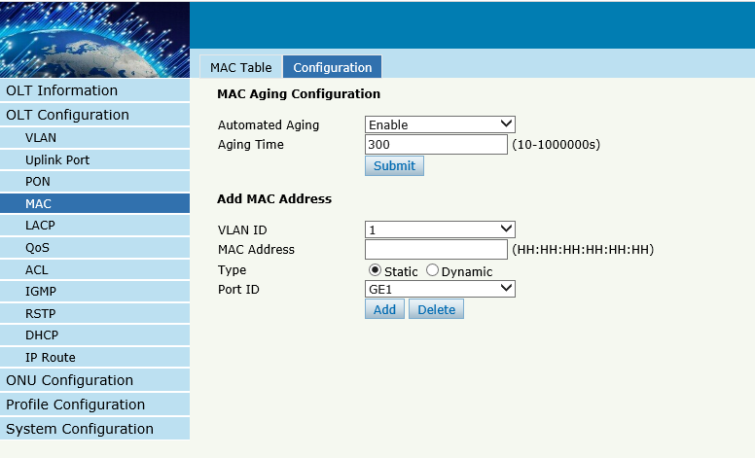
Figure 3-9:MAC Configuration

3.5 LACP
OLT ConfigurationLACPStatic LACP
To assign and configure auplink physical interface to an EtherChannel. When a traffic link can't be used suddenly, this traffic link will switch to another link automatically. The group range is from 1 to 4.Each group can add 4 ports maximally. Only GE ports can be added in the channel groups.
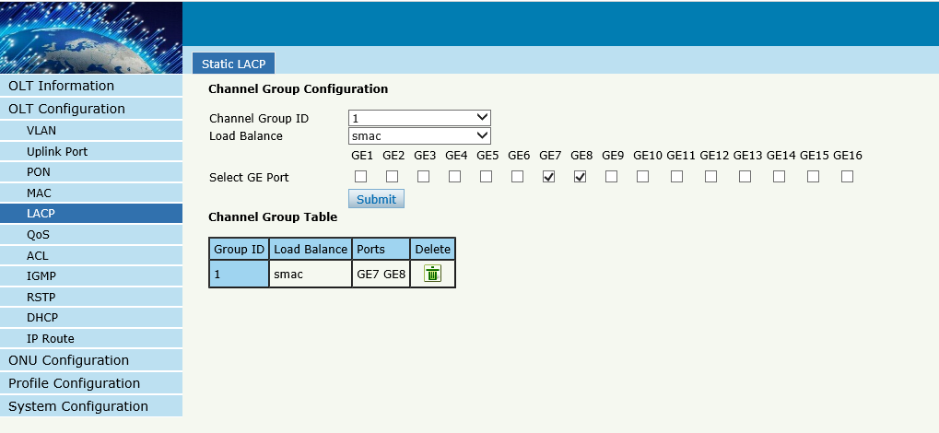
Figure 3-10: Create Static LACP

3.6 QOS
OLT ConfigurationQOS
When bandwidth is not enough or there is congestion in the network, queue scheduling can make sure high priority data traffic passes through the device firstly. Traffic will map to queues according to their priorities and transmit in the queues.
OLT supports eight queues altogether. Queue scheduling mode includes strict priority (SP), weighted round robin (WRR) and hybrid mode (SP-WRR).
Strict priority scheduling guarantees high priority traffic occupy as much as bandwidth. The lower priority traffics pass though only when there is remaining bandwidth.

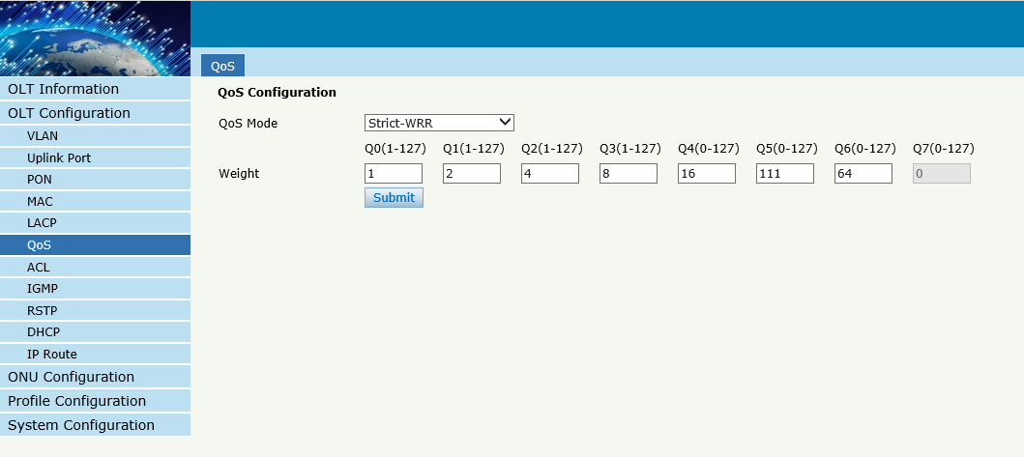
Figure 3-11: QOS Configuration

3.7 ACL
In order to filter data packages, network equipment need to setup a series of rules for identifying what need to be filtered. Only matched with the rules the data packages can be filtered. ACL can achieve this function. Matched conditions of ACL rules can be source address, destination address, Ethernet type, VLAN, protocol port, and so on. These ACL rules also can be used in other situations, such as classification of stream in QoS. An ACL rule may contain one or several sub-rules, which have different matched conditions.
This device supports the following types of ACL.

3.7.1 IP Filter
The filter is basic on the IP address, include source IP address and destination IP address.
OLT ConfigurationACLIP Filter
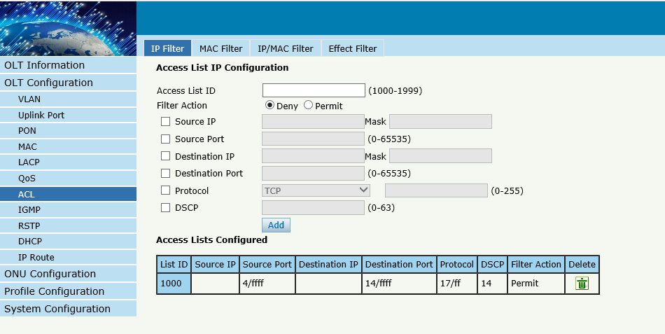
Figure 3-12: IP Filter

3.7.2 MAC Filter
The filter is basic on the MAC address, include source MAC address and destination MAC address.
OLT ConfigurationACLMAC Filter
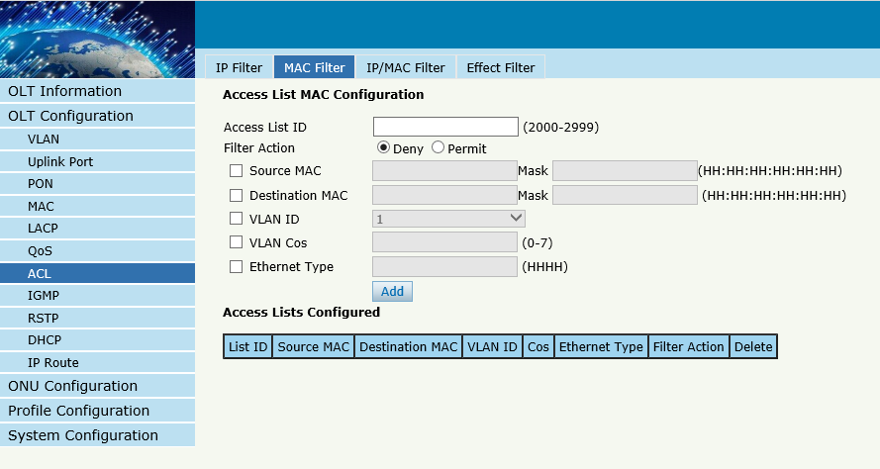
Figure 3-13: MAC Filter

3.7.3 IP/MAC Filter
This filter mix the IP address and MAC address, include source MAC address and destination MAC address, source IP address and destination IP address.
OLT ConfigurationACLIP/MAC Filter
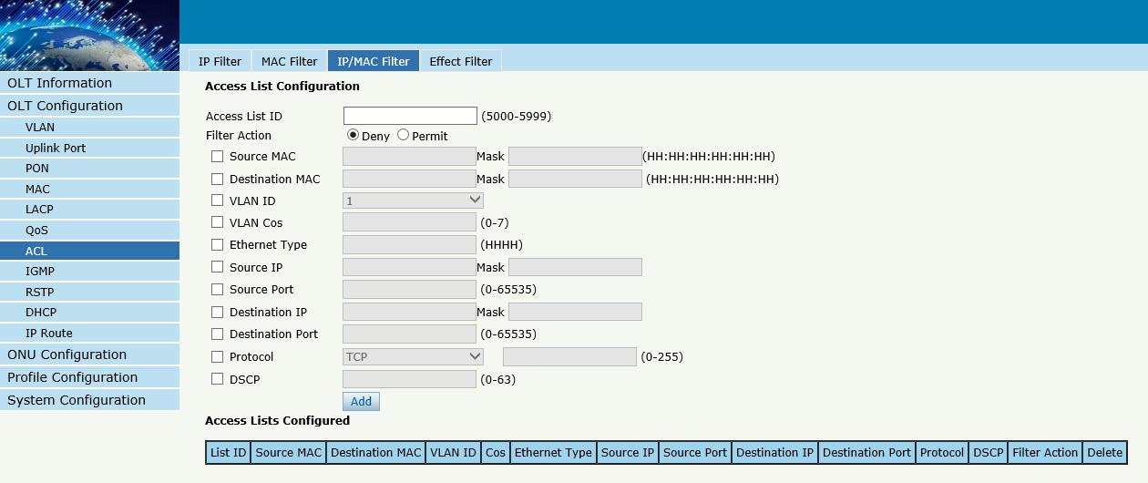
Figure 3-14 IP/MAC Filter

3.7.4 Effect Filter
Bind the access list to the portsthen it can take effect. Each access list can be bound several ports.
OLT ConfigurationACLEffect Filter
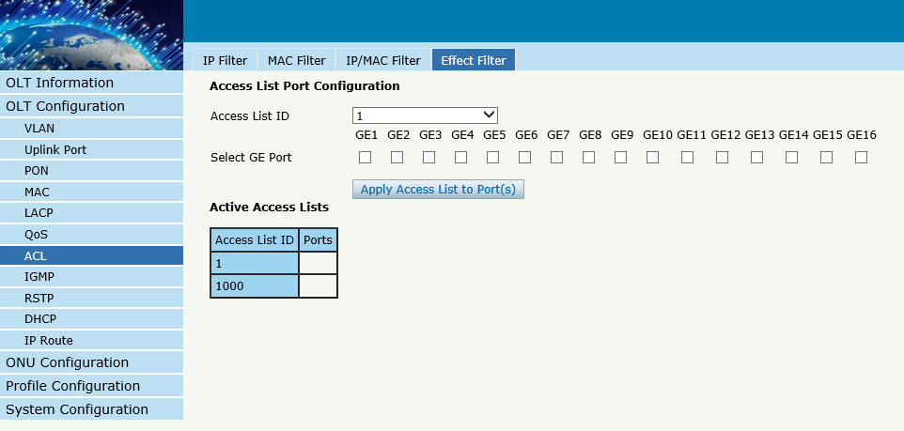
Figure 3-15: Bind Security Filter

3.8 IGMP

3.8.1 Group Member
When there is a multicast group produced, the group will display in this table.
OLT ConfigurationIGMPGroup Member
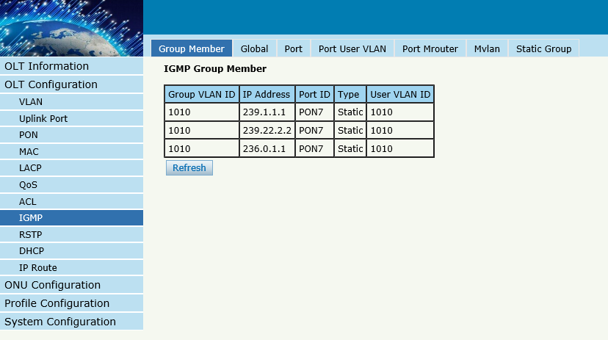
Figure 3-16: Group Member

3.8.2 Global
OLT Configuration IGMPGlobal.
IGMP basic configuration mainly contains parameters of query packet.
When IGMP status is checked, OLT works at IGMP snooping mode. IGMP snooping is the process of listening to Internet Group Management Protocol (IGMP) network traffic. The feature allows a network switch to "listen in" on the IGMP conversation between hosts and routers. By listening to these conversations, the switch maintains a map of which devices need which IP multicast streams. Multicasts may be filtered from the ports which do not need them and thus controls which ports receive specific multicast traffic. When IGMP status is disable, OLT works at transparent mode.
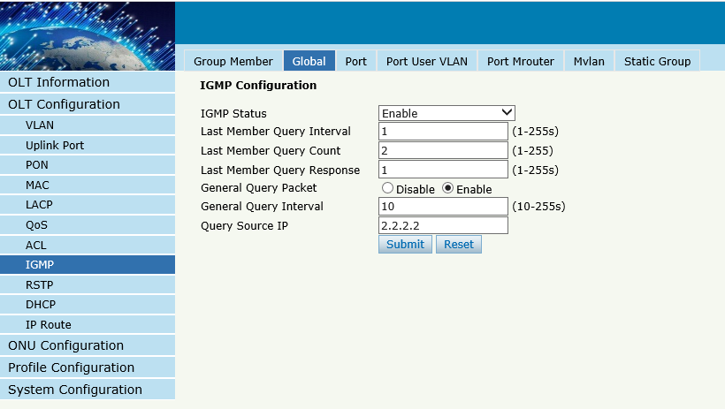
Figure 3-17: IGMP Global

3.8.3 Port
OLT Configuration IGMPPort.
This configuration is used to set the maximum number of multicast groups, filter and fast leave mode.
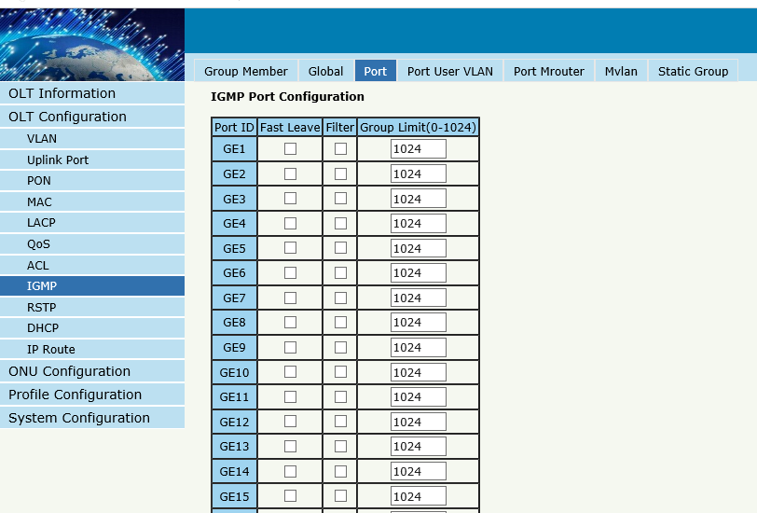
Figure 3-18: IGMP Port

3.8.4 Port User VLAN
OLT Configuration IGMPPort User VLAN
This configuration is used to configure IGMP VLAN for OLT. Generally, PON ports should be configured, and user VLAN and group VLAN are the same. If user VLAN and group VLAN are different, multicast VLAN will be translated.

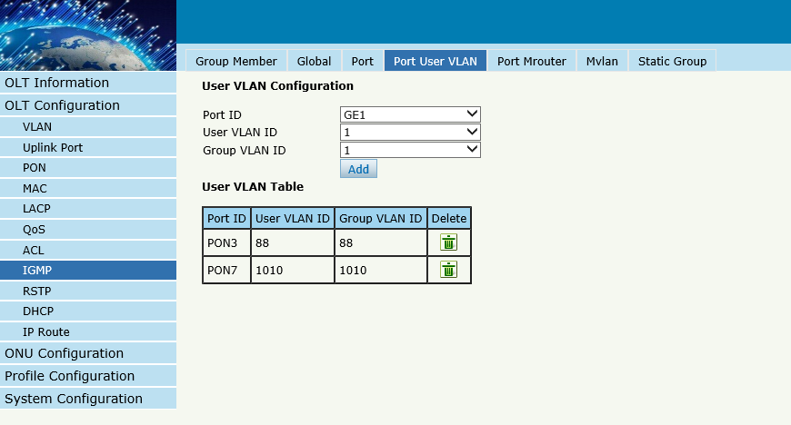
Figure 3-19: IGMP Port User VLAN

3.8.5 Port Mrouter
OLT Configuration IGMPPort Mrouter
Multicast router port is used to transmit IGMP signal messages. Generally, OLT uplink ports should be set as multicast router ports.
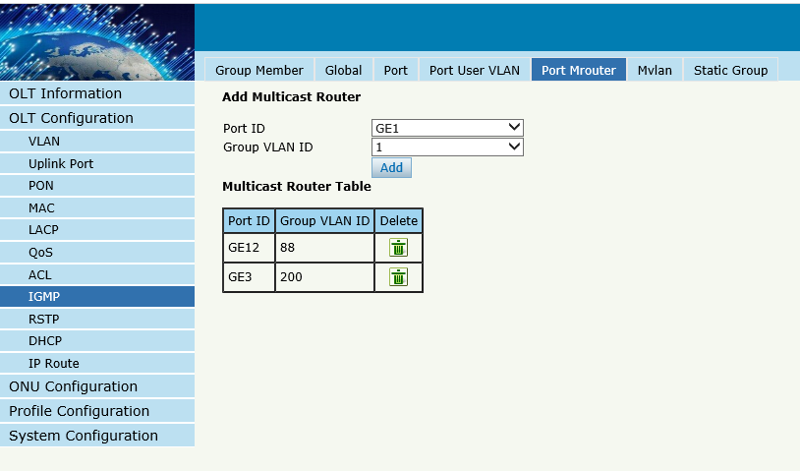
Figure 3-20: IGMP Port Mroute

3.8.6 Mvlan
OLT Configuration IGMPMvlan
This configuration is used to configure Mvlan and its mode.
IGMP mode | Unknown multicast | Igmp packet
Snooping | drop | trap –to -cpu
Disable(transparent) | forward | forward

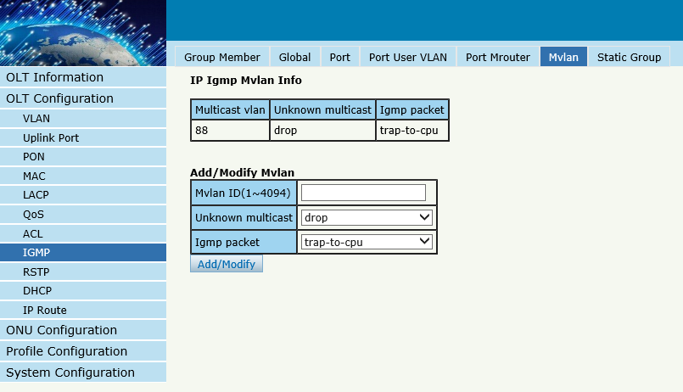
Figure 3-21: IGMP MVLAN

3.8.7 Static Group
OLT Configuration IGMPStatic Group
This configuration is used to bind multicast IP address and VLAN ID.
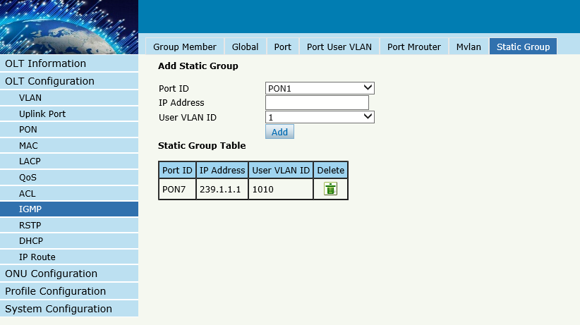
Figure 3-22: IGMP Static Group

3.9 RSTP
Spanning Tree Protocol is layer2 protocol, which is used to eliminate network loop by blocking network redundant links selectively. It has the feature of link backup as well.

3.9.1 Information
OLT ConfigurationRSTPInformation
Global information mainly displays RSTP parameters of root bridge device.
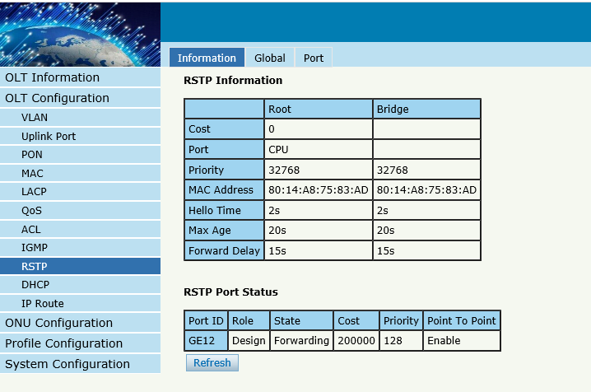
Figure 3-23:RSTP Information

3.9.2 Global
OLT ConfigurationRSTPGlobal
This configuration is used to set RSTP parameters of the device, which contains RSTP switch, priority, hello time, max age, forward delay and MAC address.

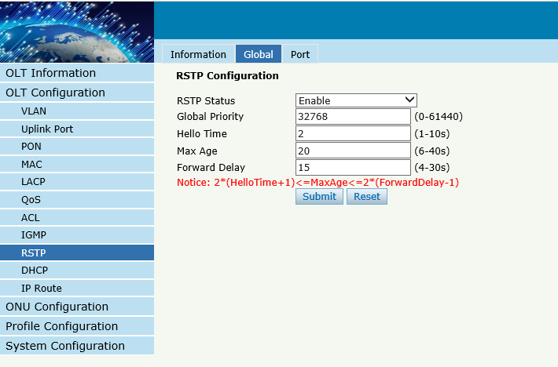
Figure 3-24: RSTP Global Setup

3.9.3 Port
OLT ConfigurationRSTPPort .
This user interface is used to set port RSTP parameters which contain RSTP switch, priority, cost, edge port and p2p port.
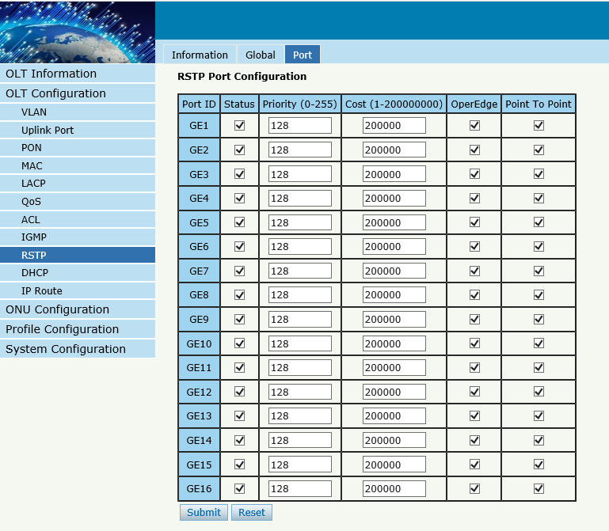

Figure 3-25: RSTP Port Setting

3.10 DHCP
OLT can support the following DHCP functions.
- DHCP Server
- DHCP Relay
- DHCP Snooping

3.10.1DHCP Server

3.10.1.1 DHCP Lease
OLT ConfigurationDHCPDHCP ServerLease
This table displays IP addresses assigned and their MAC addresses, lease time.
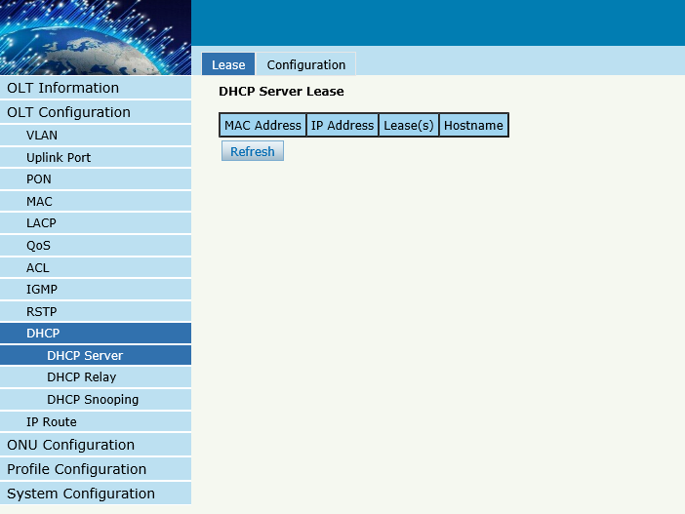
Figure 3-26: DHCP Lease

3.10.1.2 DHCP Configuration
OLT ConfigurationDHCPDHCP ServerConfiguration
Sometimes the devices need dynamic IP addresses, but there is no special DHCP server in network. These configurations can solve the problem. OLT will be a DHCP server in network and assign IP addresses to other devices.
Before enabling DHCP server, you must configure IP address for the VLAN.

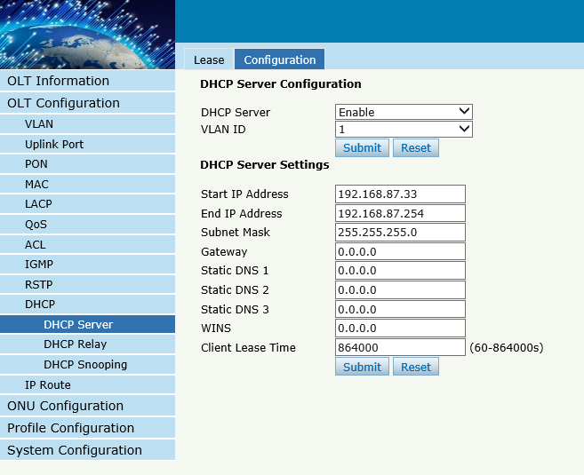
Figure 3-27:DHCP Configuration

3.10.2 DHCP Relay

3.10.2.1 DHCP Relay Configuration
OLT ConfigurationDHCPDHCP Relay
Because the DHCP service exists in one broadcast domain, the server and the client are usually in the same network segment. DHCP relay can solve the issue that DHCP server and client do not exist in the same network segment.
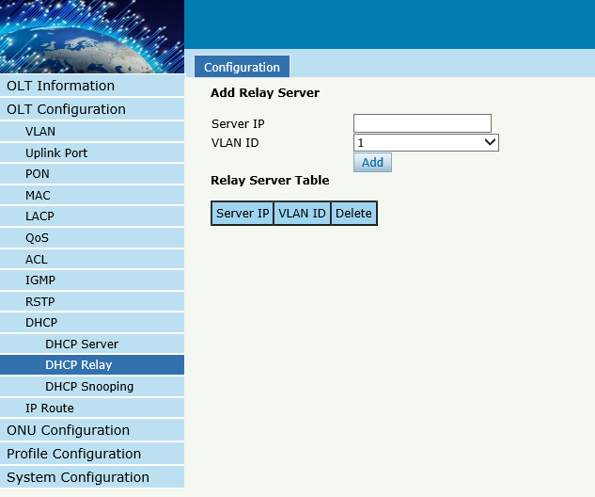
Figure 3-28:DHCP Relay Configuration

3.10.3 DHCP Snooping

3.10.3.1 DHCP Snooping Bind List
OLT ConfigurationDHCPDHCP SnoopingBind List
The static bind of the DHCP Snooping will be shown ,
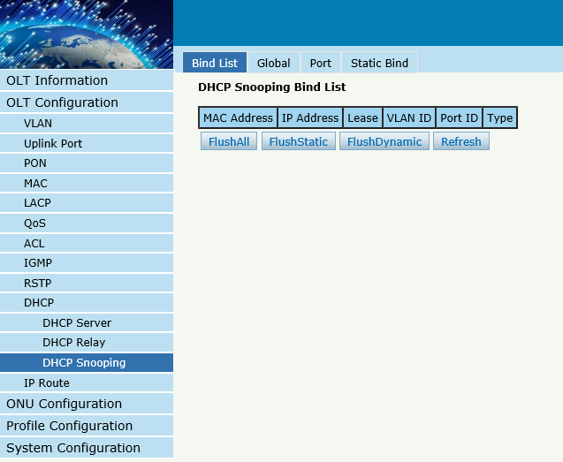
Figure 3-29:DHCP Snooping Bind List

3.10.3.2 Global
OLT ConfigurationDHCPDHCP SnoopingGlobal
DHCP Snooping is used to prevent the DHCP message attacking and guarantee network to get a correct IP address.
DHCP snooping global configuration mainly contains option 82 settings, DHCP traffic rate limit and snooping VLAN.

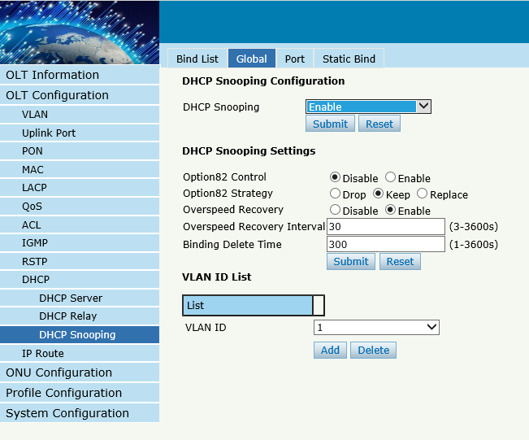
Figure 3-30:DHCP Snooping Global

3.10.3.3 Port
OLT ConfigurationDHCPDHCP SnoopingPort
This user interface is used to configure DHCP snooping parameters of ports which contain port type, option 82 parameters and rate limit.
All the ports are untrust ports by default. Option82 parameters, “Option 82 Circuit ID” and “Option 82 Remate ID”, are effective for untrust ports. “Limit Rate” is the ports’ max speed of receiving DHCP packets.

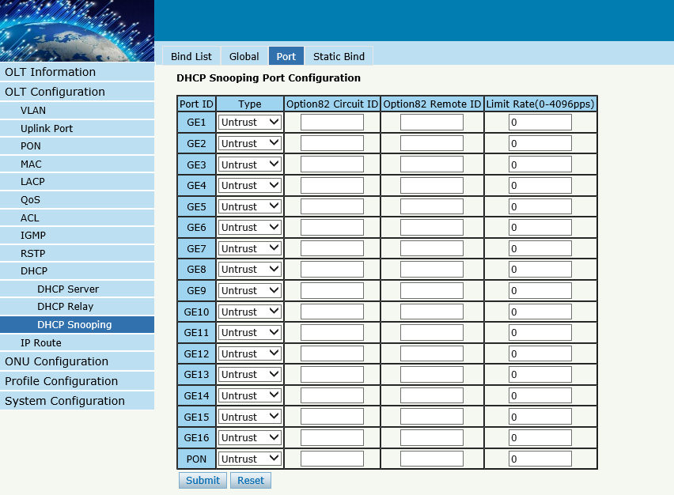
Figure 3-31:DHCP Snooping Port Setup

3.10.3.4 Static Bind
OLT ConfigurationDHCPDHCP SnoopingStatic Bind
DHCP snooping binding is useful when a host needs a fixed IP address assigned by DHCP server from the specific port.

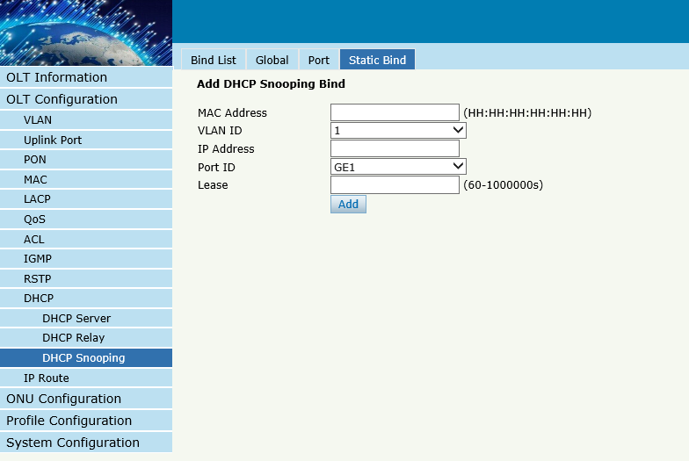
Figure 3-32 DHCP Snooping Static Bind

3.11 IP Route

3.11.1 VLAN IP
OLT ConfigurationIP RouteVLAN IP
This configuration is used to configure IP address for VLAN. When the VLAN is added to a port, you can access OLT by the IP address from the port.
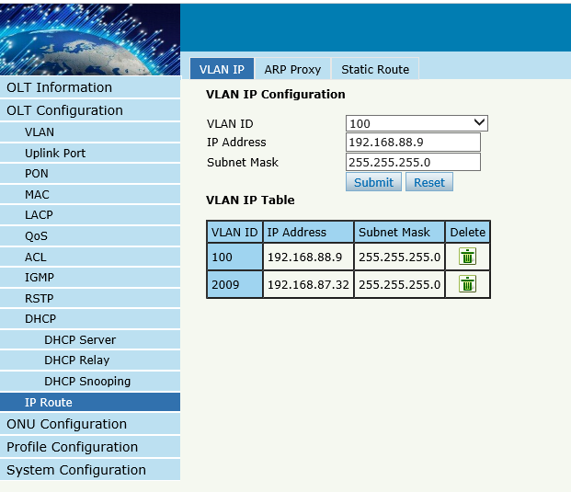
Figure 3-33:VLAN IP

3.11.2 ARP Proxy
OLT ConfigurationIP RouteARP Proxy
ARP Proxy is a technique by which a device on a given network answers the ARP queries for a network address that is not on that network. The ARP Proxy is aware of the location of the traffic's destination, and offers its own MAC address as (ostensibly final) destination. The "captured" traffic is then typically routed by the Proxy to the intended destination via another interface or via a tunnel.
The process which results in the node responding with its own MAC address to an ARP request for a different IP address for proxying purposes is sometimes referred to as 'publishing'.
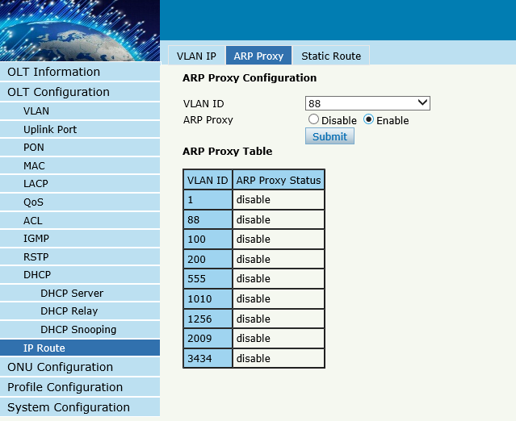
Figure 3-34: ARP proxy configuration

3.11.3 Static Route
OLT ConfigurationIP RouteStatic Route
Static route is a form of routing that a router uses a manually-configured routing entry. In many cases, static routes are manually configured by a network administrator. Unlike dynamic routing, static routes are fixed and do not change if the network is changed or reconfigured.
The OLT only supports static route. After configured VLAN IP address, add static routes to make the network on the different network segment communicate with each other.

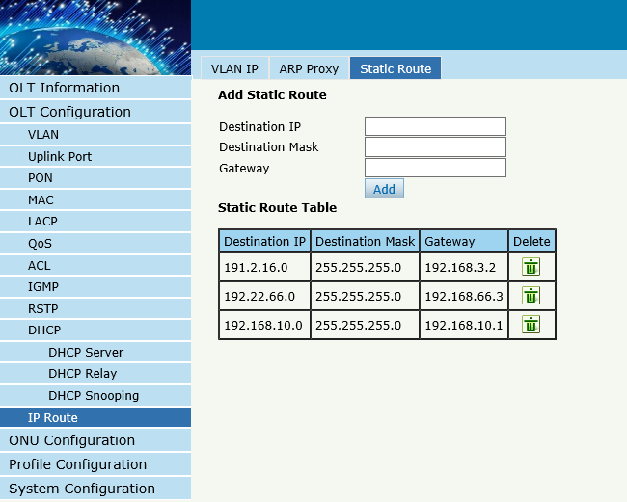
Figure 3-35: Static Route

Chapter 4 ONU Configuration
This chapter is about the ONU management by OLT.

4.1 ONU AuthList

4.1.1 ONU Status
ONU ConfigurationONU AuthListONU Status
Select PON port ID, all ONUs will be displayed in this interface.
You can check ONU Admin state、OMCC state and phase state.
If the phase state is working ,this ONU is registered successfully
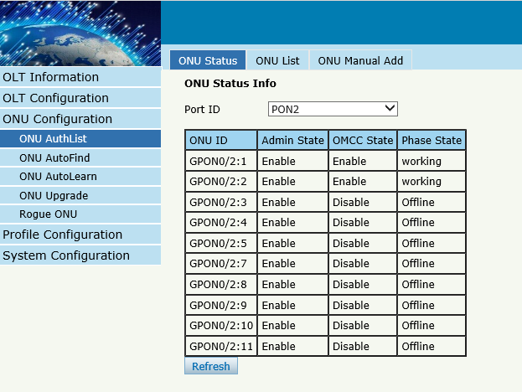
Figure 4-1 ONU Status

4.1.2 ONU List
ONU ConfigurationONU AuthListONU List
Select PON port ID, all ONUs will be displayed in this interface. You can check ONU using profile 、Registration mode and do some operations to every ONU.
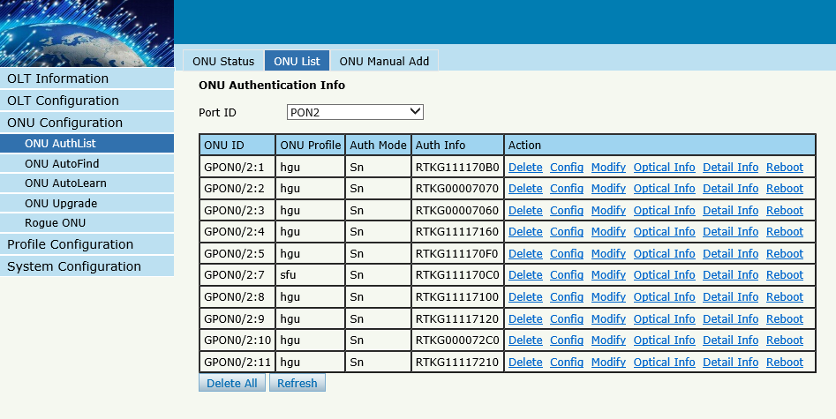
Figure 4-2 ONU List

4.1.2.1 Delete
ONU ConfigurationONU AuthListONU List
Delete ONU which you selected, the ONU will be deleted and the registration failed
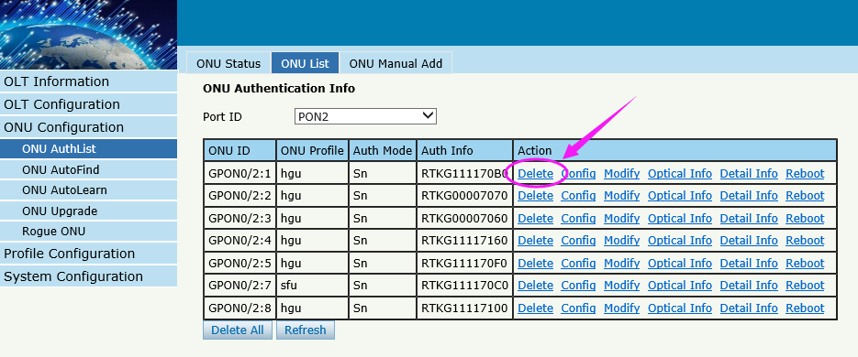
Figure 4-3Delete ONU

4.1.2.2 Config
ONU ConfigurationONU AuthListONU List
Configure ONU parameter informationwhich you selected,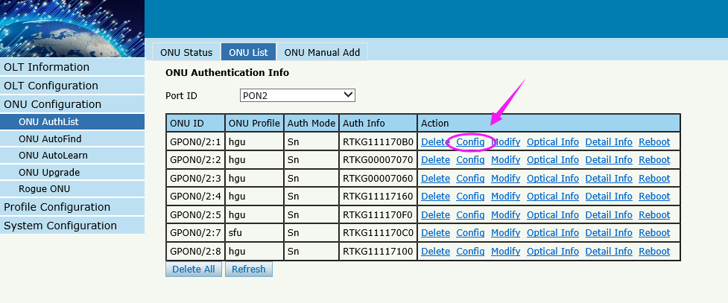
Figure 4-4 Configure ONU

Create a tcont ID and bind DBA templates
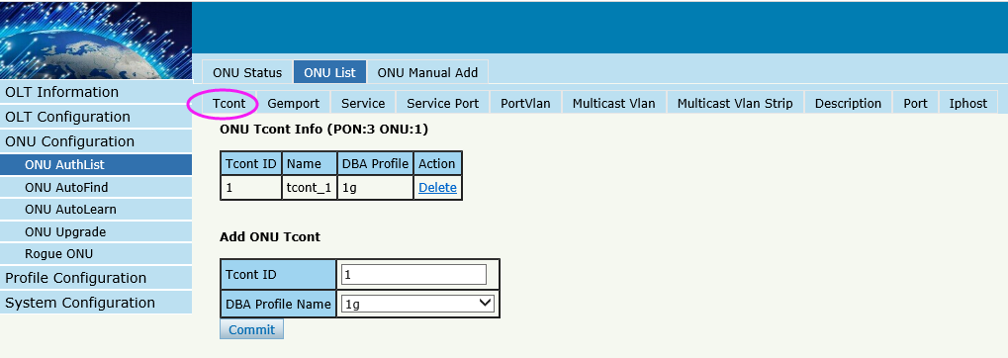
Figure 4-5 Create Tcont
Create a gemport ID and bind tcont ID
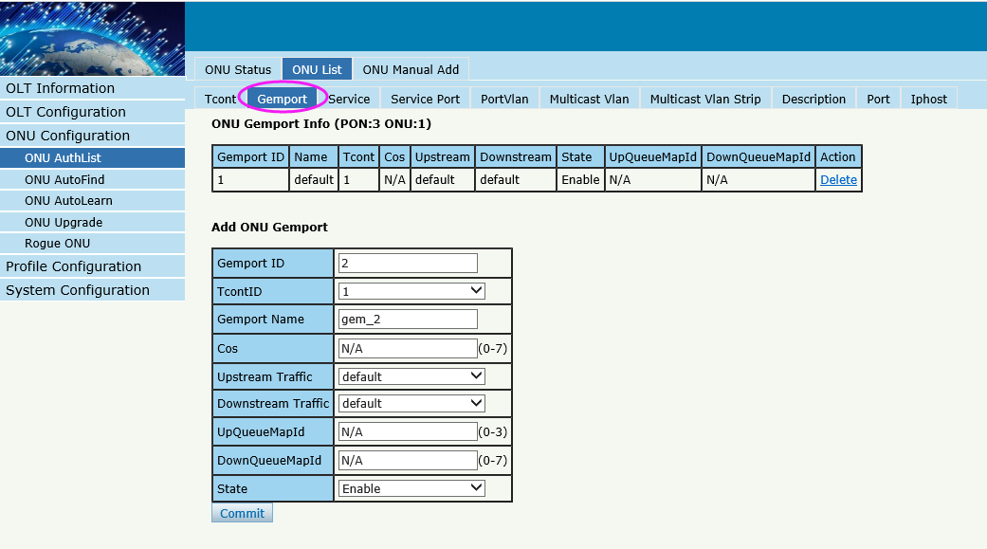
Figure 4-6 Create gemport
Create a service , Set the VLAN and VLAN mode and let it bind one gemport ID.

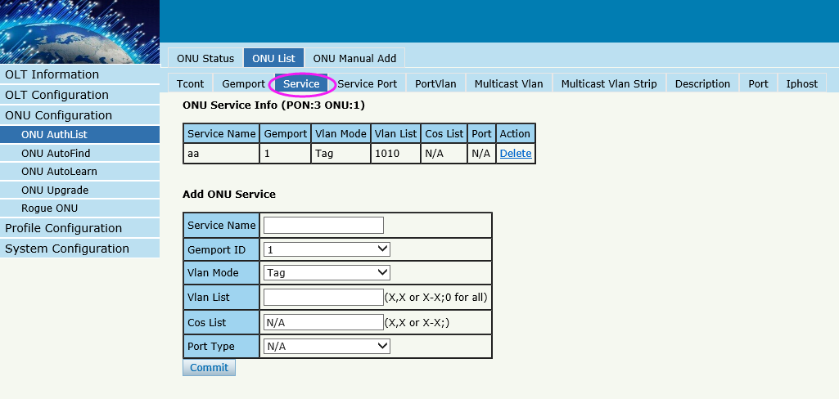
Figure 4-7 Create service
Create a service port, Set the user VLAN and translate VLAN and let it bind one gemport ID.
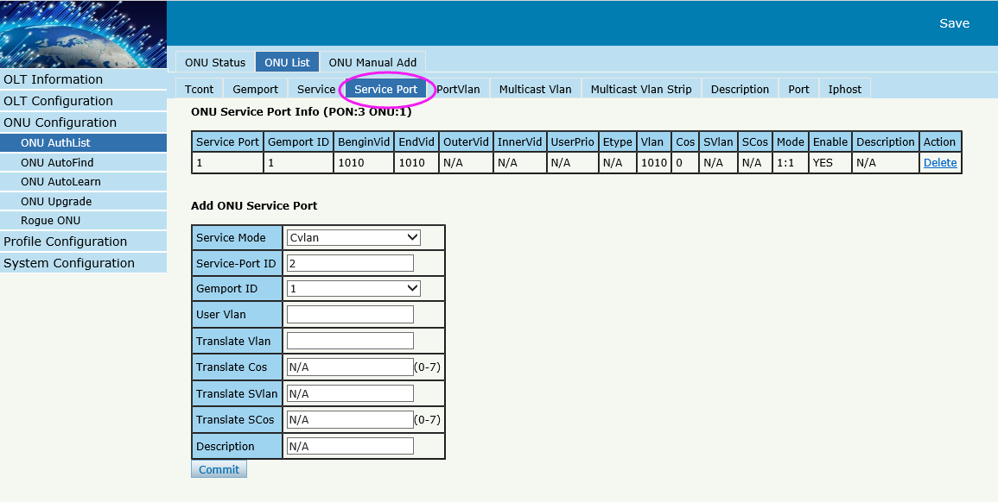
Figure 4-8 create service port
Set the VLAN mode of the ONU’s port.
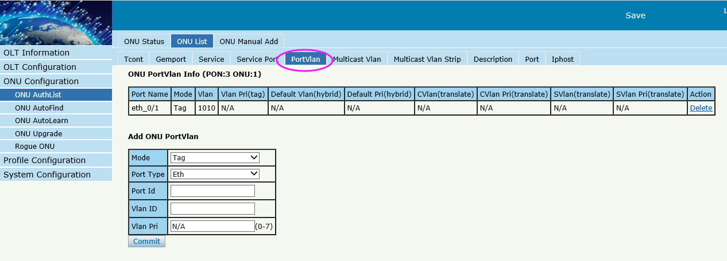
Figure 4-9 configure port VLAN mode
Set the Multicast VLAN of ONU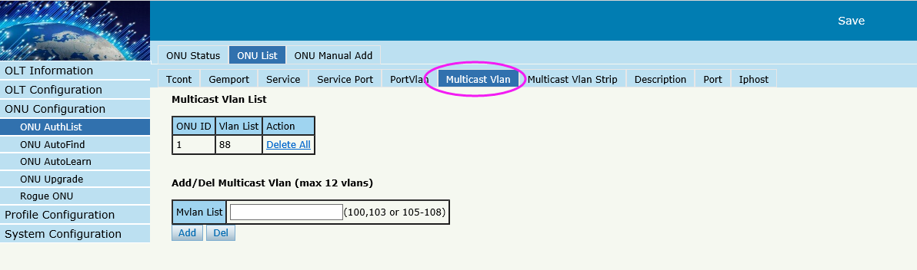
Figure 4-10 configure multicast VLAN

Set the Multicast VLAN mode of ONU’s port
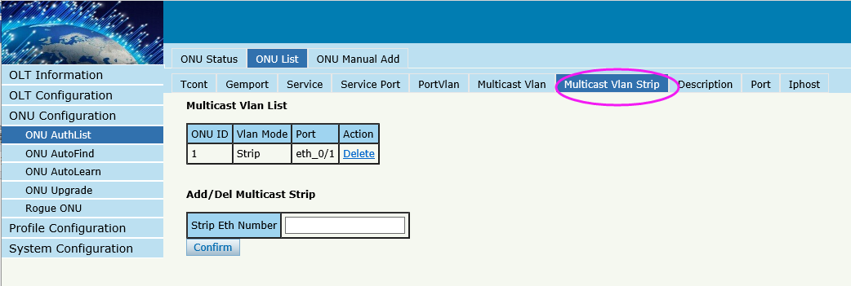
Figure 4-11 configure multicast VLAN mode

Description for ONU
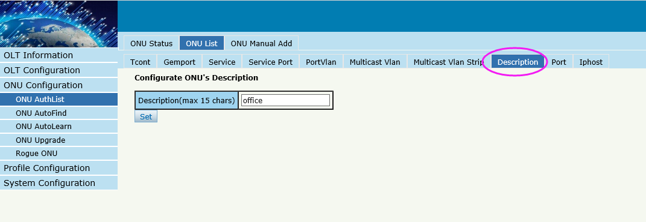
Figure 4-12 ONU’s description
Port Basic State of ONU
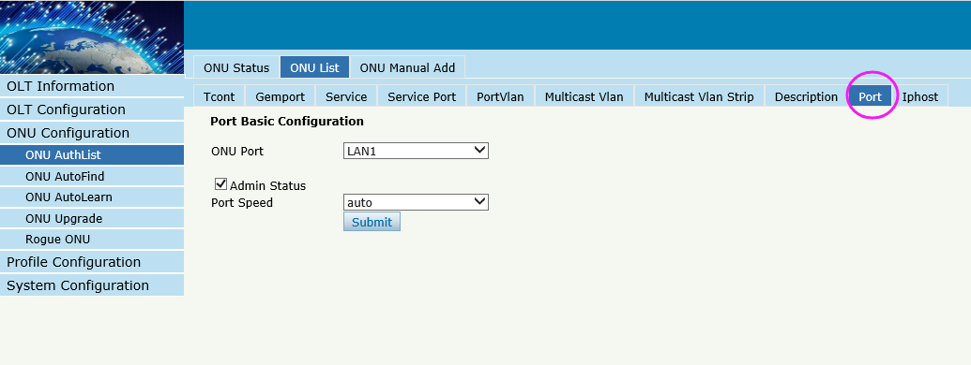
Figure 4-13 ONU’s port state
Create Iphost for ONU wan connection.
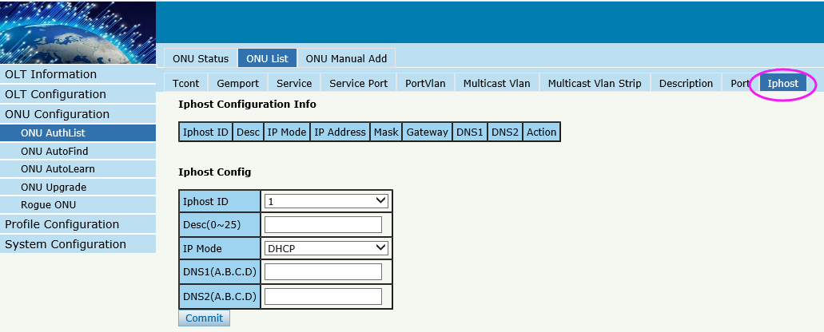
Figure 4-14 configure IPhost

4.1.2.3 Modify
ONU ConfigurationONU AuthListONU List
Modify SN or LOID of ONUwhich you selected,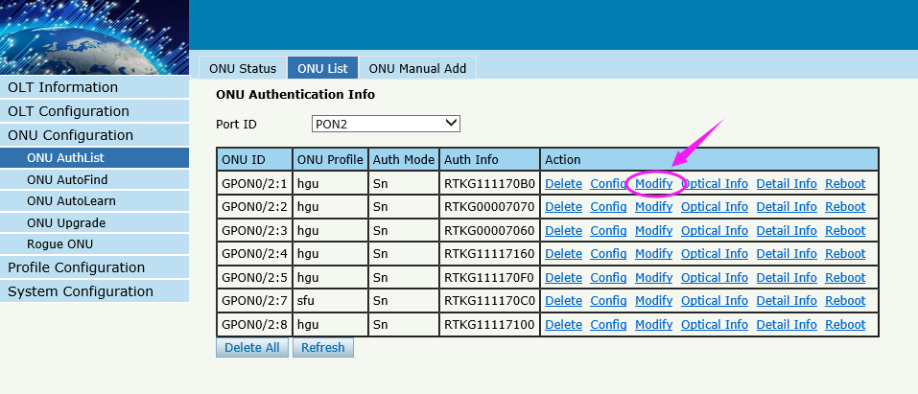
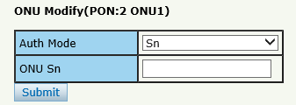
Figure 4-15 Modify ONU Registration mode

4.1.2.4 Optical Info
ONU ConfigurationONU AuthListONU List
Check the Optical Info of ONUwhich you selected,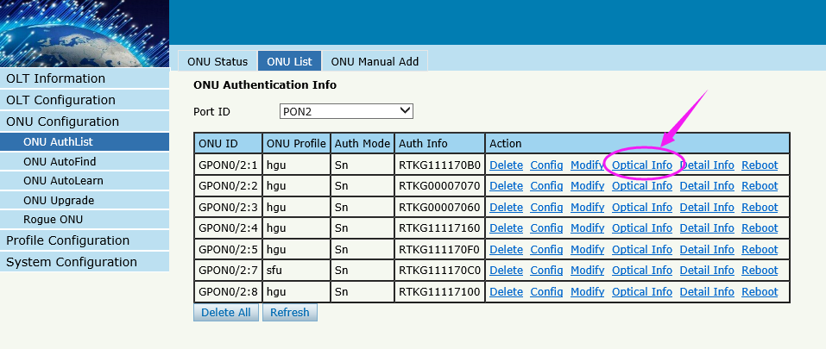
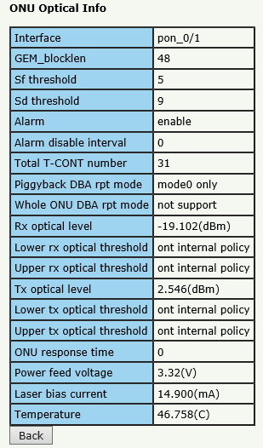
Figure 4-16 Optical info of ONU

4.1.2.5 Detail Info
ONU ConfigurationONU AuthListONU List
Check the Detail Info of ONUwhich you selected,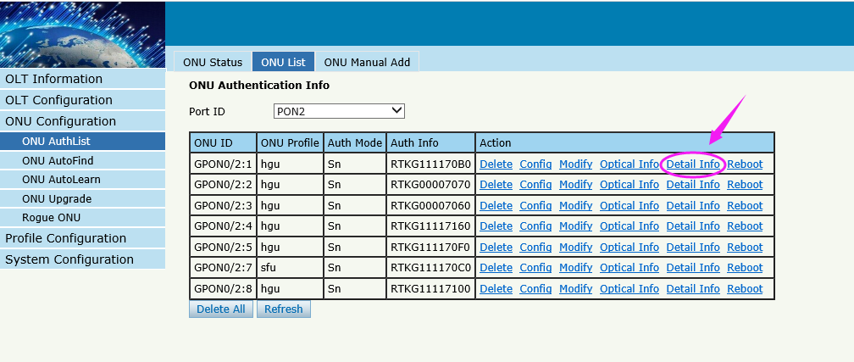
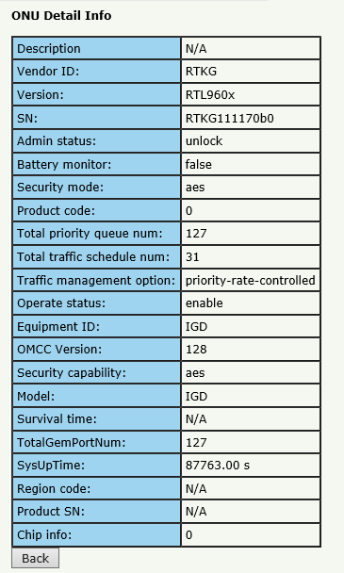
Figure 4-17 Detail info of ONU

4.1.2.6 Reoot
ONU ConfigurationONU AuthListONU List
Reboot ONUwhich you selected,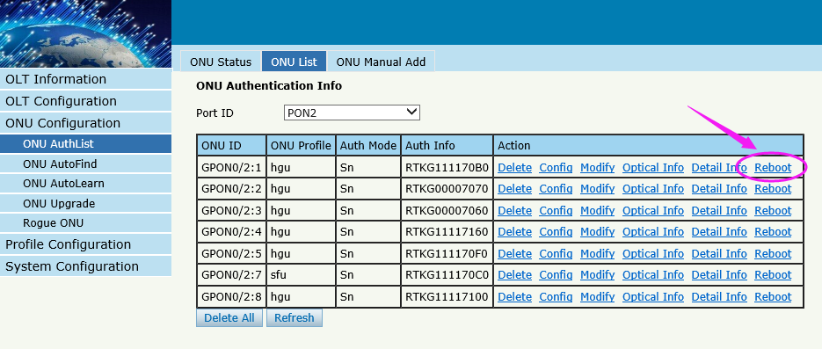
Figure 4-18 reboot ONU

4.1.3 ONU Manual Add
ONU ConfigurationONU AuthListONU Manual Add
You can manually add a ONU to your chosen PON port. ONU will appear on the ONU list after you operated.
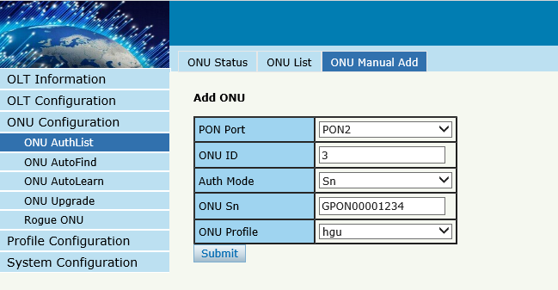
Figure 4-19 manually add a ONU
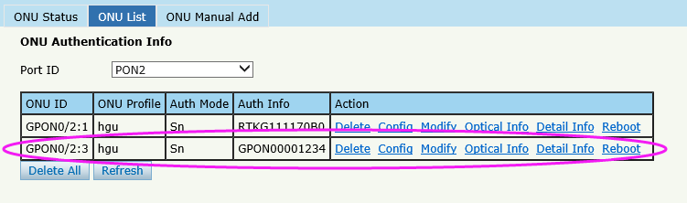
Figure 4-19 ONU info

4.2 ONU AutoFind
ConfigurationAutoFind
After selecting PON port number, all ONUs which are authenticated failed or not authenticated will be displayed in this interface. You can check the serial number of ONUs.
More information will be show under the ONU Detail menu.

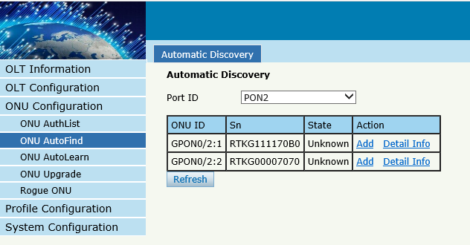
Figure 4-20 Authentication Mode
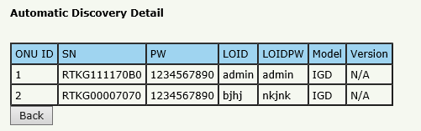
Figure 4-21 Detail info

4.3 ONU AutoLearn

4.3.1 ONU AutoLearn
ConfigurationAutoLearnONU AutoLearn
ONU can be auto authenticated after enabling PON port automatic learning.

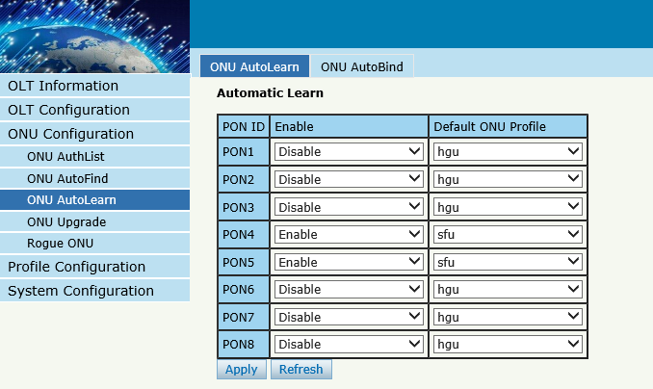
Figure 4-22 Automatic learn

4.3.2 ONU AutoBind
ConfigurationAutoLearnONU AutoBind
Input the Equipment ID and bind the template you need
Note: you must build the template first
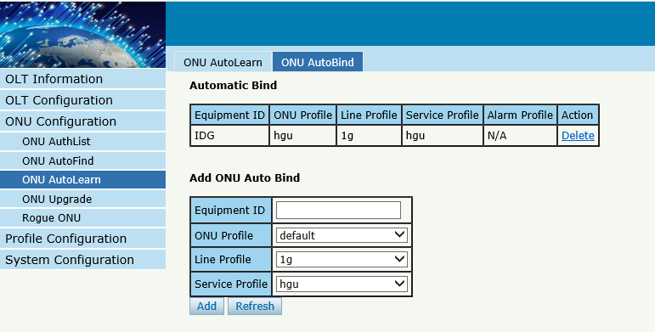
Figure 4-23 Bind profile

4.4 ONU Upgrade
ONU upgrade by OLT

4.4.1 Upload Image
Upload ONU firmware image which you need, the image will upload to OLT’s RAM
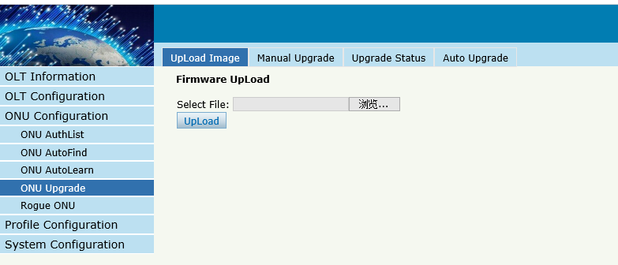
Figure 4-24 Upload image

If the operation is successful, the following will appear
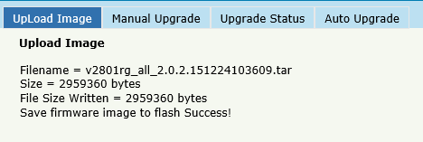
Figure 4-25 Upload info

4.4.2 Manual Upgrade
ONU ConfigurationONU UpgradeManual Upgrade
Select ONU which you need and click commit button
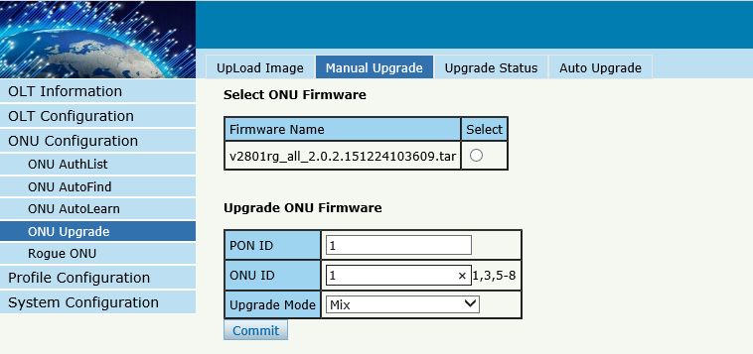
Figure 4-26 Manual Upgrade

4.4.3 Upgrade Status
ONU ConfigurationONU UpgradeUpgrade Status
When ONU is upgrading, the list will be shown in this page.
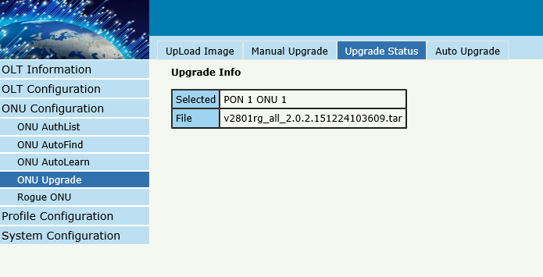
Figure 4-27 ONU Upgrade Status

4.3.4 Auto Upgrade
ONU ConfigurationONU UpgradeAuto Upgrade
The ONU firmware will be saved in the OLT’s RAM first, when the ONU come online, it will auto upgrade the firmware.
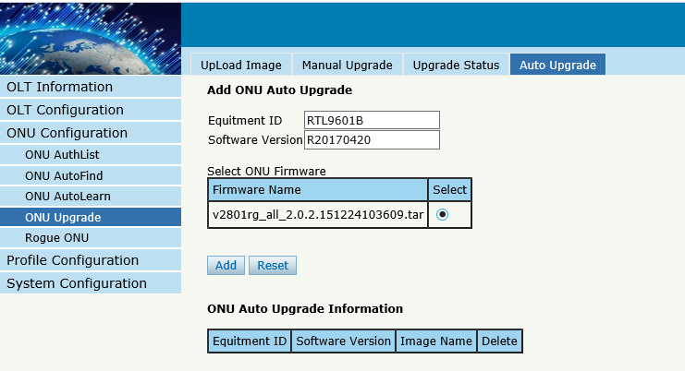
Figure 4-28 Auto Upgrade

4.5 Rogue ONU
ONU ConfigurationRogue ONU
Enable this function, If there is a rogue ONU, it will appear in the list
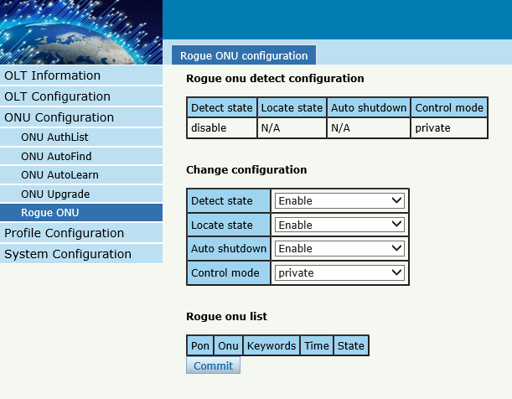
Figure 4-29 Rogue ONU detect

Chapter 5 Profile Configuration
This chapter is about the ONU profile configuration. It is designed for batch ONU management by OLT.

5.1 ONU Profile
The Onu profile is used for onu authorization, and each ONU must specify only one ONU profile when authorizated. The ONU profile specifies the capability of this ONU.

5.1.1 Information
Profile Configuration ONU profileInformation
The table displays ONU profile list.We can also do some operation, such delete and check details info.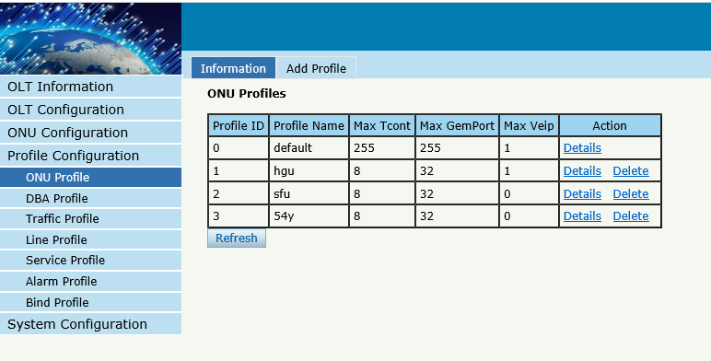
Figure 5-1 ONU profile list

5.1.2 Add profile
Create a new ONU profile what you need , Generally, ONU has two modes.
SFU mode (only using bridge mode):
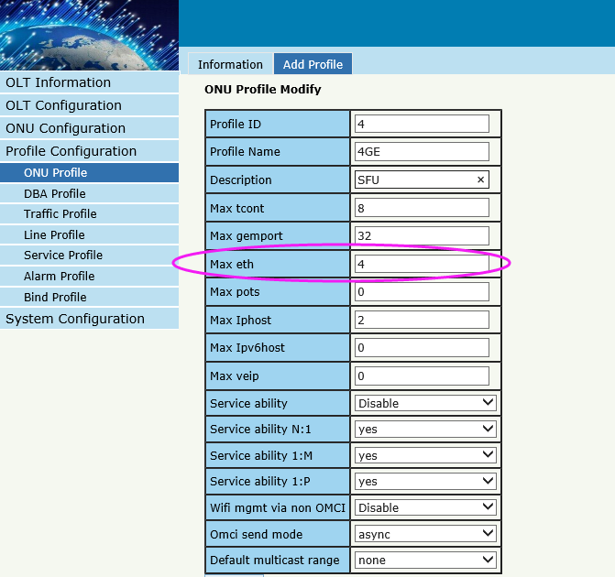
Figure 5-2 Add SFU profile
HGU mode (with the routing wan connection mode)
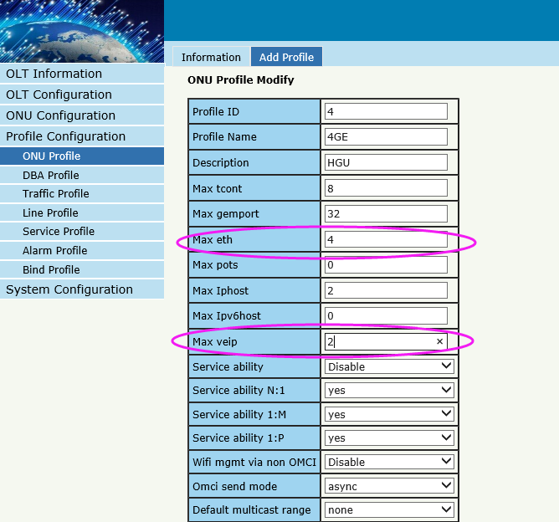
Figure 5-3 Add HGU profile

5.2 DBA Profile
DBA is a bandwidth allocation strategy that changes uplink bandwidth assigned to each T-CONT in real time according to the instant service status of each ONU. There are five BW types supported and make sure that fix<=assure<=max.

5.2.1 DBA profiles
Profile ConfigurationDBA Profile DBA Profiles
The table displays DBA profile list. We can also do some operation, such delete and modify.
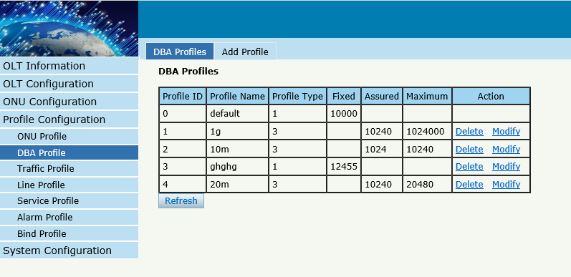
Figure 5-4 DBA profile list

5.1.2 Add profile
Profile ConfigurationDBA Profile Add profile
Types:1,2,3,4,5，In general, we use type3
Relationships:
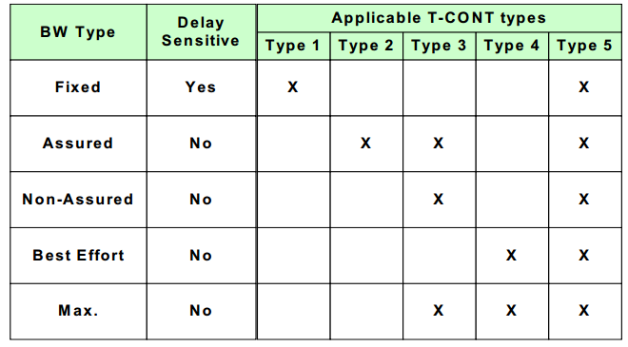
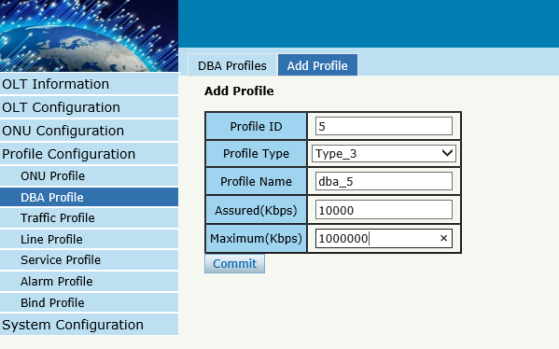
Figure 5-5 Add a DBA profile

5.3 Traffic Profile
Traffic profile is used by Gemport to specify the upstream/downstream bandwidth.

5.3.1 Traffic profiles
Profile ConfigurationTraffic Profile Traffic Profiles
The table displays Traffic profile list. We can also do some operation, such delete and modify.

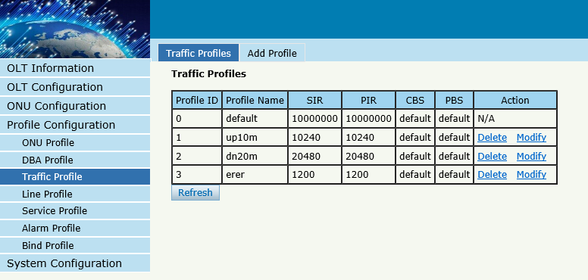
Figure 5-6 Traffic Profile list

5.2.2 Add profile
Profile ConfigurationTraffic Profile Add Profile
Configure Gemport to specify the upstream/downstream bandwidth.
SIR：Committed Information Rate
PIR：Peak Information Rate
CBS: Committed Burst Size
PBS: Peak Burst Size
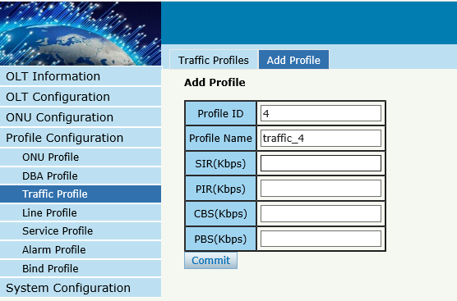
Figure 5-7 Add a traffic Profile

5.4 Line Profile
Line profile is used to configure the ANI side services of ONU such as t-cont, gem-port, service-port and so on.

5.3.1 Line profile
Profile ConfigurationLine Profile Line Profile
The table displays Line profile list. We can also do some operation, such delete and modify.

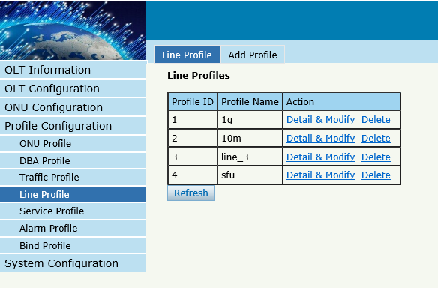
Figure 5-8 Line Profile list

5.3.2 Add profile
Profile ConfigurationLine profileAdd profile
Create a new line profile
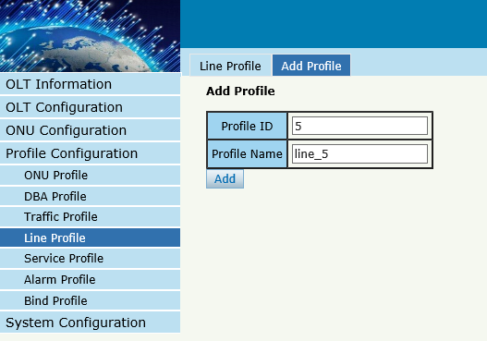
Figure 5-9 Add Line Profile
Modify the line profile parameters
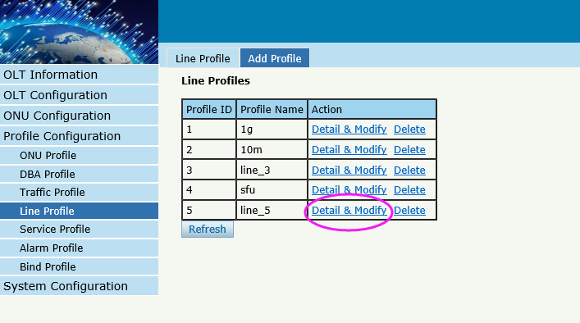
Figure 5-10 Modify Line Profile
Create a tcont ID and bind DBA templates
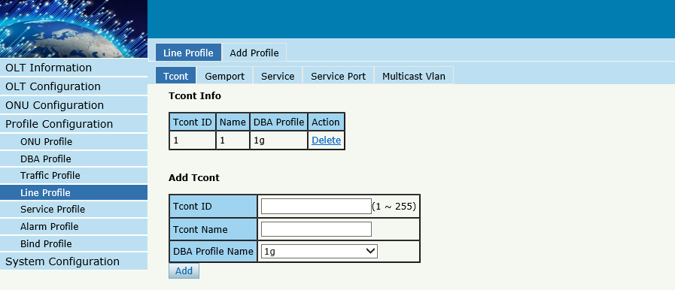
Figure 5-11 Add Tcont

Create a gemport ID and bind tcont ID
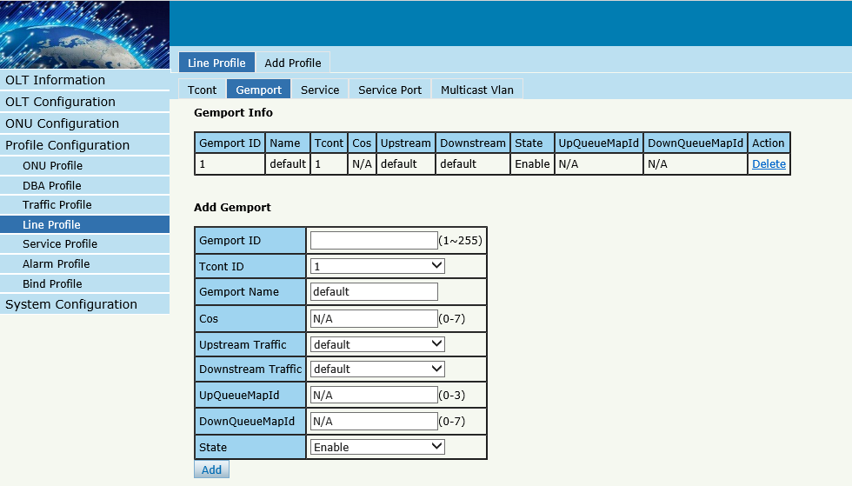
Figure 5-12 Add Gemport

Create a service , Set the VLAN and VLAN mode and let it bind one gemport ID.
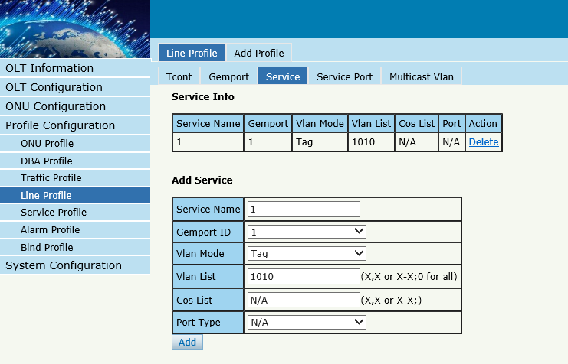
Figure 5-13 Add service

Create a service port, Set the user VLAN and translate VLAN and let it bind one gemport ID.
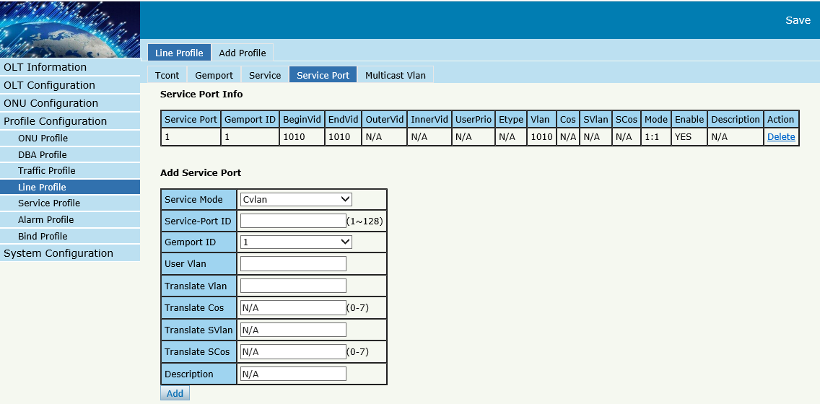
Figure 5-13 Add service prot
Set the Multicast VLAN of ONU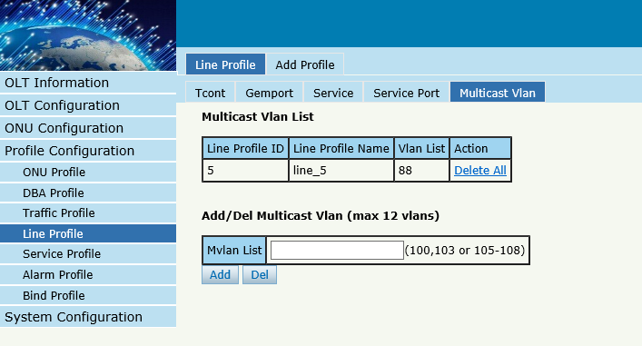
Figure 5-14 configure multicast VLAN

5.5 Service Profile
service profile is used to configure the UNI side services of onu, such as Ethernet port, wifi, veip and so on.

5.3.1 Line profile
Profile ConfigurationLine Profile Line Profile
The table displays service profile list. We can also do some operation, such delete and modify.

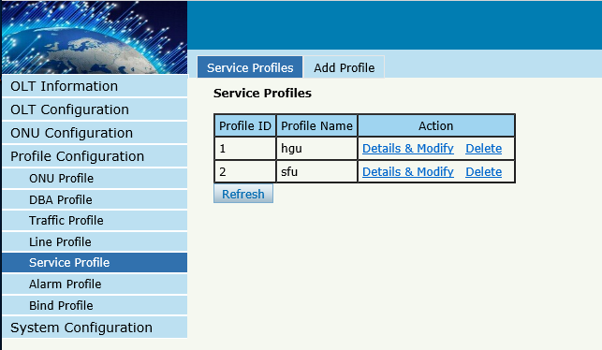
Figure 5-15 Service profile list

5.3.2 Add profile
Profile ConfigurationLine Profile Add Profile
Create a new service profile
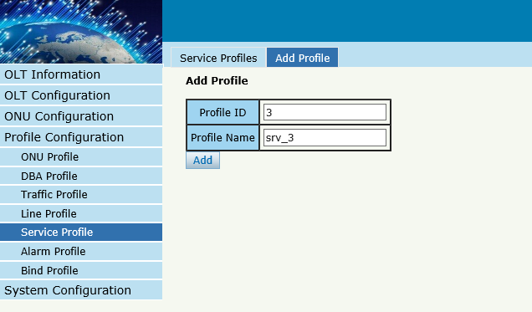
Figure 5-16 Add Service profile

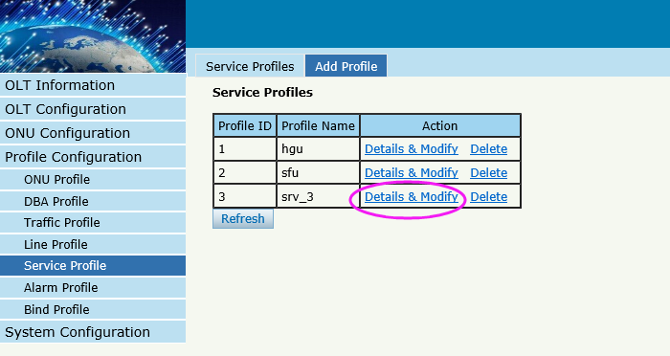
Figure 5-17 modity Service profile

Set the VLAN mode of the ONU’s port.
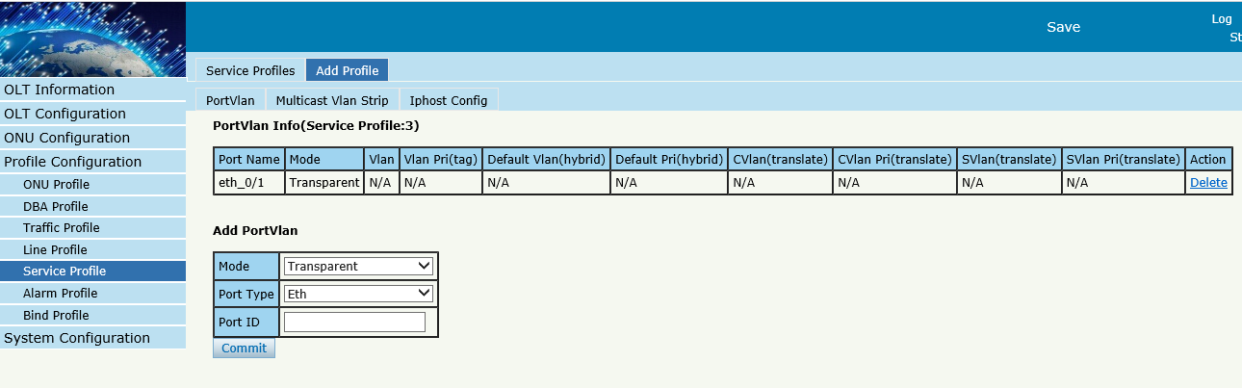
Figure 5-18 Port VLAN mode

Set the Multicast VLAN mode of ONU’s port
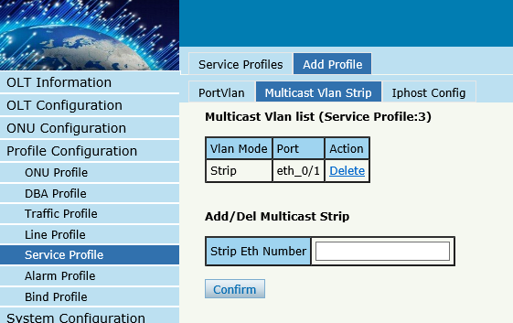
Figure 5-19 Port multicast VLAN mode

Create Iphost for ONU wan connection.
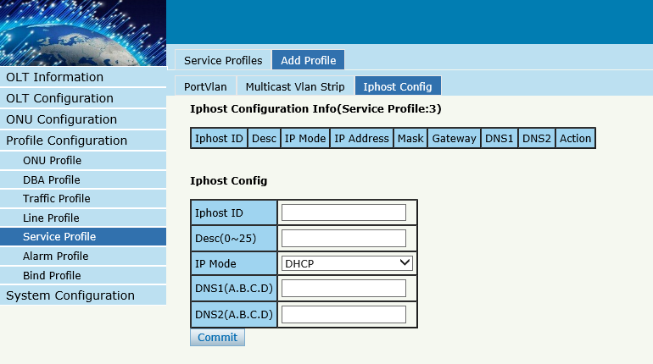
Figure 5-20 Add IPhost

5.6 Alarm Profile
alarm profile is used to configure the parameters of ONU alarm.

5.4.1 profile info
Profile ConfigurationAlarm Profile profile info
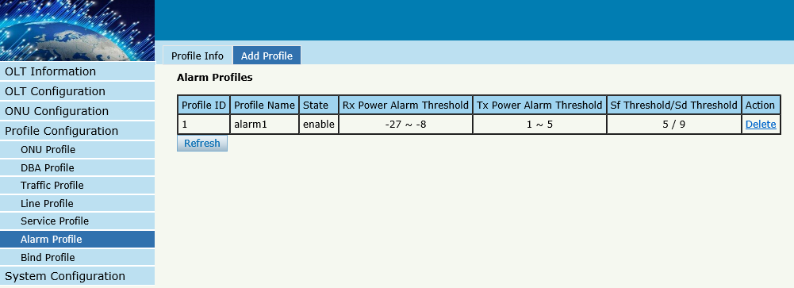
Figure 5-21 Alarm Profile list

5.4.2 Add profile
Profile ConfigurationAlarm Profile Add profile
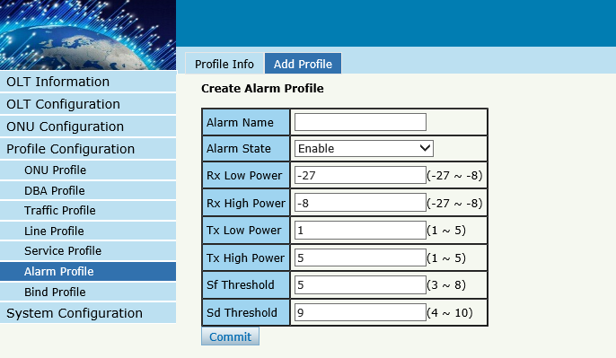
Figure 5-21 Create Alarm profile

5.7 Bind Profile
After profile is configured, it is necessary to bind it to ONU.
Profile ConfigurationBind Profile
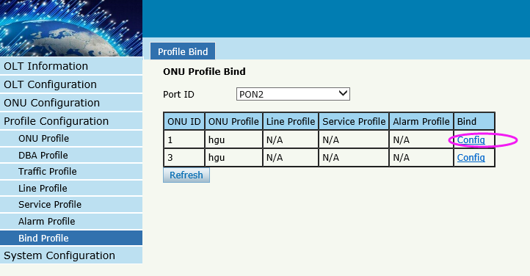
Figure 5-22 Bind profile
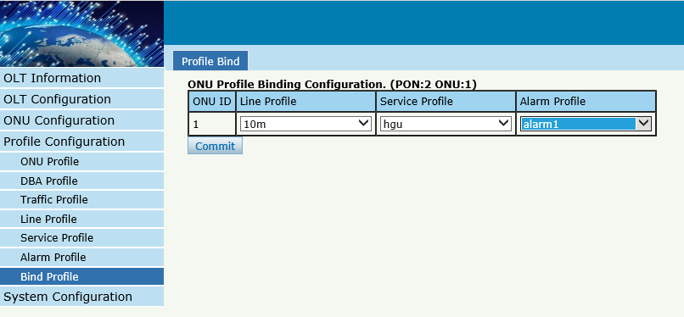
Figure 5-23 select Profile

Chapter 6 System Configuration
This chapter is about the global management of OLT.

6.1 System Log

6.1.1 System Log
System ConfigurationSystem Log
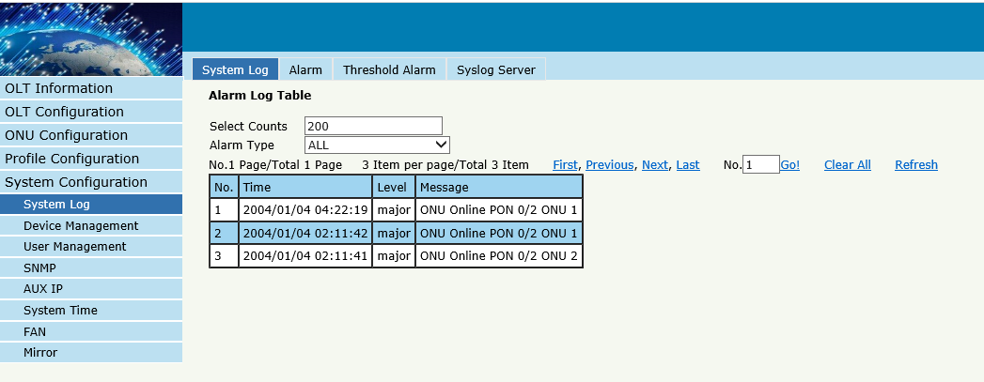
Figure 6-1 System Log

6.1.2 Alarm
System Configuration System Log Alarm.
It contains all the alarms of OLT. User can choose the different alarms to "Print", "Record", "Trap" and "Remote".
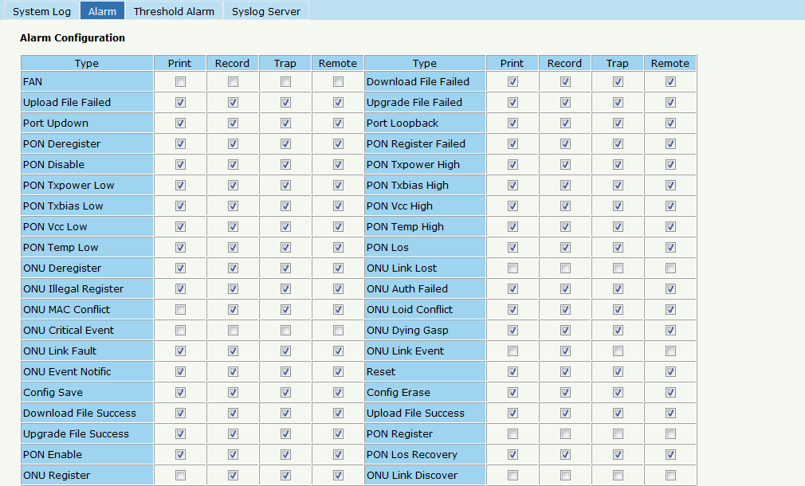
Figure 6-2 Alarm

6.1.3 Threshold Alarm
Configure the temperature threshold, CPU-usage threshold and memory- usage threshold, PON optical threshold. Click System Configuration System Log ThresholdAlarm.
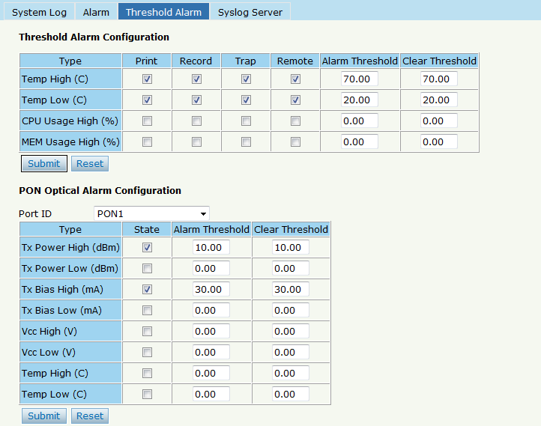
Figure 6-3 Threshold Alarm

6.1.4 Syslog Server
Configure the server of OLT remote system logs. Click System ConfigurationSystem Log Syslog Server.

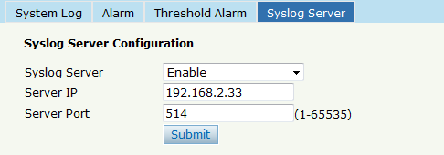
Figure 6-4 Syslog Server

6.2 Device Management

6.2.1 Firmware Upgrade
System ConfigurationDevice Management Firmware Upgrade.
You can upgrade the OLT firmware by WEB, itwant to reboot OLT after upgrade then take effect.
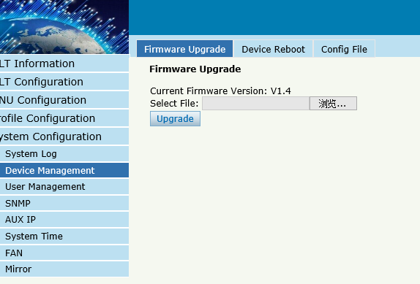
Figure 6-5 Firmware Upgrade

6.2.2 Device Reboot
System ConfigurationDevice Management Device Reboot
it will reboot the entire system.(Please save the configuration first)

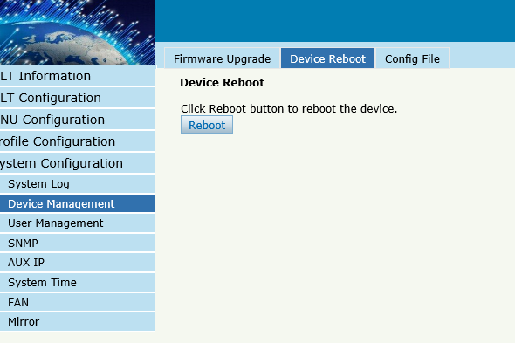
Figure 6-6 Device Reboot

6.2.3 Config File
System ConfigurationDevice Management Config File,
you can backup configuration, restore configuration, restore factory defaults and save configuration.
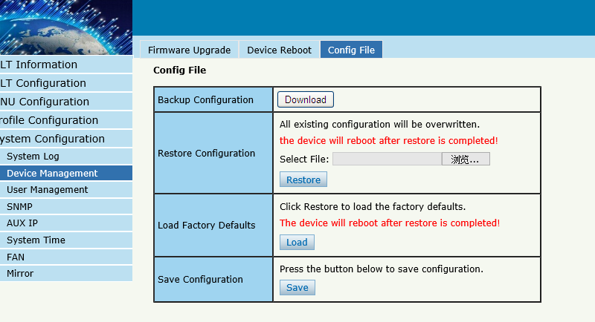
Figure 6-7 File Configuration

6.3 User Management
System ConfigurationUser manage
Two kinds of users have been defined, Normal and Admin. There are limitations to normal user, and admin user has no limits to full function of OLT. The default account member is Admin level.
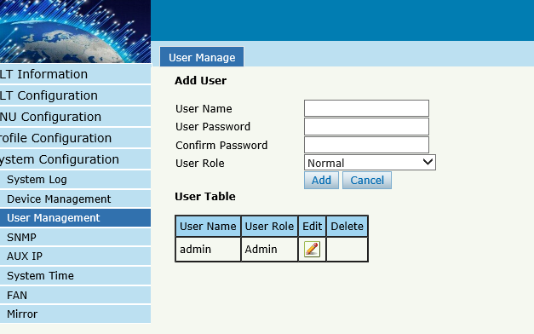
Figure6-8: User Manage

6.4 SNMP

6.4.1 SNMP V1/V2
System Configuration SNMP SNMP V1/V2
The OLT supports SNMP v1/v2,
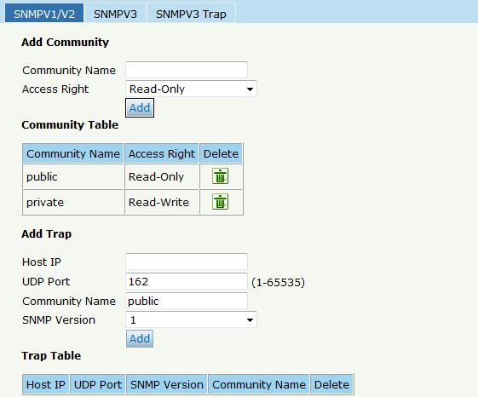
Figure6-9: SNMP V1/V2

6.4.2 SNMP V3
System Configuration SNMP SNMP V3
The OLT supports SNMP V3.
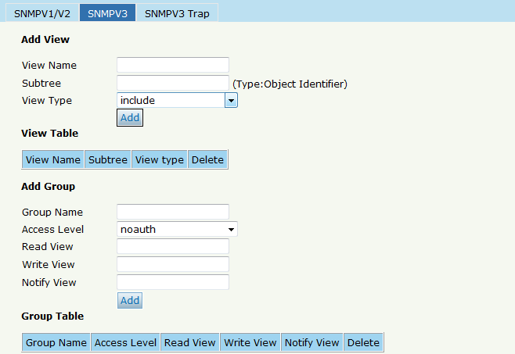
Figure6-10: SNMP V3

6.4.3 SMNP V3 Trap
System Configuration SNMP SNMP V3 Trap
Configure or remove the Trap messages of the target host IP address.
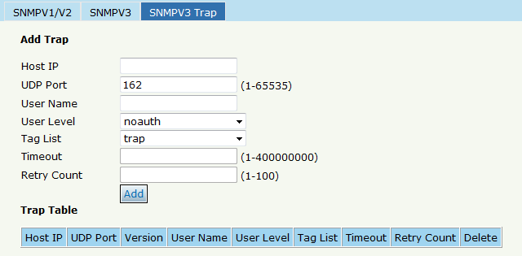
Figure 6-11: SNMP V3 Trap

6.5 AUX IP
System Configuration AUX IP
AUX port is out band management port. TheIP address is out band management IP, default IP address is 192.168.8.200.
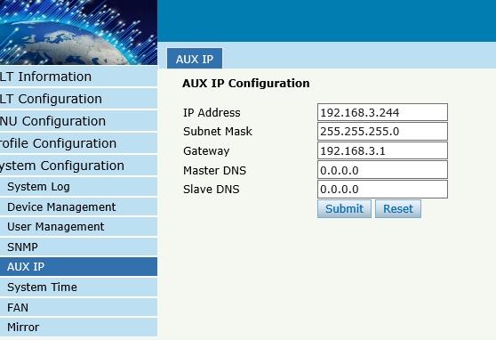
Figure 6-12: AUX IP

6.6 System Time

6.6.1 RTC
System Configuration System TimeRTC .
The user can customize the OLT system time
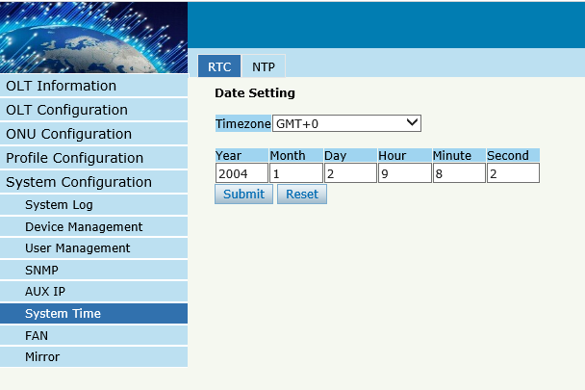
Figure 6-13: RTC Configuration

6.6.2 NTP
System Configuration System TimeNTP
Synchronize the time to the NTP server.
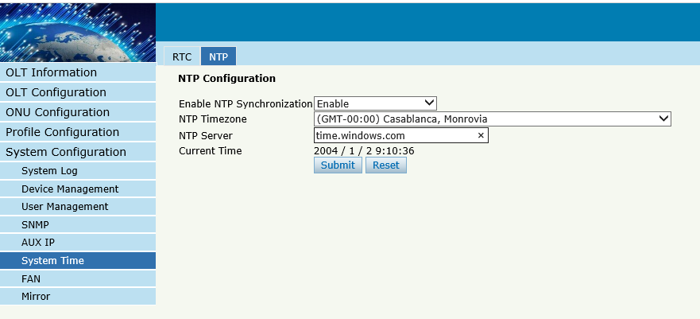
Figure 6-14: NTP Configuration

6.7 FAN
System Configuration FAN.
The fans can be controlled to turn on/off, or turn on automatically.
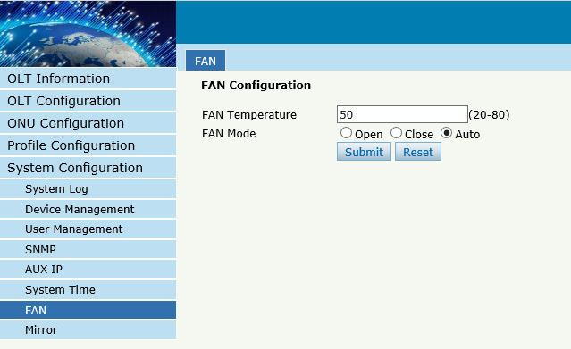
Figure 6-15: FAN Configuration

6.8 Mirror
System Configuration Mirror.
Each monitor session can be set with one destination port and up to 8 source ports.
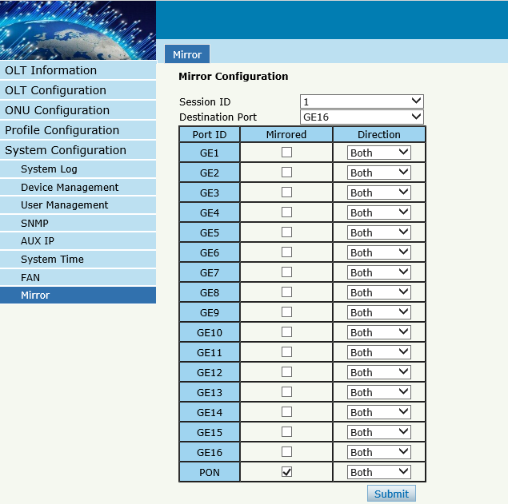
Figure 6-16: Mirror

Thank you!

