Optical Line Terminal Equipment

Element Management System

User Manual

Version 1.4.1
Thank you for choosing our products.
Preface
Revision History
Version | Revision date | Revision Reason
V1.1 | 15/10/2015 | First edition
V1.2 | 12/12/2015 | Content updates
V1.3 | 26/2/2016 | Add new functions
V1.4 | 29/4/2016 | New layout
The element management system is an integrated broadband access management platform, which can perform the effective and unified management of multiple types of broadband access equipment developed.
This manual mainly introduces the installation and basic configuration of the EPON OLT’s element management system. It aims to help users in understanding the equipment’s technologies, functions and practical application capacity and to provide technical support for the users.
Intended Readers
This manual is intended for the following readers:
- Commissioning engineers
- Operation and maintenance engineers
To utilize this manual, these prerequisite skills are necessary:
- Access network technology
- EPON principles
- Ethernet switch technology
- Computer network technology
Symbol Conventions
The symbols that may be found in this document are defined as follows.
Symbol | Class | Description
 | Notice | Indicates a potentially hazardous situation, which if not avoided, could result in equipment damage, data loss, performance degradation, or unexpected results.
 | Warning | Indicates a hazard with a medium or low level of risk, which if not avoided, could result in minor or moderate injury.
 | Note | Provides additional information to emphasize or supplement important points of the main text.
List of Glossary
AUX  CATV | Auxiliary  Cable Television
CFI | Canonical Format Indicator
CIR | Committed Information Rate
CLI | Command Line Interface
CoS | Class of Service
CVLAN | Customer VLAN
DA | Destination Address
DBA | Dynamic Bandwidth Allocation
DHCP | Dynamic Host Configuration Protocol
DNS | Domain Name System
EMS | Element Management System
EPON | Ethernet Passive Optical Network
FE | Fast Ethernet
FEC | Forward Error Correction
FIR | Fixed Information Rate
GE | Gigabit Etherent
HGU | Home Gateway Unit
IAD | Integrated Access Device
IGMP | Internet Group Management Protocol
IMS | IP Multimedia Subsystem
IP | Internet Protocol
IPTV | Internet Protocol Television
LOID | Logical ONU Identifier
LoS | Loss of Signal
MAC | Medium Access Control
MDU | Multi-Dwelling Unit
MIB | Management Information Base
MPCP | Multi-point control protocol
OAM | Operation,Administration & Maintenance
ODN | Optical Distribution Network
OLT | Optical Line Terminal
OMA | Optical Modulation Amplitude
ONT | Optical Network Terminal
ONU | Optical Network Unit
PIR | Peak Information Rate
PON | Passive Optical Network
POTS | Plain Old Telephone Service
PPPoE | Point-to-Point Protocol over Ethernet
QoS | Quality of Service
SFU | Single Family Unit
SIP | Session Initiation Protocol
SN | Serial Number
SNMP | Simple Network Management Protocol
SP | Strict Priority
SVLAN | Service VLAN
UCT | Un-condition transition
UDP | User Datagram Protocol
UNI | User Network Interface
VLAN | Virtual Local Area Network
VoIP | Voice over IP
WLAN | Wireless Local Area Network
WRR | Weighted Round Robin

Contents
Chapter1 System Description 15
1.1 Interface Types 15
1.2 Working Mode 16
1.3 Configuration Requirements 17
1.4 EMS Installation Files 18
Chapter2 EMS Installation 19
2.1 Installation Of The Server 20
2.2 Installation Of The Client 25
Chapter3 EMS Quick Start 30
3.1 Preparatory Work 30
3.2 Starting Sequence 31
3.3 Add OLT Device 33
3.4 Add Splitter 37
Chapter4 EMS Frame Introduction 40
4.1 Main Frame Overview 40
Chapter5 System Management 44
5.1 Lock Client 44
5.2 Modify Password 45
5.3 Exit System 46
Chapter6 OLT Management 47
6.1 OLT Basic Information 47
6.2 OLT System Configuration 48
6.2.1System Upgrade 48
6.2.2Save System Configuration 50
6.2.3System Restart 52
6.2.4PON ONU Operation 53
6.2.5Restore Factory Settings 54
6.2.6Export/Import Configuration 55
6.2.7Configure Aux Port 57
6.2.8RTC Time configuration 59
6.2.9FAN configuration 61
6.2.10 Delete OLT Device 62
6.3 Ports Configuration 63
6.3.1Uplink Ports Configuration 63
6.3.2PON Ports Configuration 67
6.3.3PON Downward Encryption 68
6.3.4Port Channal Group 70
6.3.5Port Mirror Configuration 71
6.4 Port VLAN Configuration 72
6.4.1VLAN Configuration 72
6.4.1.1 Show VLAN Table 72
6.4.1.2 Add a New VLAN 74
6.4.1.3 Delete VLAN 74
6.4.2VLAN IP Configuration 75
6.4.3Static Route Configure 76
6.4.4QinQ Configuration 78
6.5 MAC Configuration 78
6.6 OLT IGMP Configuration 79
6.6.1IGMP Router Port 80
6.6.2Port Configuration 81
6.6.3IGMP User VLAN Configuration 81
6.6.4Static Group Table 82
6.7 ONU Auth Configuration 83
6.7.1ONU Authorized Mode 83
6.7.2MAC White List 84
6.7.3Mac Black List 85
6.8 ACL configuration 86
6.8.1IP Standard ACL 87
6.8.2IP Extend ACL 88
6.8.3MAC ACL 89
6.8.4Port Base ACL 90
6.8.5QoS Base ACL 90
6.8.6ACL Port Binding 91
6.9 DHCP Configuration 92
6.9.1DHCP Server 92
6.9.2DHCP Relay 94
6.9.3DHCP Snooping 95
6.10 QoS configuration 97
6.11 ONU Template Configuration 99
6.11.1 DBA Bandwidth Template 100
6.11.1.1DBA Bandwidth Template Binding 101
6.11.2 Service (SRV) Template 103
6.11.2.1Service (SRV) Template Binding 107
6.11.3 Voice (VoIP) Template 108
6.11.3.1Voice (VoIP) Template Binding 110
6.11.4 Alarm Threshold Template 111
6.11.4.1Alarm Threshold Template Binding 114
6.12 Alarm Management 114
6.13 Alarm Configuration 118
6.14 ONU Batch Upgrade 121
Chapter7 ONU Management 124
7.1 ONU System Configuration 124
7.1.1ONU Details 124
7.1.2ONU Rename 126
7.1.3Private OAM Maintain 128
7.1.4Reregister ONU 128
7.1.5Reset ONU 129
7.1.6Unauthorized ONU 130
7.2 ONU Port Configuration 131
7.2.1Port Basic Configuration 131
7.2.2Port VLAN Configuration 134
7.2.2.1 Transparent Mode 134
7.2.2.2 Tag Mode 135
7.2.2.3 Trunk Mode 136
7.2.2.4 Translation Mode 139
7.2.2.5 Aggregation Mode 141
7.2.3Port IGMP Configuration 143
7.2.4Classify Configuration 146
7.3 ONU VoIP Configuration 147
Chapter8 Service Configuration 151
8.1 Network Topology 151
8.2 Service Configuration 152
8.2.1OLT Configuration 152
8.2.2ONU Configuration 159

Chapter1 System Description

Interface Types
EPON OLT provides various types of network interface, service interface and maintenance interface to adapt to different networking environments. All the interfaces could comply with the relevant telecommunications standards.
Table 1-1 lists all OLT interface types.
Type | Interface | Remarks
PON  interface | PON optical interface | The point-to-multipoint architecture and the passive fiber transmission mode are used. The downstream rate and upstream rate can reach up to1.25 Gbps.
Uplink interface | GE Copper interface | It can direct connection RJ45 copper cable to uplink to Ethernet.
Maintenance interface | Console port | It is used for local maintenance.
 | AUX port | It is used for remote maintenance.

Working Mode
At present, the EMS uses the Client-Server working mode.
When the network maintenance engineers are far from both the access equipment and the network element management system server, this Client -Server working mode can be used for access the server via the client for achieving the purpose of managing the equipment.
In this case, the client and the server can be installed on one computer, or respectively on two computers. When both the client and server are installed on a computer, this is also called a stand-alone mode.
Figure 1-1 Working mode
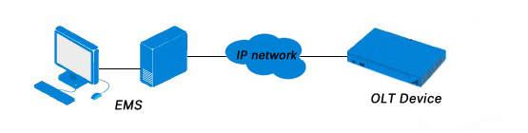

Configuration Requirements
The requirements of the hardware configuration for the EMS’s Server depend on the network scale.
Requirements of hardware configuration on the Server
Table 1-2 Server configuration
CPU | Memory | DISK | Operating System
Frequency above 2GHz | 2GB or above 2GB | 20GB disk space | Windows2008  Windows XP  Windows 7  Windows 8  Windows 10

Requirements of hardware configuration on the Client
Table 1-3 Client configuration
CPU | Memory | DISK | Video Card | Operating System
Frequency above 2GHz | 1GB  Or above | 10GB  disk space | 65000 color  resolving capability 1024*768  and above | Windows2008  Windows XP  Windows 7  Windows 8  Windows 10

EMS Installation Files
The installation file contains two files:
EMS-client.exe
EMS-server.exe
Figure 1-4 Installation file
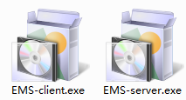

Chapter2 EMS Installation
This chapter describes the procedure for EMS installation.
Installation Flow Diagrams
Figure 2-1 Installation procedure
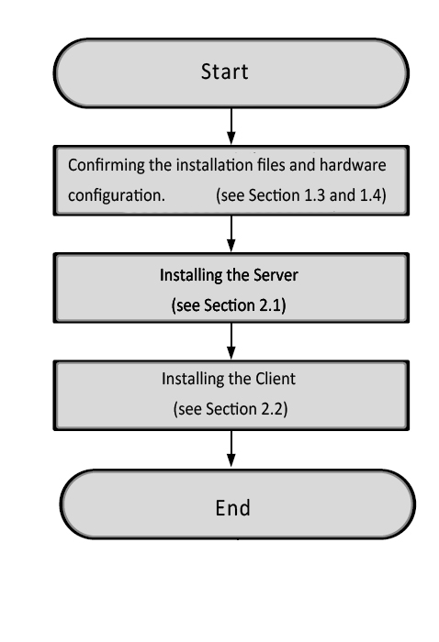

- Installation Of The Server
Double-click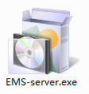 to make the Language dialog box appear.
Figure 2-2 Language dialog box
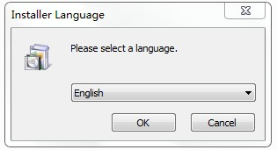
Select “English” and click OK.
Figure 2-3 Installation introduction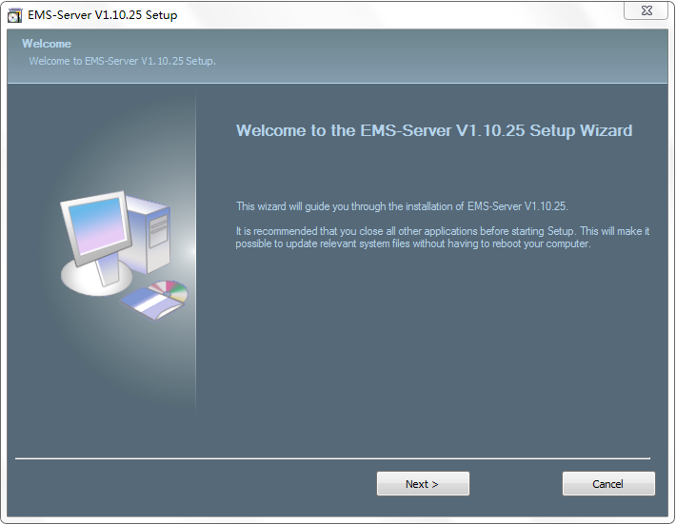
Click “Next” to proceed.
Figure 2-4 Accept the software agreement
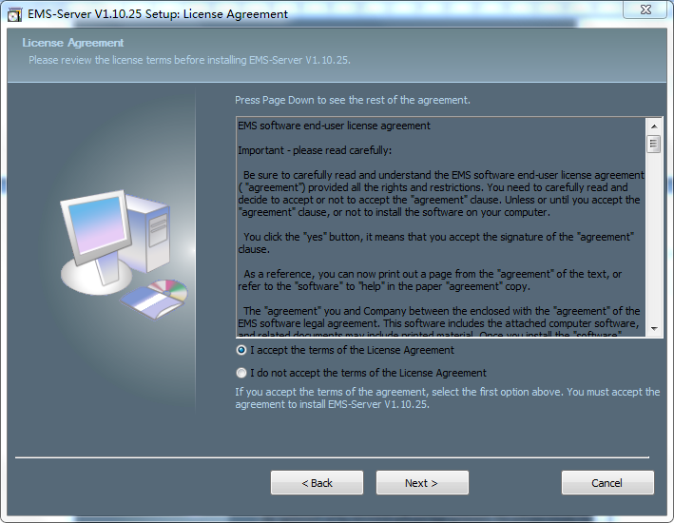
Select I accept the terms of the License Agreement and click “Next” to proceed.
Figure 2-5 Installation path
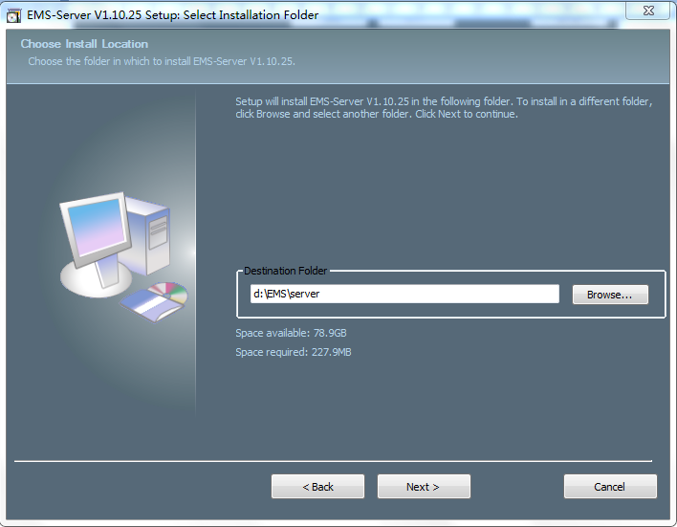
Set the installation path and click “Next” to proceed.
Figure 2-6 Software installation
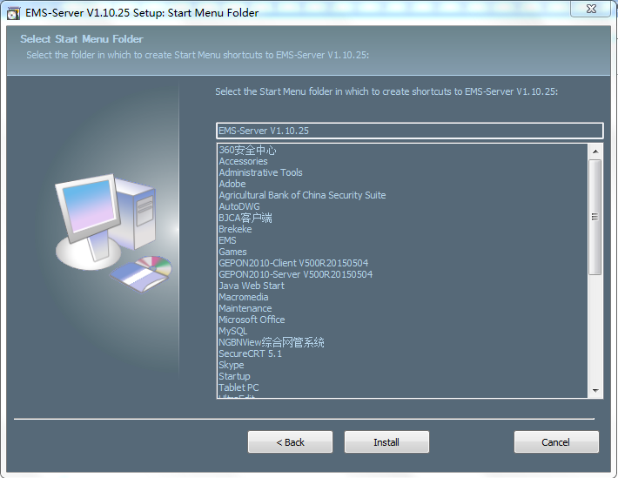
Click “Install” to start installing the server.
Figure 2-7 Software installation
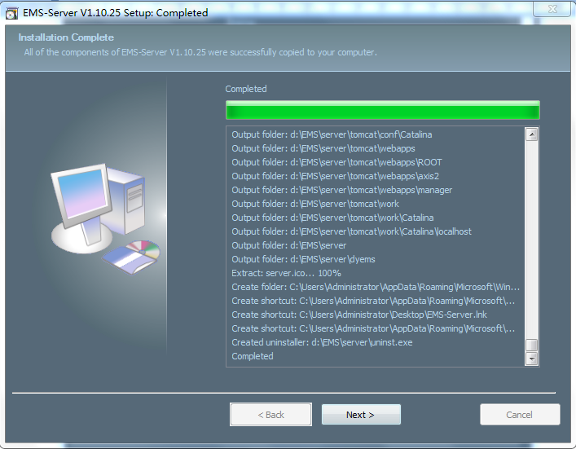
Click “Next” to proceed.
Figure 2-8 Installation complete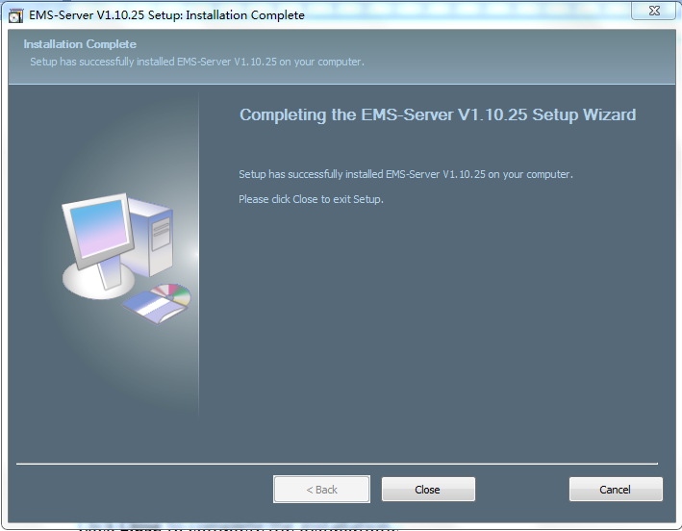
Click “Close” to complete the installation.
- Installation Of The Client
Double-click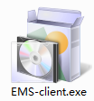 to make the Language dialog box appear,
Figure 2-9 Language dialog box
Select English and click OK.
Figure 2-10 Installation introduction
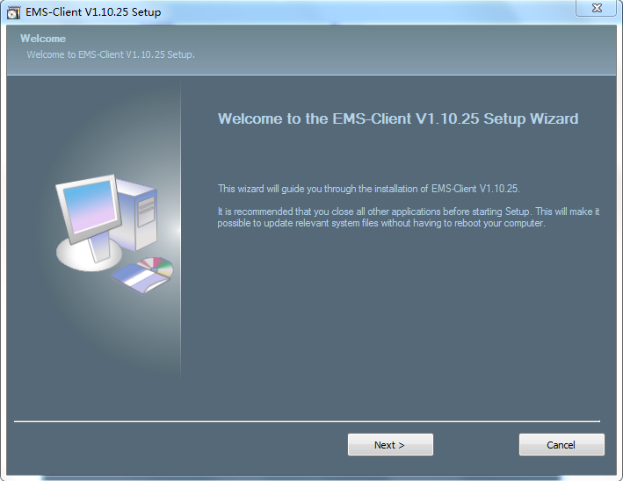
Click “Next” to proceed.
Figure 2-11 Accept the software agreement
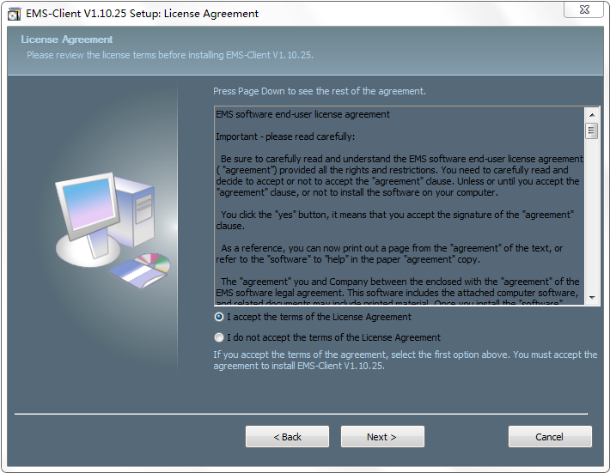
Select I accept the terms of the License Agreement and click “Next” to proceed.
Figure 2-12 Installation path
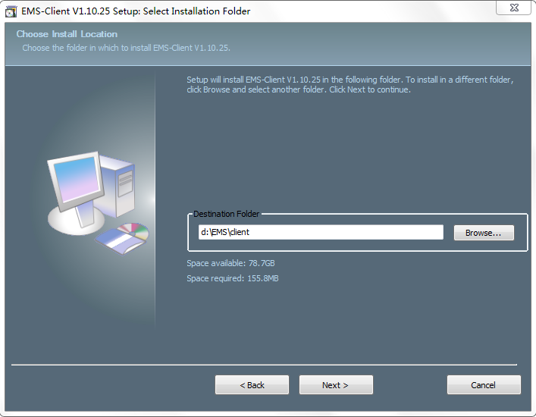
Set the installation path and click “Next” to proceed.
Figure 2-13 Software installation
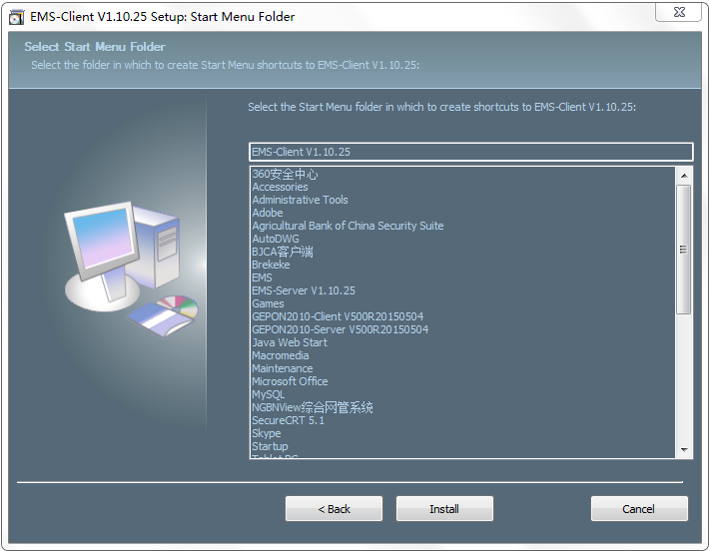
Click “Install” to start installing the server.
Figure 2-14 Software installation
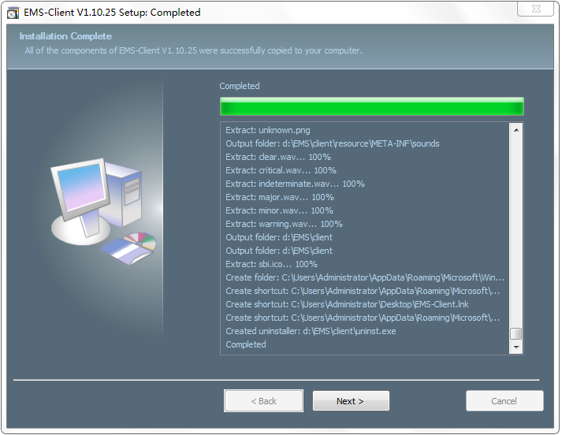
Click “Next” to proceed.
Figure 2-15 Installation complete
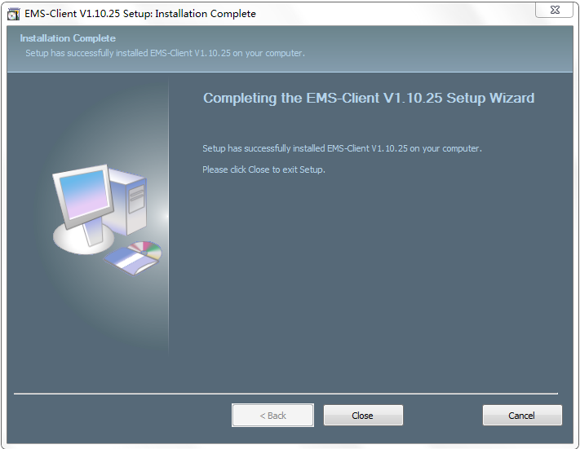
Click “Close” to complete the installation.

Chapter3 EMS Quick Start
This chapter describes the procedure for starting the EMS quickly. It mainly includes the following contents:
- Ensure smooth network to OLT
- Starting sequence
- Add device
- Synchronous OLT configuration
- Preparatory Work
Step1: Connect to the OLT’s AUX port with server PC.
Figure 3-1 Connection diagram
AUX
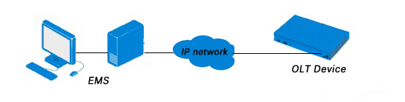
Step2: Configure the server PC IP address
The OLT default management IP is 192.168.8.100
Please set your server PC IP is 192.168.8.X (e.g. 192.168.8.200)
- Starting Sequence
Step1: Starting server
Double-click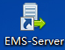 to start the EMS server.
Step2: Click Start button and wait a moment, you can see the button changed to “Stop”. This indicates that the installation is successful.
Figure 3-2 Start server
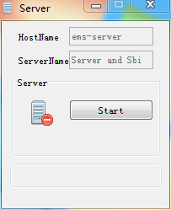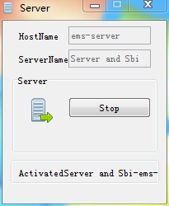
Step3: After the server complete, start the client.
Double-click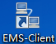 to start the EMS server.
Step4: Login
Input the username and the password of the EMS, and the IP address of server to login. Then click Login.
The default username and the password are both root.
The port is 5188.
The server IP address is your PC（server）IP address or 127.0.0.1
Figure 3-3 Login dialog
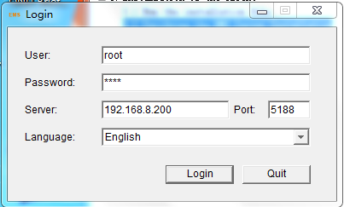
Figure 3-4 EMS interface
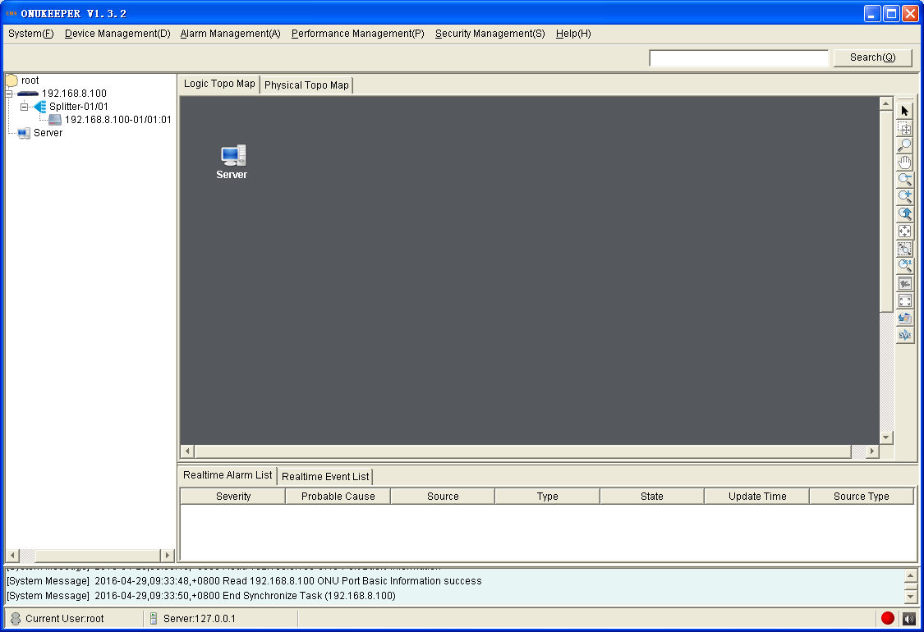
- Add OLT Device
Step1: At primary topological diagram, right-click any of the blanks to enter a menu, and select "Add Device".
Figure 3-5 Add Device
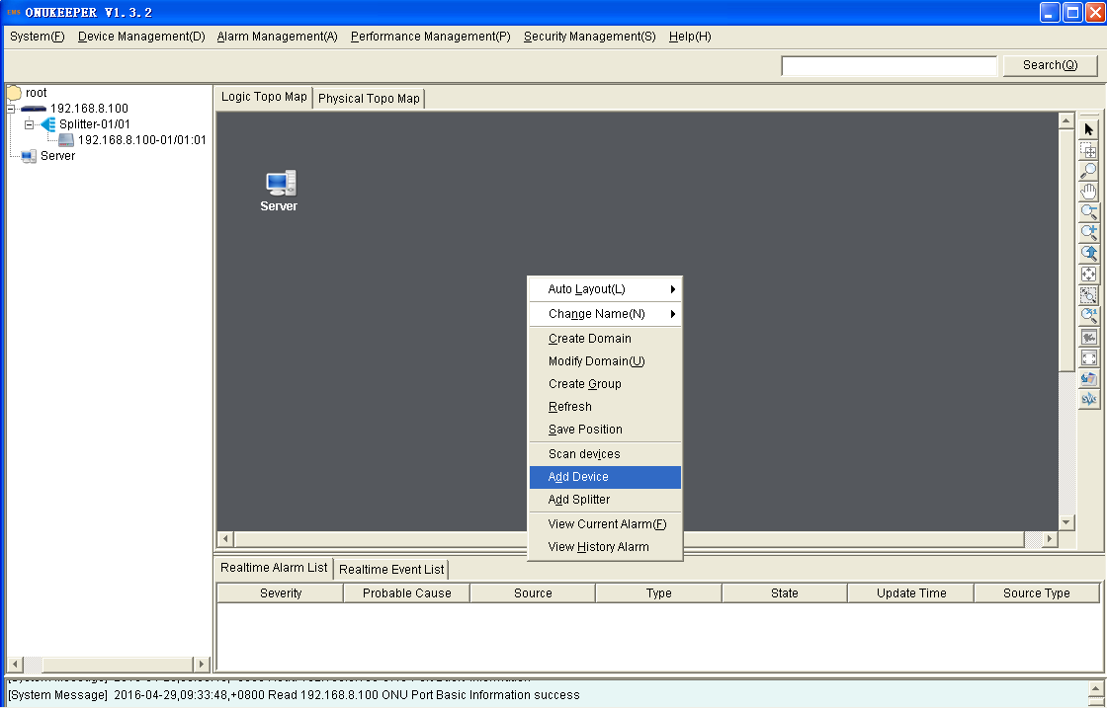
Step2: In the pop-up window, input the management IP of OLT, the OLT default IP is 192.168.8.100
Figure 3-6 Select community parameters
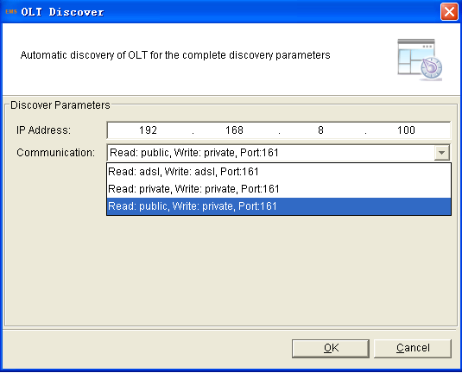
Select Read community is public, and write community is private.
If there is no option in a list, please add new community parameters.
Figure 3-7 Add community parameters
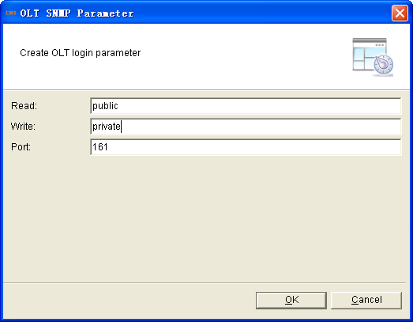
Step3: After adding device, there will be a device icon in the topological diagram.
Figure 3-8 Device icon in the topological diagram
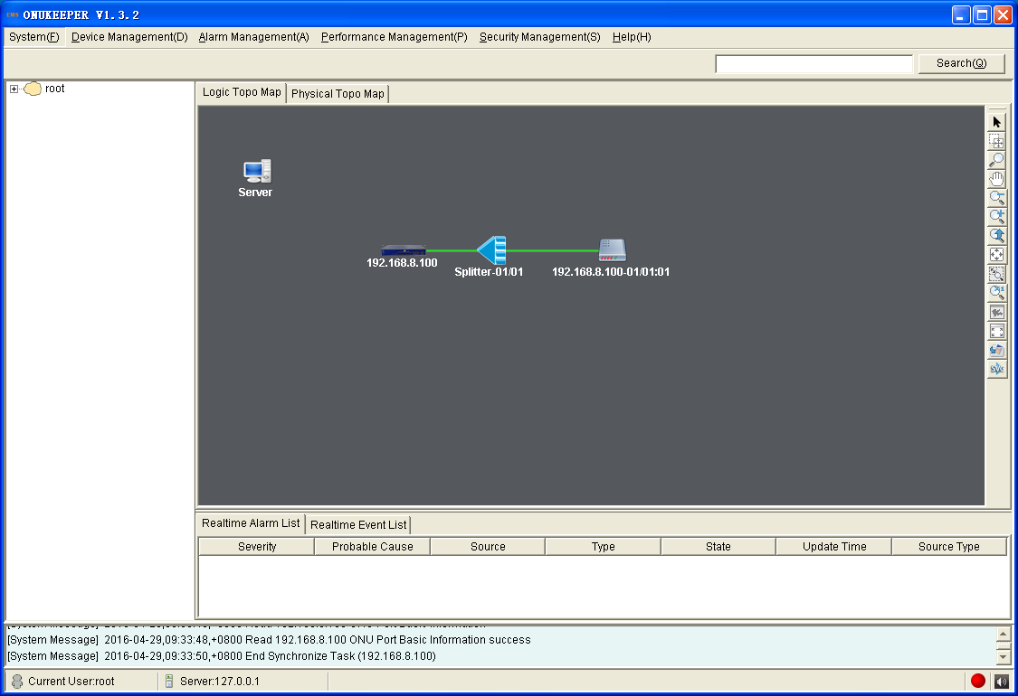
Step4: Sync device ensure device configuration consistent with EMS configuration.
Figure 3-9 Sync Device
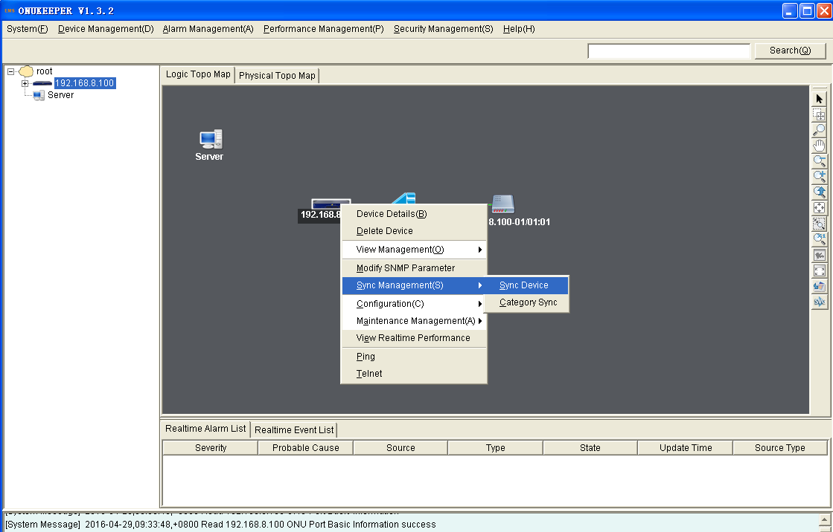
- Add Splitter
Adding an OLT, connect a splitter between the OLT and the ONUs by default. PLC Splitter is viable. Add or delete splitter can help to edit the network topology.
Step1: Right click splitter, “delete” or “link” are permitted.
Figure 3-10 Default splitter
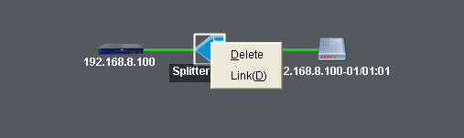
Step2: Add splitter
At the primary topological diagram, right-click any of the blanks, select “Add Splitter”
Figure 3-11 Add Splitter
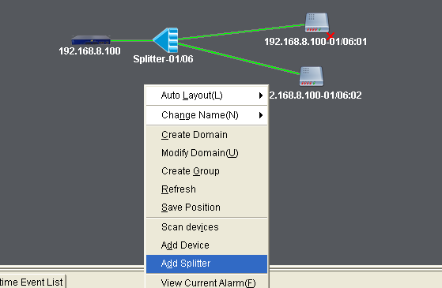
choose the splitter type 1:2、1:4、1:8、1:16、1:32、1:64 and fill in the name.
Figure 3-12 Select splitter
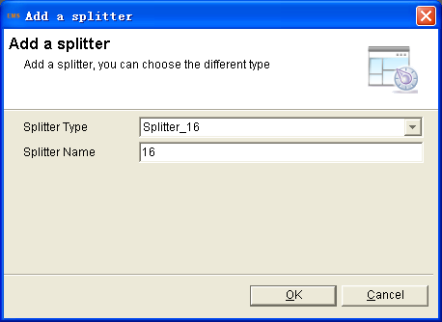
Right click the new splitter, select “link”, choose the “Parent Node” first, and choose the relevant “Sub Node”, click “OK”.
Figure 3-13 Splitter connecting
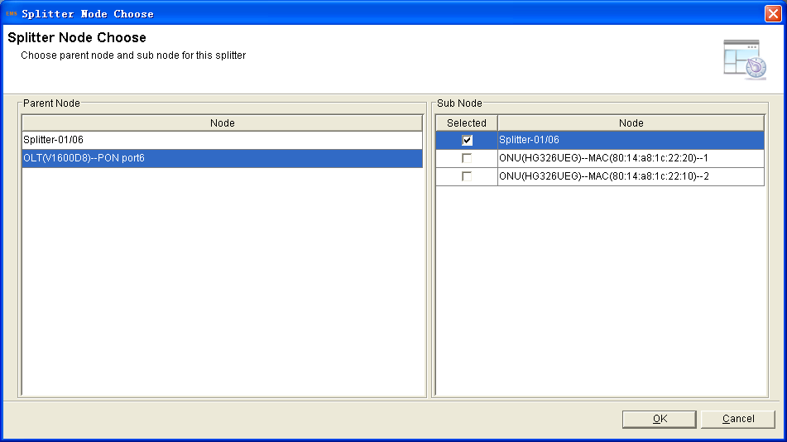
Figure 3-14 Show splitter connected
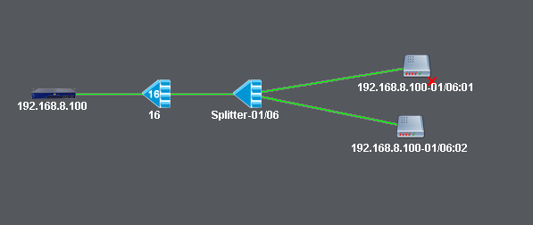

Chapter4 EMS Frame Introduction
This chapter describes the main interface of the OLT’s EMS. It mainly includes the following contents:
- Main interface
- Main menu
- Main toolbar
- Rolling log output bar
- Status bar
- Main Frame Overview
After successfully login, enter the main frame interface of EMS. The main interface is composed by "Title bar", "Menu bar", "Toolbar", "The topological navigation tree", "Topology", "The current alarm event" and "Rolling log bar" etc. The bottom of the interface is composed by "Status bar", "Alarm light" and "Alarm sound switch".
Figure 4-1 Main frame overview

Title bar
Menu Bar
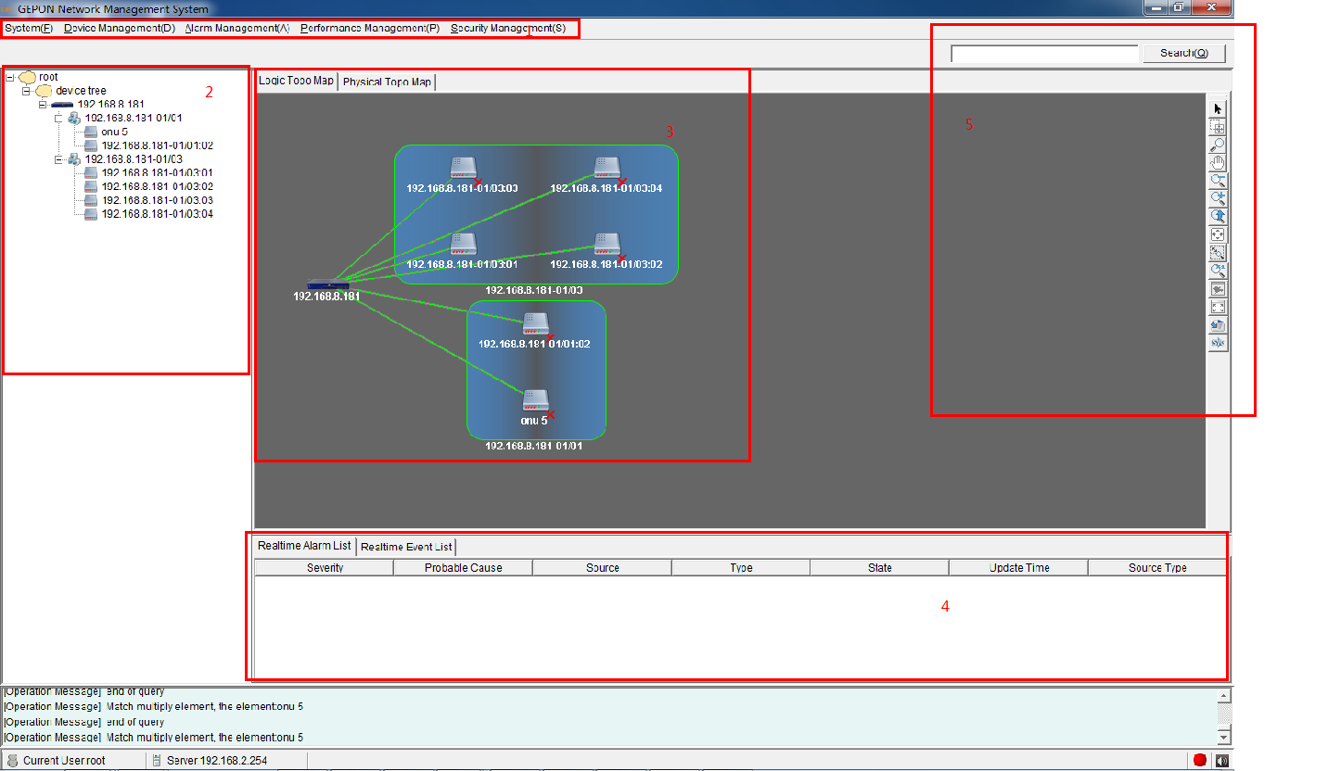
Rolling log bar / Stauts bar
Toolbar
Current Alarm Event
Topology
Topological navigation tree
As shown in Figure 4-1, main frame contain following several parts:
1. Main menu
The main menu includes: System, Device management, Alarm, Performance and Security parts.
2. Topological navigation tree
The tree is Domain -> Device (OLT) -> Group (splitter) -> Device (ONU). Through the tree, manager can add, delete and manage the node. Click the OLT or ONU node, can operate the device.
3. Topological map
The Topological map is the main area of EMS. In the blank, Click the right mouse button, manager can add an OLT device, change layout, show name, etc. For convenience of managing, manager can move device icons to appropriate locations.
When an OLT device is added to the map, EMS will auto synchronization ONUs which connect to the OLT device. Now, in the map, manager can operate the OLT and ONU device.
4. Current alarm event
This window located on the bottom of the main frame, including Alarm Log and Operation Log page.
Alarm log page shows and records the real time alarm information, including alarm object, occur time and alarm content.
Operation log page shows and records the manager’s operation records, in order to trace back when needed.
5. Search and Shortcut bar
Toolbar includes: search box. You can search or locate a network element by the keywords (IP, MAC address or name) in the search box.
6. Status bar
The status bar includes state information, alarm light and alarm sound switch.

Chapter5 System Management
This chapter describes the system management function of EMS. It mainly includes the following contents:
- Lock client
- Modify password
- Database backup and restore
- Polling switch configuration
- Exit
- Lock Client
When administrator need to leave the client computer but not wants to shut the client program, he/she can lock the client.
Step1: Click "System (F)">"Lock Client" to enter client dialog.
Figure 5-1 System lock dialog
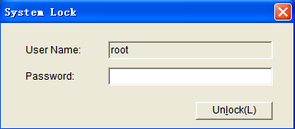
Step2: Upon the client is locked, others cannot use it. The current user can enter password to use again when he/she comes back to the client.
- Modify Password
Step1: Click "System (F)">"Modify Password", enter modify password dialog.
Figure 5-2 Reset password dialog
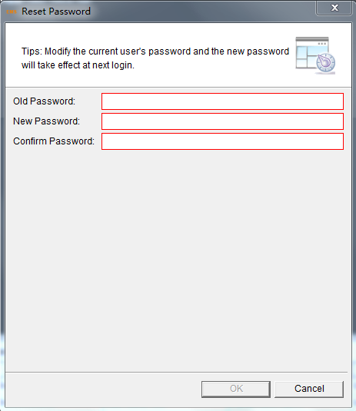
Step2: Input old password and the new password in the password box, click "OK".
Step3: The new password will take effect in the next login.
- Exit System
Step1: Click "System">"Exit", enter exit dialog.
Step2: Click "Yes" to exit.

Chapter6 OLT Management
- OLT Basic Information
The device management console is the entrance of basic information and configuration. It can be used for manage and control device, including basic information, PON Transceiver, ONU Online List, ONU Auth List and ONU No Auth List.
Select one OLT, click right-menu "Device Detail", to enter device detail interface.
Figure 6-1 Location of device detail
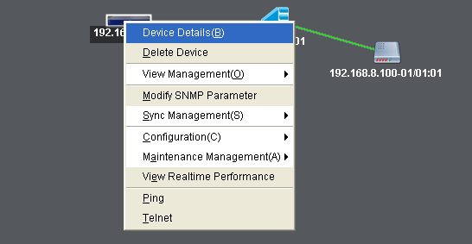

Figure 6-2 Show the OLT basic information
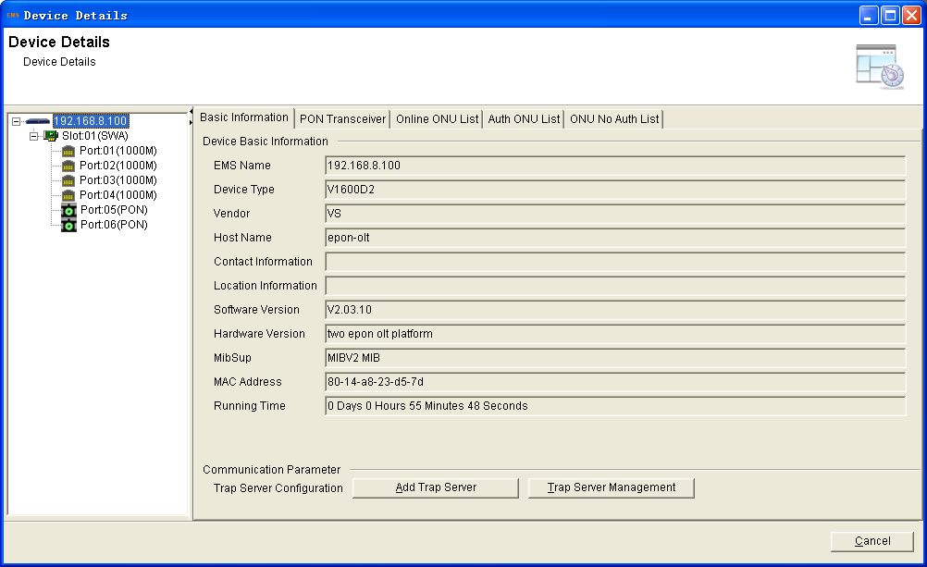
- OLT System Configuration
- System Upgrade
The upgrade operation is used for upgrading the specified object, including upgrading the software of OLT（UBOOT or Kernel）.
Before upgrading you are required to start the TFTP server, and put the upgrade files into the corresponding folder.
After the TFTP server settings, you can carry out system software and ONU software upgrade.
1.Right click OLT, select "Maintenance Management">"Upgrade System Software "to enter Upgrade system software interface.
Figure 6-3 Location of system upgrade
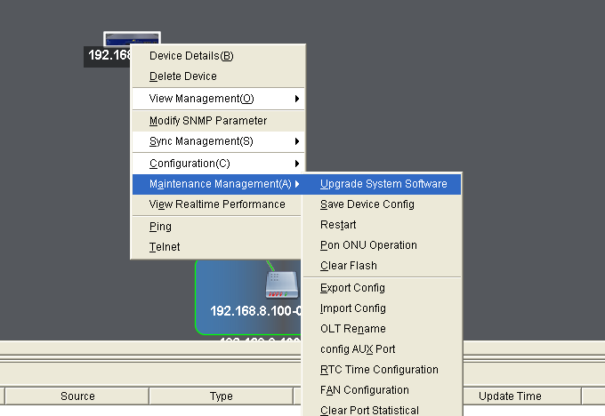
Click the "download file type "drop-down list, choose the file type.
Figure 6-4 System upgrade dialog
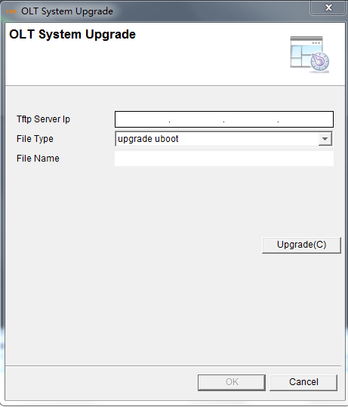
2. Input TFTP server IP in TFTP server IP box.
3. In the "File Name" text box input upgrade file name, the file name is not more than twenty characters.
4. Click "Upgrade" button and upgrade firmware.
After the completion of the upgrade, you must reboot the OLT device, the new upgrade file will take effect when the OLT device reboot.
- Save System Configuration
When configuration is completed, you need to do "Save Device Configuration "operation. The current configuration will be written to the device Flash.
1.Right click OLT, select "Maintenance Management">"Save Device Configuration" to enter “save device configuration” interface.
Figure 6-5 Location of save configuration
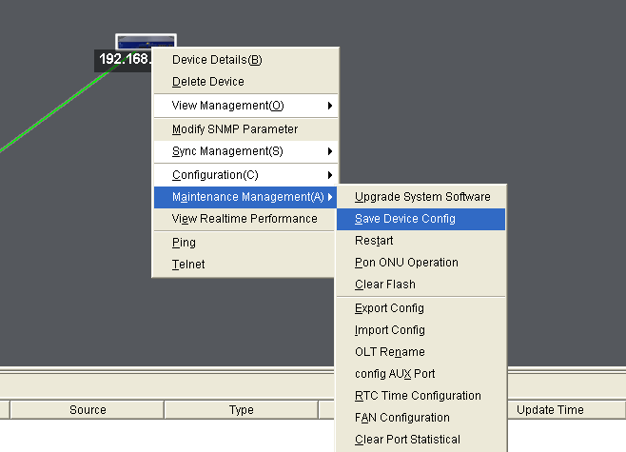
2. Enter dialog, click "Yes", save the current device configuration.
Figure 6-6 Save operating dialog
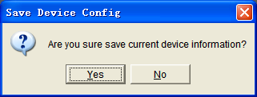
3. The current configuration will be saved to the OLT's Flash.
- System Restart
Restart the whole OLT device. This command will cause all services interruption, be careful execution.
1. Right click OLT, select "Maintenance Management">" Restart" to enter restart the device interface.
Figure 6-7 Location of system restart
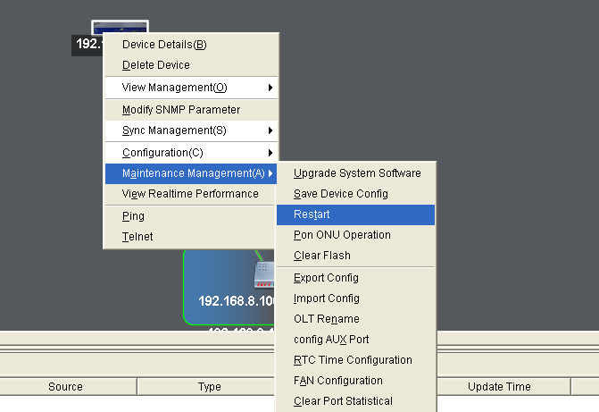
2. It will enter dialog box, chick "Yes".
Figure 6-8 Restart operating dialog
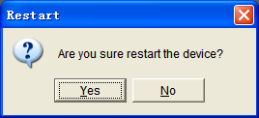
- PON ONU Operation
Control all the ONU at the same PON port of OLT. The operation includes Reset, Reregister and NoAuth.
1. Right click OLT, select "Maintenance Management">"PON ONU Operation" to enter the interface.
Figure 6-9 Enter PON ONU interface
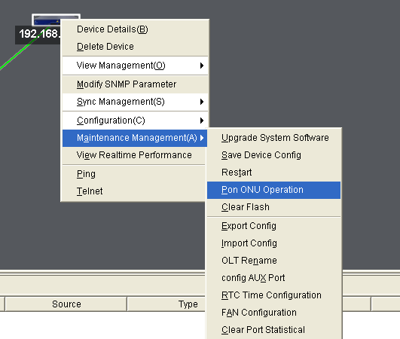
2. Choose the PON, and click the button you want to operate.
Figure 6-10 Operate the PON ONU
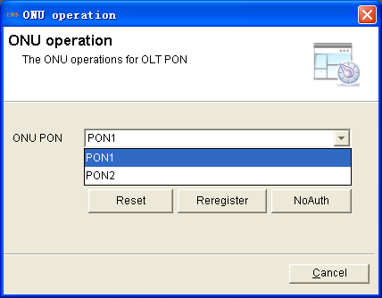
3. Click"Yes" to confirm your choice.
- Restore Factory Settings
This operation is used for clear the all of the current configuration information of device stored in OLT’s FLASH. It makes the system restore to factory default configuration.
1. Right click OLT, select "Maintenance Management">"Clear Flash", enter dialog box, as below.
Figure 6-11 Location of clear flash configuration
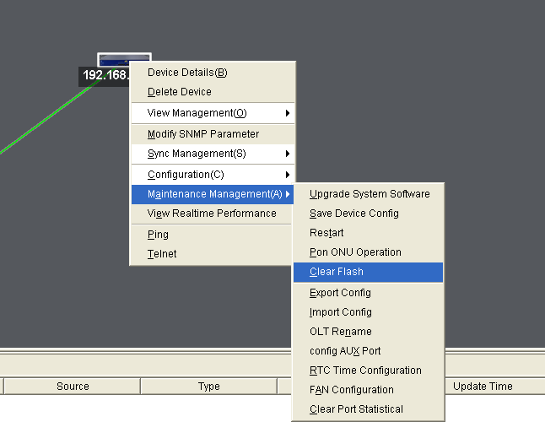
2. Click "Yes" to perform the clear FLASH operation, the device will automatically restart.
Figure 6-12 Clear flash operating dialog
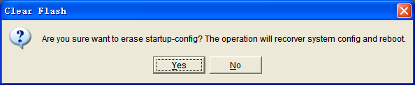
- Export/Import Configuration
This operation is used for upload the OLT configuration by the TFTP server / download configuration files from the TFTP server to the Flash of OLT.
1.Right click OLT, select "Maintenance Management">" Import Configuration" to enter" Import configuration files" interface.
Figure 6-13 Location of import configuration
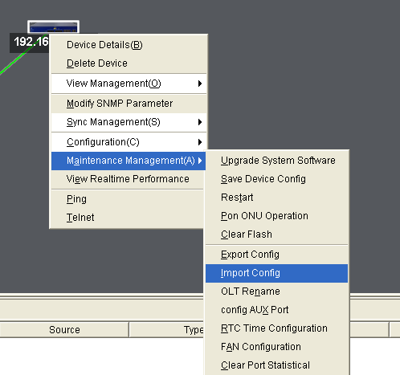
2. Input TFTP server IP in TFTP server IP box.
Figure 6-14 Import configuration
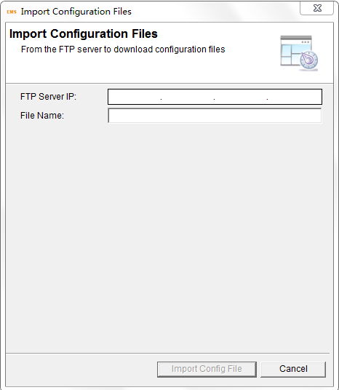
3. In the "File Name" text box input configuration file name, the file name is not more than twenty characters.
4. Click "Import Configuration File", as below.
5. If you need to run the imported configuration, it is required to restart the device.
- Configure Aux Port
This operation is used for configure AUX port of OLT.
1. Right click OLT, select "Maintenance Management">" configure AUX Port "to enter" configure AUX port" interface.
Figure 6-15 Location of AUX configuration
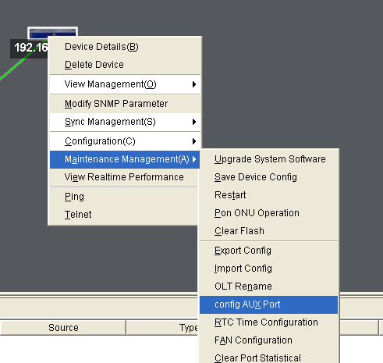
2. In the text box input configuration IP address and mask.
Figure 6-16 AUX configuration
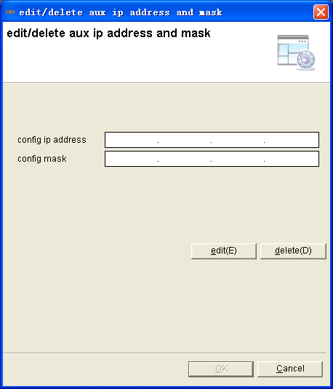
- RTC Time configuration
Configure the OLT system time.
1.Right click OLT, select "Maintenance Management">" RTC Time Configuration "to enter systerm time configuration interface.
Figure 6-17 RTC time configuration
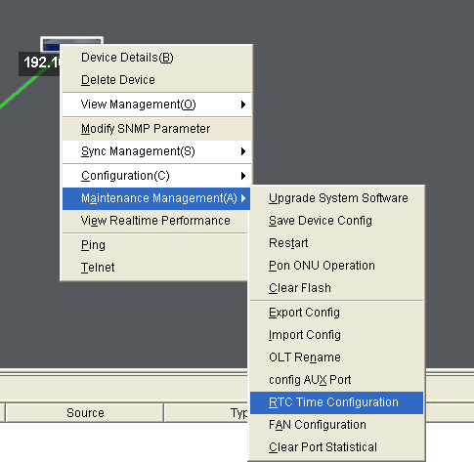
2. Fill in the time parameters.And click "Configuration" to save.
Figure 6-18 RTC time parameters
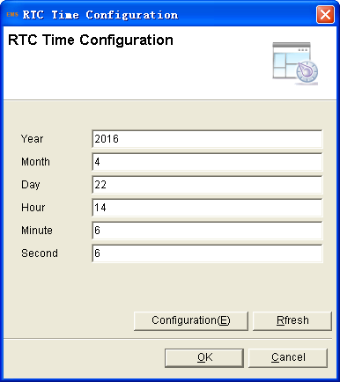
- FAN configuration
Control the FAN in the OLT when it will be activate automatically.
1. Right click OLT, select "Maintenance Management">"FAN Configuration "to enter interface.
Figure 6-19 Enter fan configuration
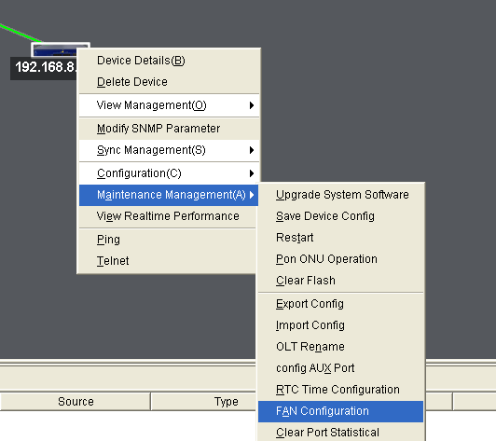
2. Fill in the FAN configuration parameter, includes FAN mode and the opening temperature.
Figure 6-20 FAN configuration parameters
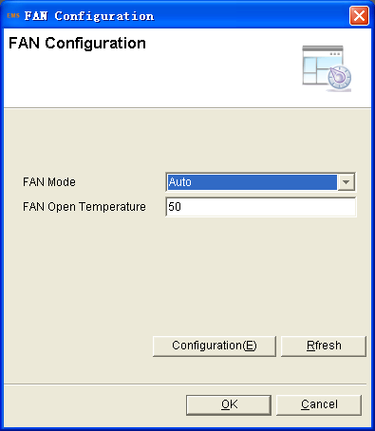
- Delete OLT Device
Delete needless OLT device in topology map.
1. Select OLT device which you want to delete, right click "Delete Devices".
2. Click "OK", the OLT device will be deleted.
Figure 6-24Delete OLT operating dialog
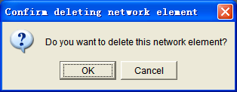
- Ports Configuration
- Uplink Ports Configuration
This operation is used for configure related functions and characteristic parameters of uplink port, which is mainly used for set Ethernet parameters, flow control, storm inhibition of the uplink port. Such as: auto negotiation, rate, duplex mode, etc.
1. Right click OLT, select "Configuration">"Port Configuration">"Uplink Port Configuration" to enter port list interface
Figure 6-22 Location of uplink ports configuration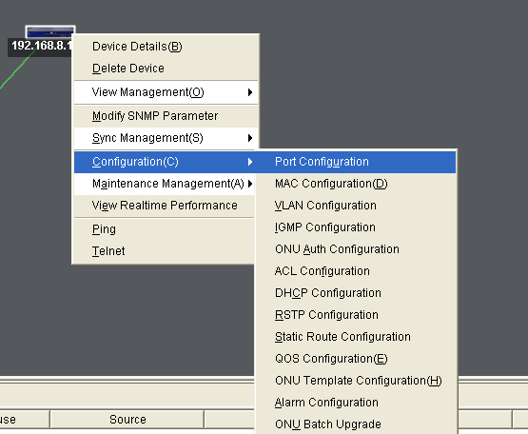

2. Select one port, modify the basic information.
Figure 6-23 Uplink ports configuration

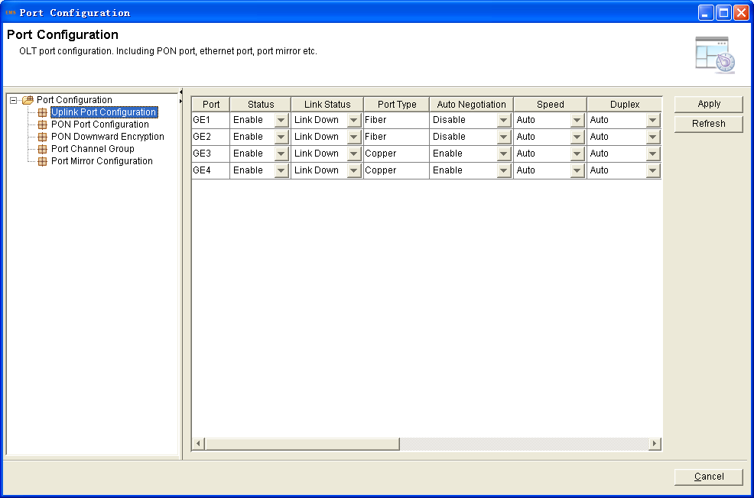
- State: It is used for activate or inactivate port. Only when the port enable, can continue to configure the subsequent parameters. The default is "Enable".
- Link status: Showing the link status of uplink ports, link down or link up.
- Port type: GE port has two types, which are Fiber and Copper.
- Auto negotiation: It is used for enable or disable auto negotiation of the uplink port. The default is “Enable”. After enable, Uplink port will negotiate with the connected port to reach the largest possible transmission rate.
"Speed" and "duplex" are not configurable when auto negotiation function is enabled.
- Speed: Configure uplink ports speed. There are four options: 10Mbps, 100Mbps, 1000Mbps and 10Gbps. This parameter is configurable only when auto negotiation disabled.
- Duplex: Configure port working mode as duplex or half duplex. This parameter is configurable only when auto negotiation disabled. The default is "duplex".
Figure 6-24 Uplink ports advanced configuration
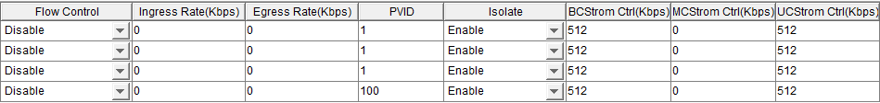
- Flow control: Used for enable or disable the flow control function of uplink port to control congestion. The default is "disable".
- Ingress Rate: Configure port ingress rate.
- Egress Rate: Configure port egress rate.
- PVID: Configure port default VLAN ID.
- Isolate: Port isolate with each other
- BC Storm: Broadcast storm inhibition
- MC Storm: Multicast storm inhibition
- UC Storm: Unknown unicast storm inhibition
2. Click "Apply", apply to the device.
- PON Ports Configuration
This function is used for configure related functions and characteristic parameters of PON port, which is mainly used for set parameters, flow control, storm inhibition of the uplink port, such as: auto negotiation, rate, duplex mode, etc.
1. Right click OLT, select "Configuration">"Port Configuration">"PON Port Configuration" to enter port list interface.
Figure 6-25 PON configuration
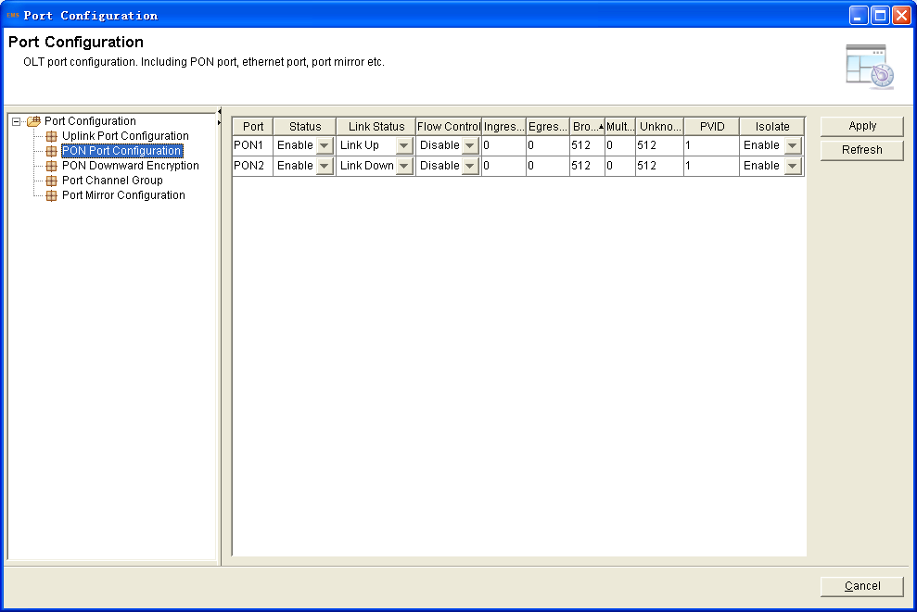
- States: It is used for activate or inactivate port. Only when the port enable, can continue to configure the subsequent parameters. The default is "Enable".
- Flow control: Used for enable or disable the flow control function of uplink port to control congestion. The default is "disable".
- Ingress Rate: Configure port ingress rate.
- Egress Rate: Configure port egress rate.
- BC Storm: Broadcast storm inhibition
- MC Storm: Multicast storm inhibition
- UC Storm: Unknown unicast storm inhibition
- PVID: Configure port default VLAN ID.
- Isolate: Port isolate with each other
2. Click "Apply", apply to the device.
- PON Downward Encryption
EPON system downward transmit by broadcast, protect the user safe is neccesssary. Triple churning is the way for OLT to protect the user safe.
Right click OLT, select "Configuration">"Port Configuration">"PON Downward Encryption" to enter PON list interface.
Figure 6-26 PON Downward Encryption
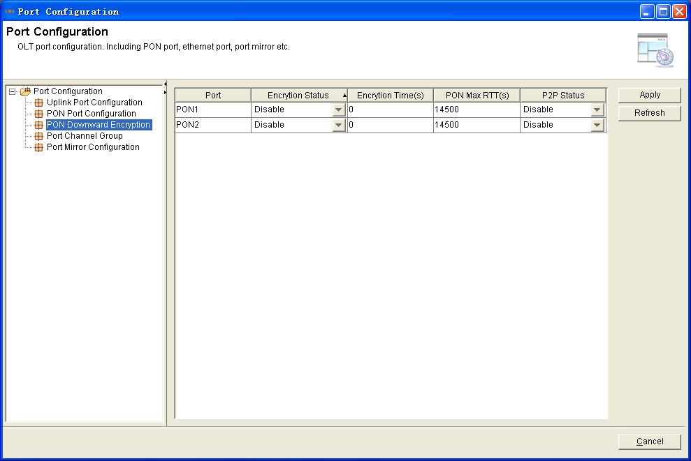
- Encryption status: It is used for activate or inactivate this function. Only when enable, can continue to configure the subsequent parameters. The default is "Disable".
- Encryption time: This is the key timer of the triple churning. Range(774~786426)
- PON Max RTT: To avoid the ONUS’signal reach OLT at the same time，configure the Max RTT will refrain from this conflict.The default is 14500. Range（2000~32000）
- P2P status: It is the switch of the ONU communication with each other at the same PON.
- Port Channal Group
Add the GE ports as a group, all the ports in the group as the same. When the one can not be used suddently, it will change the link to another port. The max groups is 4 and each group can add 4 ports as the max.
1. Right click OLT, select "Configuration">"Port Configuration">"Port Channal Group" to enter group adding interface.
2. Click "Add", select the Load-Balance.All the ports configuration should be the same in the group.
Figure 6-27 Port channal group configuration
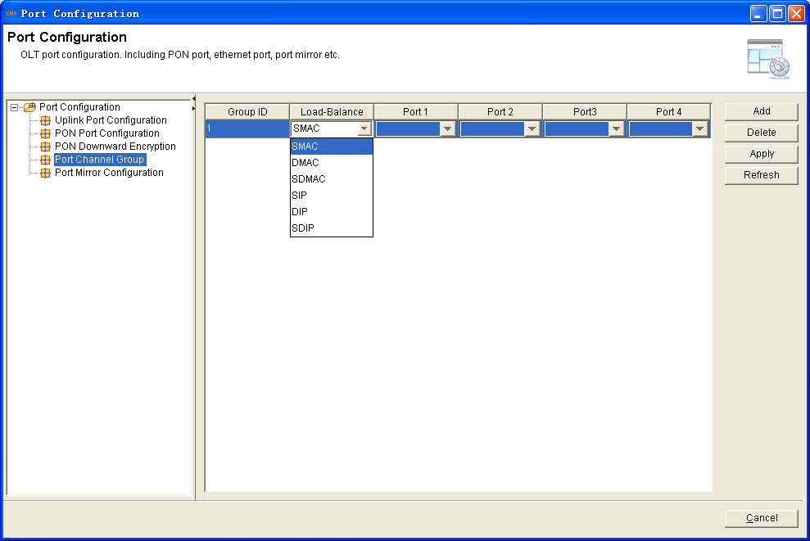
- Port Mirror Configuration
Copy the data from one or more ports to the specified port, which can help for traffic analysis and network error diagnostics. It can add the max 4 mirror groups. Be based on the ports, the source port include rx(receive data )、tx(transmit data)and both.
1. Right click OLT, select "Configuration">"Port Configuration">"Port Mirror Configuration" to enter group adding interface.
2. Click "Add">select"Mirror DstPort">click "Mirror SrcPort" blank entries to select one or more ports>choose the "Mirror Type"
Figure 6-28 Port Mirror configuration
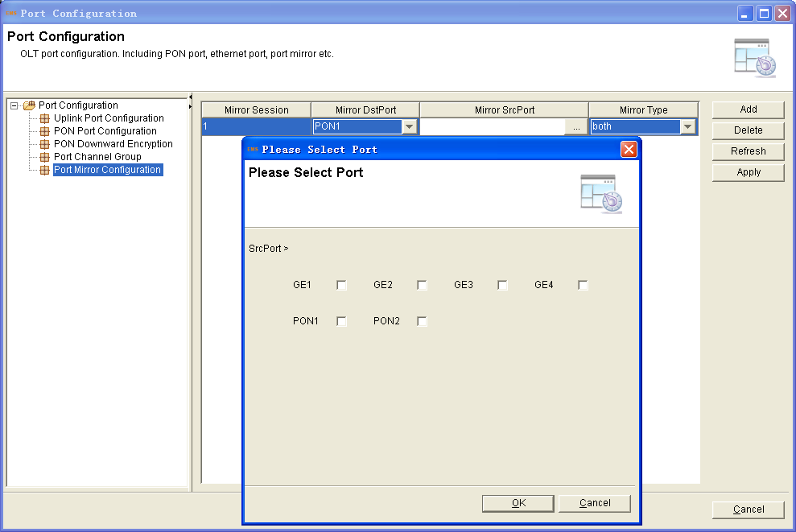
- Port VLAN Configuration
- VLAN Configuration
OLT equipment switch engine is fully compliant with the IEEE802.1Q VLAN standard and has following main features.
- Support Port-based VLAN and IEEE802.1Q VLAN;
- Support full 4K VLAN group, VID range 1~4095;
- All switch ports, including uplink ports and downlink ports support VLAN partition;
- VLAN 1 is the system reserved VLAN, it includes all switch ports, all ports is UNTAG mode;
- Show VLAN Table
1. Right click OLT, select "Configuration">"VLAN Configuration">"VLAN Configuration" to enter port list interface.
Figure 6-29 Location of VLAN configuration
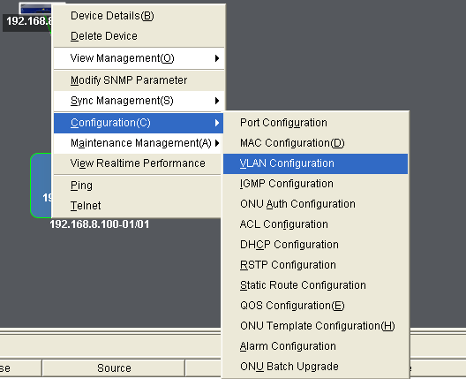
Figure 6-30 VLAN configuration
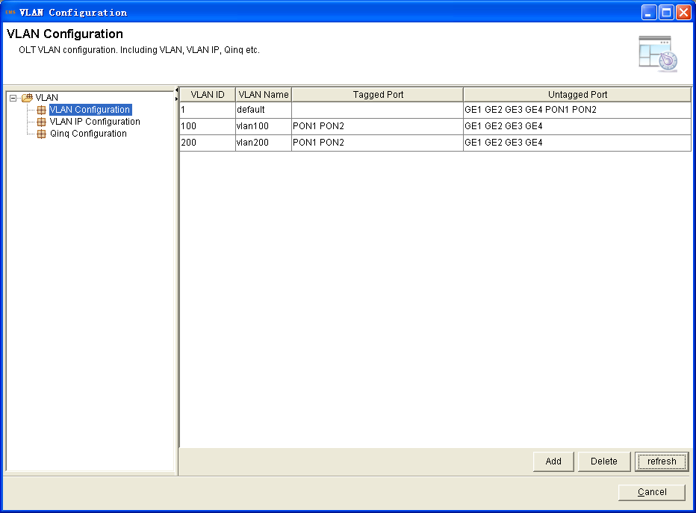
- Add a New VLAN
1. Set the VLAN ID;
Figure 6-31 Add an new VLAN
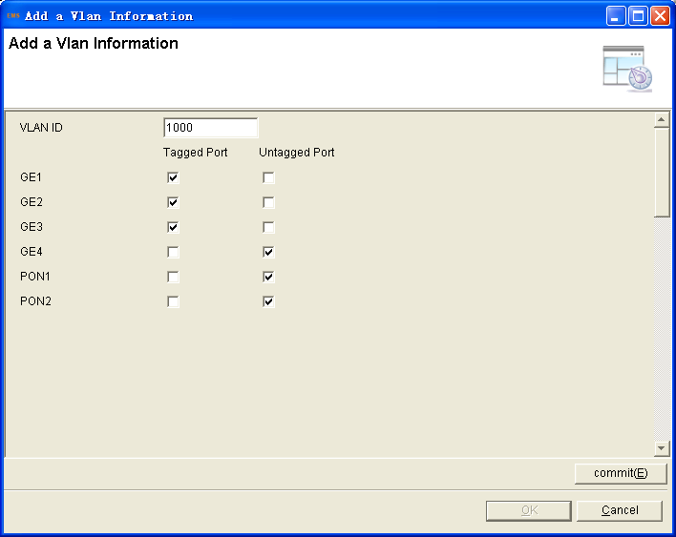
2. Choose the port members to be assigned to this VLAN group in Ports list;
3. Click “Commit” button to create the new VLAN group;
- Delete VLAN
1. Select the VLAN group entry to be deleted in VLAN table;
2. Click Delete button to delete the selected VLAN;
Figure 6-32 Show VLAN table
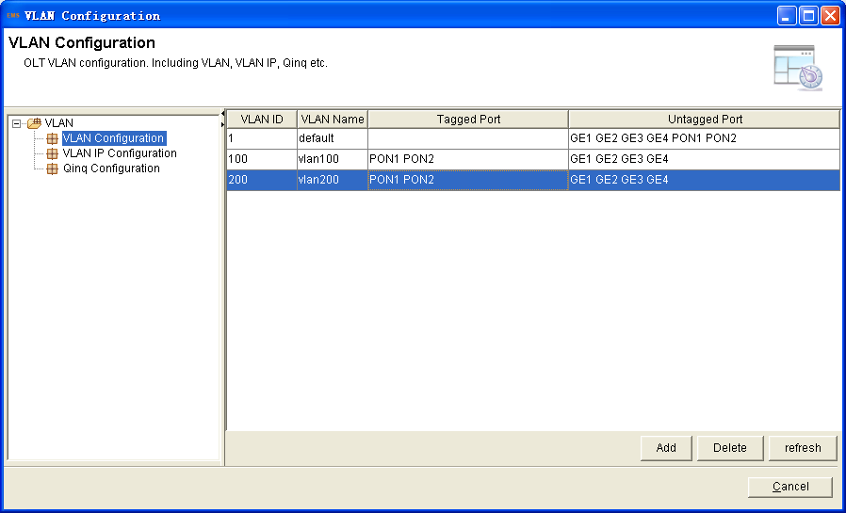
- VLAN IP Configuration
Create the VLAN first. This configuration can add the IP to the VLAN. When the VLAN is added to the port, the IP address will be added.
Click "VLAN IP Configuration">click "Add">select the existed VLAN>fill in the VALN IP address、submask>choose ARP proxy status
Figure 6-33 Show VLAN table
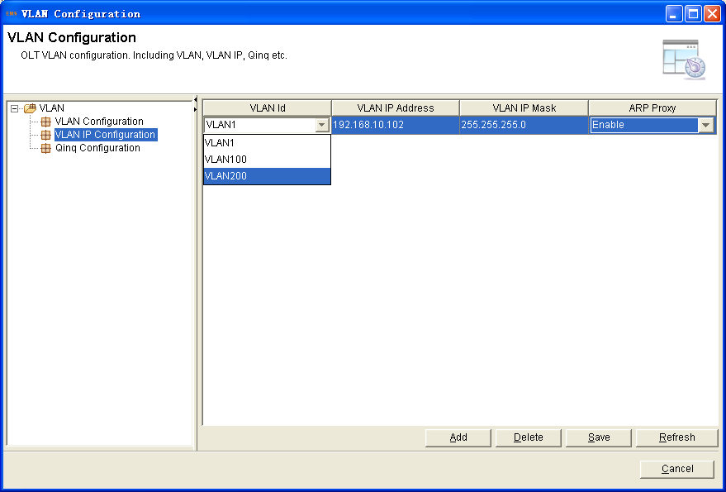
- Static Route Configure
This is the OLT router function. The OLT look like the router but only support ststic route. As the above “VLAN IP Configuration”.When configure the VLAN IP address and then add the static route, the network at the different network segment can communicate with each other.
1. Right click OLT, select "Configuration">"Static Route Configuration " to enter showing list interface.
Figure 6-34 Show static route table
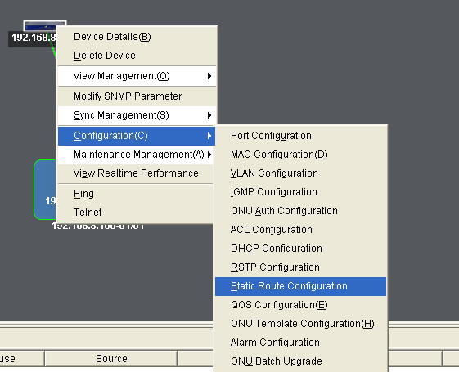
2. Click "Add",fill in the IP address、Mask and Gateway>click "Apply"
Figure 6-35 Configure static route
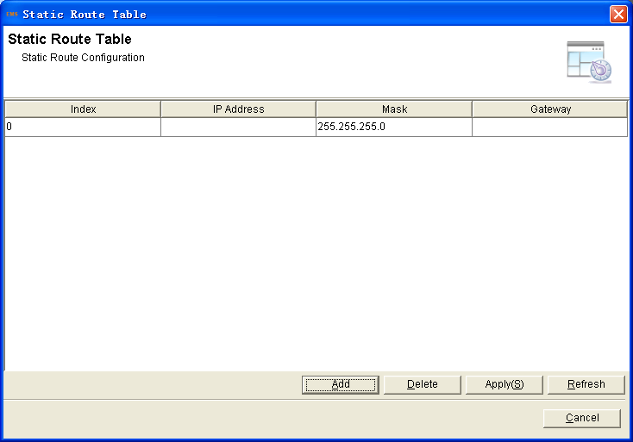
- QinQ Configuration
In this interface, VLAN QinQ and VLAN translation can be configured.
Click "QinQ Configuration">click "Add">select the port、CVLAN、SVLAN and choose the mode(translation or qinq).
Figure 6-36 QinQ configuration
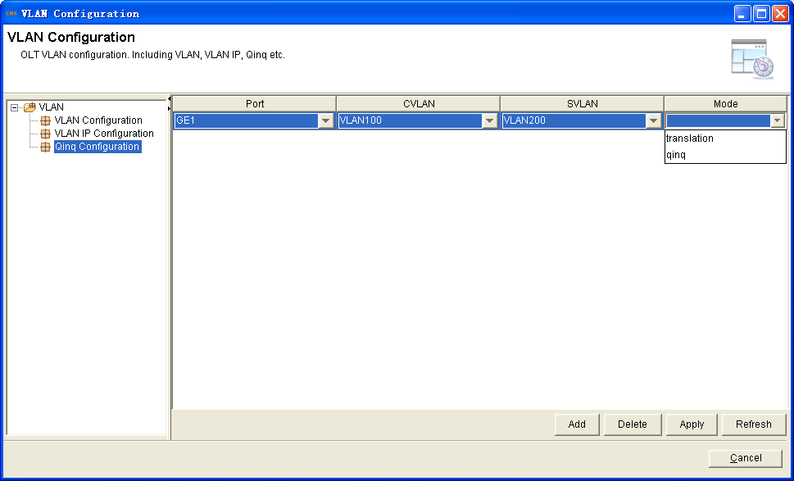
- MAC Configuration
1. Confirgure the MAC aging time.The default value is 300s.
2. The MAC address list, the showing of OLT learn MAC address from PON port and GE port.
3. Configure the count of the OLT learning MAC address from GE port.
- OLT IGMP Configuration
Configure multicast global parameters.
1. Right click OLT, select "Configuration">"IGMP Configuration" to enter the IGMP interface.
Figure 6-37 IGMP configuration
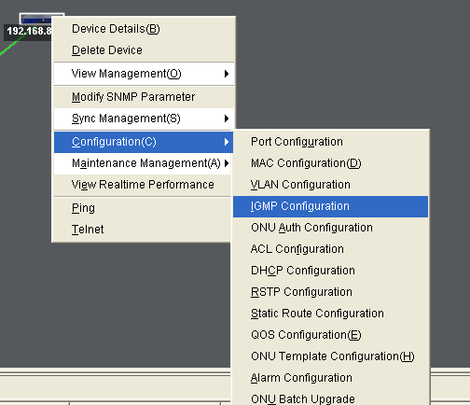
2. You can modify IGMP mode, proxy IP and IGMP VLAN.
IGMP mode includes snooping and disable.
- Snooping: IGMP snooping is the process of listening to Internet Group Management Protocol (IGMP) network traffic. The feature allows a network switch to "listen in" on the IGMP conversation between hosts and routers. By listening to these conversations the switch maintains a map of which devices need which IP multicast streams. Multicasts may be filtered from the ports which do not need them and thus controls which ports receive specific multicast traffic.
- Disable: When choose disable mode, OLT is working in transparent mode.
- IGMP Router Port
The uplink ports can be used add IGMP router VLAN.
Figure 6-38 IGMP router port configuration
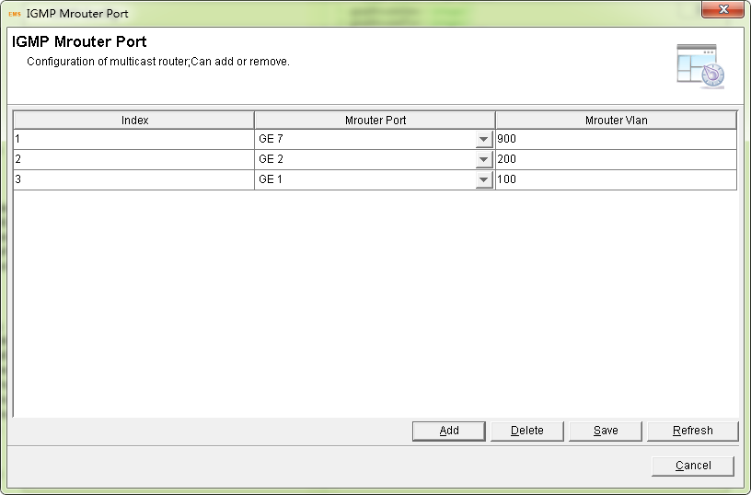
- Port Configuration
This operation used to set the maximum number of multicast groups, port mode and fast leave mode.
Figure 6-39 IGMP port configuration
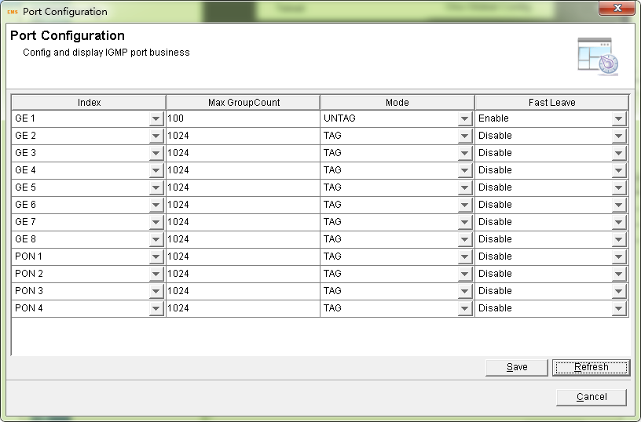
- IGMP User VLAN Configuration
This operation used to add IGMP VLAN. If users VLAN and group VLAN are the same, please set the same VLAN ID.
Figure 6-40 IGMP VLAN configuration
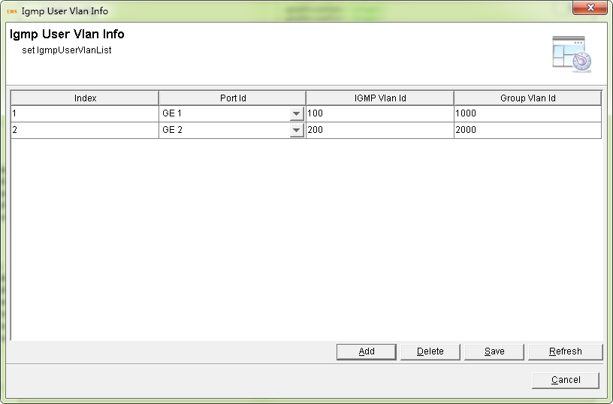
- Static Group Table
This operation used to Binding multicast IP address and VLAN ID.
Figure 6-41 IGMP static group configuration
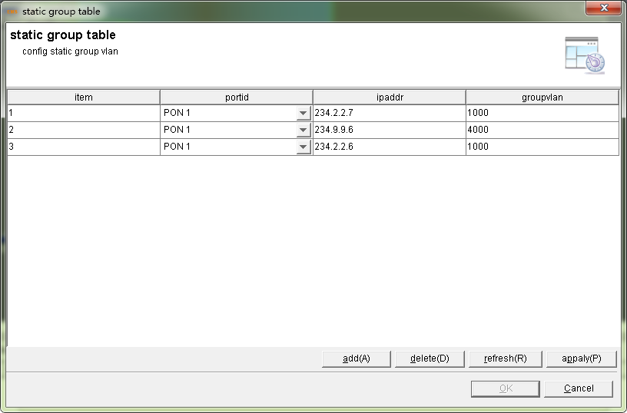
- ONU Auth Configuration
- ONU Authorized Mode
1. Right click OLT, select "Configuration">"ONU Auth Configuration" to enter the ONU authorized mode interface.
Figure 6-42 Location of ONU authorized mode
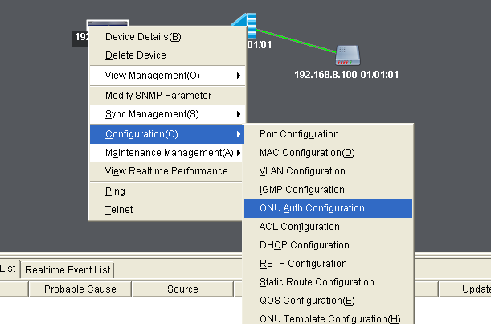
2. Configure authorized strategy
Authorized Strategy include: MAC, LOID, MAC+LOID and NONE.
Figure 6-43 ONU authorized mode configuration
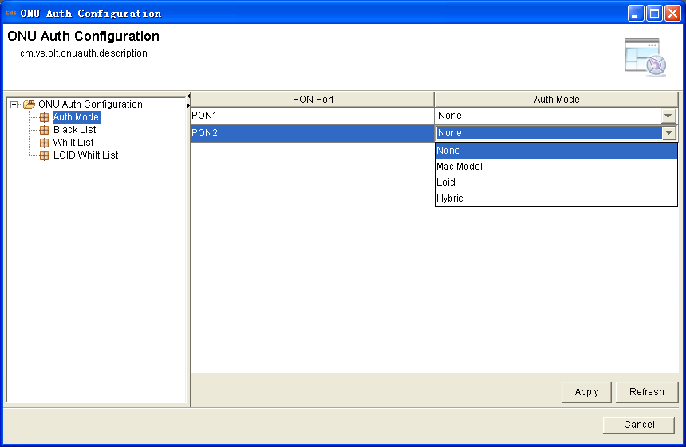
- MAC White List
Use MAC-based authentication function to manage the access of ONUs in PON port, the ONUs in the white list can pass through the authentication. Premise condition is the ONU authentication mode is based on MAC address based mode or mixed mode.
1. Add new MAC address: click the add button, fill in the number you need to add.
Figure 6-44 ONU MAC white list configuration
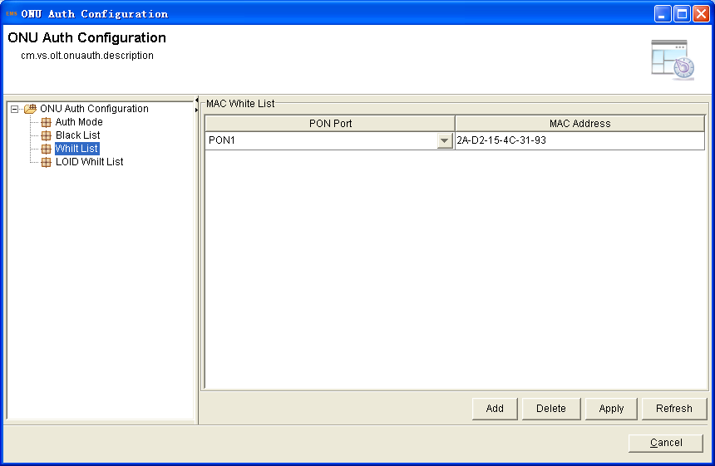
3. Click on the "Apply" apply to the device.
- Mac Black List
Use MAC-based authentication function to manage the access of ONUs in PON port, the ONUs in the black list can’t pass through the authentication. Premise condition is the ONU authentication mode is based on MAC address based mode or mixed mode.
1. Add new MAC address: click the add button, fill in the number you need to add.
Figure 6-45 ONU MAC black list configuration
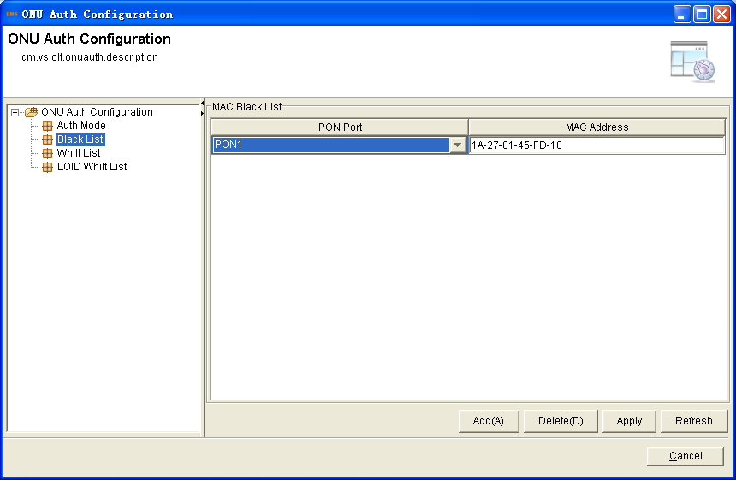
3. Click on the "Apply" apply to the device.
- ACL configuration
In order to filter data packages, network equipments need to setup a series of rules for identifying what need to be filtered. Only matched with the rules the data packages can be filtered. ACL can achieve this function. Matched conditions of ACL rules can be source address, destination address, Ethernet type, VLAN, protocol port, and so on.
These ACL rules also can be used in other situations, such as classification of stream in QoS. An ACL rule may contain one or several sub-rules, which have different matched conditions.
This device supports the following types of ACL.
- IP Standard ACL.
- IP Extended ACL.
- ACL based on MAC address
- ACL based on port binding.
- ACL based on QoS.
Right click OLT, select "Configuration">"ACL Configuration" to enter the ACL configuration interface.
Figure 6-46 ACL configuration list
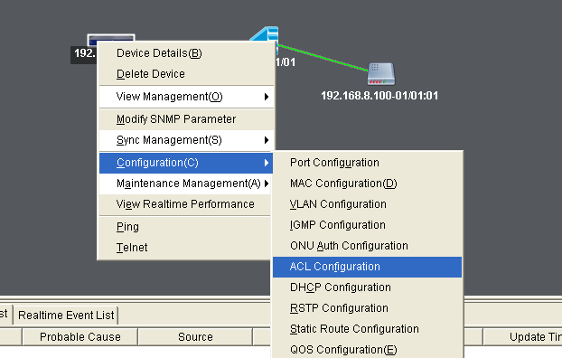
- IP Standard ACL
It support deny/permit the source IP address.
Select “Standars IP ACL”>click“Add”>fill in the ip address and the submask.
Figure 6-47 IP standard ACL list
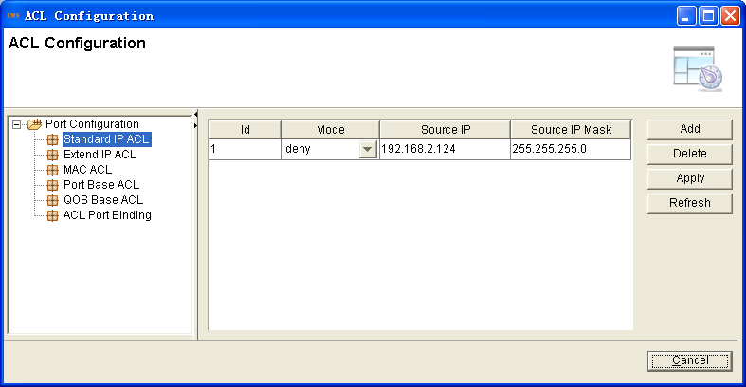
- IP Extend ACL
It is the extended of the ip standard ACL. In this interface, you can permit/deny the IP address both source and destination.
Figure 6-48 IP extend ACL configuration
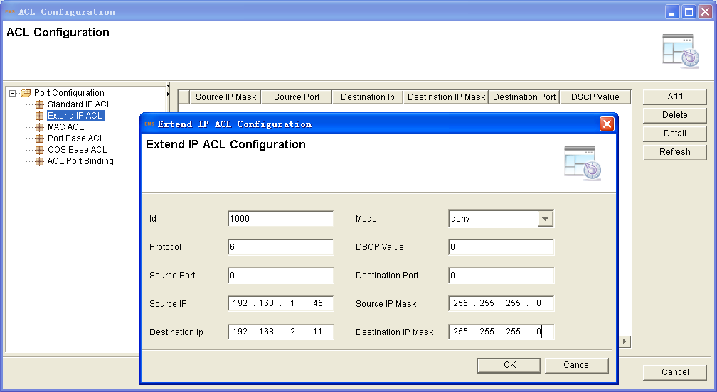
- MAC ACL
This ACL is based on MAC address. It can filter data packages both the source MAC address and destination MAC address.
Figure 6-49 MAC ACL configuration
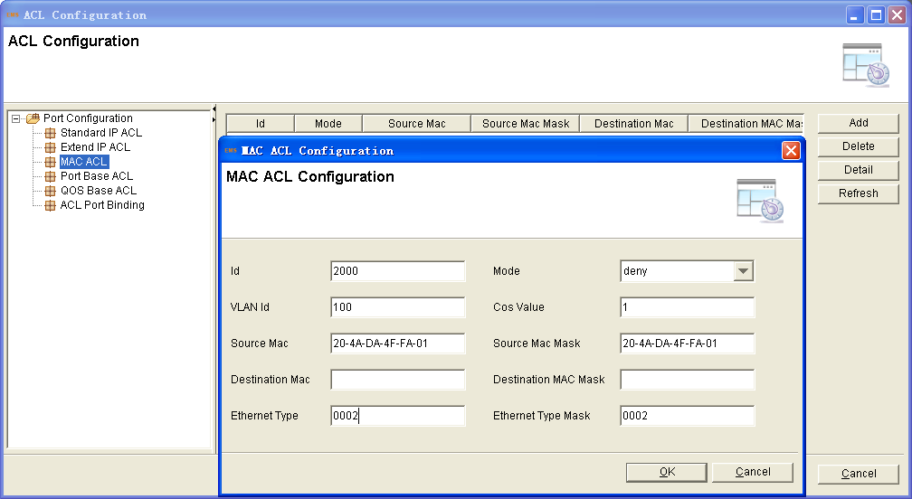
- Port Base ACL
Here is adding the ACL basis for ports. Most of the parameters about the port can be configured.Such MAC filter、IP address filter and so on.
Figure 6-50 Port base ACL configuration
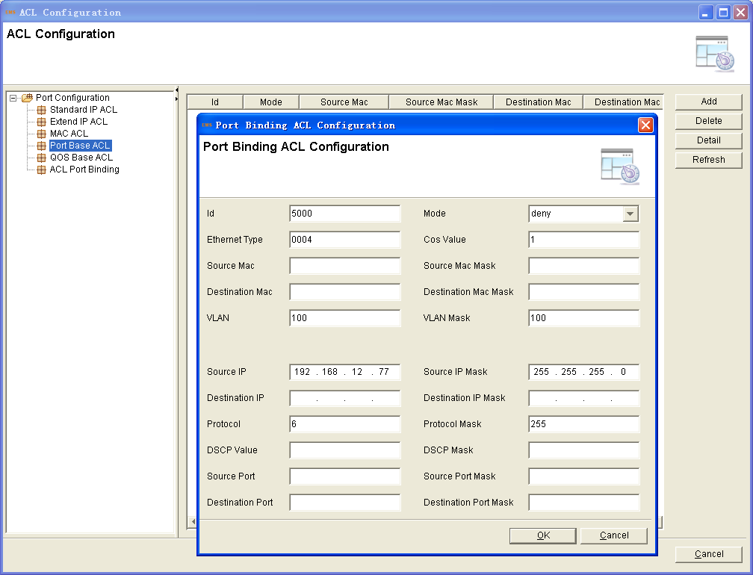
- QoS Base ACL
Configure the QoS by ACL. Bind this ACL to a port , it will limit the data by the priority.
Figure 6-51 QoS base ACL configuration
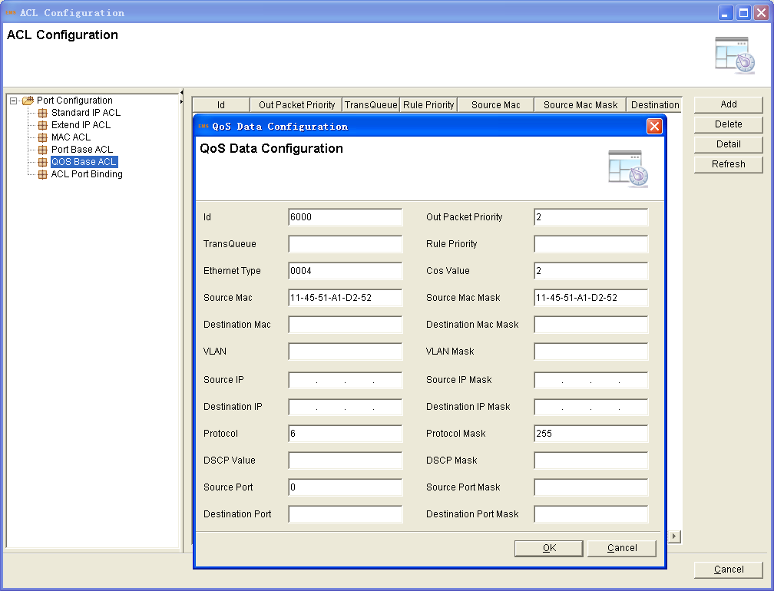
- ACL Port Binding
As the above creating an ACL list which the port should bind in it .Then it can take effect. The index existed automatically when created.
Click “ACL Port Binding”>click the port choice>set “OK”>click “Apply”
Figure 6-52 ACL port binding
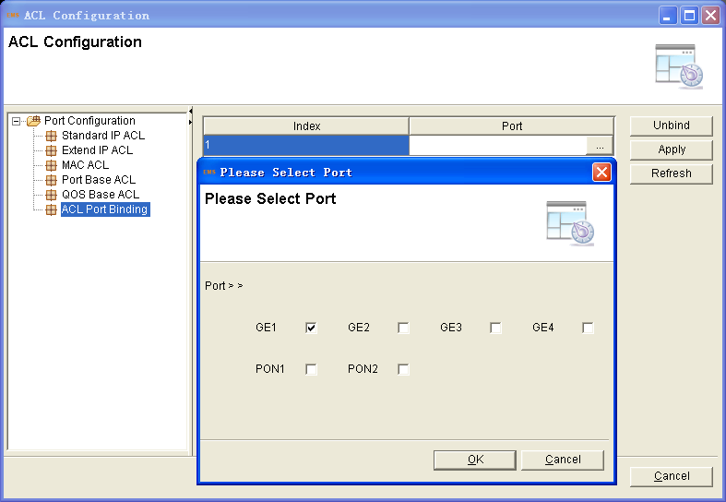
- DHCP Configuration
OLT can support the DHCP function, including:
- DHCP Server
- DHCP Relay
- DHCP Snooping
- DHCP Server
OLT turn on the function of DHCP server.Connecting behind the OLT PON ports, the devices will get an IP address. It can solve the problem that the IP address not enough to allocate. The OLT be a DHCP server, the devices behind the PON port be the clients.
Right click OLT, select "Configuration">"DHCP Configuration" >to enter the DHCP configuration interface.
Figure 6-53 Enter DHCP interface
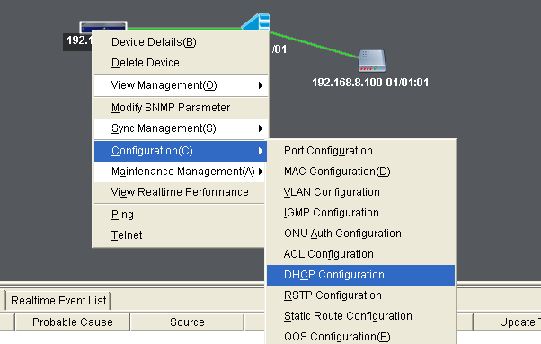
Figure 6-54 DHCP server configuration
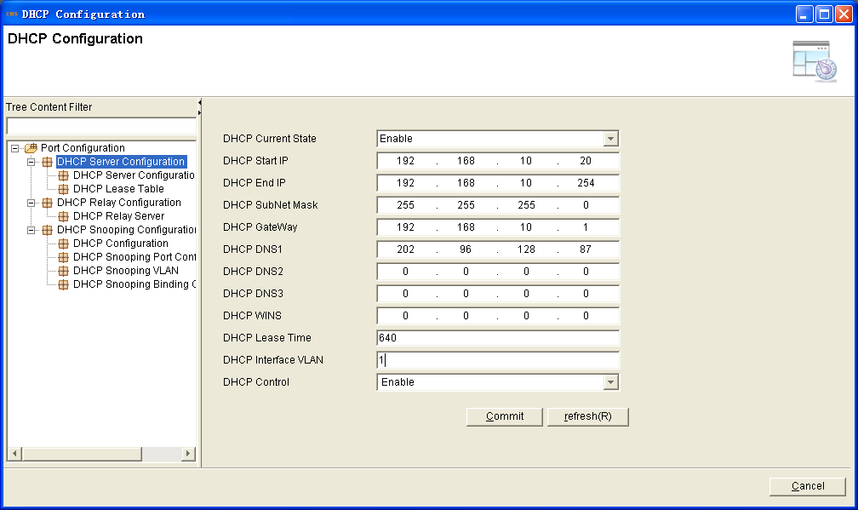
- DHCP Relay
Because the DHCP receiving need to broadcast, so the server and the client should be in the same network.The DHCP relay can save this issue effective. The relay vlan should be added to the GE port .The relay server IP address network segment should be the same as the DHCP server
Figure 6-55 DHCP relay configuration
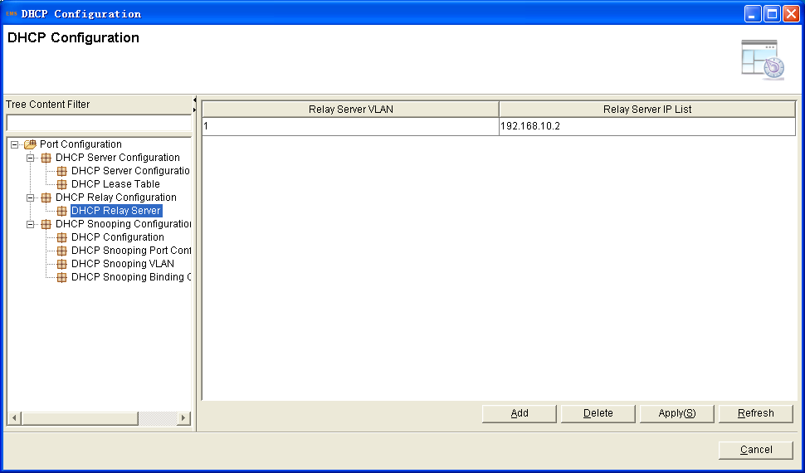
- DHCP Snooping
To prevent the DHCP message attacking and protect your network to get a useful IP address.DHCP Snooping is used for denying the DHCP offers packets. The DHCP server is forbided, which can not allocate the IP address successfully.
1. Click “DHCP Snooping Configuration” to enable this function.
Figure 6-56 Switch of DHCP Snooping
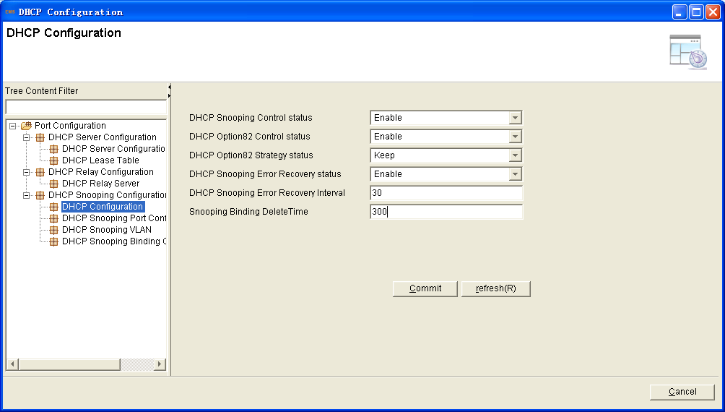
2. Click “DHCP Snooping Port Configuration”. All the port type is untrust by default. The “Port User Circuit” and “Port User Remate ID” are the parameters of Option82. The “Port Rate Limit” is about the port max speed of receiving the DHCP packet. It doesn’t limit by default.
Figure 6-57 DHCP snooping ports configuration
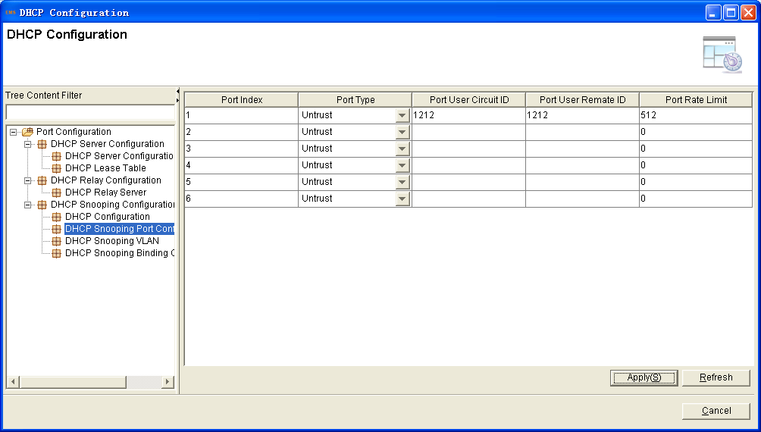
3. Click “DHCP Snooping VLAN”. Fill in the VLAN ID>click “Add”, the list will show the added VLAN. All the DHCP Offers packets will be forbided in this VLAN. The DHCP clients will not get the IP address by this VLAN ID.
Figure 6-58 DHCP snooping VLAN configuration
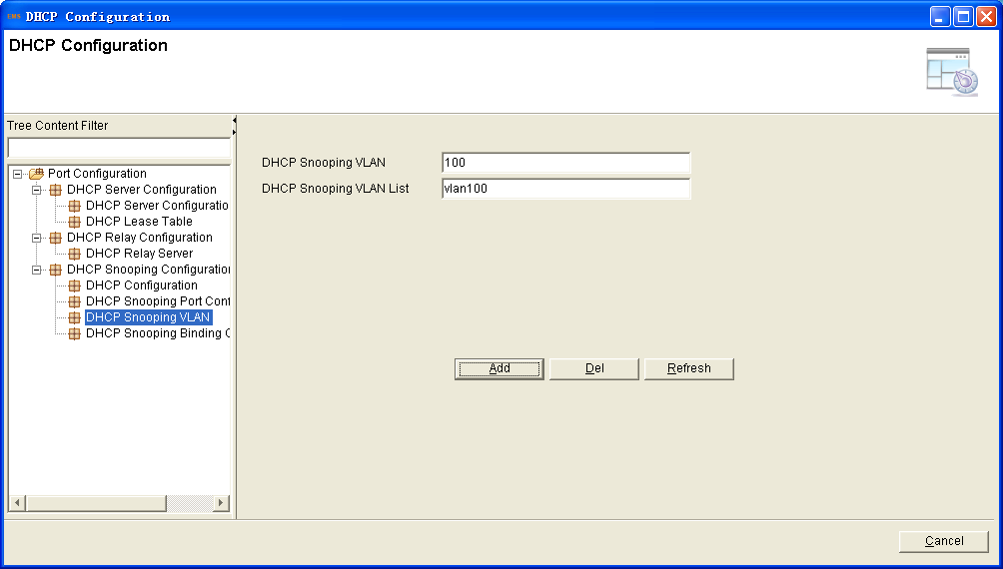
- QoS configuration
Queue scheduling mode contains strict priority, weighted round robin and hybrid mode. This device supports 8 queues altogether.
Right click OLT, select "Configuration">"QoS Configuration" to enter the QoS configuration interface.
Figure 6-59 QoS configuration interface
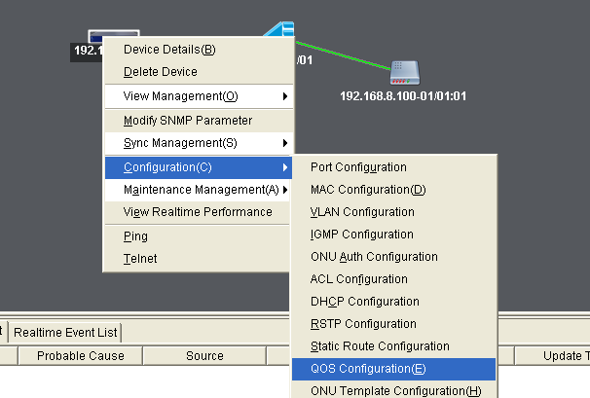
Select the mode. Then Click “Apply”.
Figure 6-60 Queue Schedule mode
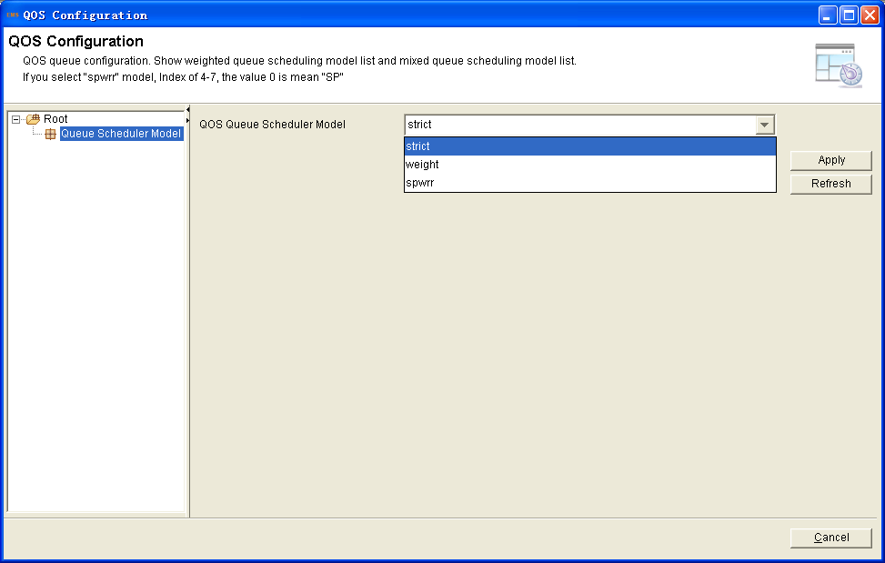
For example, select the hybrid mode. When one queue weight is 0, the queue behind it should be filled in 0. The queue with weight 0 regulation is strict priority, and the others regulation is weighted round robin.
Figure 6-61 Queue Schedule hybrid mode
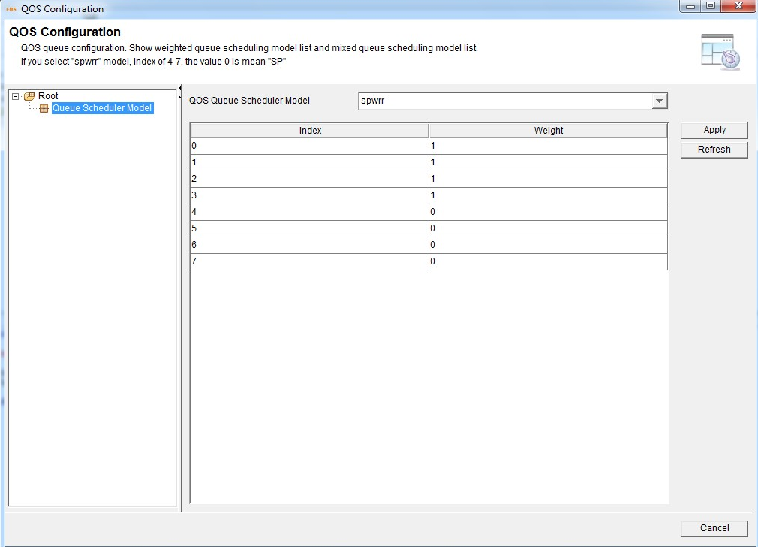
- ONU Template Configuration
This section is about the OLT configuring the template for ONU, according to the characteristics of multiple services (data, voice, alarm) integrated in an ONU, huge quantity terminals and configuration similar.It can be binded by the user manually. The template is included:
- DBA Bandwidth Template
- Service (SRV) Template
- Voice (VoIP) Template
- Alarm Threshold Template
Figure 6-62 Template configuration
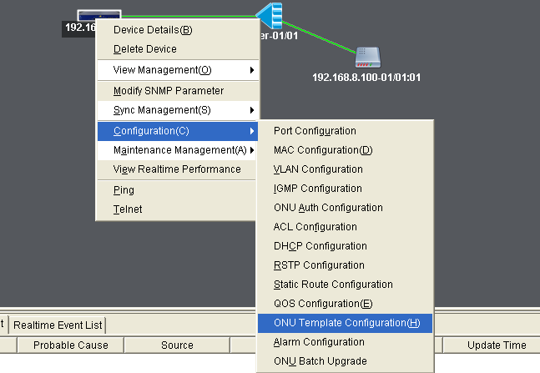
- DBA Bandwidth Template
DBA is a bandwidth allocation strategy that changes uplink bandwidth assigned to each ONU in real time according to the instant service status of each ONU.
Click “Add”button, fill in the parameters.Finishing the operation, click “OK”;
Figure 6-63 DBA template configuration
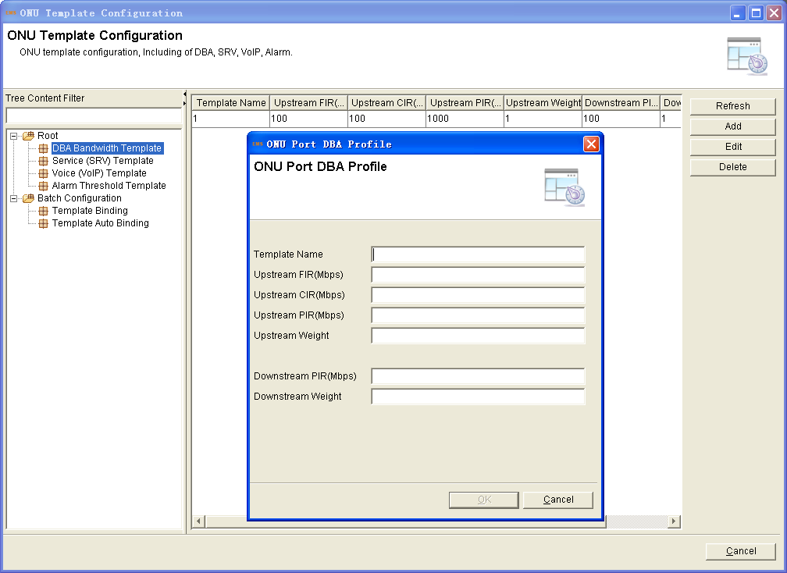
- DBA Bandwidth Template Binding
After creating a DBA Bandwidth Template, binding it to an ONU is necessary. When binded it to an ONU, it means configuration the ONU’S upstream and downstream withonu configure one by one.
Operation Procedure
Click”Template binding” in the left tree of template management interface .
Click the “select” button, find out the ONU you operate bindfing. Choose the bar of returning interface, click”Configure” button, then choose the DBA
bandwidth template to bind.
Figure 6-64 Template binding select ONU
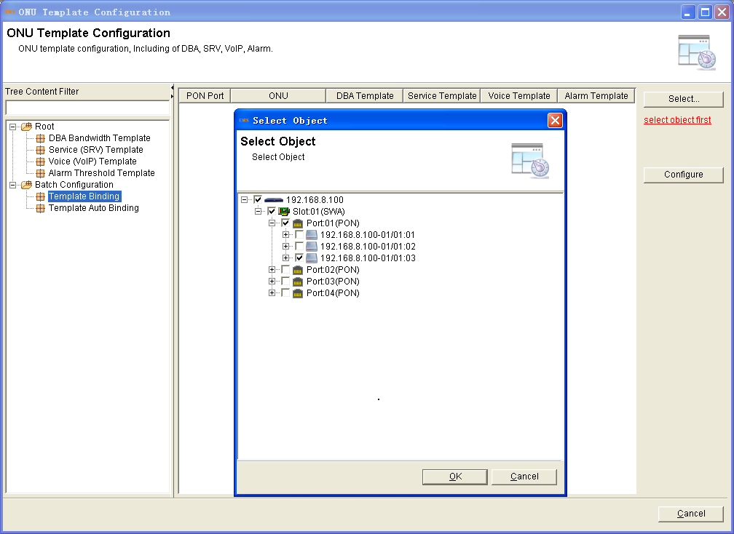
Figure 6-65 Template binding configuration
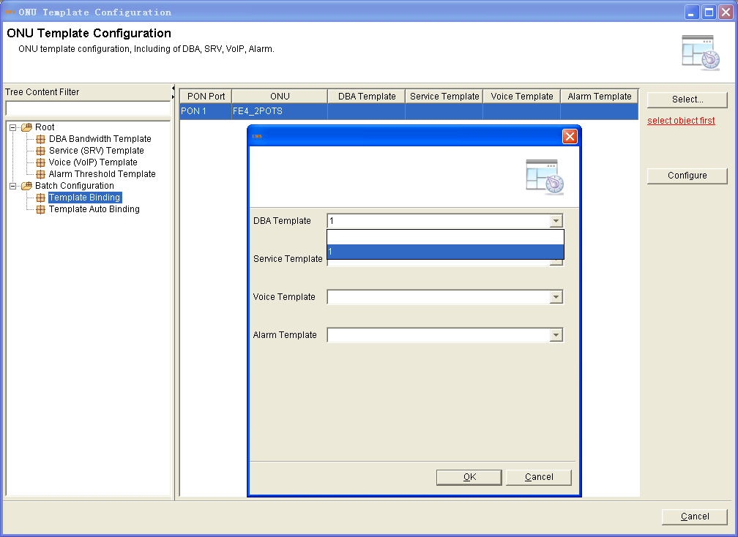
- Service (SRV) Template
This section is about the service template, it can configure most service of the ONU.After create, it can be binded in an ONU. The function will show below：
- LAN Conut
- ONU Main PON Port
- Optical Link Protection
- Management IP
- FEC
- Multicast Mode
- LLID Conut
- Port Loop Detection
- IGMP VLAN Tag
- IGMP VLAN Translation
- ONU SNMP Parameters
- Port Flow Control Pause
- Physical Port
- Port Auto-Negotitation
- IGMP Max Group Count
- Port VLAN
- Upstream Port Limit
- Downstream Port Limit
- IGMP VLAN
- Classify Configuration
- MAC Aging Time
- PON Optical Link Protection
- Power Saving Mode
- Saving Mode Parameters
- Port Packet Statistic
- Port Loop
- WIFI Function Status
- WIFI SSID Set
- WAN Conn
Operation Procedure
Click”Service (SRV) Template” in the left tree of template management interface.There is no default template,so adding a template is necessary.
Click “Add” button at the top of the interface , creating a template name
as the prompt.
Accessing to the template, configure the service by clicking “Root” tree
Click the “LAN Count”, many services are based on configuration it. Fill in the value refer to ONU be using.

Figure 6-66 Add service(SRV) template
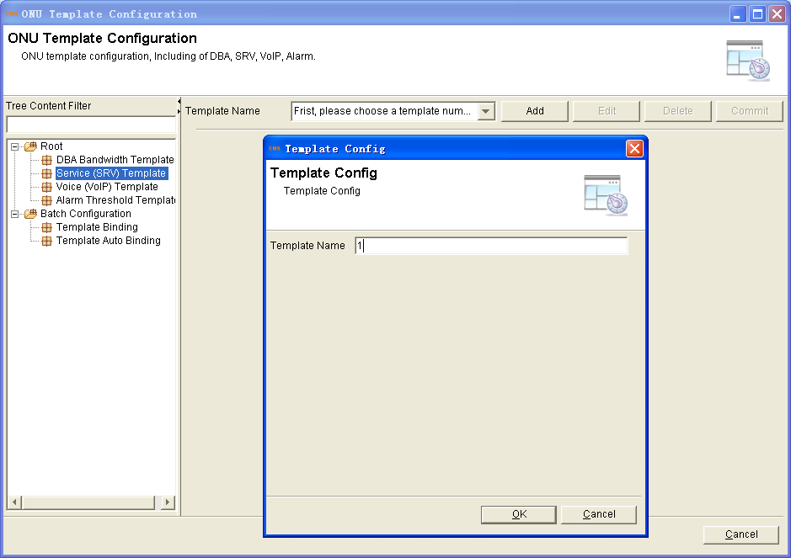

Figure 6-67 Service(SRV) template configuration
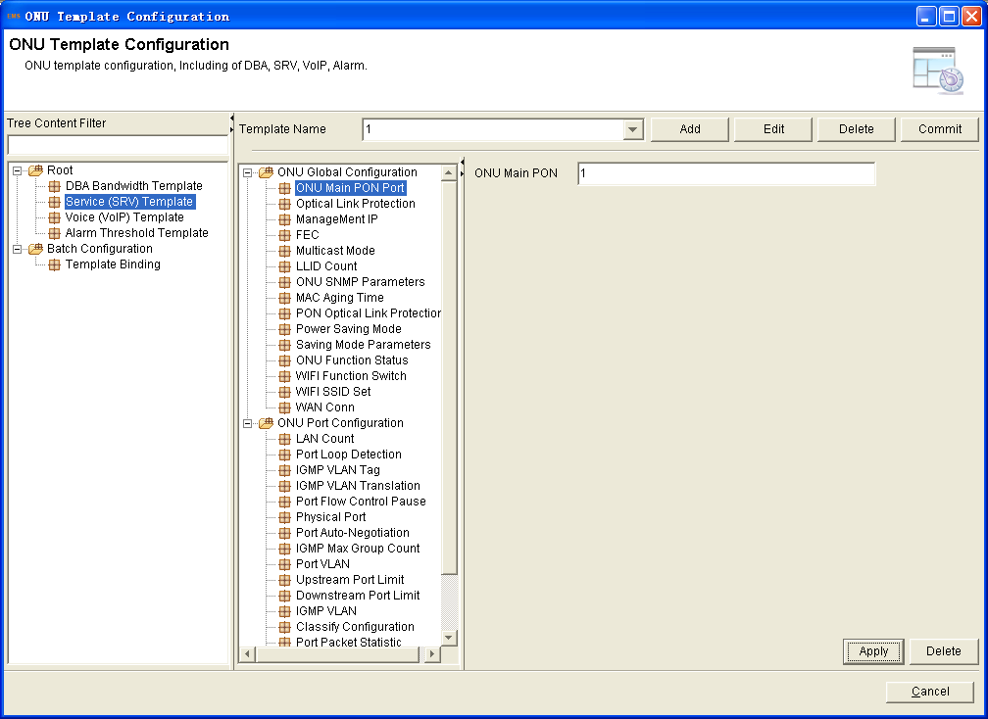
- Service (SRV) Template Binding
Mentioned earlier in the “DBA Bandwidth Template Binding”, by the same operation can bind the template to an ONU.
Figure 6-68 Service (SRV) template binding
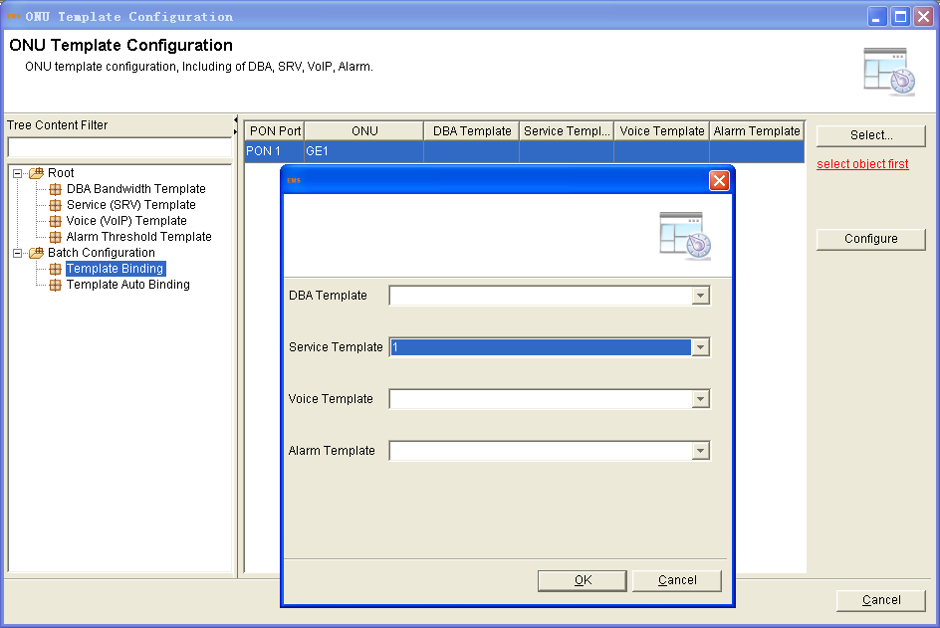
- Voice (VoIP) Template
This function is designed for the ONU, which is with FXS pots. Most of the base parameters of voice can be configured in this template. When finishing configuration, binding to an ONU will make it work supporting voice. The base configuration parameters will be shown below:
- POTS Conut
- VoIP Global Configuration
- SIP Protocol Parameters
- SIP User Parameters
- SIP Protocol Tree Graph
- Fax Parameter
- VoIP POTS Management
Operation Procedure
Click “Voice (VoIP) Template” in the left tree of template management interface. Add a new template first, click “Add” button at the top of the interface, and fill in the template name.
Accessing to the template, configure the VoIP by clicking “Root” tree
Click the “POTS Count”, it should be configured first. Fill in the value refer to ONU be using.
Figure 6-69 Add voice (VoIP) template
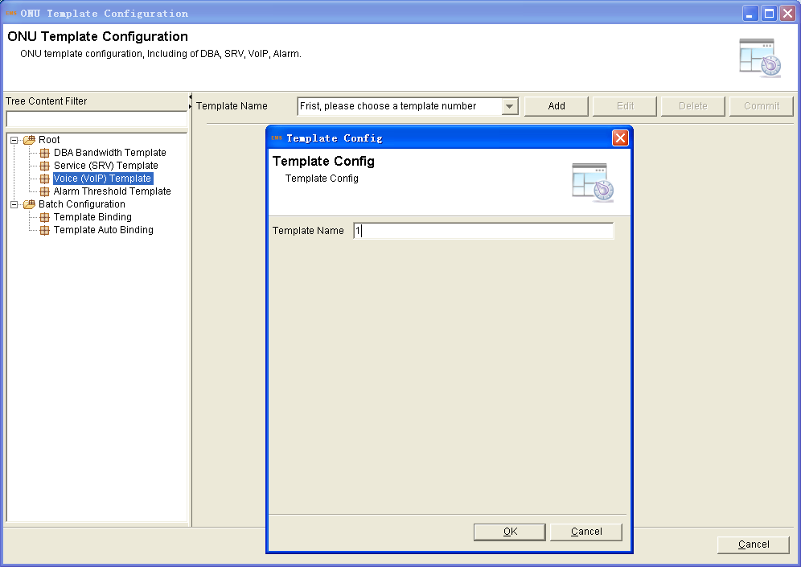
Figure 6-70 Voice (VoIP) template configuration
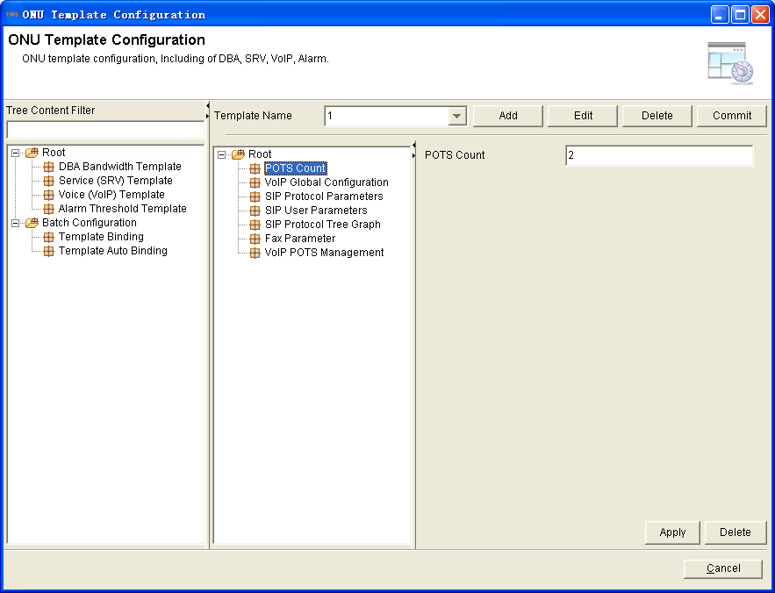
- Voice (VoIP) Template Binding
Select the ONU you want to bind the voice template. The same operation refer to the “DBA Bandwidth Template Binding”.
Figure 6-71 Voice (VoIP) template binding
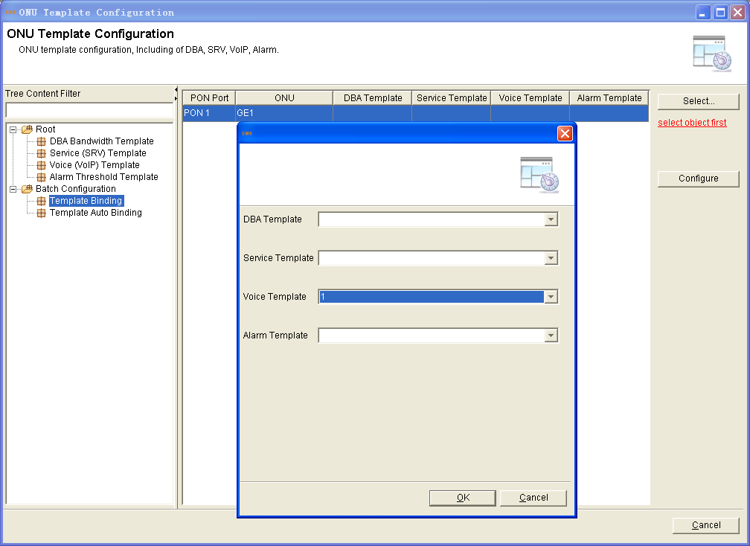
- Alarm Threshold Template
This section is about configutation the ONU alarm threshold, it only can be configured by template.The alarm threshold can be included below:
- ONU Alarm Status
- ONU Template Alarm
- ONU Low Vlotage Alarm
- PON Vlotage Alarm
- Pon Current Alarm
- PON Tx And Rx Power
- PON Template Alarm
- PON Data Alarm
- Port Alarm Status
- Port Data Alarm
- POTS Alarm Status
- E1 Alarm Status
Operation Procedure
Click“Alarm Threshold Template” in the left tree of template management interface. Add a new template first, click “Add” button at the top of the interface, and fill in the template name.
Accessing to the template, configure the alarm by clicking “Root” tree
For example, click “ONU Alarm Status”, click “Add” button at the botton of the interface, there is some alarm type to select.Choose the need of the onu alarm, and choose “Enable”.
Figure 6-72 Add alarm threshold template
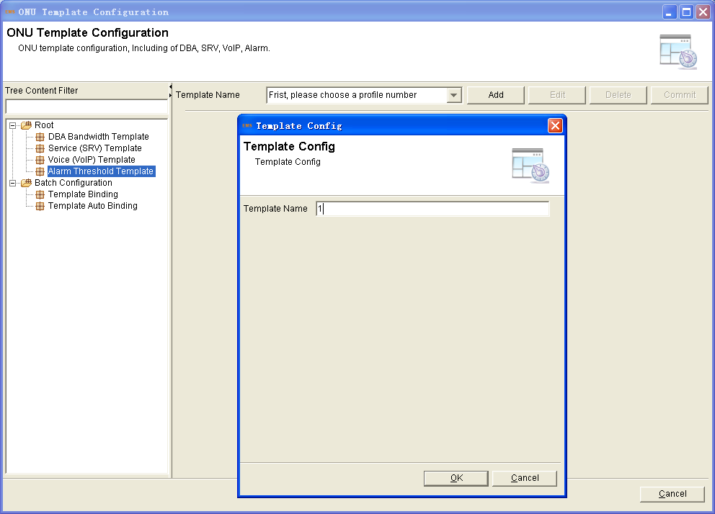
Figure 6-73 Alarm threshold template configuration
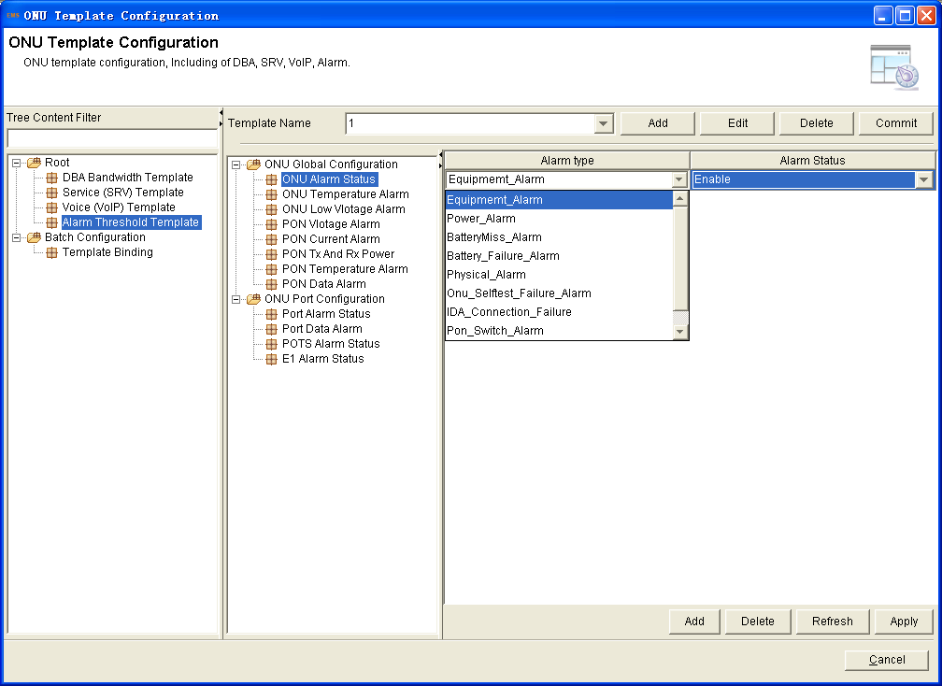

- Alarm Threshold Template Binding
Binding the template to an ONU, then it can take effect. Operation as the DBA bandwidth template binding, select the ONU and bind the alarm threshold template.
Figure 6-74 Alarm threshold template binding
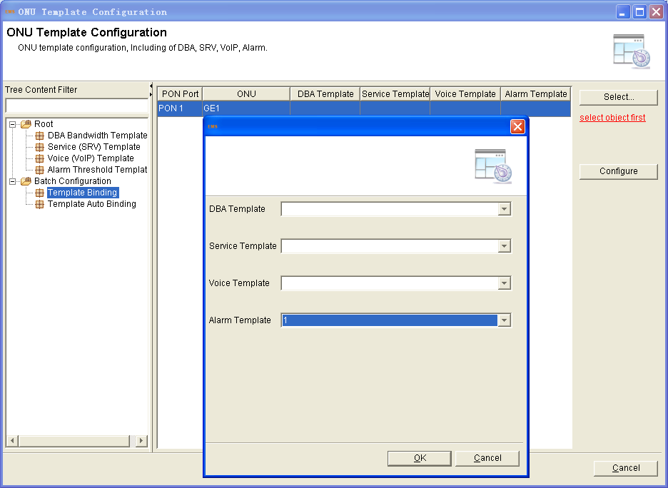
- Alarm Management
This section describes the alarm and event management. It mainly includes the following contents:
- OLT Connecting Status
When OLT disconnect suddenly，it will show a red “X” at the OLT in the EMS interface in 12 seconds, and with sound reminding. The function of showing the status is by default. The sound reminding shoud be configured.
Click “Alarm Management” button, select “Alarm Sound”, access to the configuration interface .
Figure 6-75 Access alarm sound interface
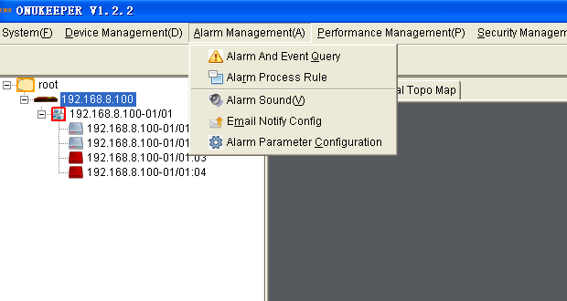

Figure 6-76 Alarm sound configutation
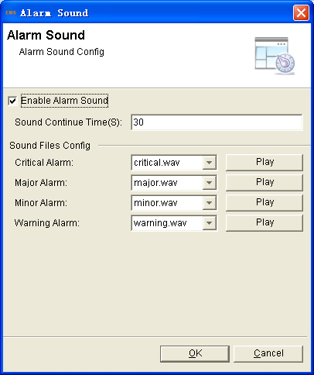
- ONU Connecting Status
When the ONU status changes, it will be shown in the EMS.If the ONU change to disconnect, the EMS will show red“X”at the ONU. If the ONU change to connect, the red “X” will disappear.

Figure 6-77 ONU change to disconnect
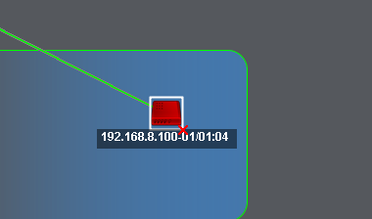
Figure 6-78 ONU change to connect
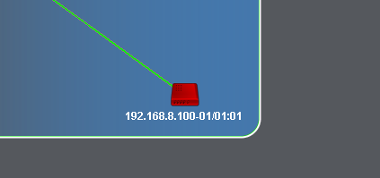
This function takes effect after adding trap server. Right click the OLT, select the “Device Details”, click the “Add Trap Server” button.

Figure 6-79 Click device details
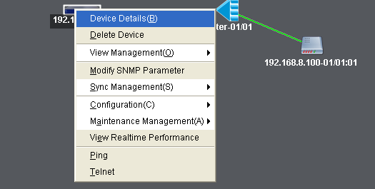
Figure 6-80 Add trap server
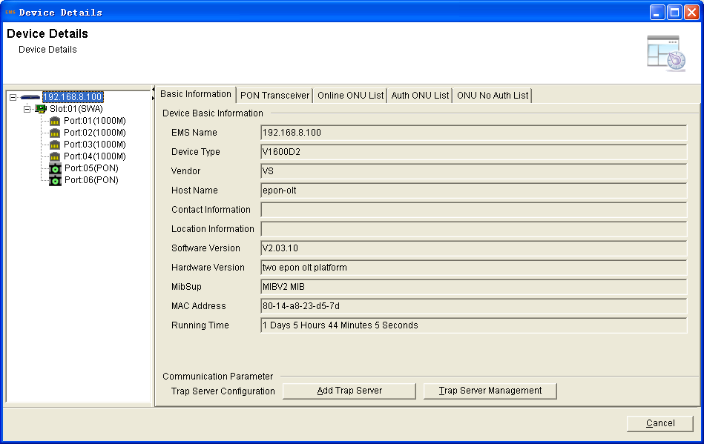
- Alarm Configuration
Configure all the alarm including OLT system alarm and ONU alarm.
Right click OLT, select "Configuration">"Alarm Configuration" to enter the Alarm configuration interface.
Figure 6-81 Enter alarm configuration list
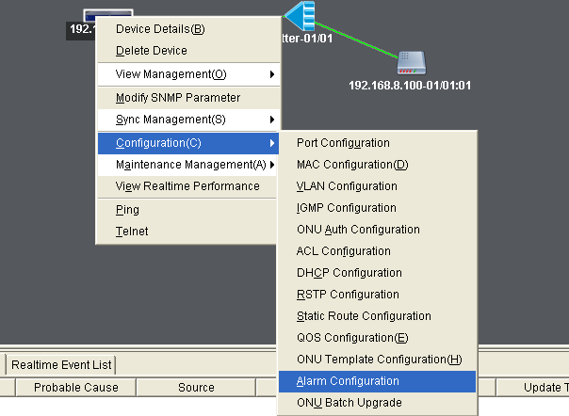
Click “PON Optical Alarm”. The PON alarm can be configured, contain transmit power、vcc、bias、tempereture high and low alarm.

Figure 6-82 PON optical alarm configuration
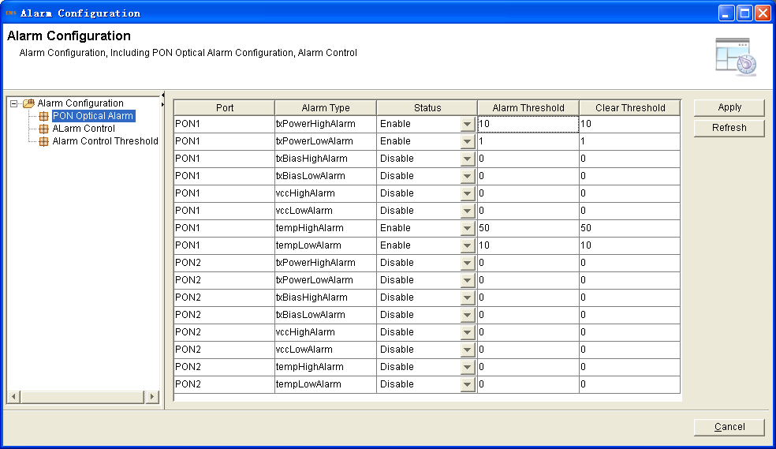
Click “Alarm Control”, it is about the OLT system global alarm configuration and the ONU global alarm.
Figure 6-83 Alarm control configuration
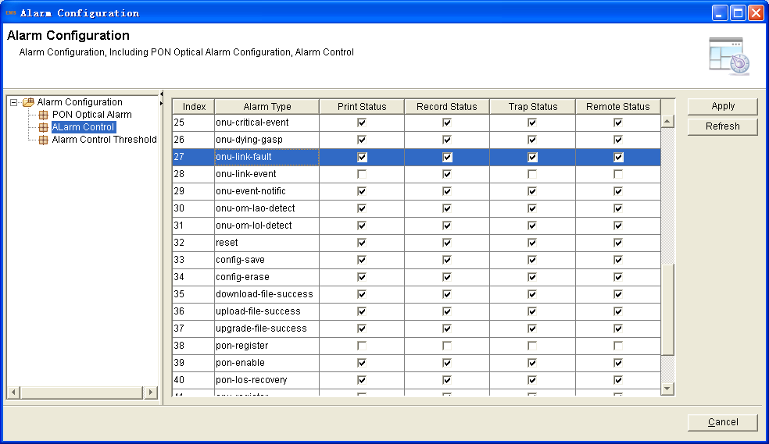
Click “Alarm Control Threshold”.
Figure 6-84 Alarm control threshold configuration
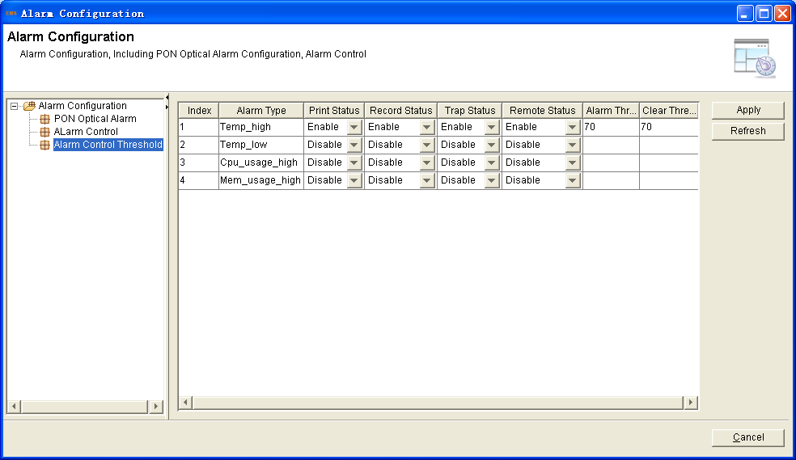
- ONU Batch Upgrade
Upgrade a good supply of ONUs，the upgraded ONUs should be the same type.
1. Right click OLT, select "Configuration">"ONU Batch Upgrade" to enter the upgrade ONUs interface.
Figure 6-85 Enter ONU upgrade interface
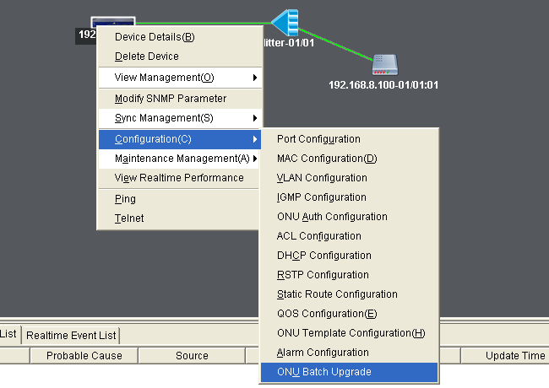2. Fill in the firmware name and the TFTP server IP address>click “Select”>select the ONUs you want to upgrade>click “commit”.
Figure 6-86 Fill in the upgrade parameters
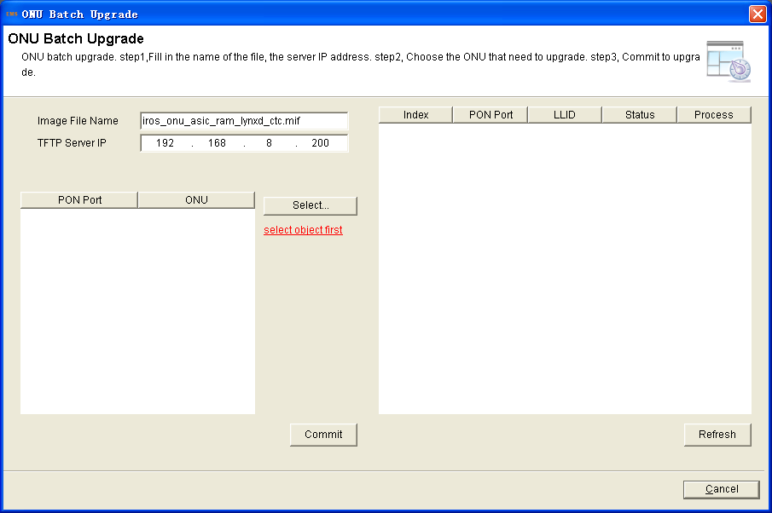
Figure 6-87 Select the ONUs
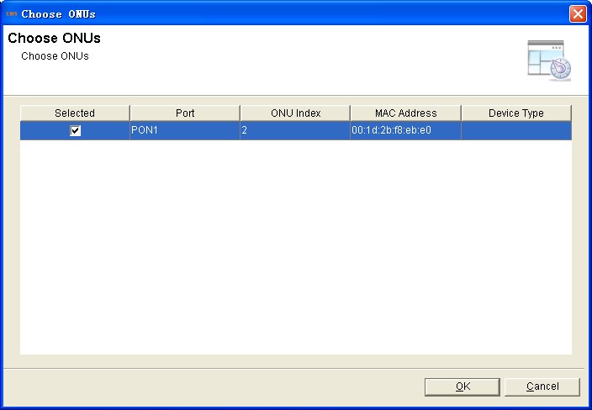

Chapter7 ONU Management
This chapter mainly introduces the ONU management function of EMS
- ONU System Configuration
- ONU Details
ONU detail interface is used for manage and control ONU.
Right click ONU, select "ONU Details" to enter ONU info interface>click “Stream Limite Configuration” to configure the ONU global stream limit>click “Management IP” to configure remote IP.
Figure 7-1 Location of ONU global configuration
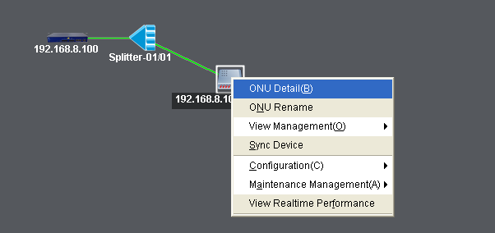

Figure 7-2 ONU basic information
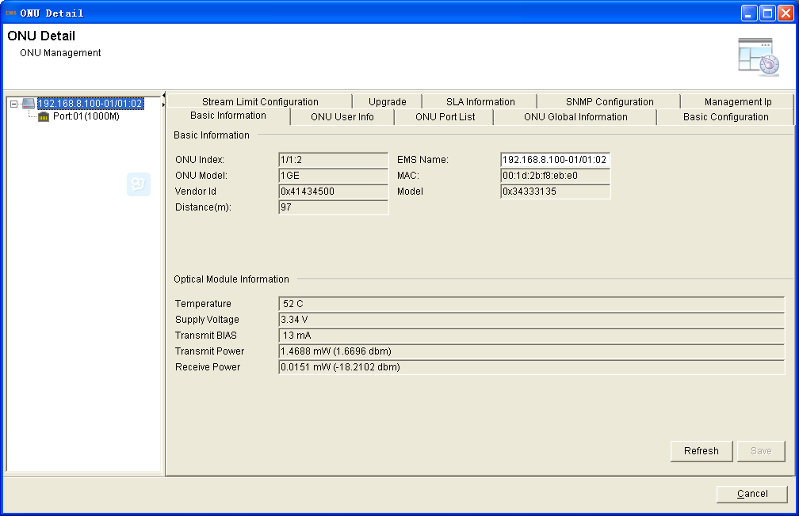
Figure 7-3 ONU global stream limit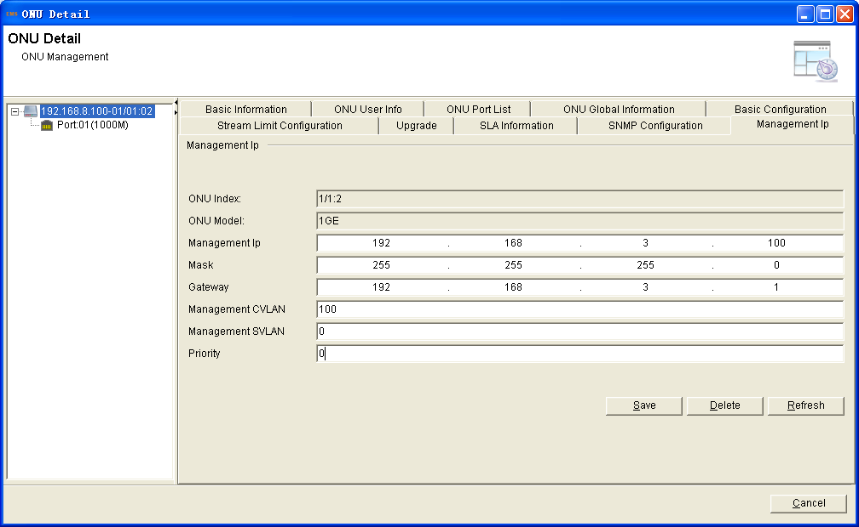

Figure 7-4 ONU management IP
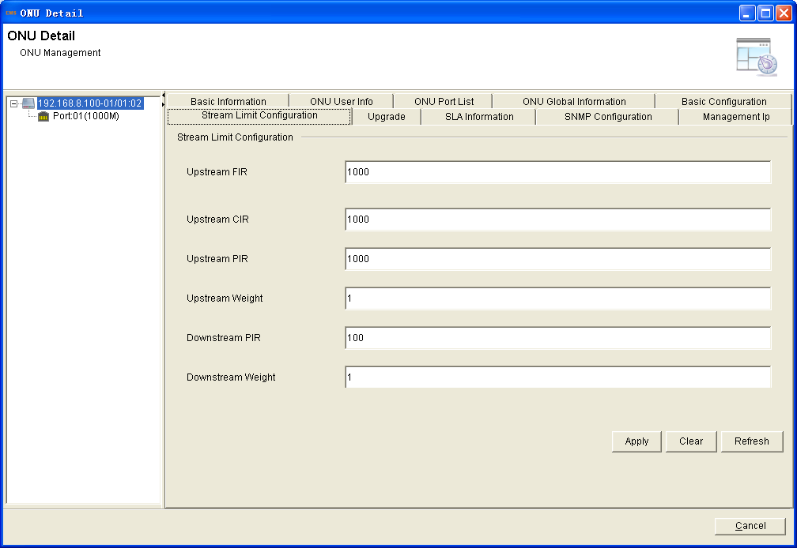
- ONU Rename
This operation is used for set or modify ONU’s name.
1. Right click ONU, select "ONU Rename" to enter rename interface.

Figure 7-5 Location of ONU rename
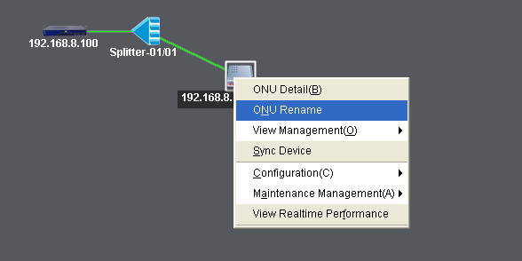
2. Enter a new label and click "OK" to complete setup.
Figure 7-6 ONU rename configuration
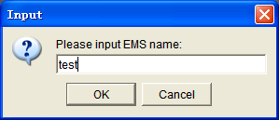
3. In the domain logic topology graph and in the "ONU Details" menu, and in the left side tree, the ONU’s EMS name has become the new name.
Figure 7-7 show ONU new name
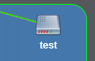
- Private OAM Maintain
This section is about the private OAM configuration of V-SOL’s ONUs. It contains load manufactory default、clean MAC address list amd save onu configuration.
Figure 7-8 Private OAM maintain
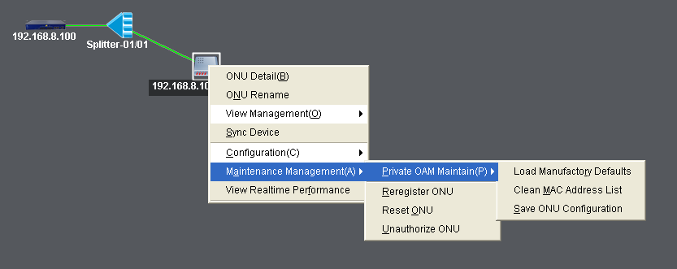
- Reregister ONU
This operation is used for force ONU to re-register.
1. Right click ONU, select "Maintenance Management ">"Reregister ONU" to enter re-register ONU interface.

Figure 7-9 Location of ONU reregister
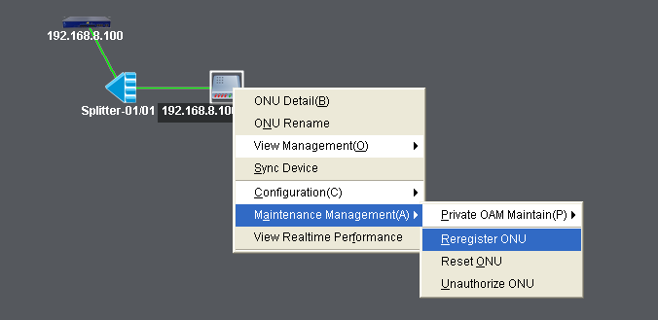
2. When ONU reregister successful, rolling log bar will display the prompt message.
- Reset ONU
This operation is used for reset ONU. After reboot, the ONU will register again.
The operation will cause ONU's user service interruption, take care operation.
1. Right click ONU, select "Maintenance Management ">"Reset ONU", enter dialog box, click "Yes" will carry out the ONU reset action.

Figure 7-10 Location of ONU reset
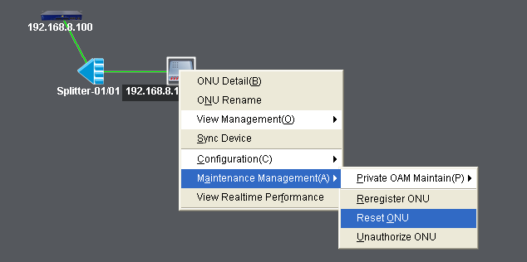
2. Some log will display the prompt message when the ONU reset successfully.
- Unauthorized ONU
This operation is used for un-authorized ONU.
If you do this operation, the ONU will delete the registration information.
1. Right click ONU, select "Maintenance Management ">"Unauthorized ONU" to unauthorized ONU.

Figure 7-11 Location of ONU un-authorized
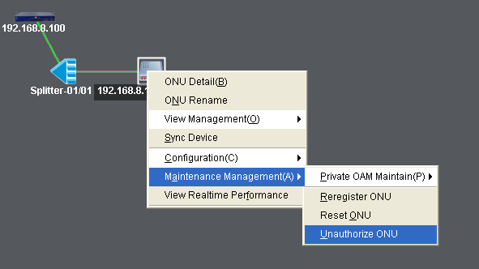
Figure 7-12 ONU unauthorized operating dialog
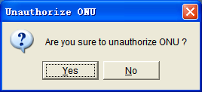
2. The results of un-authorization will be real-time displayed in the message box.
- ONU Port Configuration
- Port Basic Configuration
This operation is used for configure related functions and characteristic parameters of ONU port, which is mainly used for set Ethernet parameters, flow control, auto negotiation, Loop detection etc.
1. Right click ONU, select "Configuration">"ONU Port Configuration"to enter port parameters list interface.
Figure 7-13 Location of ONU port basic configuration
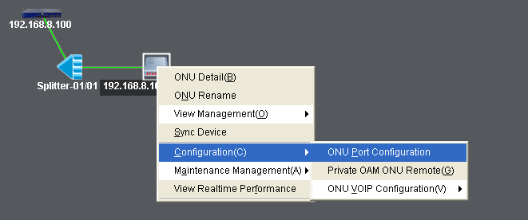
Figure 7-14 ONU port basic configuration
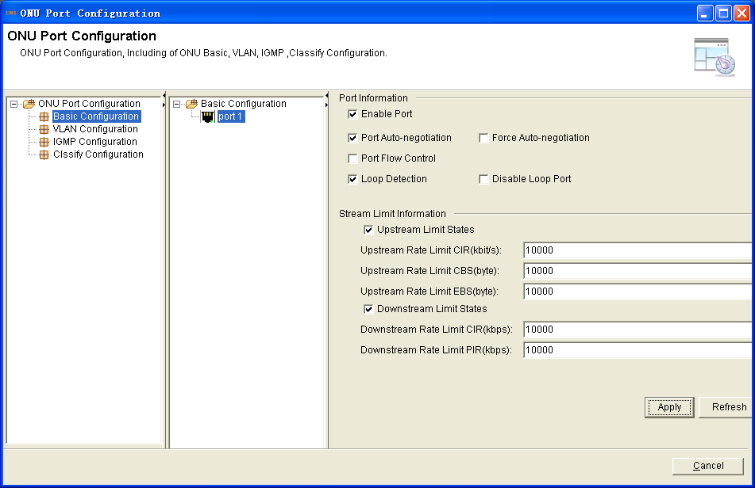
2. Select one port, modify the basic information.
- Enable Port: Used for enable or disable port
- Port Auto-negotiation: It is used for enable or disable auto negotiation of the uplink port. After enable, the port will negotiate with the connected port to reach the largest possible transmission rate.
- Force Auto-negotiation: Force port auto-negotiation again
- Flow control: Used for enable or disable the flow control function of uplink port to control congestion. The default is "disable".
- Loop Detection: Used for enable or disable port loop detection function
- Disable Loop Port: Disable the port of Loop port
- Upstream Limit: ONU port upstream bandwidth limit
- CIR: Committed Information Rate
- CBS: Committed Burst Size
- EBS: Excess Burst Size
- Downstream Limit: ONU port downstream bandwidth limit
- CIR: Committed Information Rate
- PIR: Peak Information Rate
Click "Apply ", to Save Configuration of the ONU device.
- Port VLAN Configuration
This operation is used for configure ONU port VLAN mode.
ONU supports five port VLAN modes: Transparent mode, Tag mode, Trunk mode, Translate mode, Aggregation mode.
Right click ONU, select "Configuration">"ONU Port Configuration"> to enter port VLAN configuration interface.
Figure 7-15 Location of ONU port VLAN configuration
- Transparent Mode
In this mode, upstream or downstream Ethernet packet will get through this port directly.
1. Select transparent mode.
Figure 7-16 ONU port VLAN transparent mode configuration
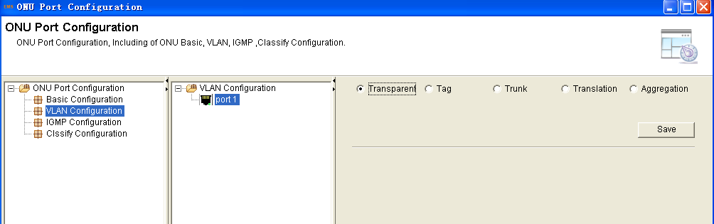
2. Click "Save", apply to the ONU device.
- Tag Mode
The method of an ONU port under tag mode process an Ethernet packet is shown in Table 7-1:
Direction | VLAN tag | Operation
Upstream | Yes | Discard this packet
 | No | Add default VLAN Tag to this packet
Downstream | Yes | If the VID is not equal to default VLAN ID, discard this packet. Otherwise strip the VLAN Tag of this packet.
 | No | Discard this packet
Select tag mode, and click the “save” button.
Figure 7-17 ONU port VLAN tag mode configuration
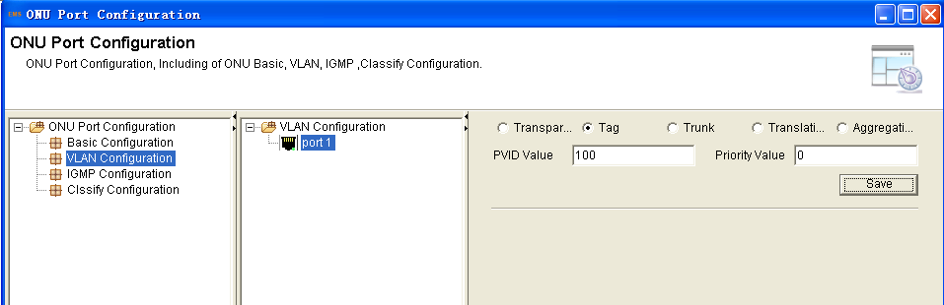
1. Set the PVID and the VLAN priority
PVID: default VLAN ID
2. Click "Save ", apply to the ONU device.
- Trunk Mode
Direction | VLAN tag | Operation
Upstream | Yes | If the packet’s VID exist in the VLAN Trunk allow list or equal to the port default VLAN ID, forward this packet, otherwise discard this packet.
 | No | Add default VLAN Tag to this packet and forward this packet.
Downstream | Yes | If the packet’s VID equal to the port default VID, strip the VLAN Tag of this packet and forward this packet.  If the packet’s VID not equal to the port default VID but exist in the VLAN Trunk allow list, forward this packet.  If the packet’s VID not equal to the port default VID and not exist in the VLAN Trunk allow list, discard this packet.
 | No | Discard this packet
1. Select Trunk mode, and click the “save” button.

Figure 7-18 ONU port VLAN trunk mode configuration
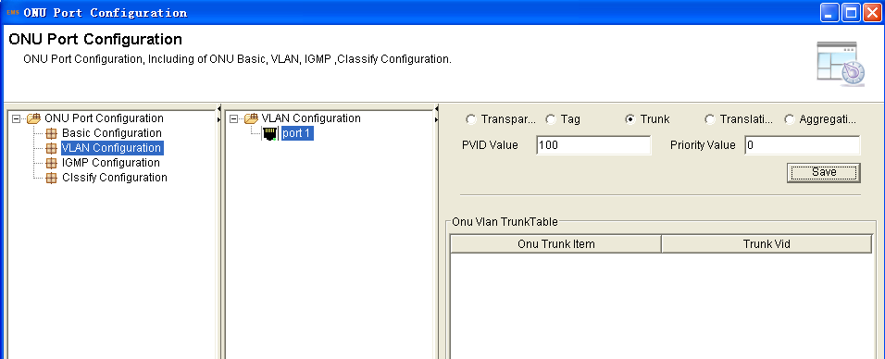
2. Click “Add” button and add a new VLAN ID.
Figure 7-19 Add a new VLAN
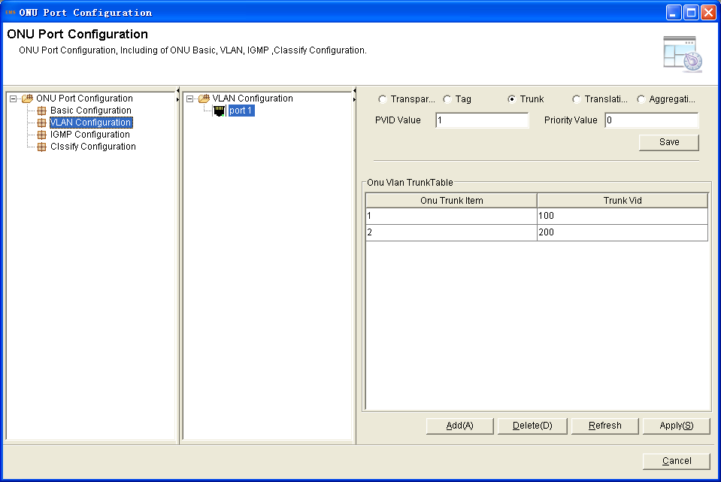
3. Click "Apply ", apply to the ONU device.
- Translation Mode
Translation mode allows the port overwrites VLAN tag.
The method of an ONU port under translation mode process an Ethernet packet is shown in table 7-3:
Direction | VLAN tag | Operation
Upstream | Yes | If the VID of a packet equal to the CVLAN ID of a certain translation entry, overwrite the packet’s VID with this entry’s SVLAN ID and forward this packet;  If the VID of a packet is not equal to any translation entry’s CVLAN ID, discard this packet.
 | No | Add default VLAN Tag to this packet and forward this packet.
Downstream | Yes | If the VID of a packet equal to the SVLAN ID of a certain translation entry, overwrite the packet’s VID with this entry’s CVLAN ID and forward this packet;  If the VID of a packet is not equal to any translation entry’s SVLAN ID, discard this packet.
 | No | Discard this packet
1. Select translation mode and click the “save” button.
Figure 7-20 ONU port VLAN translation mode configuration
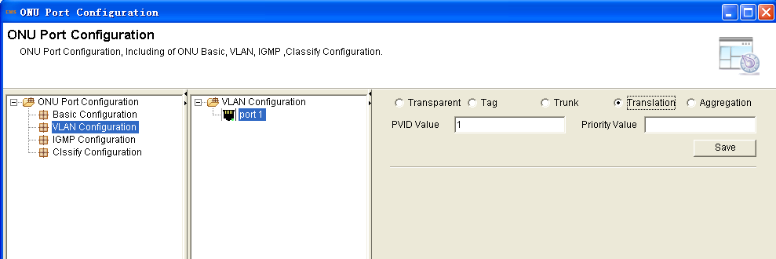
2. Click “Add” button and add a new VLAN translation rule.

Figure 7-21 Add a new VLAN translation rule
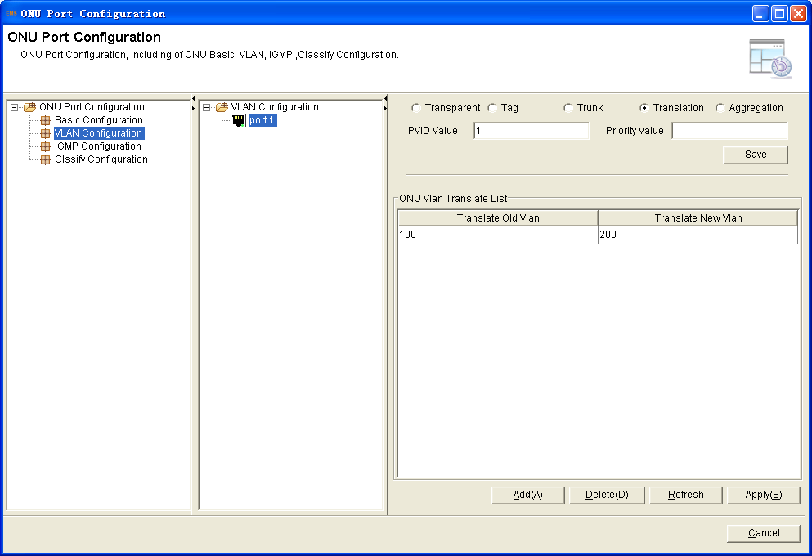
3. Click "Apply ", apply to the ONU device.
- Aggregation Mode
Aggregation mode allows multi VLAN of port can overwrites VLAN tag.
The method of an ONU port under aggregation mode process an Ethernet packet is shown in Table 7-4:
Direction | VLAN tag | Operation
Upstream | Yes | If the VID of a packet equal to the CVLAN ID of a certain translation entry, overwrite the packet’s VID with this entry’s SVLAN ID and forward this packet;  If the VID of a packet is not equal to any translation entry’s CVLAN ID, discard this packet.
 | No | Add default VLAN Tag to this packet and forward this packet.
Downstream | Yes | If the VID of a packet equal to the SVLAN ID of a certain translation entry, overwrite the packet’s VID with this entry’s CVLAN ID and forward this packet;  If the VID of a packet is not equal to any translation entry’s SVLAN ID, discard this packet.
 | No | Discard this packet
1. Select aggregation mode and click the “save” button

Figure 7-22 ONU port VLAN aggregation mode configuration.
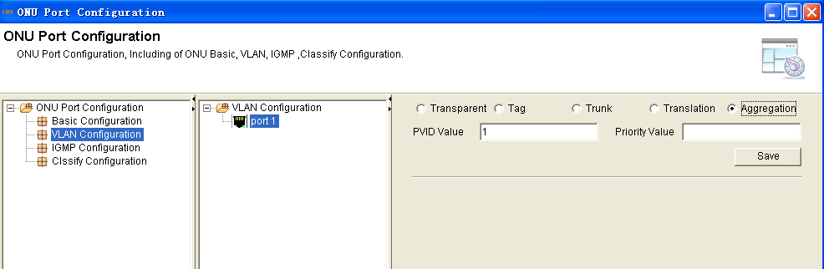
Figure 7-23 Add a new VLAN aggregation rule
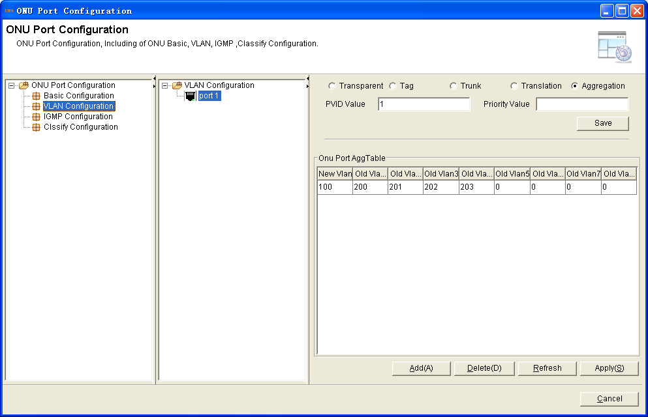
3. Click "Apply ", apply to the ONU device.
- Port IGMP Configuration
This operation is used for configure ONU port IGMP parameter.
Right click ONU, select "Configuration">"ONU Port Configuration">"IGMP Configuration" >select port number to enter port IGMP configuration interface.
Figure 7-24 Location of ONU port IGMP configuration
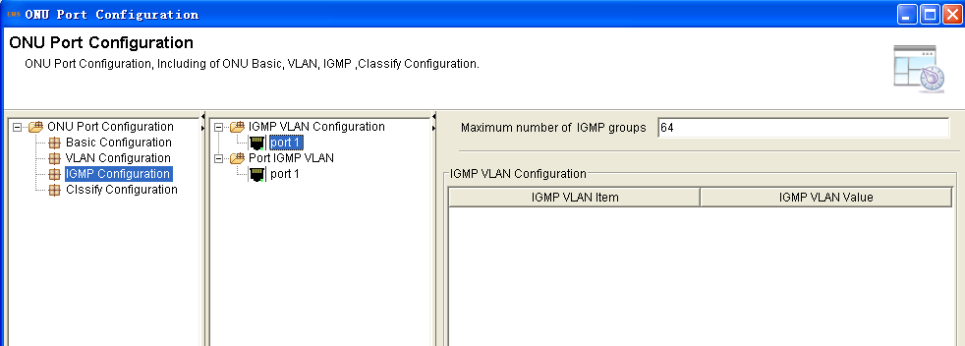
Figure 7-25 ONU port IGMP configuration
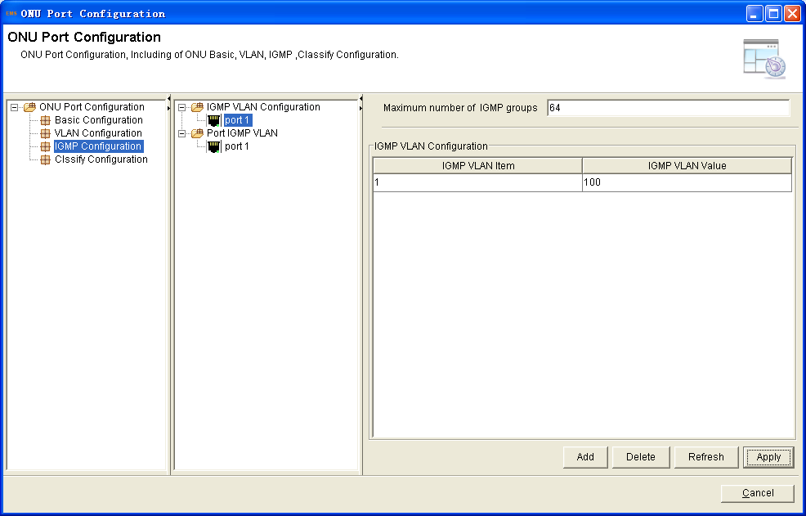
- Maximum number of IGMP groups: used for configure how many multicast groups this ONU port can join in.
- IGMP VLAN configuration: set multicast VLAN for the port.
Set the port multicast VLAN mode
Figure 7-26 ONU port VLAN mode configuration
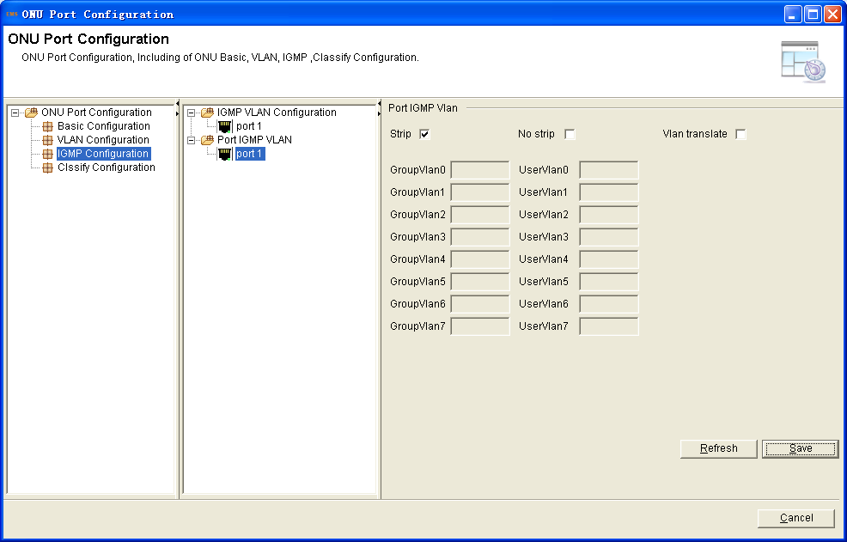
The method of an ONU port under mode process a multicast packet is show in Table 7-5:
Mode | Operation
strip | Multicast stream sent this port does not contain a multicast VLAN Tag.
No strip | Multicast stream sent this port still contains a multicast VLAN Tag.
Translate | Multicast stream sent this port the group VLAN change to user VLAN.
- Classify Configuration
QoS function includes data stream classification and mark. Customers can mark different streams by priority according to different rules.
This OLT supports these matchable conditions: VLAN ID, Ethernet type, priority, IP type,ToS, IP Precedence, layer 4 port, IP address, MAC address, and so on.
1. Right click ONU, select "Configuration">"ONU Port Configuration"> to enter port configuration interface.
Figure 7-27 ONU port configuration
2. Click “Classify Configuration”>select the port>click “Add”.
Figure 7-28 ONU port configuration
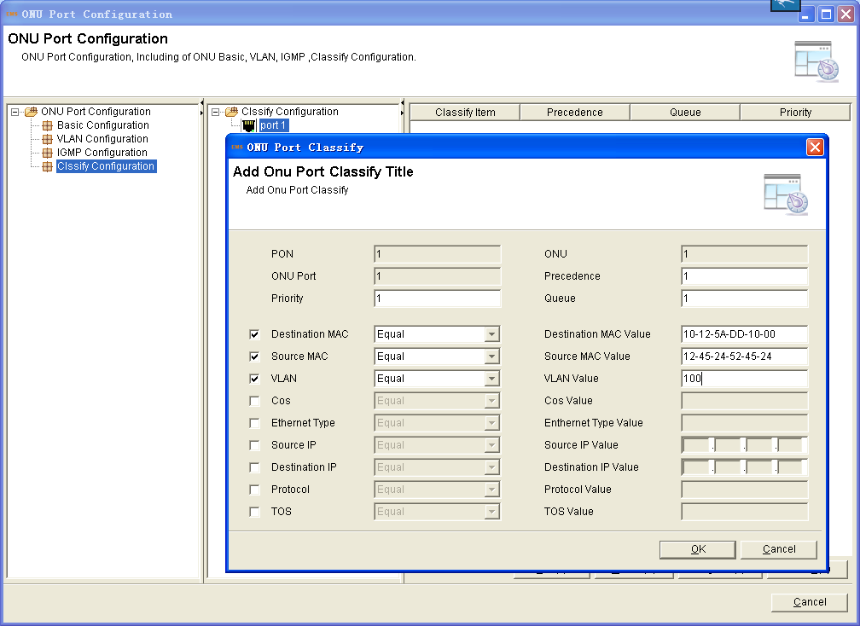
- ONU VoIP Configuration
This section is configuration the voice in the ONU. First, the ONU should support VoIP function. When the ONU connect to OLT, it will be identified by the OLT whether the ONU support VoIP. If the OLT identify it with this funxtion, there is an bar to select VoIP configuration.
Figure 7-29 Select ONU VoIP configuration
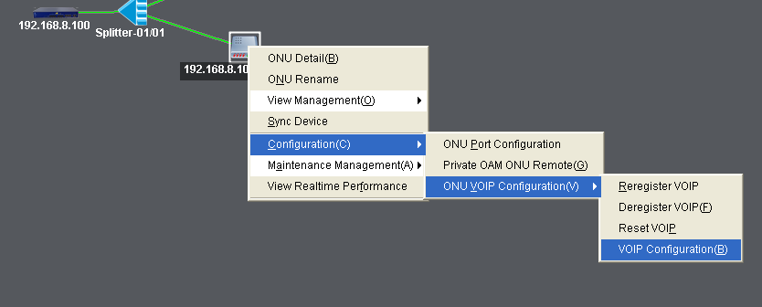
1. Click the “VoIP Configuration” button, access to the VoIP configuration interface. Fill in the SIP proxy server and the register server IP address.
Figure 7-30 SIP server configuration
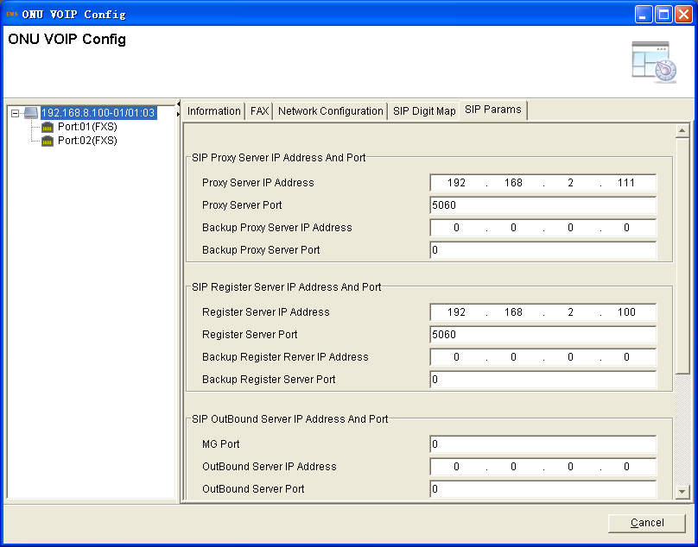
2. Click “VoIP Basic Info” at the top of the interface, confiure the networkfor the voice service. Choose the VLAN mode and the network mode.
Figure 7-31 Voice neteork configuration
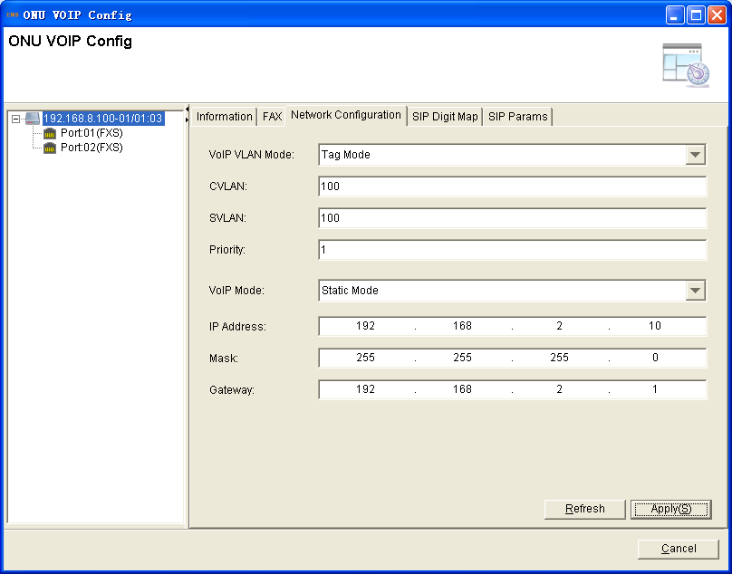
2. About the phone base configuration, Click“Port 01”in the left tree of the interface. Fill in the phone information, about the account、username、password.

Figure 7-32 FXS base configuration
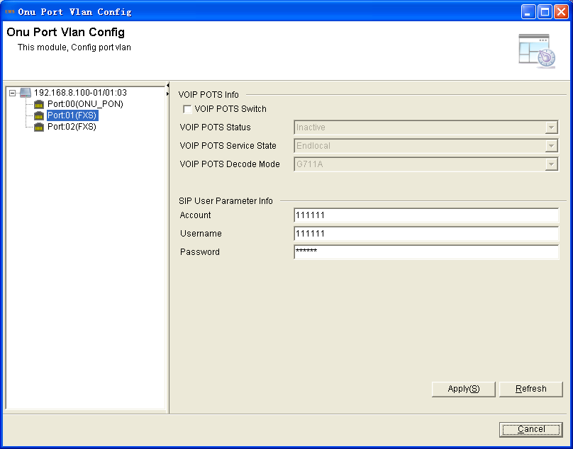

Chapter8 Service Configuration
This chapter mainly introduces how to configure the service using the EMS.
- Network Topology
Figure 8-1 Three services network topology
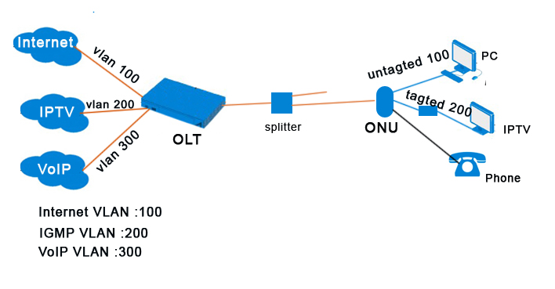
For example:
OLT is 8 PON OLT, Configuration of three services, configuration as shown.
If your product is 2 PON OLT or 4 PON OLT, please refer to the following configuration

- Service Configuration
- OLT Configuration
1. Create services VLAN, binding Uplink ports and PON ports.
Right click OLT, select "Configuration">"VLAN Configuration">"VLAN Configuration" to enter port list interface.
Figure 8-2 Location of VLAN configuration
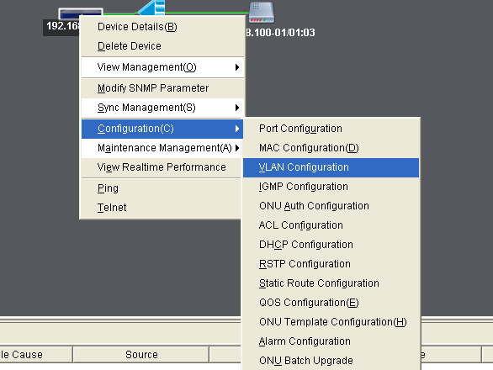

Create VLAN 100, binding 8 GE Copper and 8 PON port.
Figure 8-3 VLAN 100 binding port
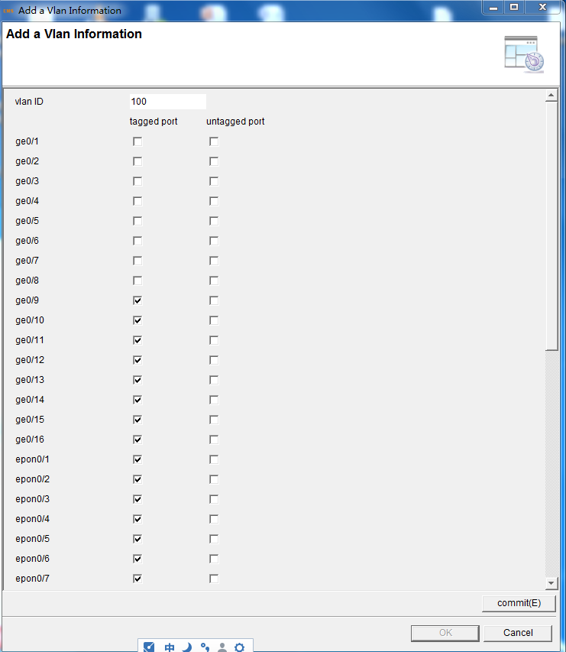

In the same way, create VLAN 200 and VLAN 300.
Figure 8-4 VLAN 200 binding port
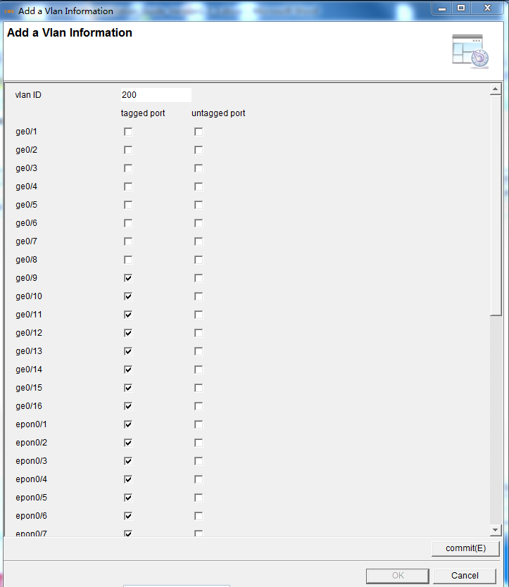

Figure 8-5 VLAN 300 binding port
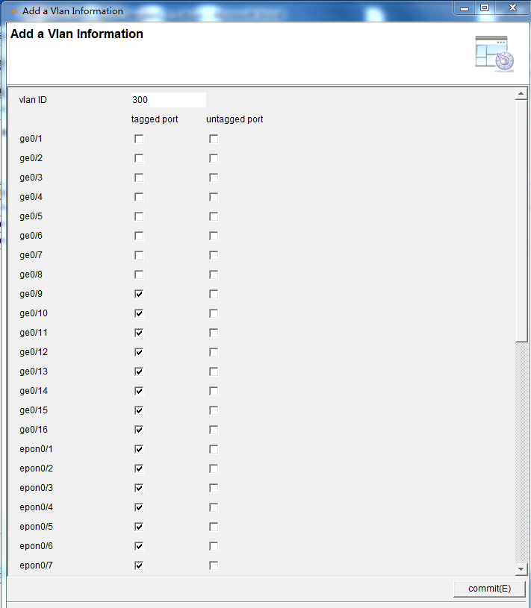

Please click the “refresh” button, confirm the VLAN configuration.
Figure 8-6 show VLAN table
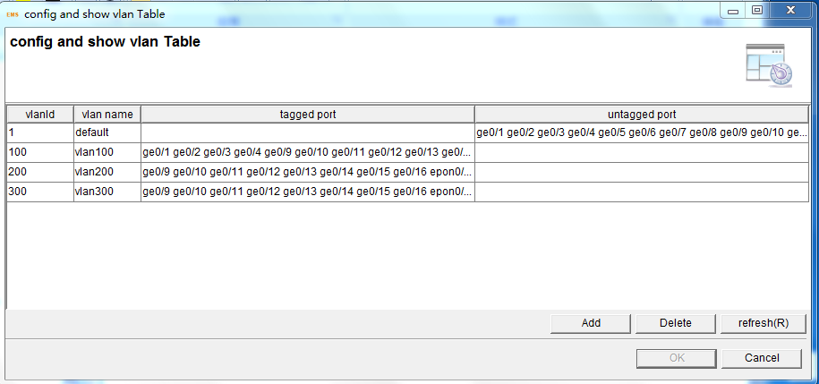
2. OLT IGMP Configuration
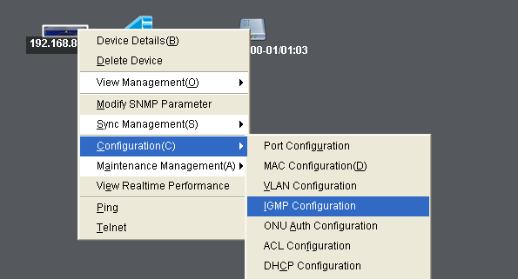
Please press refresh button to read the latest configuration, and enable IGMP snooping mode
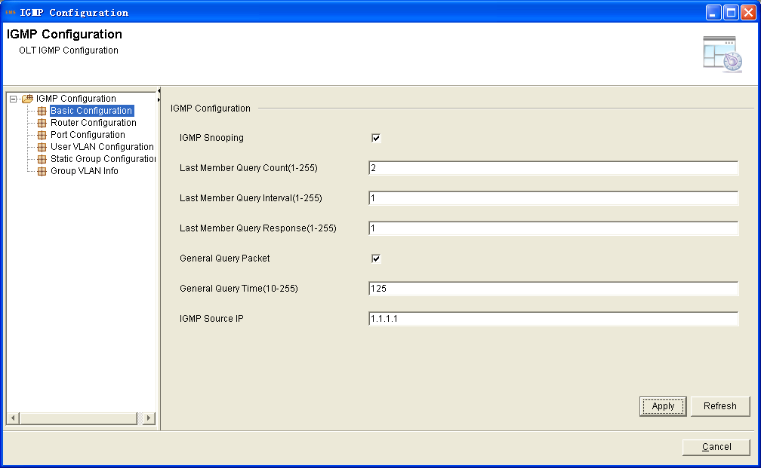
Setting OLT multicast Router port and VLAN
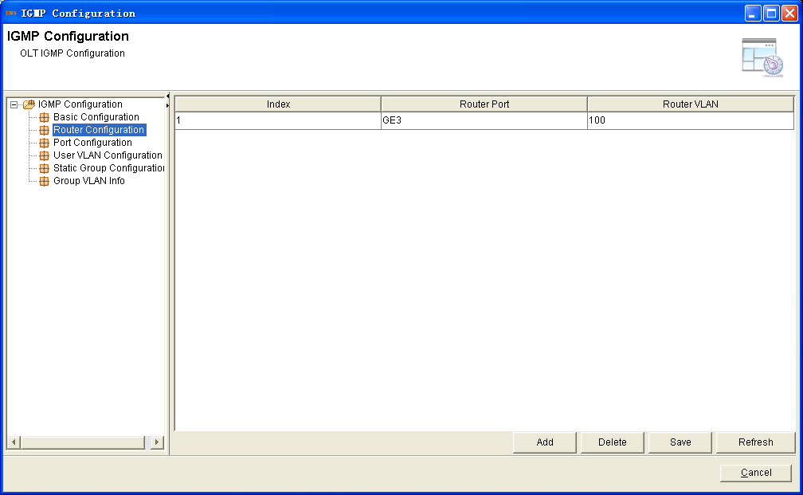
Setting the OLT port multicast tag or untag
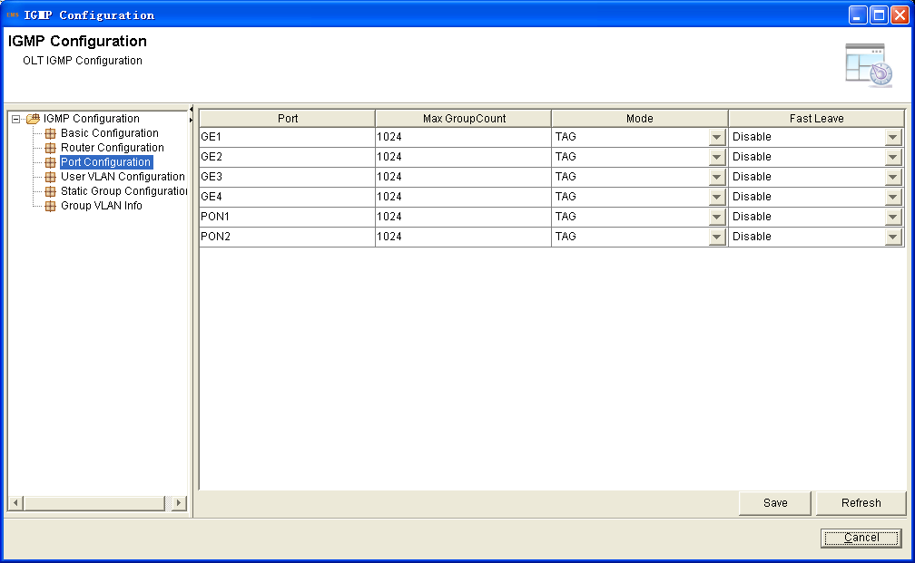
Setting the multicast user VLAN and group VLAN]
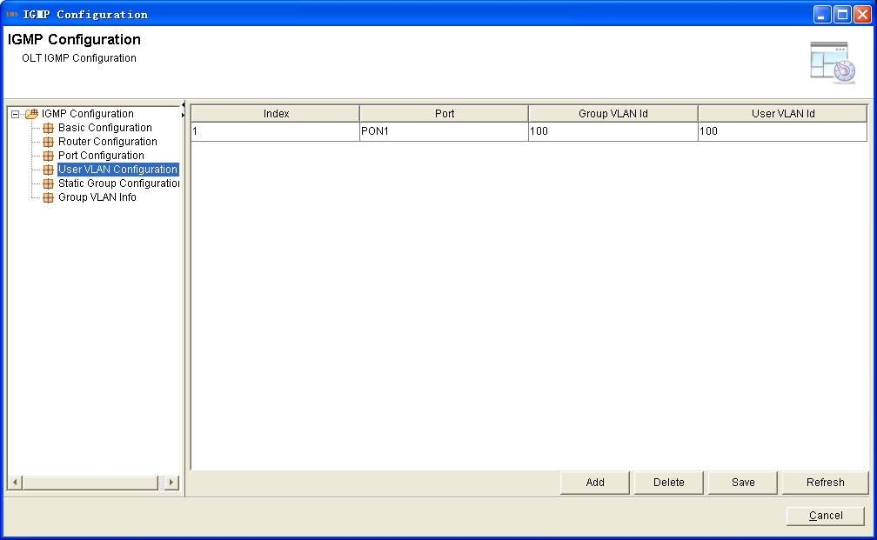

- ONU Configuration
1. ONU port VLAN configuration
Right click ONU, select "Configuration">"ONU Port Configuration">" VLAN Configuration" to enter port VLAN configuration interface.
Figure 8-7 port VLAN configuration
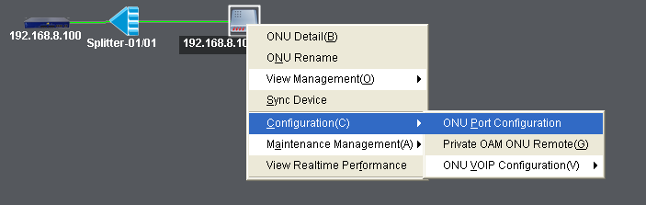
Internet service: ONU LAN port 1/3/4
IPTV service: ONU LAN port 2
Port configuration is as follows:
Figure 8-8 Port VLAN configuration
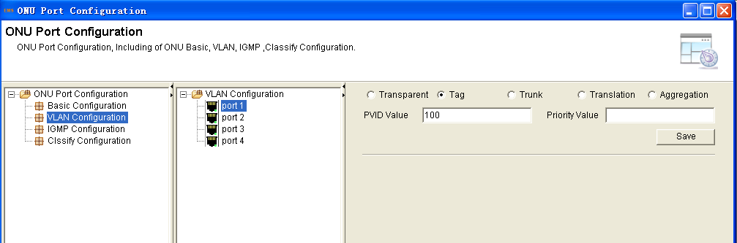
2. ONU port IGMP configuration
Right click ONU, select "Configuration">"ONU Port Configuration">"IGMP Configuration" to enter port IGMP configuration interface.
Figure 8-9 Location of ONU port IGMP configuration
Select port 1 from ports list.
Figure 8-10 Select port 2
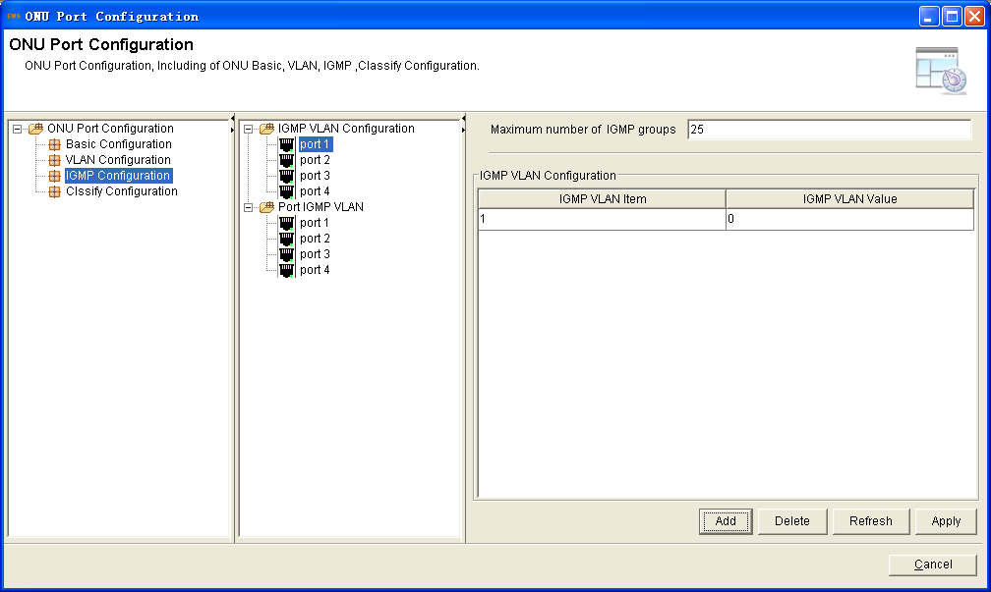
Click “Add” button, add a new IGMP VLAN 200.
Figure 8-11 Add an IGMP VLAN
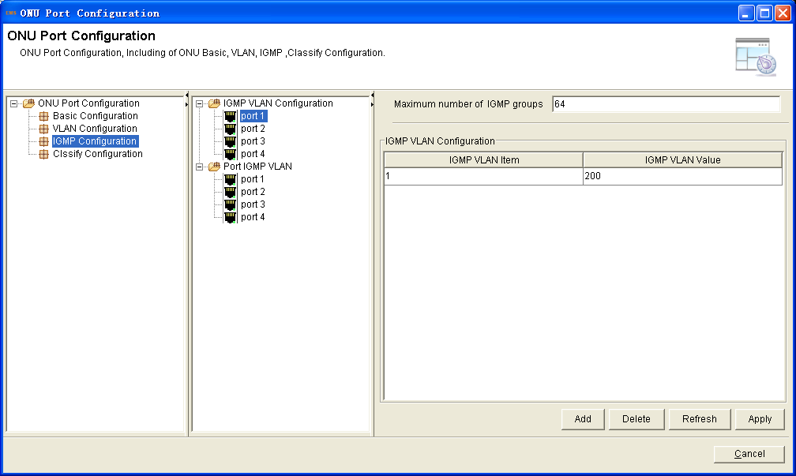
Click “Port IGMP VLAN”,set the port multicast VLAN mode.
Figure 8-12 Port multicast VLAN mode
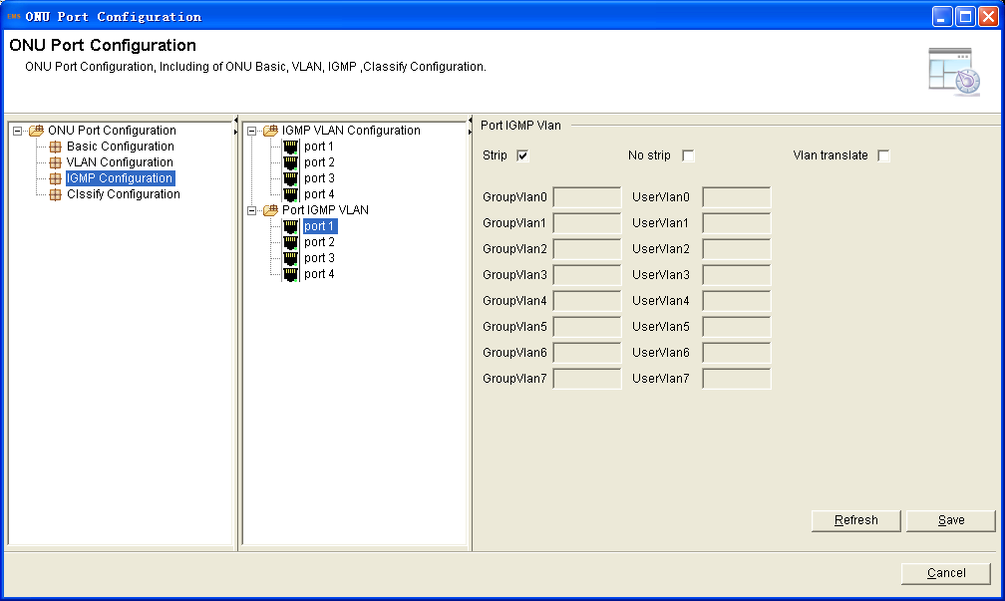
In this case, the configuration of the services completed.

End of the document.
Thank you

