Overview
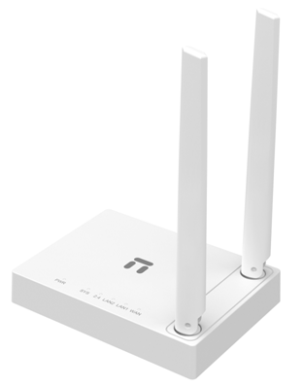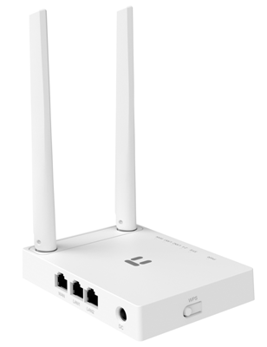
The router offers 300Mbps high speed to connect your computers, smartphones, wireless cameras and other Wi-Fi devices. Bundled with two high gain antennas, it ensures a better wireless coverage and allows you to enjoy the wireless freedom anywhere around your home, ideal for faster downloading, Internet calling and HD video streaming.

Features
- Incredible wireless high speed up to 300Mbps, great for faster downloading, Internet calling and HD video streaming
- MIMO high gain antennas providing maximum range and stable connections
- Dual operation modes- Router, Bridge (pure access point)
- Various WAN connection types in AP Router mode- DHCP, Static IP, PPPoE, L2TP, PPTP, Dual Access, WISP
- Multiple wireless modes- AP, Repeater, AP+WDS, WDS, Client
- Multi-SSID providing up to 3 additional separate networks for guests and friends
- Easy wireless security setup at a push of the WPS button
- Intelligent bandwidth control to manage the bandwidth usage for each computer reasonably
- Internet Access Control- IP filtering, MAC Filtering, Domain Filtering based on time
- Quick setup, with built-in multilingual management page

Specification
Wireless
Standards | IEEE 802.11b, IEEE 802.11g, IEEE 802.11n
Signal Rate | Up to 300Mbps
Frequency Range | 2.4-2.4835GHz
Transmit Power | 20dBm(MAX)
Data Transfer Rates | 802.11n:  40MHz(300Mbps, 270Mbps, 240Mbps, 180Mbps, 120Mbps, 90Mbps, 60Mbps, 30Mbps)  20MHz (144Mbps, 130Mbps, 115Mbps, 86Mbps, 57Mbps, 43Mbps, 28Mbps, 14Mbps) (Auto-Sense)  801.11g:  (54Mbps, 48Mbps, 36Mbps, 24Mbps, 18Mbps, 12Mbps, 11Mbps, 9Mbps, 6Mbps)  802.11b:  (11Mbps,9Mbps, 6Mbps, 5.5Mbps, 2Mbps, 1Mbps)
Wireless Modes | AP, Repeater, AP+WDS, WDS, Client, Multi-SSID
Wireless Security | 64/128-bit WEP,  WPA-PSK/WPA2-PSK (TKIP/AES)  SSID Broadcast Enable/Disable  Wireless MAC Filtering

Hardware
Chipset | RTL8196D+RTL8192ER
DRAM/Flash | 32MB/4MB
Standards | IEEE 802.3 10Base-T, IEEE 802.3u 100Base-TX
Interfaces | 1 * 10/100Mbps Auto MDI/MDIX RJ45 WAN port  2 * 10/100Mbps Auto MDI/MDIX RJ45 LAN port
LED Indicators | PWR, SYS,2.4G, LAN2-1, WAN,
Buttons | WPS/Default in one button
Antennas | 2* Fixed High gain Antenna
Power Supply | DC 9V/500mA (Output)
Dimensions(L x W x H ) | 115x 86 x25mm

Software
WAN Type | DHCP, Static IP, PPPoE, L2TP, PPTP, Dual Access, WISP
Port Forwarding | Virtual Servers, Port Triggering, UPnP, DMZ, FTP Private Port
QoS | WMM, Bandwidth Control
Access Control | IP/MAC/Domain Filtering
VPN Pass-through | PPTP, L2TP, IPSec
Others | Dynamic DNS, Static Routing, WOL, Backup & Restore, Firmware Upgrade

Others
Certification | FCC, CE
Environment | Operating Temperature: 0℃~40℃  Storage Temperature: -40℃~70℃  Operating Humidity: 10%~90% non-condensing  Storage Humidity: 5%~90% non-condensing
Package | 1* device  1* 9V/500mA Power Adapter  1* Quick Installation Guide(Multilingual)

