Optical Line Terminal Equipment

Element Management System

User Manual

Version 1.6

Thank you for choosing our products.

Preface

Revision History
Version | Revision date | Revision Reason
V1.1 | 15/10/2015 | First edition.
V1.2 | 12/12/2015 | Content updates.
V1.3 | 26/2/2016 | Add New functions.
V1.4 | 29/4/2016 | New layout.
V1.5 | 7/7/2017 | New layout and new Graphical User Interface.
V1.6 | 15/8/2017 | Add GPON—V1600G1 functions.
The element management system is an integrated broadband access management platform, which can perform the effective and unified management of multiple types of broadband access equipment developed.
This manual mainly introduces the installation and basic configuration both of the GPON and EPON OLT’s element management system. It aims to help users in understanding the equipment’s technologies, functions and practical application capacity and to provide technical support for the users.

Intended Readers
This manual is intended for the following readers:
- Commissioning engineers
- Operation and maintenance engineers
To utilize this manual, these prerequisite skills are necessary:
- Access network technology
- EPON principles
- Ethernet switch technology
- Computer network technology
- Symbol Conventions
- GPON network technology
The symbols that may be found in this document are defined as follows.
Symbol | Class | Description
 | Notice | Indicates a potentially hazardous situation, which if not avoided, could result in equipment damage, data loss, performance degradation, or unexpected results.
 | Warning | Indicates a hazard with a medium or low level of risk, which if not avoided, could result in minor or moderate injury.
 | Note | Provides additional information to emphasize or supplement important points of the main text.

List of Glossary
AUX | Auxiliary
CATV | Cable Television
CFI | Canonical Format Indicator
CIR | Committed Information Rate
CLI | Command Line Interface
CoS | Class of Service
CVLAN | Customer VLAN
DA | Destination Address
DBA | Dynamic Bandwidth Allocation
DHCP | Dynamic Host Configuration Protocol
DNS | Domain Name System
EMS | Element Management System
EPON | Ethernet Passive Optical Network
FE | Fast Ethernet
FEC | Forward Error Correction
FIR | Fixed Information Rate
GE | Gigabit Etherent
HGU | Home Gateway Unit
IAD | Integrated Access Device
IGMP | Internet Group Management Protocol
IMS | IP Multimedia Subsystem
IP | Internet Protocol
IPTV | Internet Protocol Television
LOID | Logical ONU Identifier
LoS | Loss of Signal
MAC | Medium Access Control
MDU | Multi-Dwelling Unit
MIB | Management Information Base
MPCP | Multi-point control protocol
OAM | Operation,Administration & Maintenance
ODN | Optical Distribution Network
OLT | Optical Line Terminal
OMA | Optical Modulation Amplitude
ONT | Optical Network Terminal
ONU | Optical Network Unit
PIR | Peak Information Rate
PON | Passive Optical Network
POTS | Plain Old Telephone Service
PPPoE | Point-to-Point Protocol over Ethernet
QoS | Quality of Service
SFU | Single Family Unit
SIP | Session Initiation Protocol
SN | Serial Number
SNMP | Simple Network Management Protocol
SP | Strict Priority
SVLAN | Service VLAN
UCT | Un-condition transition
UDP | User Datagram Protocol
UNI | User Network Interface
VLAN | Virtual Local Area Network
VoIP | Voice over IP
WLAN | Wireless Local Area Network
WRR | Weighted Round Robin
GPON | Gigabit-Capable Passive Optical Network
OMCI | ONU Management and Control Interface
TCONT | Transmission Container
GEM | G-PON Encapsulation Mode

Contents
Preface I
Revision History I
Intended Readers I
List of Glossary III
Contents VI
1 System Description 1
1.1 Interface Types 1
1.2 Working Mode 1
1.3 Installation Requirements 2
1.4 EMS Installation Files 3
2 EMS Installation 4
2.1 Installation of the Server 4
2.2 Installation of the Client 8
3 EMS Quick Start 12
3.1 Preparatory Work 12
3.2 Starting Sequence 13
3.3 Frame Introduction 14
3.4 Add OLT Device 17
3.5 Scan Device 20
3.6 Delete Device 21
3.7 Add Splitter 22
4 Security Management 25
4.1 User Management 25
4.2 Role Management 27
4.3 Permission Management 29
4.4 Online User 30
4.5 Operation Log 31
5 EMS System Management 33
5.1 Lock Client 33
5.2 Modify Password 34
5.3 Database Backup and Restore 34
5.4 Exit System 35
6 OLT Management 36
6.1 OLT Basic Information 36
6.2 System Configuration 37
6.2.1 OLT Upgrade 38
6.2.2 ONU Upgrade--EPON 40
6.2.3 Config File 41
6.2.4 Configure Aux Port 42
6.2.5 DNS Parameter 43
6.2.6 System Time 44
6.2.7 FAN Configuration 46
6.2.8 System Mirror 46
6.3 OLT Configuration 47
6.3.1 VLAN Configuration 48
6.3.1.1 VLAN Port 49
6.3.1.2 QinQ/Translation 51
6.3.2 Port Configuration 51
6.3.2.1 Uplink Port Traffic Statistics 51
6.3.2.2 Uplink Port Configuration 52
6.3.2.3 PON Port Traffic Statistics 55
6.3.2.4 PON Ports Configuration 55
6.3.3 MAC Configuration 57
6.3.3.1 MAC Table 57
6.3.3.2 Aging Time 58
6.3.3.3 Port MAC Limit 59
6.3.4 LACP Configuration 60
6.3.5 QoS Configuration 61
6.3.6 ACL Configuration 64
6.3.6.1 Standard IP Filter 65
6.3.6.2 Extend IP Filter 66
6.3.6.3 MAC Filter 67
6.3.6.4 Base Port Filter 68
6.3.6.5 Base QoS Filter 69
6.3.6.6 Effect Filter 70
6.3.7 IGMP Configuration 71
6.3.7.1 Group Member 71
6.3.7.2 IGMP Basic Configuration 72
6.3.7.3 Port Mroute 73
6.3.7.4 IGMP Port Configuration 74
6.3.7.5 Multicast VLAN 75
6.3.7.6 Port User VLAN 76
6.3.7.7 Static Group 77
6.3.8 RSTP Configuration 78
6.3.8.1 Global Information 78
6.3.8.2 Global Configuration 79
6.3.8.3 Port Information 80
6.3.8.4 Port Configuration 81
6.3.9 DHCP Configuration 82
6.3.9.1 Server Configuration 82
6.3.9.2 Lease Table 83
6.3.9.3 Relay Server 84
6.3.9.4 Snooping Global 85
6.3.9.5 Snooping Port 86
6.3.9.6 Snooping Binding 87
6.3.10 Route Configuration 88
6.3.10.1 VLAN IP 88
6.3.10.2 ARP Proxy 89
6.3.10.3 Static Route 90
6.4 OLT Maintenance Management 91
6.4.1 Save Device Config 91
6.4.2 Restart 92
6.4.3 OLT Rename 93
6.4.4 Clear Port Statistics 94
6.4.5 Clear Flash 95
7. ONU Authentication--EPON 97
7.1 ONU Authentication 97
7.1.1 Authentication Mode 97
7.1.2 MAC Black List 98
7.1.3 MAC White List 99
7.1.4 LOID White List 100
7.2 ONU List 101
7.2.1 Authenticated ONU 101
7.2.2 Unauthenticated ONU 102
8 Profile Configuration--EPON 103
8.1 Profile Configuration 104
8.1.1 DBA Profile 104
8.1.2 Service Profile 105
8.1.2.1 LAN Count 106
8.1.2.2 Global 107
8.1.2.3 Port 107
8.1.2.4 VLAN 108
8.1.2.5 QoS 109
8.1.2.6 IGMP 110
8.1.2.7 WAN 111
8.1.2.8 WIFI 112
8.1.3 VoIP Profile 113
8.1.3.1 POTS Count 114
8.1.3.2 VoIP 114
8.1.3.3 SIP 115
8.1.3.4 POTS 116
8.1.4 Alarm Profile 117
8.1.4.1 ONU Alarm 117
8.1.4.2 PON Alarm 118
8.1.4.3 Port Alarm 119
8.1.4.4 POTS Alarm 120
8.2 Binding Configuration 121
9 ONU Management--EPON 124
9.1 ONU Basic Information 124
9.2 ONU Maintenance Management 126
9.2.1 ONU Rename 126
9.2.2 Reregister ONU 127
9.2.3 Reset ONU 128
9.2.4 Unauthorize ONU 129
9.2.5 Load Factory Default 129
9.2.6 Clean MAC Address List 130
9.2.7 Save ONU Configuration 131
9.3 ONU Configuration 131
9.3.1 Information 132
9.3.2 Bandwidth 133
9.3.3 Port 133
9.3.4 VLAN 135
9.3.4.1 Transparent Mode 135
9.3.4.2 Tag Mode 136
9.3.4.3 Trunk Mode 137
9.3.4.4 Translation Mode 139
9.3.4.5 Aggregation Mode 140
9.3.5 QoS 141
9.3.6 IGMP 143
9.3.7 VoIP 145
9.3.8 SIP 146
9.3.9 POTS 146
9.3.10 Private Function 147
9.3.11 WIFI 148
9.3.12 WAN 149
9.3.13 DHCP 150
9.3.14 Advance 151
10. ONU Authentication--GPON 153
10.1 ONU AuthList 153
10.1.1 ONU List 153
10.1.2 ONU manual add 154
10.2 ONU AutoFind 155
10.2.1 Discover ONU 155
10.2.2 ONU Detail 156
10.3 ONU AutoLearn 157
10.3.1 Automatic Learn 157
10.3.2 Automatic Bind 158
10.4 ONU Upgrade 159
10.4.1 Upload Image 159
10.4.2 ONU Batch Upgrade 160
10.4.3 ONU Auto Upgrade 162
11 Profile Configuration--GPON 164
11.1 Profile Configuration 165
11.1.1 ONU Profile 165
11.1.2 DBA Profile 167
11.1.3 Traffic Profile 168
11.1.4 Line Profile 169
11.1.5 Service Profile 173
11.1.6 Alarm Profile 176
11.2 Binding Configuration 178
12 ONU Management--GPON 180
12.1 ONU Configuration 180
12.1 .1 ONU Information 181
12.1 .1 .1 Detail Info 181
12.1 .1 .2 Optical Info 181
12.1.2 ONU Configuration 182
12.1 .2 .1 T-CONT 182
12.1 .2 .2 Gemport 183
12.1 .2 .3 Service 184
12.1 .2 .4 Service Port 184
12.1 .2 .5 Port vlan 185
12.1 .2 .6 Multicast vlan 186
12.1 .2 .7 Multicast vlan strip 186
12.2 ONU Rename 187
12.3. Maintenance Management 188
12.3.1 Reset ONU 188
12.3.2 Delete ONU 189
13 Alarm Management 190
13.1 Alarm Configuration 191
13.1.1 Alarm Process Rule 191
13.1.2 Alarm Sound 193
13.2 Alarm and Event Query 194
13.3 Real Time Alarm 196
13.4 OLT Alarm Management 197
13.4.1 OLT Alarm Configuration 197
13.4.1.1 OLT PON alarm 198
13.4.1.2 Alarm Control 199
13.4.1.3 Threshold Alarm 200
13.4.1.4 System Log Server 201
13.4.2 View OLT Alarm 202
13.4.2.1 View Current Alarm 202
13.4.2.2 View History Alarm 204
13.5 ONU Alarm Manangement 207
13.5.1 ONU Alarm Configuration 207
13.5.2 View ONU Alarm 207
13.5.2.1 View Current Alarm 207
13.5.2.2 View History Alarm 209
14 Performance Management 211
14.1 OLT Performance 211
14.2 ONU performance—EPON 212

1 System Description

1.1 Interface Types
EPON OLT provides various types of network interface, service interface and maintenance interface to adapt to different network environments. All the interfaces could comply with the relevant telecommunications standards.
Type | Interface | Remarks
PON interface | PON optical interface | The point-to-multipoint architecture and the passive fiber transmission mode are used. The downstream rate and upstream rate can reach up to 1.25 Gbps.
Uplink interface | GE Copper interface | Connect RJ45 copper cable to Ethernet directly.
 | SFP optical interface | Connect fiber to Ethernet with SFP module inserted.
Maintenance interface | Console port | It is used for local maintenance.
 | AUX port | It is used for remote maintenance.

1.2 Working Mode
The EMS uses the Client-Server working mode. When network maintenance engineers are far from both the access equipment and the network element management system server, this Client -Server working mode can be used to access the server via the client for achieving the purpose of managing the equipment.
In this case, the client and the server can be installed on one computer, or respectively on two computers. When both the client and server are installed on a computer, this is also called a stand-alone mode.
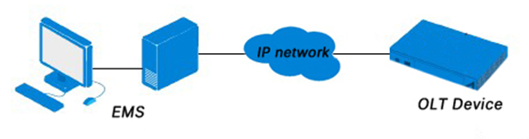
Figure 1-1 Working Connection

1.3 Installation Requirements
The requirements of the hardware configuration for the EMS’ Server depend on the network scale.
 | CPU | Memory | DISK | Video Card | Operating System
Server | Frequency above 2GHz | 2GB | 20GB |  | Windows2008/XP/7/8/10
Client | Frequency above 2GHz | 1GB | 10GB | 65000 color resolving capability 1024*768 or above | Windows2008/XP/7/8/10

1.4 EMS Installation Files
The installation file contains two files:
EMS-client.exe and EMS-server.exe
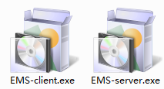
Figure 1-2 Installation File

2 EMS Installation
This chapter introduces the procedures of EMS installation.
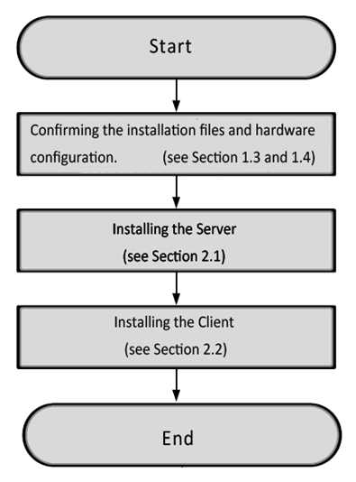
Figure 2-1 Installation Procedures

2.1 Installation of the Server
Double-click 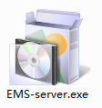 to launch installation.
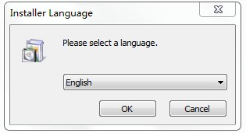
Figure 2-2 Select Installation Language
Select “English” and click “OK”.
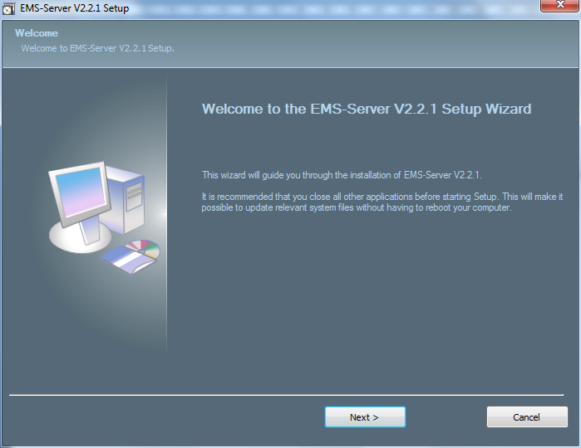
Figure 2-3 Installation Introductions
Click “Next” to proceed.
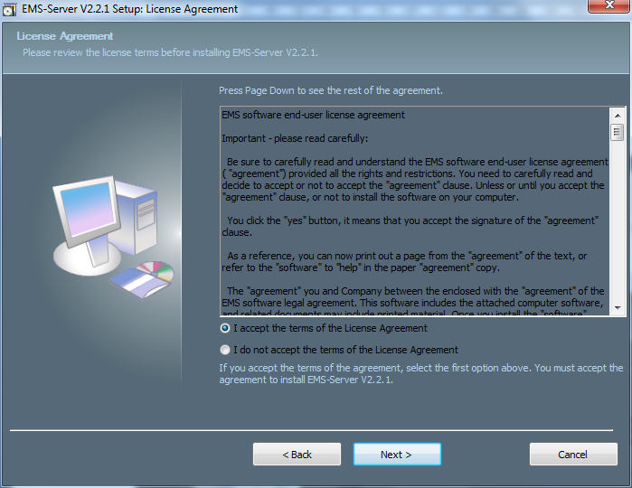
Figure 2-4 Accept the Software Agreement
Select “I accept the terms of the License Agreement” and click “Next” to proceed.
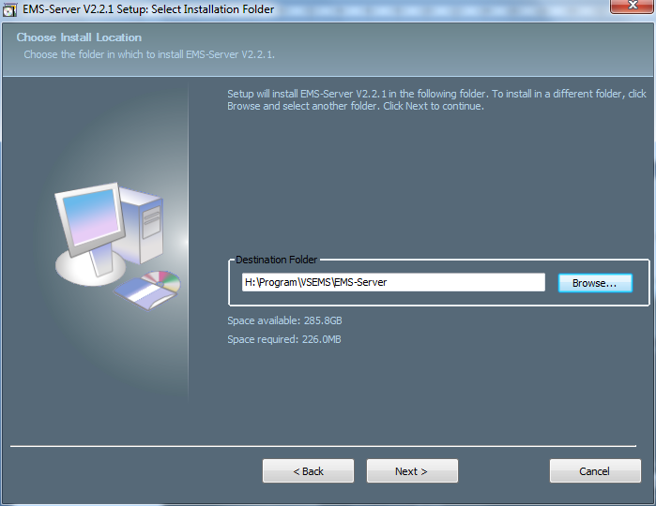
Figure 2-5 Set Installation Path
Set the installation path and click “Next” to proceed.
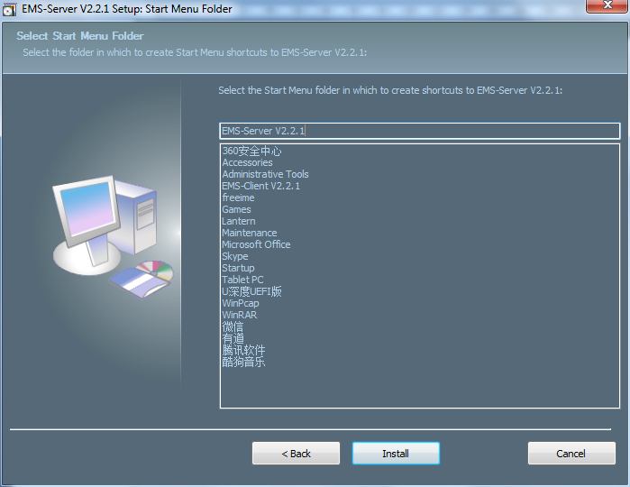
Figure 2-6 Select Start Menu Folder
Click “Install” to start installing the server.
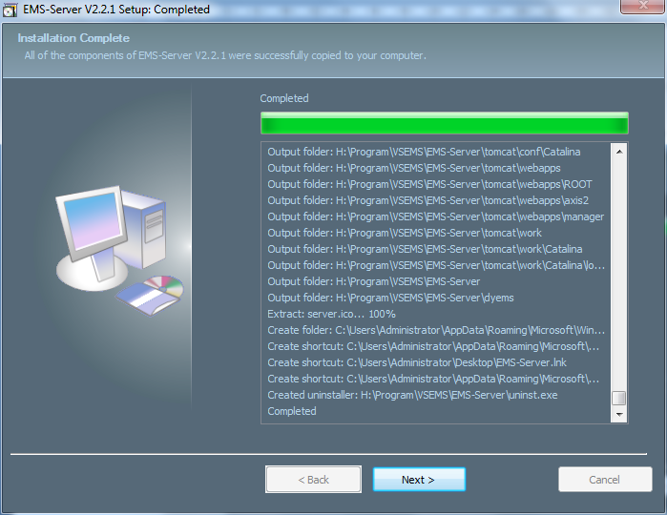
Figure 2-7 Software Installation
Click “Next” to proceed.
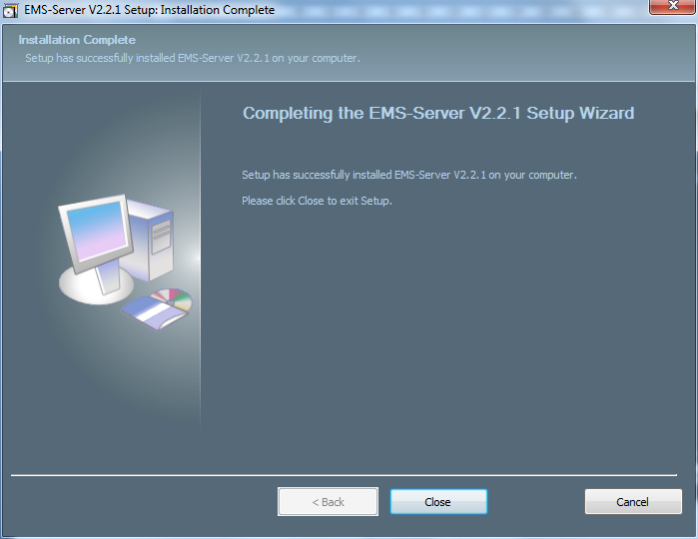
Figure 2-8 Complete Installation
Click “Close” to complete the installation.

2.2 Installation of the Client
Double-click 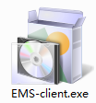 to make the Language dialog box appear.
Figure 2-9 Select Installation Language
Select “English” and click “OK”.
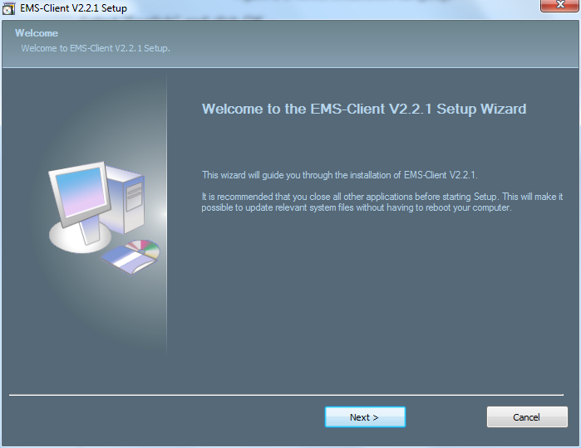
Figure 2-10 Installation Introductions
Click “Next” to proceed.
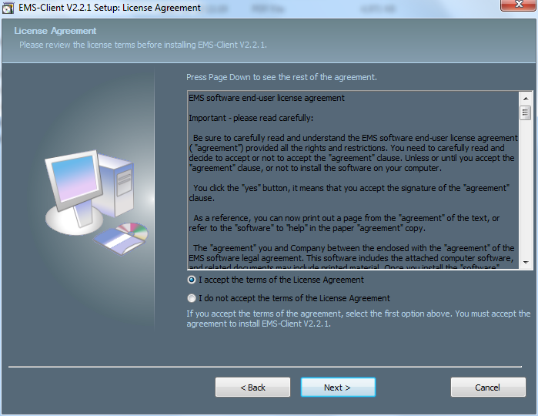
Figure 2-11 Accept the Software Agreement
Select “I accept the terms of the License Agreement” and click “Next” to proceed.
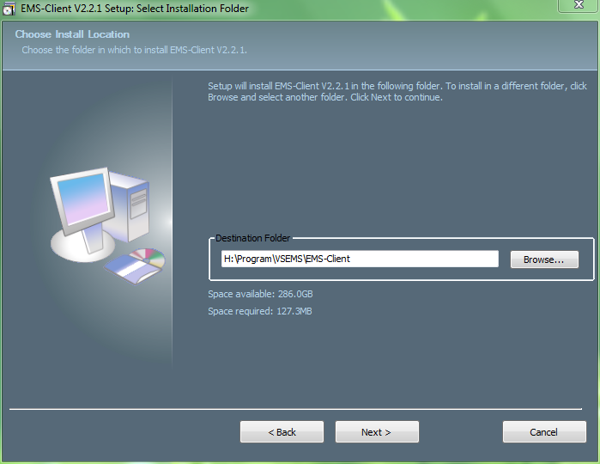
Figure 2-12 Set Installation Path
Set the installation path and click “Next” to proceed.
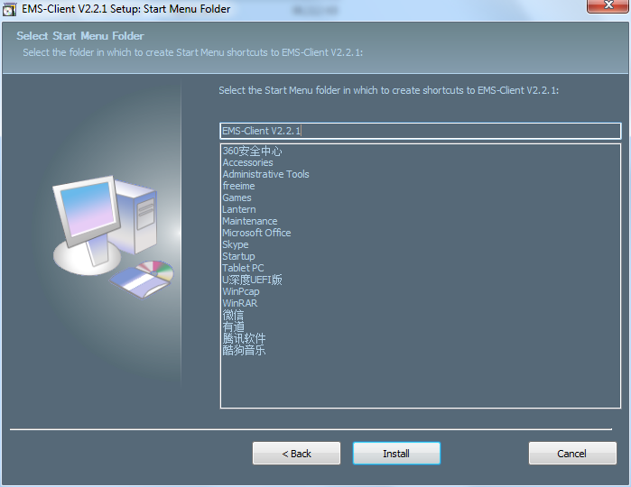
Figure 2-13 Select Start Menu Folder
Click “Install” to start installing the server.
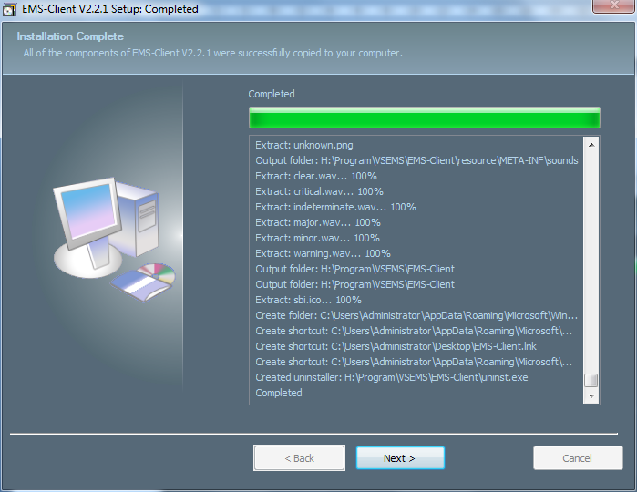
Figure 2-14 Software Installation
Click “Next” to proceed.
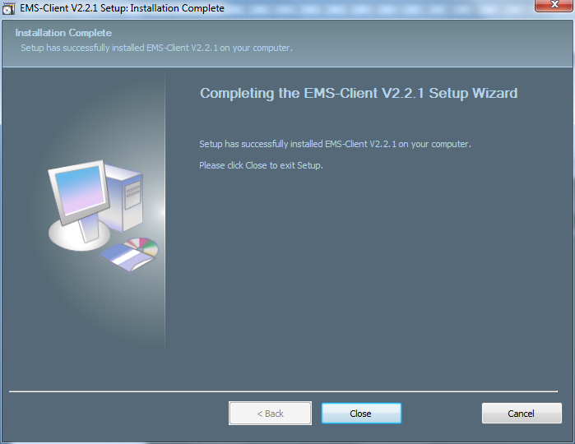
Figure 2-15 Complete Installation
Click “Close” to complete the installation.

3 EMS Quick Start
This chapter introduces the procedure for starting the EMS quickly. It mainly includes the following contents:
- Ensure smooth network to OLT
- Starting sequence
- Add device
- Synchronous OLT configuration.

3.1 Preparatory Work
Connect server PC to the OLT’s AUX port with CAT5 cable. Configure IP address of the server PC with the same network segment of OLT management IP such as 192.168.8.X (e.g. 192.168.8.10).
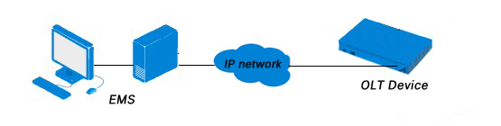
AUX
Figure 3-1 Connection Diagram
The OLT default management IP：EPON 192.168.8.100
GPON 192.168.8.200

3.2 Starting Sequence
Double-click icon 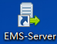 to start the EMS server.
Click “Start” button and wait a moment, you can see the button changes to “Stop”. This indicates that the server starts successfully.
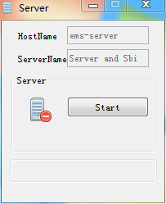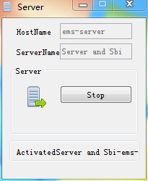
Figure 3-2 Start Server
After the server started completely, double-click icon 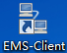 to start the EMS client. Input username and password of the EMS, server IP address and port of the server. Then click Login.
The default username and default password both are root.
The port is 5188.
The server IP address is your PC（server）IP address or 127.0.0.1.
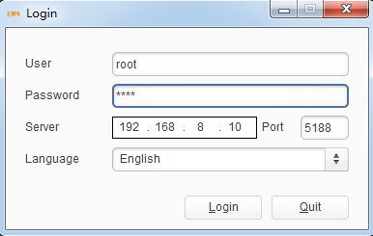
Figure 3-3 Login Dialog Box
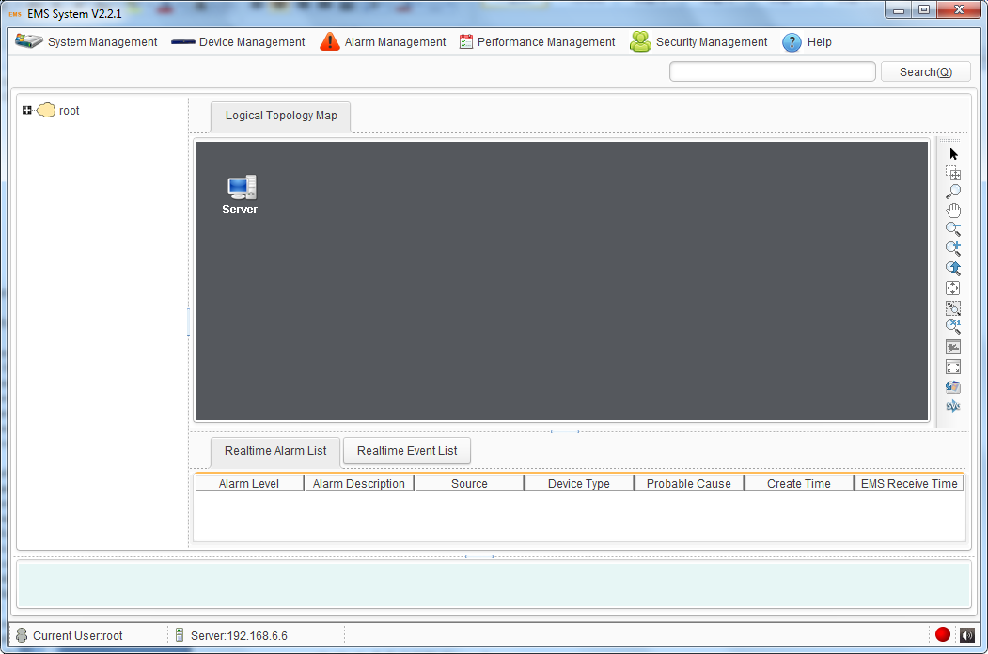
Figure 3-4 EMS Main Interface

3.3 Frame Introduction
This chapter introduces the main interfaces of the EMS. It mainly includes the following contents:
- Main interface
- Main menu
- Main toolbar
- Rolling log
- Status bar
After successfully login, enter the main frame interface of EMS. The main interface is composed by "Title bar", "Menu bar", "Toolbar", "Topological navigation tree", "Topology", "Current alarm event" and "Rolling log", etc. The bottom of the interface is composed by "Status bar", "Alarm light" and "Alarm sound switch".
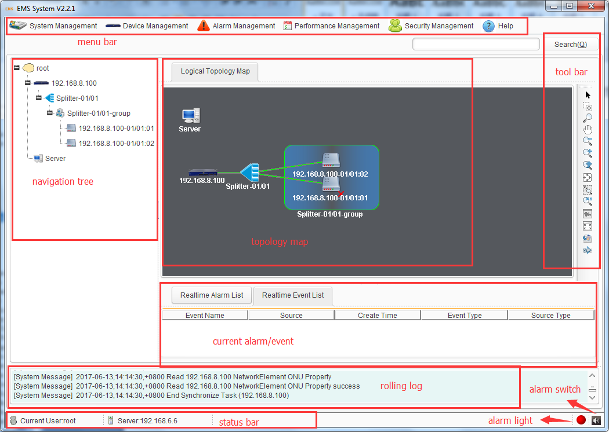
Figure 3-5 Main Frame Overview
As shown in Figure 3-5, main frame contains following several parts:
1. Main menu
The main menu includes: System, Device management, Alarm, Performance and Security parts.
2. Topological navigation tree
The tree is Domain -> Device (OLT) -> Group (splitter) -> Device (ONU). Through the tree, manager can add, delete and manage the node. Click the OLT or ONU node, can operate the device.
3. Topological map
The Topological map is the main area of EMS. In the blank, Click the right mouse button, manager can add an OLT device, change layout, show name, etc. For convenience of managing, manager can move device icons to appropriate locations.
When an OLT device is added to the map, EMS will auto synchronization ONUs which connect to the OLT device. Now, in the map, manager can operate the OLT and ONU device.
4. Current alarm event
This window located on the bottom of the main frame, including Alarm Log and Operation Log page.
Alarm log page shows and records the real time alarm information, including alarm object, occur time and alarm content.
Operation log page shows and records the manager’s operation records, in order to trace back when needed.
5. Search and Shortcut bar
Toolbar includes: search box. You can search or locate a network element by the keywords (IP, MAC address or name) in the search box.
6. Status bar
The status bar includes state information, alarm light and alarm sound switch.

3.4 Add OLT Device
At interface of topological diagram, right-click the blank to open a menu and choose "Add Device".
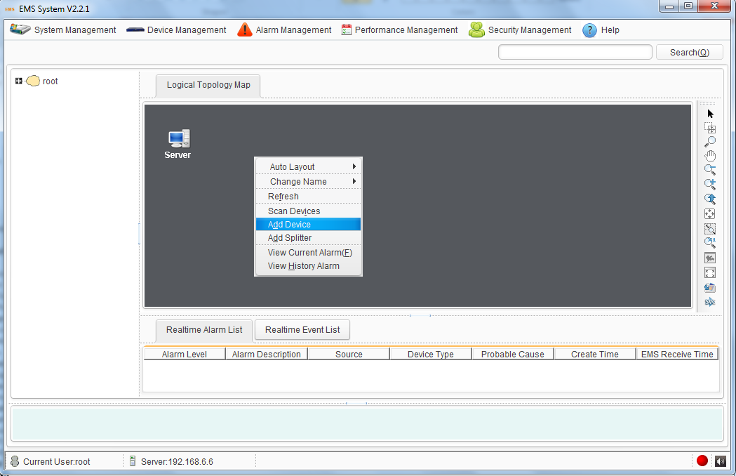
Figure 3-6 Add Device
In the pop-up window, input the management IP of OLT. The OLT default IP is 192.168.8.100.
Please select Read community public, and write community private.
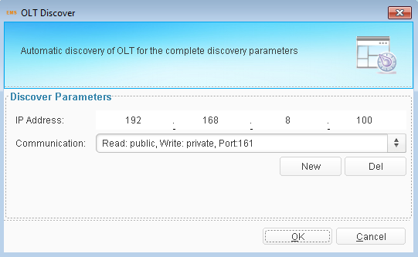
Figure 3-7 Select Community Parameters
If there is no option in communication list, please add new community parameters. Only when the computer ping OLT, the device can be added successful.
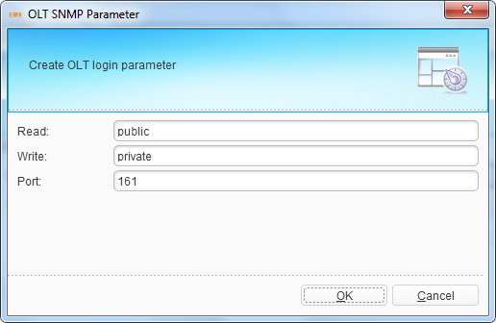
Figure 3-8 Add Community Parameters
After adding device, there will be a device icon in the topological diagram.
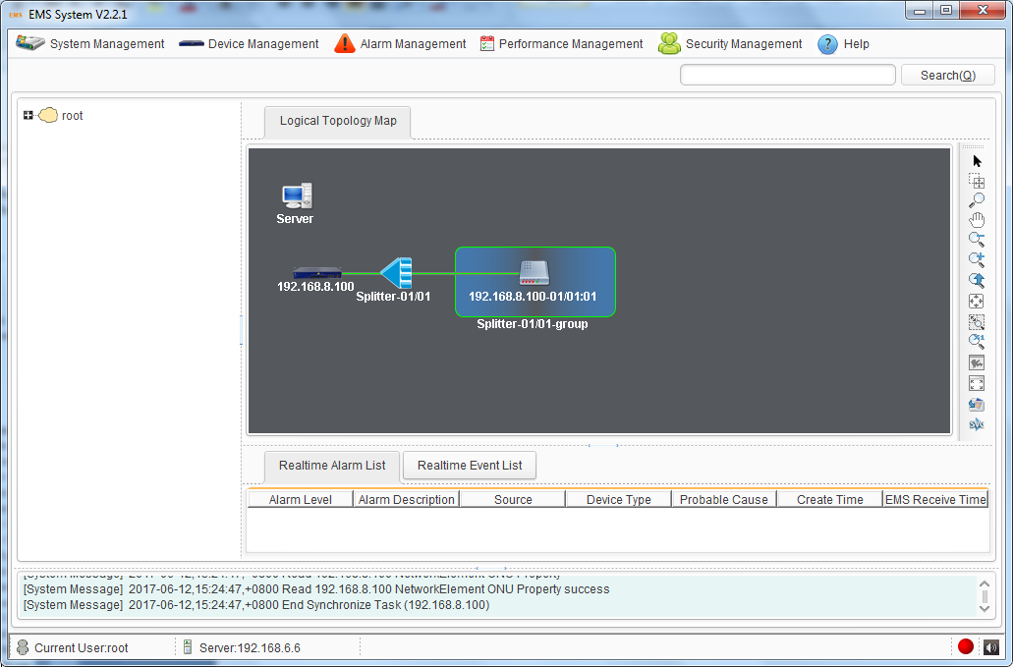
Figure 3-9 Device icons in the topological diagram
The device will sync automatically. You can also sync manually. Sync device ensure device configuration consistent with EMS configuration.
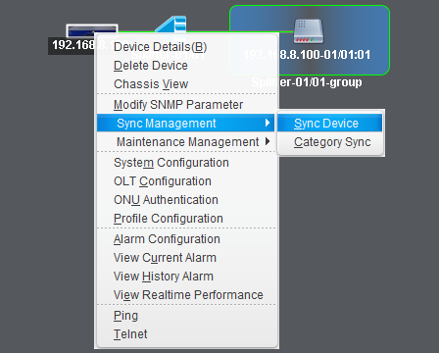
Figure 3-10 Sync Device

3.5 Scan Device
If there are more than one OLT in the network, you can use Scan Device to add them into EMS at the same time. Right-click the blank and choose “Scan Devices” on the menu to scan devices in the network. Input IP range, device type and click “start to scan”, all devices which match the device type will be found. Select them and add to EMS.
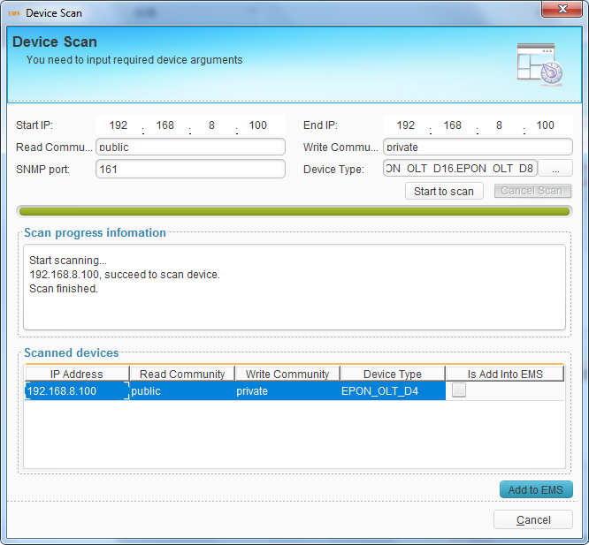
Figure 3-11 Scan Device

3.6 Delete Device
This command is used to delete needless OLT device in topology map.
Select OLT device which you want to delete, right click "Delete Devices".
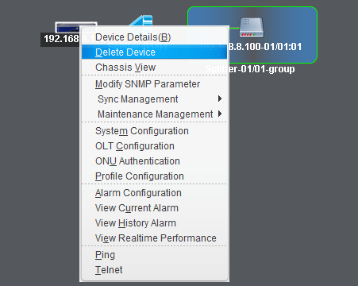
Figure 6-12 Delete Device
Click "OK", the OLT device will be deleted.
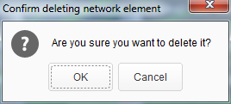
Figure 6-13 Delete Device Dialog Box

3.7 Add Splitter
By default, there is at least one splitter is connected between OLT and ONU. You can also add another one between existed splitter and ONU. This, in some way, can help to edit or good to manage the network topology.
At the primary topological diagram, right-click any of the blanks, choose “Add Splitter”. Fill in the name and click “OK”.
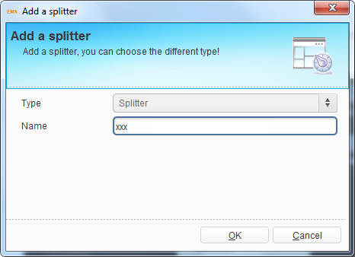
Figure 3-14 Set Splitter Name
Right click the new splitter, choose “Parent Link”, choose the relevant parent node, and then click “OK”.
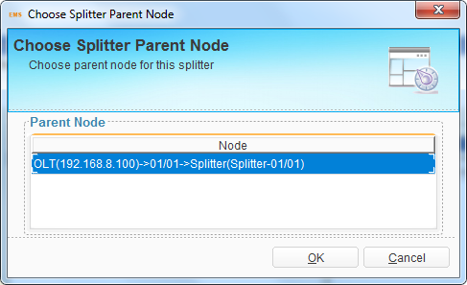
Figure 3-15 Set Parent Node
Right click the new splitter, choose “Sub Link”, choose the relevant sub node, and then click “OK”.
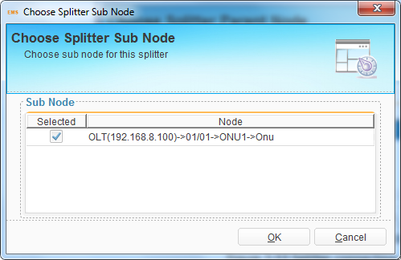
Figure 3-16 Set Sub Node
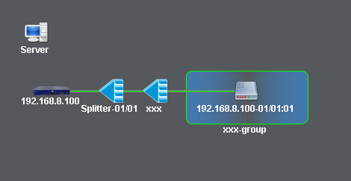
Figure 3-17 Connect Splitter Successful

4 Security Management
This chapter mainly introduces EMS username management, which contains username, user role, operation permission and operation log.
Click any option of “Security Management” menu, enter security management interface.

4.1 User Management
The username is used to login EMS. All existing users will display in the table. Default user root cannot be deleted and edited except modifying its own password and contact information. Added usernames can be modified, deleted and prohibited by administrator root, but cannot by other users. Each user can only modify its own information.
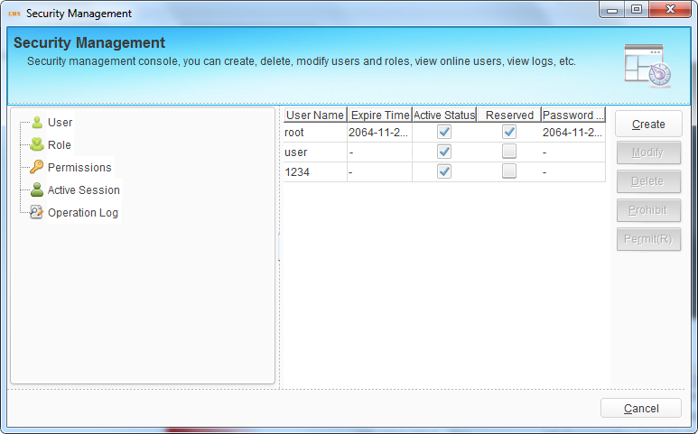
Figure 4-1 User Management
Click “Create” button to open a dialog box, fill in new username and its password, select role for this username and click “OK” button to apply configurations. Other parameters or information are optional. If you have configured period, the user is available in the period. If the user is deleted or prohibited by root, it will not login EMS any more.
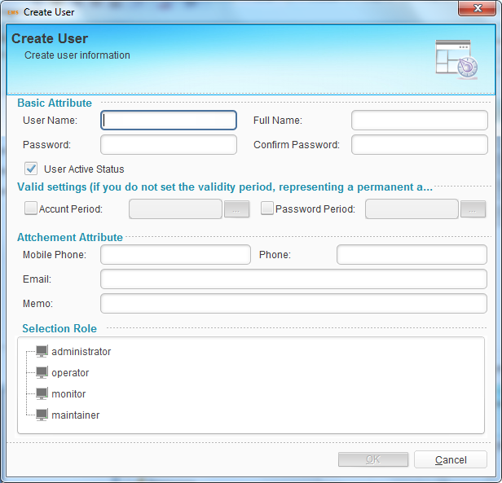
Figure 4-2 Create User

4.2 Role Management
The role specifies user operation permission. Default roles cannot be modified and deleted.
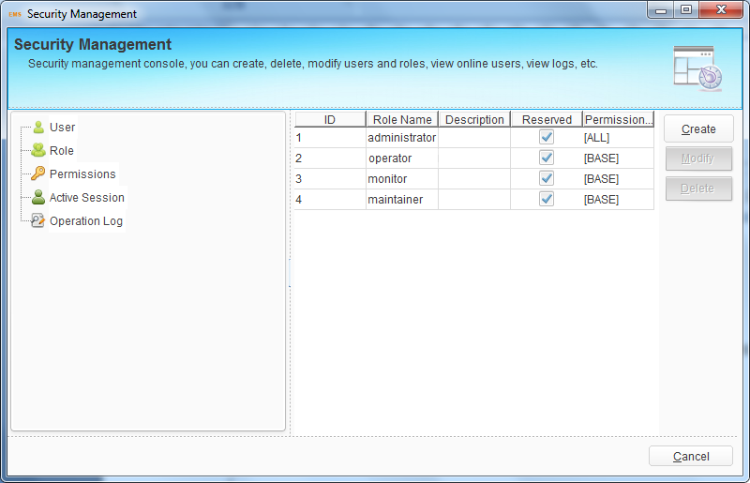
Figure 4-3 Role Management
Click “Create” button to open a dialog box, fill in role name and select operation permission, then click “OK” button to apply the configurations.
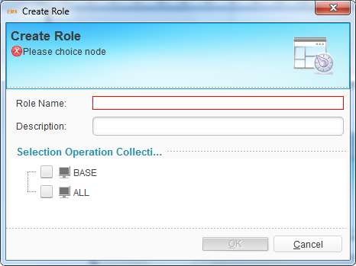
Figure 4-4 Create Role

4.3 Permission Management
Permission group specifies which operations can be done by users. Default permission cannot be modified and deleted.
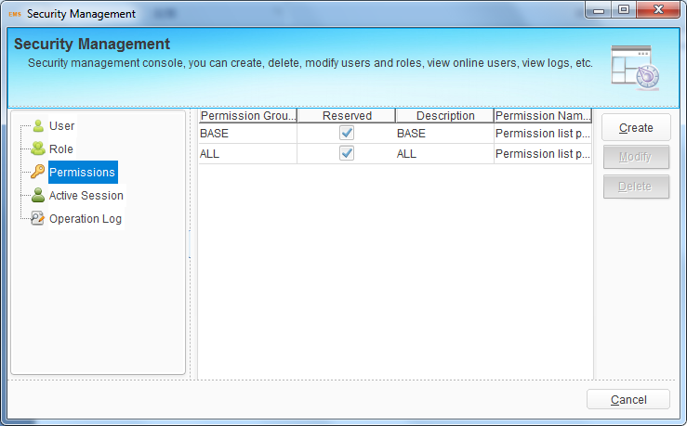
Figure 4-5 Permission Management
Click “Create” button to open a dialog box, fill in permission name and select operation options, then click “OK” button to apply the configurations.
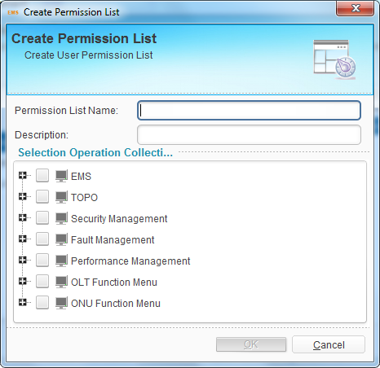
Figure 4-6 Create Permission

4.4 Online User
This interface displays users who are logging in. it displays client IP, username and login time. If the user is not administrator, it can be kicked out.
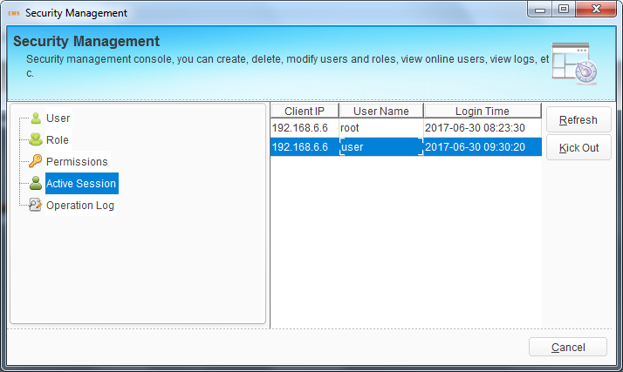
Figure 4-7 Online User

4.5 Operation Log
Operation log displays logs of all users’ operations. It contains operation type, operation source, login time, operation result, user, login IP, operation catalog and so on, which can be set as search conditions for log query.
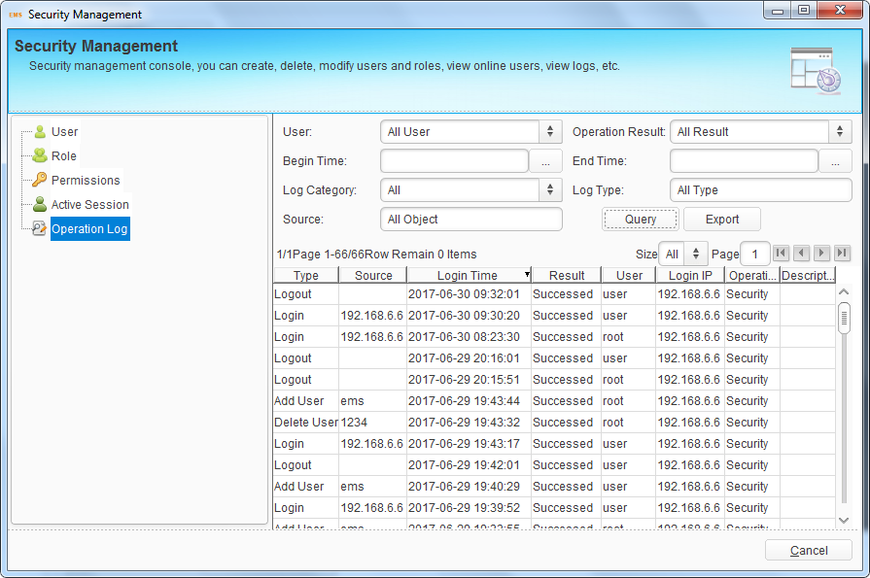
Figure 4-8 Operation Log

5 EMS System Management
This chapter introduces the system management function of EMS. It mainly includes the following contents:
- Lock client
- Modify password
- Database Backup and restore
- Polling switch configuration
- Exit

5.1 Lock Client
When administrator needs to leave the client computer but not wants to shut the client program, he/she can lock the client.
Click "System Management" > "Lock Client", the EMS client will be locked.
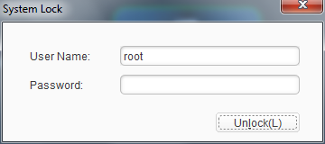
Figure 5-1 System Lock Dialog Box
Once the client is locked, others cannot use it. The current user can enter password to unlock when he/she comes back to the client.

5.2 Modify Password
Modify current user’s password. Click "System Management">"Modify Password", open modify password dialog box.
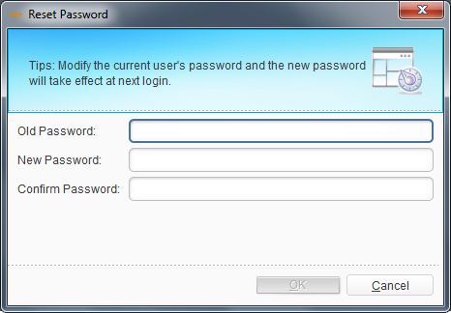
Figure 5-2 Reset Password
Input old password and the new password in the password box, click "OK". The new password will take effect at next login.

5.3 Database Backup and Restore
Database stores OLT, ONU information, comment or location of the devices, EMS login username and password, etc. if you need to install EMS at another computer but not want to changes these information, you should backup the database and restore at the new EMS.
Click "System Management">" Db backup and restore ", open database backup and restore dialog box. The backup file is named by the backup time by default and stored at EMS installation path. When you restore the database file, put the file at the path and choose it, then click “Restore”. New data will take effect after restart EMS server.
EMS will backup database automatically if Timing is enabled.
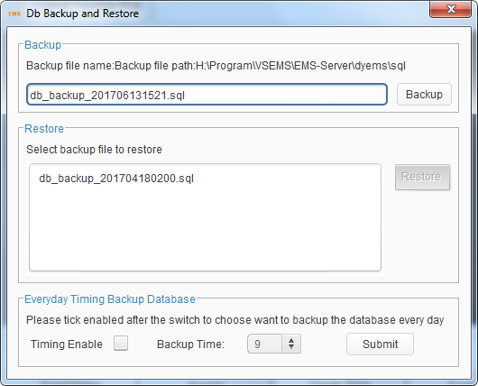
Figure 5-3 Databese Backup

5.4 Exit System
Exit the element management system.
Click "System Management">"Exit", and click "Yes" to exit.

6 OLT Management
This chapter introduces the OLT management function of EMS.

6.1 OLT Basic Information
Choose OLT icon and open right-click menu; click “Device Details” to display OLT basic information, optical information and traffic statistics.
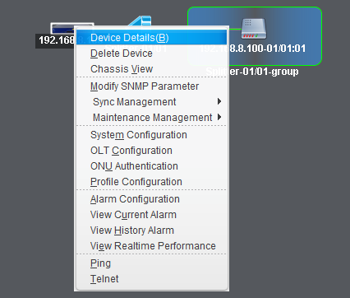
Figure 6-1 Open OLT Device Detail
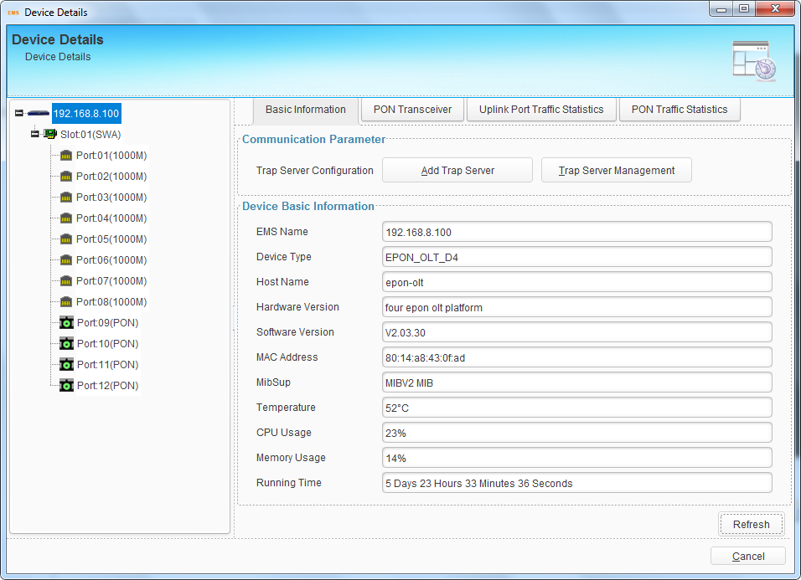
Figure 6-2 OLT Device Details

6.2 System Configuration
This section introduces OLT system configurations, such as OLT upgrade, configuration file backup or restores, management IP address, system time, mirroring and so on.
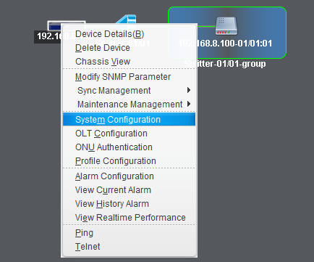
Figure 6-3 Enter System Configuration

6.2.1 OLT Upgrade
This operation is used to upgrade software of OLT (Uboot or Kernel). Before upgrading you are required to start the TFTP server, and put the upgrade files into the corresponding folder. Follow the steps below to upgrade OLT.
- Set IP address of computer with the same network segment as that of OLT. Connect the TFTP server with OLT by a CAT5 cable. Make sure the computer can ping OLT.
- Run TFTP server in the computer. Current directory is where the firmware stores.
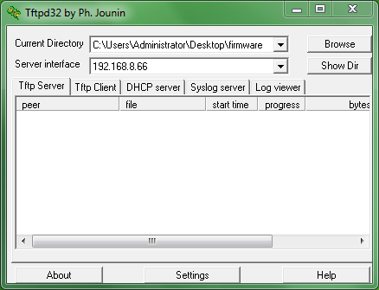
Figure 6-4 TFTP Server
- Fill in FTP server IP and file name which is not more than twenty characters. Click the "Upgrade" to start upgrading.
- After completion of the upgrade, you must reboot the OLT device; the new upgrade file will take effect after the OLT device reboot.
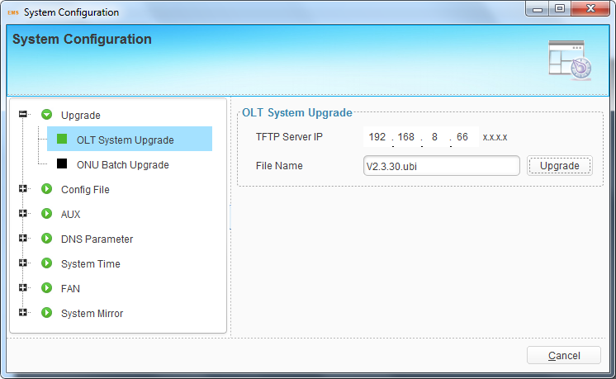
Figure 6-5 OLT System Upgrade

6.2.2 ONU Upgrade--EPON
You can upgrade one or many ONUs at the same time at this interface. But the ONUs need to be updated should be the same device type.
Follow the steps of TFTP settings which are shown above in OLT upgrade section. Then fill in the firmware name and the TFTP server IP. And select the ONUs that need to be upgraded. You can only select the online ONUs.
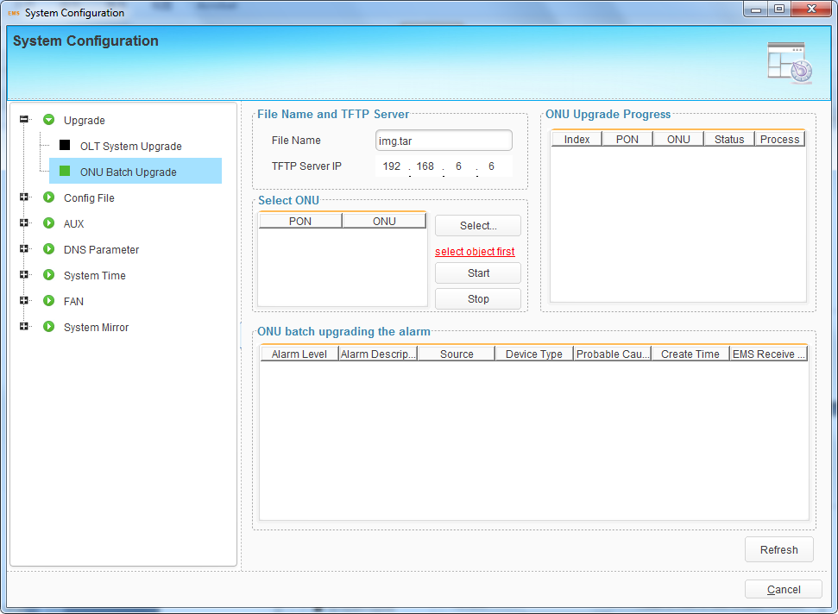
Figure 6-6 ONU Upgrade
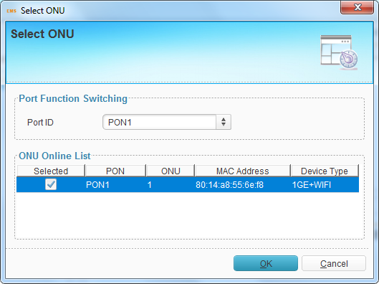
Figure 6-7 Select ONU
Click “Start” button to start upgrading. Upgrade process will display on the right of this interface. Click “Stop” button to stop upgrading.

6.2.3 Config File
This operation is used to upload the OLT configuration to the TFTP server or downloading configuration file from the TFTP server to the Flash of OLT.
Fill in TFTP server IP and file name which is not more than twenty characters, and click “Upload” or “download”.
OLT will restart immediately after downloaded config file.
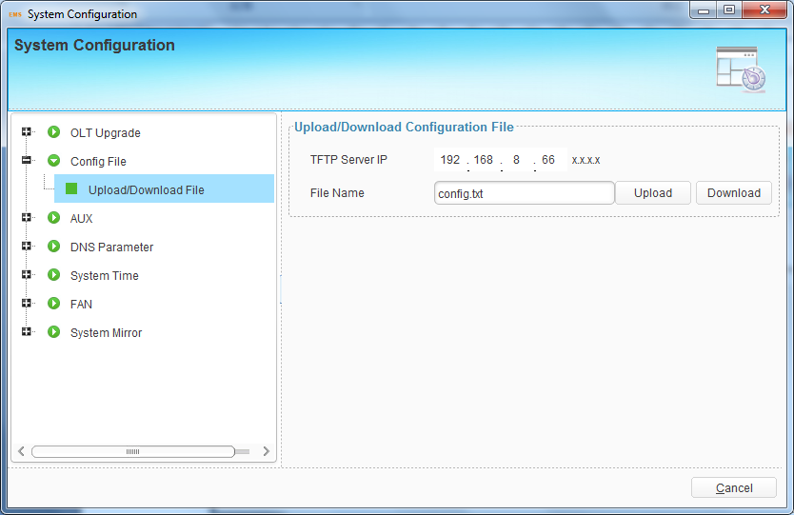
Figure 6-8 Config File Management

6.2.4 Configure Aux Port
This operation is used to configure IP address of aux port which is also called outband management IP.
Fill in the correct IP address and mask that you want to set, and click “Submit” to take effect.
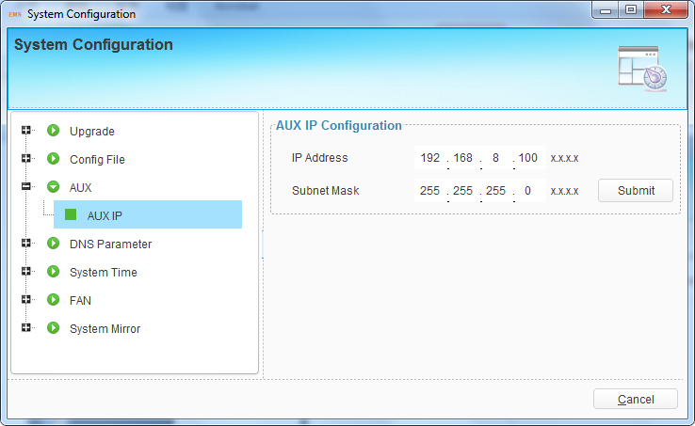
Figure 6-9 AUX Configuration

6.2.5 DNS Parameter
DNS (Domain Name Server) is used to resolve domain name. When OLT is configured NTP server with domain name, DNS is required. You can set at most two DNS servers.
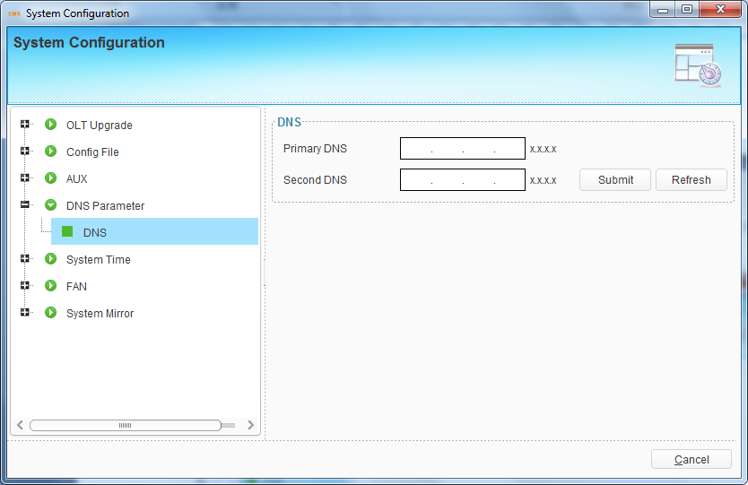
Figure 6-10 DNS Configuration

6.2.6 System Time
The OLT has its own system time. System time is helpful to check system log and alarms.
You can set system time manually. Fill in correct parameters and click “Submit”.
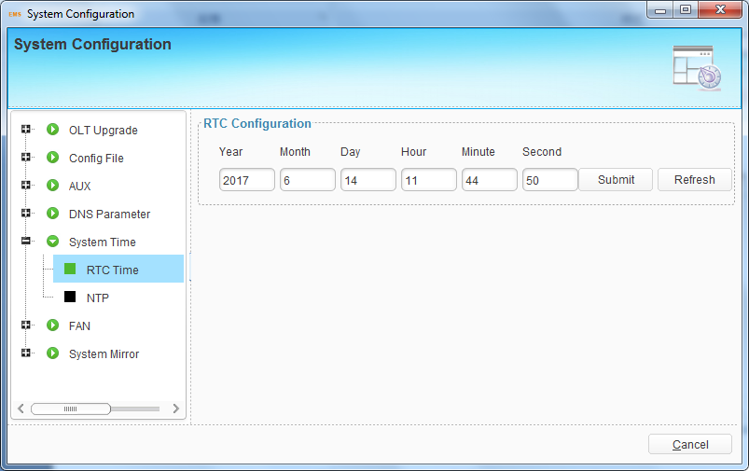
Figure 6-11 RTC Configuration
You can also set NTP server so that OLT can sync time from network.
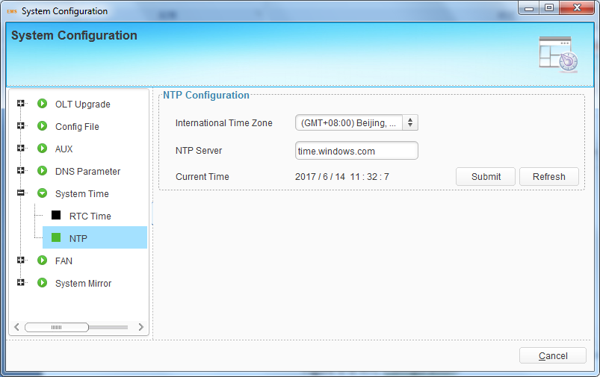
Figure 6-12 NTP Configuration

6.2.7 FAN Configuration
These settings are used to control the fans of OLT. The Fans can start or stop according to OLT temperature changes. You can set the fan start temperature.
There are three modes:
- Auto: The fans will start or stop automatically by detecting temperature.
- Open: The fans will always run.
- Close: The fans will not run.
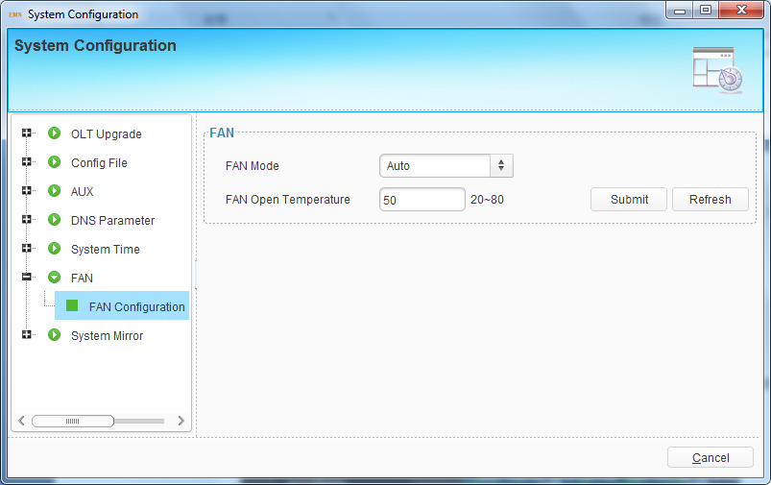
Figure 6-13 FAN Configuration

6.2.8 System Mirror
Mirror is to copy the data from one or more ports to a specified port, which can help for traffic analysis and network error diagnostics. OLT supports max 4 mirror groups.
Add a session ID and choose destination port, source port and traffic direction of source port. Then click “Submit”.
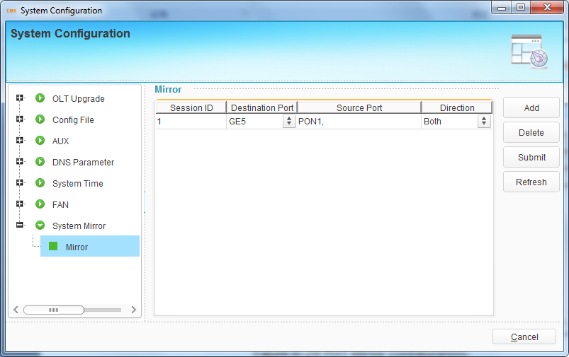
Figure 6-14 System Mirror Configuration

6.3 OLT Configuration
This section introduces OLT service configurations such as VLAN, ports, LACP, IGMP, DHCP, RSTP, ACL, and so on.
Right-click OLT icon, choose “OLT Configuration” and enter OLT configuration interface.
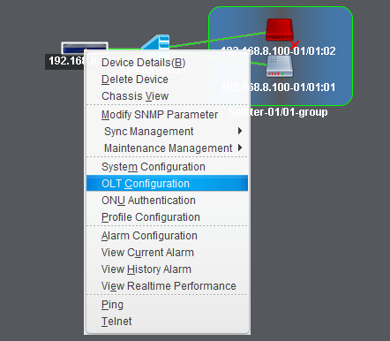
Figure 6-15 Enter OLT Configuration

6.3.1 VLAN Configuration
OLT equipment switch engine is fully compliant with the IEEE802.1Q VLAN standard and has the following main features:
- Support Port-based VLAN and IEEE802.1Q VLAN.
- Support full 4K VLAN group, VID range 1~4095.
All switch ports, including uplink ports and downlink ports, support VLAN partition.
VLAN 1 is the system reserved VLAN, it includes all switch ports which are UNTAG mode.

6.3.1.1 VLAN Port
This section is used to create VLAN and setting VLAN for OLT uplink ports and PON ports.
NOTE: For GPON, all vlan created will be added to all PON port, but just PON1 will be displayed, the user don’t need to pay attention on it.
Create VLAN
Click “Add” button on the right of VLAN Port window to open a pop-up dialog box, fill in VLAN ID and select the ports to be assigned to this VLAN group in Ports list.
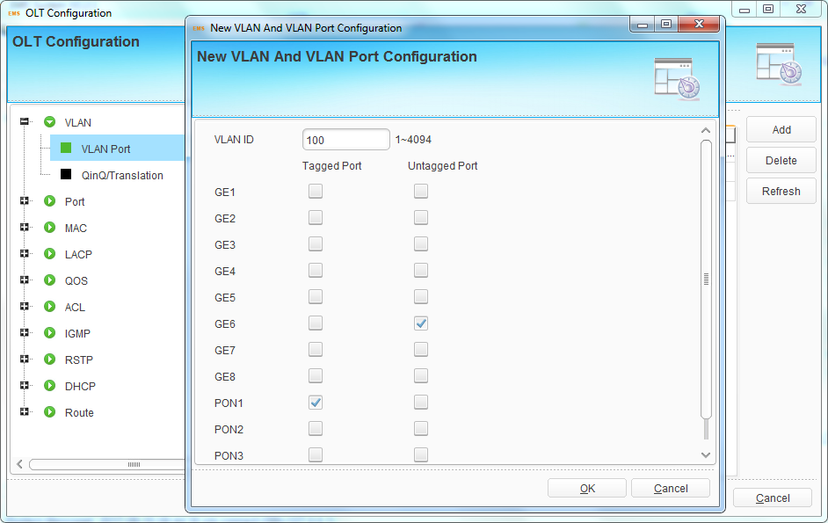
Figure 6-16 Add New VLAN
Click “OK” button, the VLAN will be created.
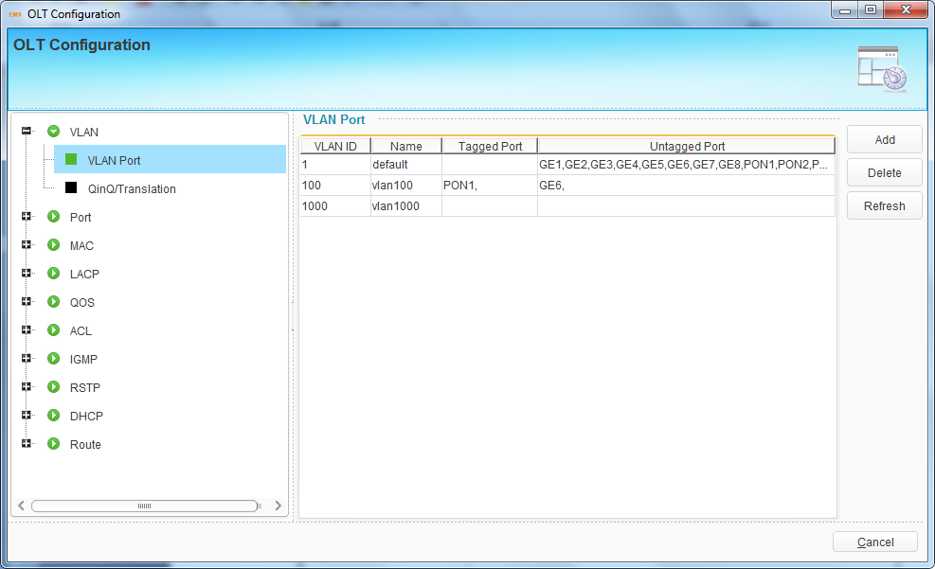
Figure 6-17 VLAN List
Delete VLAN
Select the VLAN ID in VLAN table and click “Delete” button to delete the selected VLAN.
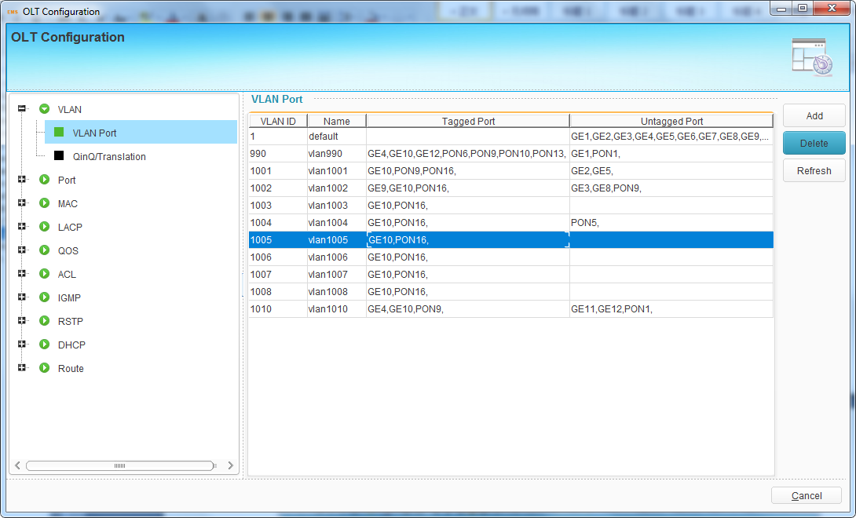
Figure 6-18 Delete VLAN

6.3.1.2 QinQ/Translation
In this user interface, VLAN QinQ and VLAN translation can be configured. VLAN QinQ and translation are effective for ingress.
Add an item and select port, client VLAN, service VLAN and the mode. Click “Submit” button to take effect.
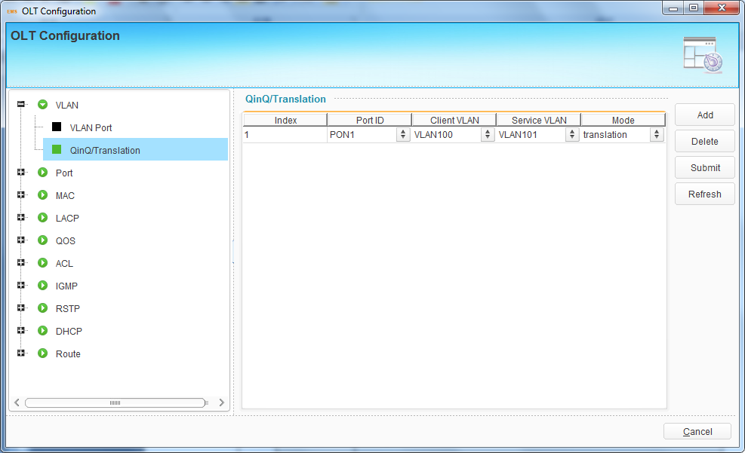
Figure 6-19 VLAN QinQ/Translation

6.3.2 Port Configuration

6.3.2.1 Uplink Port Traffic Statistics
This user interface displays traffic statistics of uplink ports.
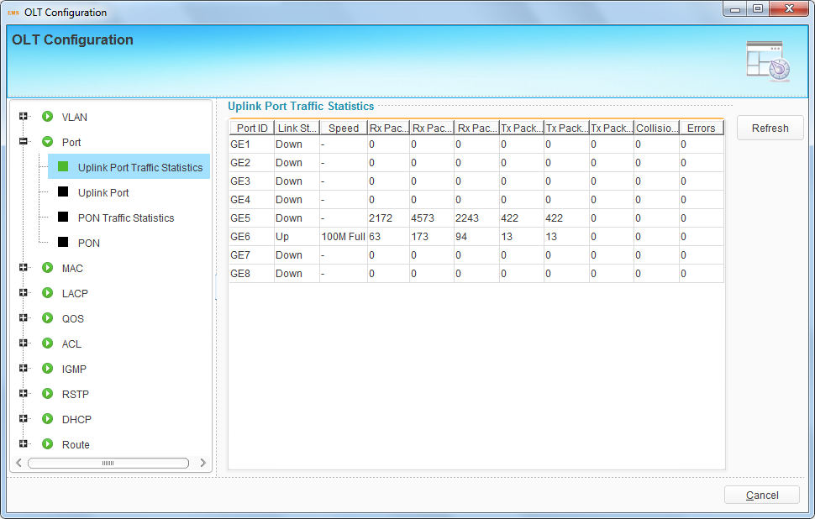
Figure 6-20 Uplink Ports Statistics

6.3.2.2 Uplink Port Configuration
This user interface is used to configure port related functions and characteristic parameters of uplink port, such as port attributes, PVID, flow control, rate limit, storm inhibition, port isolation and so on.
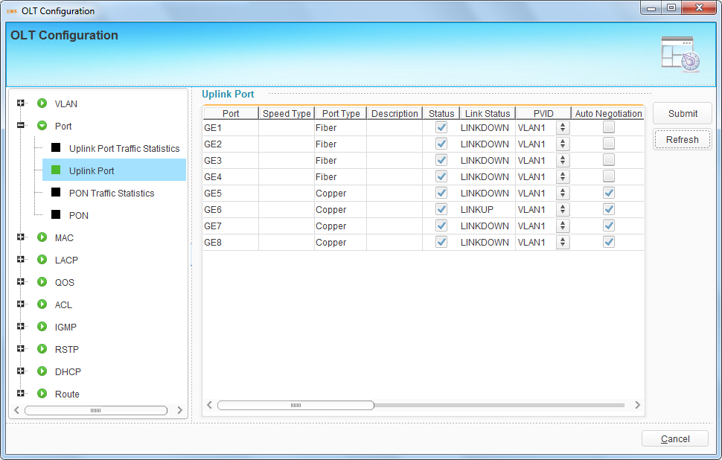
Figure 6-21 Uplink Ports Configuration
Illustrations of each parameter:
Parameters | Illustration
Type | GE port has two types, fiber and copper.
Description | Descriptions or remarks of port.
Status | Active or inactive status of port. It is "Enable" by default. Only when the port is enabled can continue to configure the subsequent parameters.
Link Status | Link status of uplink port. When the port is connected with another active port, it displays link up, otherwise displays link down.
PVID | Default VLAN ID of the port.
Auto-negotiation | Enable or disable auto negotiation of uplink port. It is “Enable” by default. Uplink port will negotiate with the connected port when it is enabled. The two connected ports will reach the largest possible transmission rate.
Speed | Uplink port link speed. There are three options, which are 10Mbps, 100Mbps and 1000Mbps, for copper ports. Speed of optical ports cannot be set. It is not configurable when auto negotiation is enabled.
Duplex | Uplink port duplex mode. There are full and half mode for copper ports. Duplex of optical ports cannot be set. It is not configurable when auto negotiation is enabled.
Flow Control | Enable or disable flow control function of uplink port to control congestion. It is "disable" by default.
Ingress Rate | Port ingress rate.
Egress Rate | Port egress rate.
Broadcast | Broadcast storm inhibition.
Multicast | Multicast storm inhibition.
Unknown Unicast | Unknown unicast storm inhibition.
Isolate | Port isolation with each other.
Jumbo Frame | Enable jumbo frame to pass through the port.

6.3.2.3 PON Port Traffic Statistics
This user interface displays traffic statistics of uplink ports.
NOTE: For GPON, all PON ports statistics will be showed in one line, the user don’t need to pay attention on it.
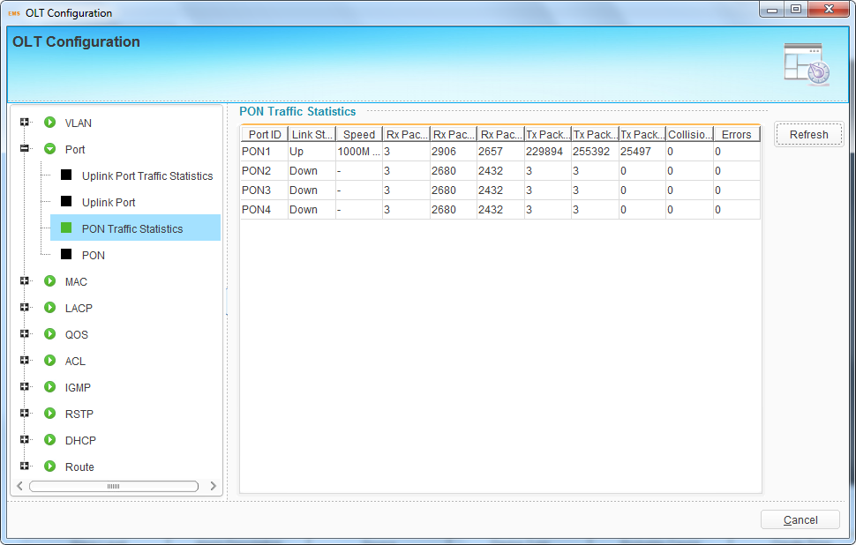
Figure 6-22 PON Ports Statistics

6.3.2.4 PON Ports Configuration
This user interface is used to configure port related functions and characteristic parameters of PON port, such as port attributes, PVID, triple churning, flow control, rate limit, storm inhibition, port isolation and so on.
NOTE: For GPON, only port’s status will be operation able.
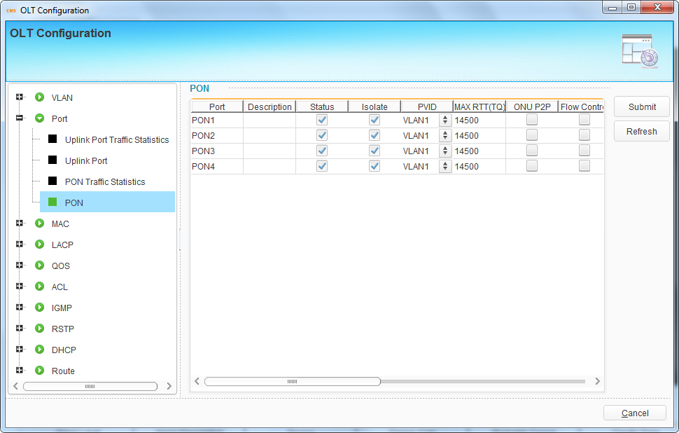
Figure 6-23 PON Ports Configuration
Illustrations of each parameter:
Parameters | Illustration
Description | Descriptions or remarks of port.
Status | Active or inactive status of port. It is "Enable" by default. Only when the port is enabled can continue to configure the subsequent parameters.
PVID | Default VLAN ID of the port.
Encryption time | This is the key timer of the triple churning. (Range: 774~786426)
Max RTT | Configuring Max RTT can refrain from ONUs’ signal reaching OLT at the same time. Default value is 14500. (Range: 2000~32000)
ONU P2P | Switch of intercommunication among ONUs under the same PON.
Flow Control | Enable or disable flow control function of PON port to control congestion. It is "disable" by default.
Ingress Rate | Port ingress rate.
Egress Rate | Port egress rate.
Broadcast | Broadcast storm inhibition.
Multicast | Multicast storm inhibition.
Unknown Unicast | Unknown unicast storm inhibition.
Isolate | Port isolation with each other.
Jumbo Frame | Enable jumbo frame to pass through the port.

6.3.3 MAC Configuration
In this section, you can check MAC address table of OLT, set MAC aging time and MAC limit of the ports.

6.3.3.1 MAC Table
This table displays MAC addresses that OLT has learnt at PON port and GE port.
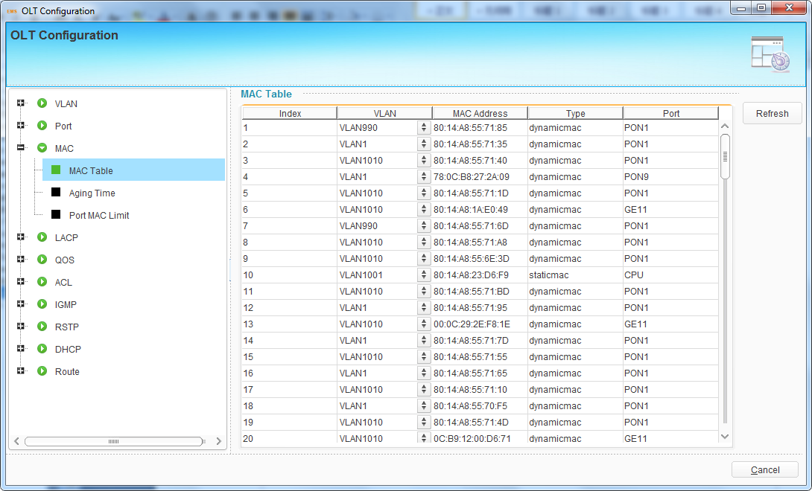
Figure 6-24 MAC Address Table

6.3.3.2 Aging Time
MAC address aging time, default value is 300s.
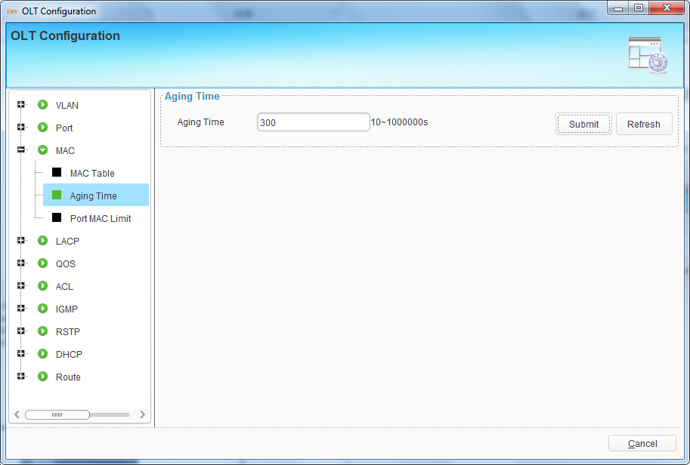
Figure 6-25 Aging Time

6.3.3.3 Port MAC Limit
Limit of learning MAC address at each port.
NOTE: For GPON, all PON port’s limit in one, show as PON1.
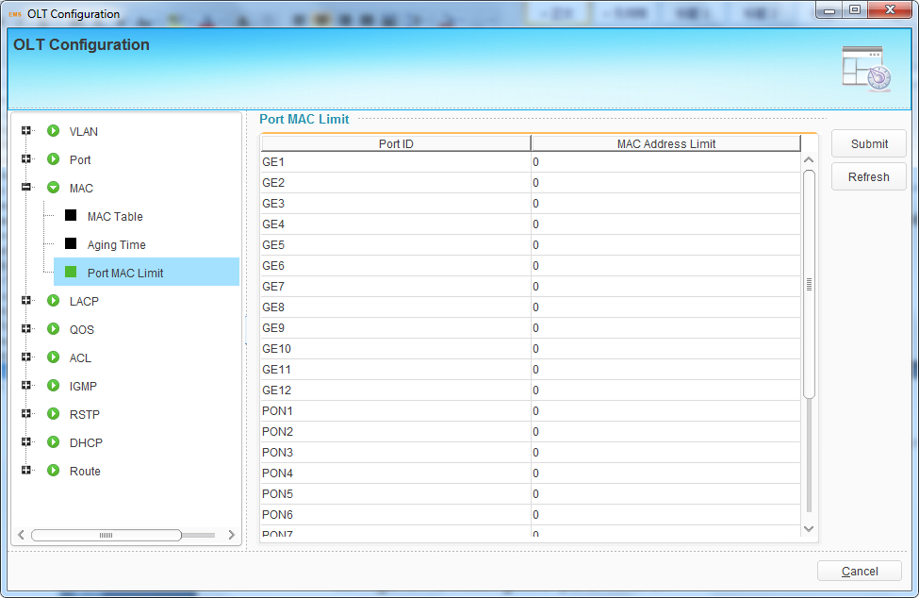
Figure 6-26 Port MAC Limit

6.3.4 LACP Configuration
In order to balance the loads at the member ports of a trunk group and improve the reliability of connectivity, it is necessary to configure LACP of ports. There are static LACP and dynamic LACP. For static LACP, trunk group and member ports must be configured manually; for dynamic LACP, trunk group and member ports can be configured by system.
OLT only supports static LACP function. Add a group, select load balance mode and member ports, then click “Submit” button to apply the configurations. Only four member ports can be added into one group.
Select one group and click “Delete” button to delete it.
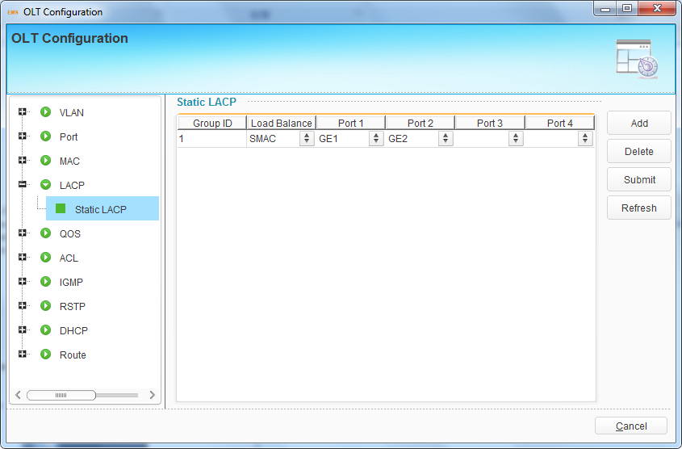
Figure 6-27 LACP Configuration

6.3.5 QoS Configuration
When bandwidth is not enough or there is congestion in the network, queue scheduling can make sure high priority data traffic passes through the device firstly. Traffic will map to queues according to their priorities and transmit in the queues.
OLT supports eight queues altogether. Queue scheduling mode includes strict priority (SP), weighted round robin (WRR) and hybrid mode (SP-WRR).
Strict priority scheduling guarantees high priority traffic occupy as much as bandwidth. The lower priority traffics pass though only when there is remaining bandwidth.
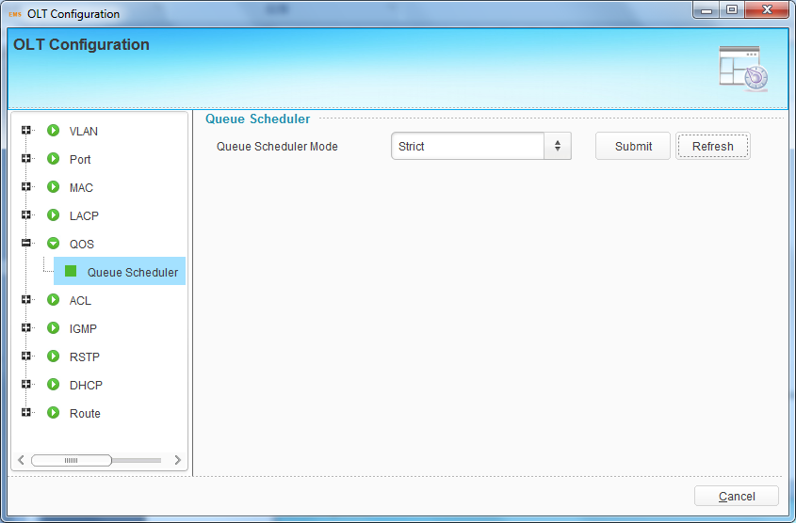
Figure 6-28 Strict Queue Schedule Mode
When working at WRR queue scheduling mode, OLT will assign bandwidth to traffic according to the weight of their corresponding queue.
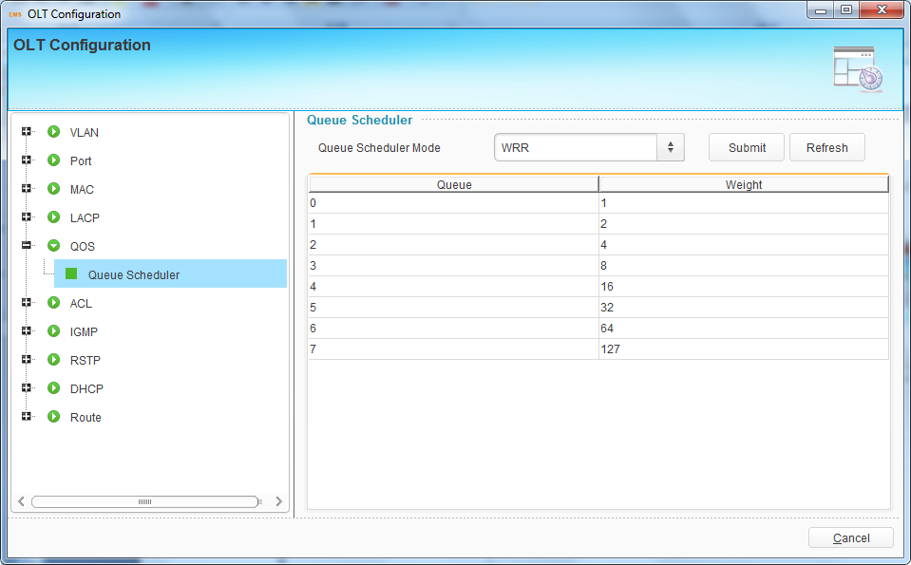
Figure 6-29 WRR Queue Schedule Mode
When working at SP-WRR queue scheduling mode, weight of queue 7 is 0, others are not. The queue with weight 0 which its regulation is strict priority scheduling mode, otherwise its regulation is weighted round robin scheduling mode.
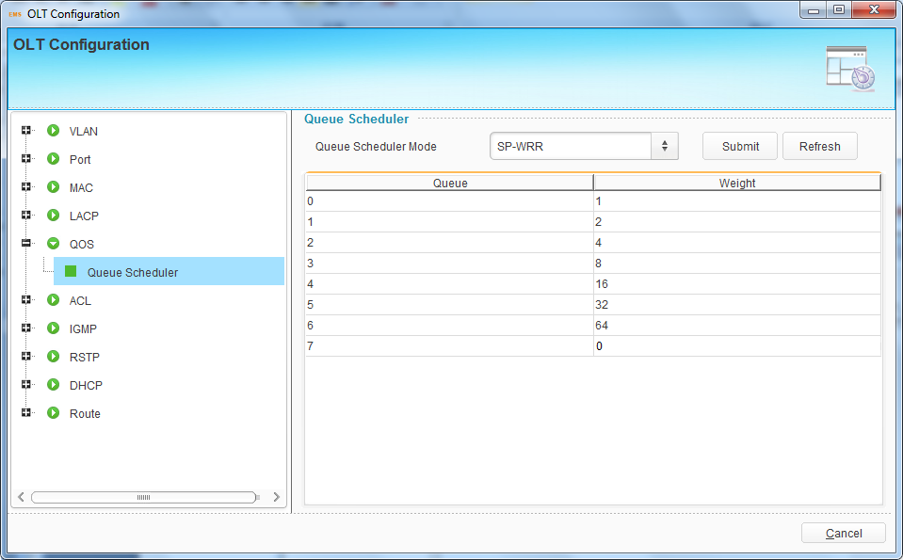
Figure 6-30 SP-WRR Queue Schedule Mode

6.3.6 ACL Configuration
In order to filter data packages, network equipments need to setup a series of rules for identifying what need to be filtered. Only matched with the rules the data packages can be filtered. ACL can achieve this function. Matched conditions of ACL rules can be source address, destination address, Ethernet type, VLAN, protocol port, and so on. These ACL rules also can be used in other situations, such as classification of stream in QoS. An ACL rule may contain one or several sub-rules, which have different matched conditions.
This device supports the following types of ACL.
- IP Standard ACL.
- IP Extended ACL.
- ACL based on MAC address
- ACL based on port binding.
- ACL based on QoS.
Numbers of each ACL rule:
ACL type | ACL index | Maximum rules
IP Standard ACL | 0-999 | 1000
IP Extended ACL | 1000-1999 | 1000
ACL based on MAC address | 2000-2999 | 1000
ACL based on port binding | 5000-5999 | 1000
ACL based on QoS | 6000-6999 | 1000

6.3.6.1 Standard IP Filter
This type of ACL supports deny or permit source IP address of data traffic.
Click “Add” button, choose operation mode, and fill in IP address and mask. The mask is a little different from that we usually set to devices. For example, if you want to deny only the IP address 192.168.1.3, you should set the mask as 255.255.255.255, but not 255.255.255.0. If you set 192.168.1.3/255.255.255.0, all the IP addresses 192.168.1.x will be denied.
Click “Add” button, select mode and fill in source IP address and its mask, then click “Submit” button to apply the configurations.
Select an item and click “Delete” button to delete it.
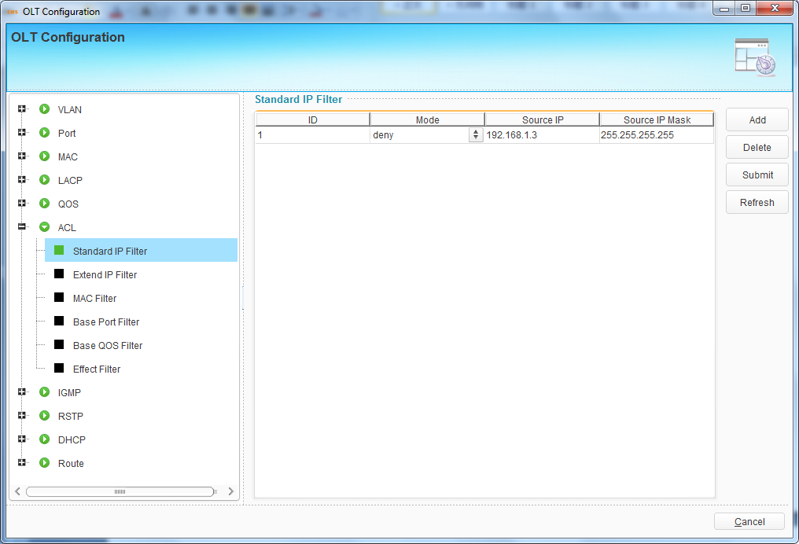
Figure 6-31 Standard IP Filter

6.3.6.2 Extend IP Filter
This type of ACL is the extended of standard IP filter. You can permit or deny both source and destination IP address. Other corresponding parameters such as protocol, DSPC and TCP/UDP port also can be set.
Click “Add” button to open a pop-up dialog box, fill in parameters, then click “OK” button to apply the configurations.
Select an item and click “Delete” button to delete it.
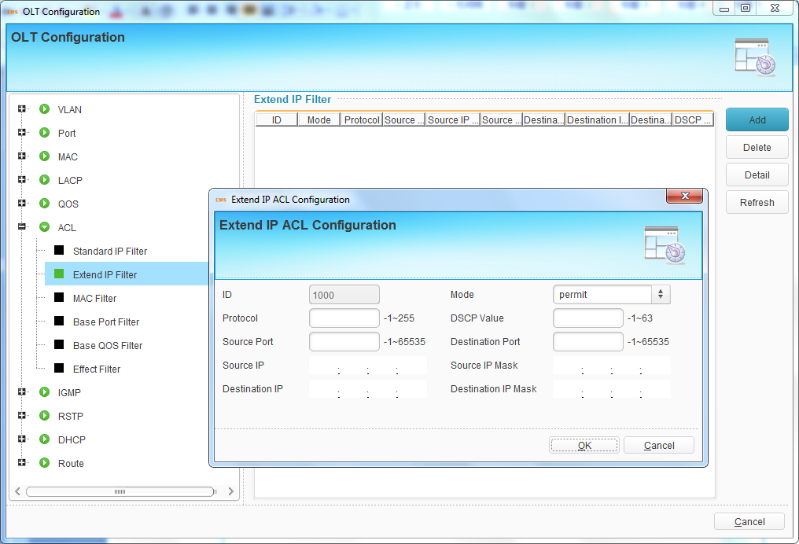
Figure 6-32 Extend IP Filter

6.3.6.3 MAC Filter
This type of ACL is based on MAC address. Filter conditions contains VLAN, cos, source MAC, destination MAC and Ethernet type.
Click “Add” button to open a pop-up dialog box, fill in parameters, then click “OK” button to apply the configurations.
Select an item and click “Delete” button to delete it.
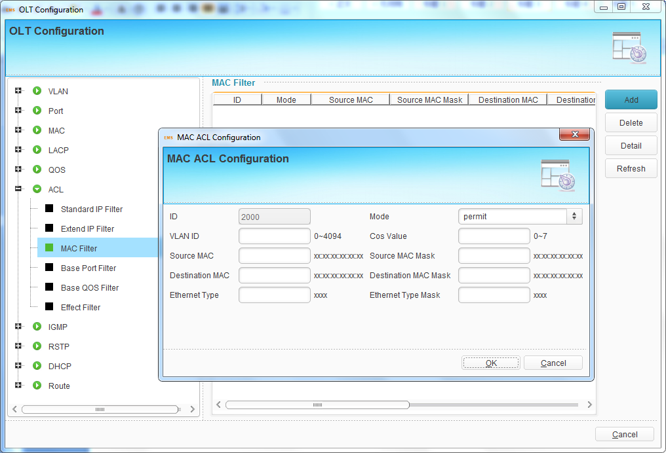
Figure 6-33 MAC Filter

6.3.6.4 Base Port Filter
This type of ACL is based on port. Nearly all the parameters related to port can be set as filter conditions. Such as MAC, IP address, VLAN, protocol and so on.
Click “Add” button to open a pop-up dialog box, fill in parameters, then click “OK” button to apply the configurations.
Select an item and click “Delete” button to delete it.
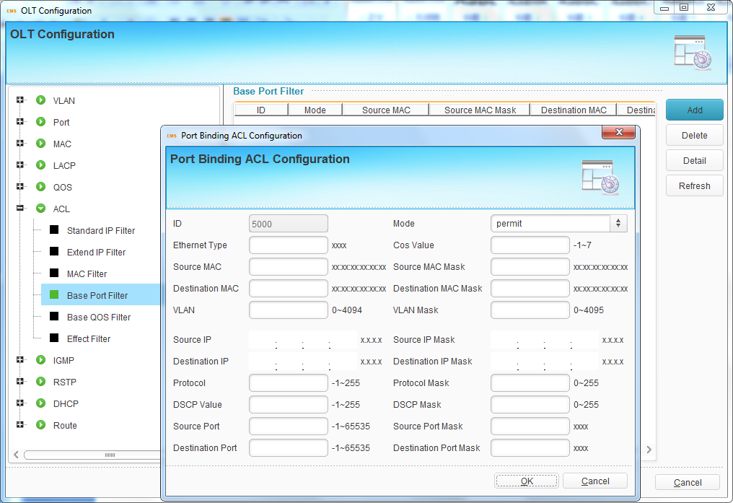
Figure 6-34 Base Port Filter

6.3.6.5 Base QoS Filter
Actually this is QoS function based on ACL. Traffic will abide by scheduling rules if it matches this type of ACL which binds to port.
Click “Add” button to open a pop-up dialog box, fill in parameters, then click “OK” button to apply the configurations.
Select an item and click “Delete” button to delete it.
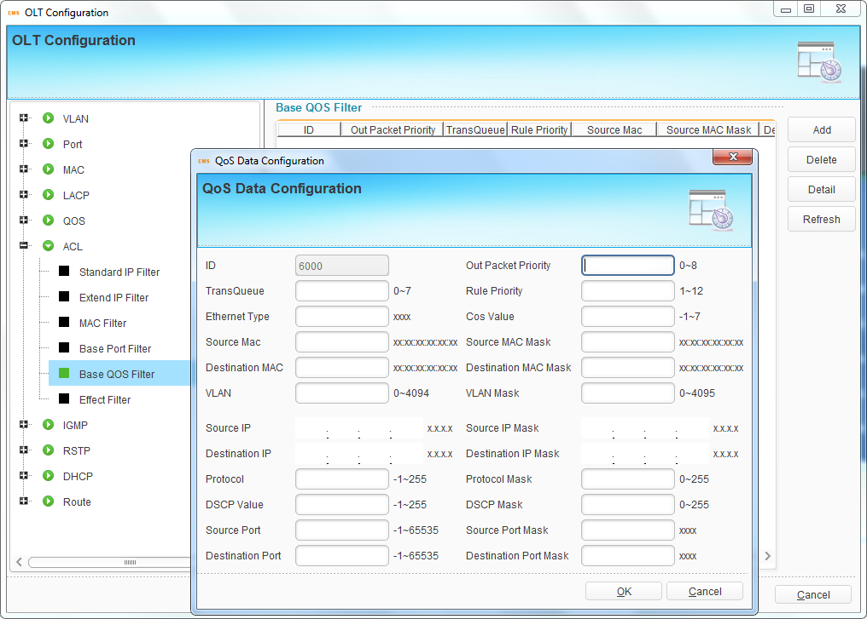
Figure 6-35 Base QoS Filter

6.3.6.6 Effect Filter
After created ACL rules, you need to bind then to ports so that the functions can take effect. The index displays automatically when ACL rule is created.
Select one ACL index, click “Select Port” button and open a pop-up dialog box, select the ports that need to bind ACL and click “OK” button. Click “Submit” to apply ACL configurations.
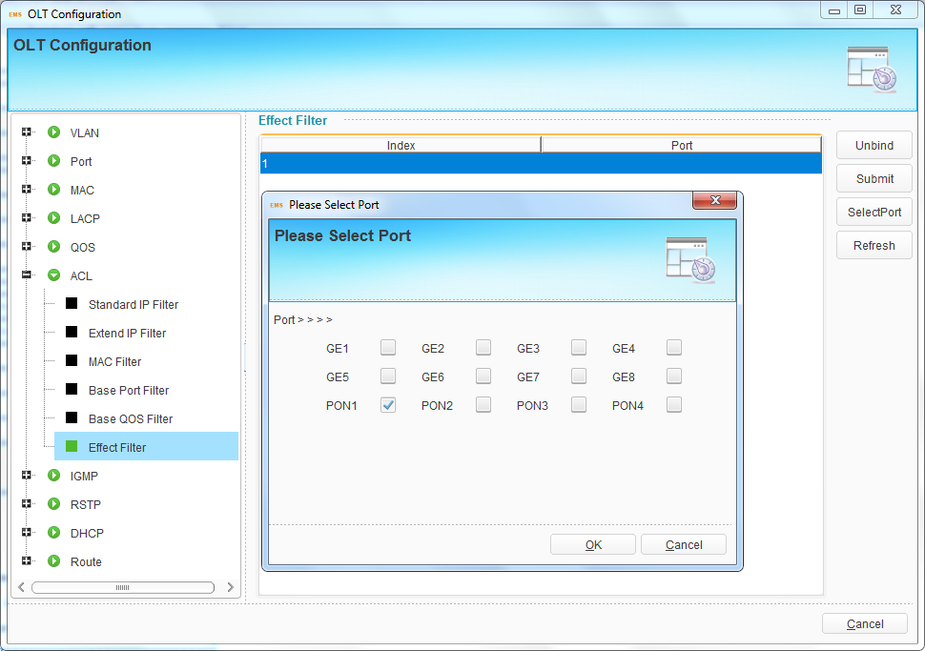
Figure 6-36 ACL Port Binding

6.3.7 IGMP Configuration

6.3.7.1 Group Member
When there is a multicast group produced, the group will display in this table.
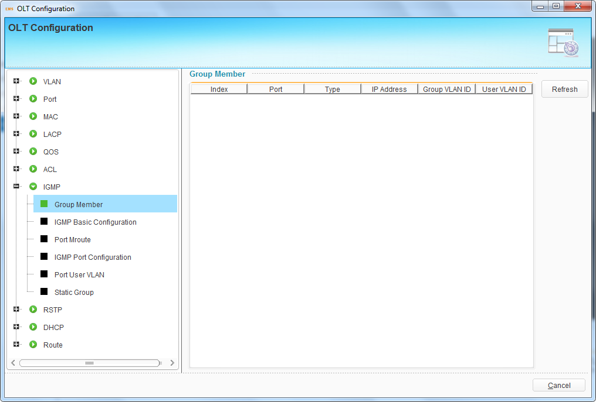
Figure 6-37 Multicast Group Member

6.3.7.2 IGMP Basic Configuration
IGMP basic configuration mainly contains parameters of query packet.
When IGMP status is checked, OLT works at IGMP snooping mode. IGMP snooping is the process of listening to Internet Group Management Protocol (IGMP) network traffic. The feature allows a network switch to "listen in" on the IGMP conversation between hosts and routers. By listening to these conversations, the switch maintains a map of which devices need which IP multicast streams. Multicasts may be filtered from the ports which do not need them and thus controls which ports receive specific multicast traffic. When IGMP status is unchecked, OLT works at transparent mode.
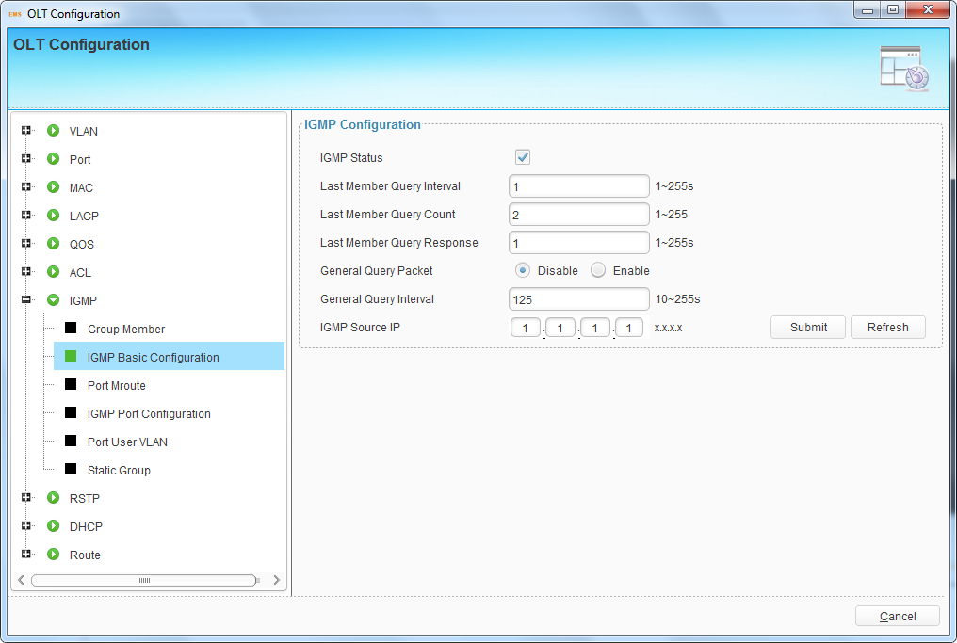
Figure 6-38 IGMP Basic Configuration

6.3.7.3 Port Mroute
Multicast router port is used to transmit IGMP signal messages. Generally, OLT uplink ports should be set as multicast router ports.
Click “Add” button, select a port and correct multicast VLAN, then click “Submit” button to apply the configurations.
Select an index and click “Delete” button to delete it.
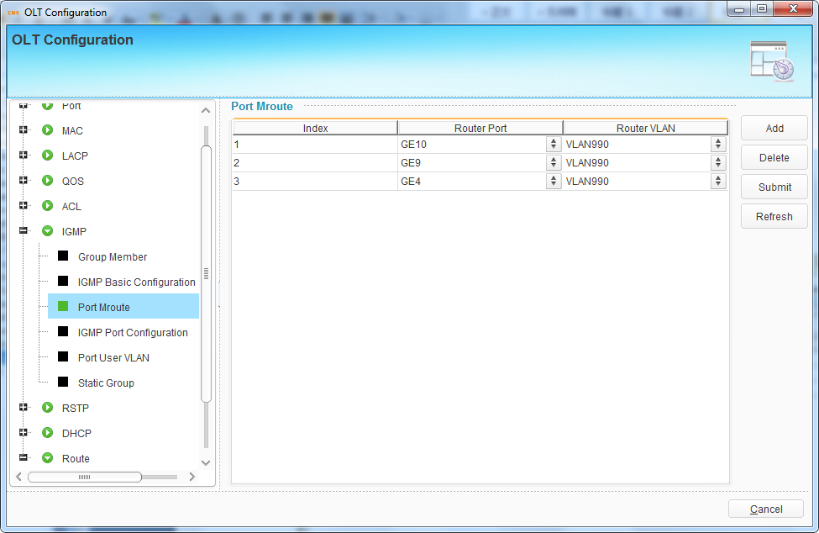
Figure 6-39 Multicast Router Port

6.3.7.4 IGMP Port Configuration
This configuration is used to set the maximum number of multicast groups, IGMP VLAN mode of ports and fast leave mode.
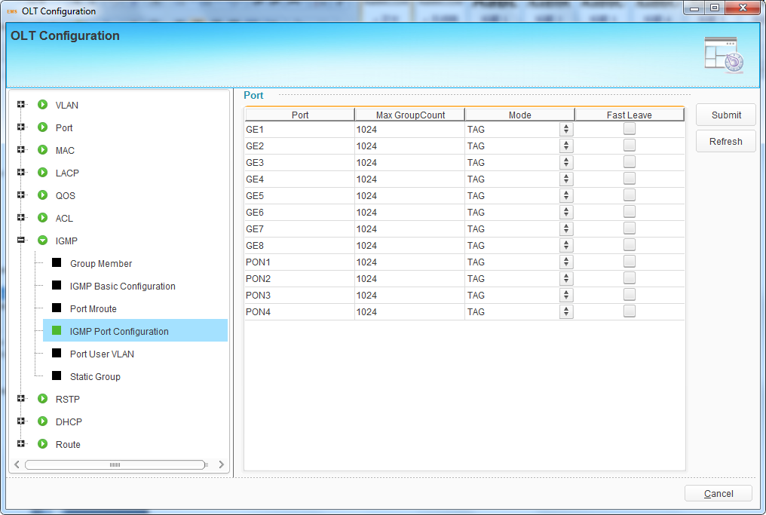
Figure 6-40 IGMP Port Configuration

6.3.7.5 Multicast VLAN—GPON
This configuration is used to set PON’s unknown multicast and IGMP process mode.
Step1. Click ‘Add’ button to add a new multicast vlan operation record.
Step2. Click ‘multicast vlan’, enter the correct value.
Step3. Select unknown multicast packet process mode. Default value is drop.
Step4. Select igmp packet process mode. Default value is trap-to-cpu.

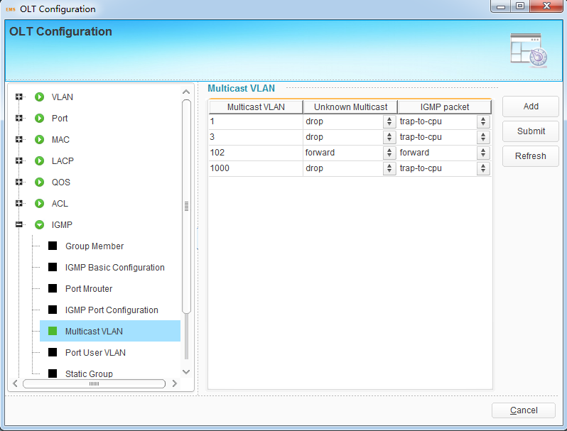
Figure 6-41 Multicast vlan operation

6.3.7.6 Port User VLAN
This configuration is used to configure IGMP VLAN for OLT. Generally, PON ports should be configured, and user VLAN and group VLAN are the same. If user VLAN and group VLAN are different, multicast VLAN will be translated.
Click “Add” button, select a port and correct user VLAN and group VLAN, then click “Submit” button to apply the configurations.
Select an index and click “Delete” button to delete it.
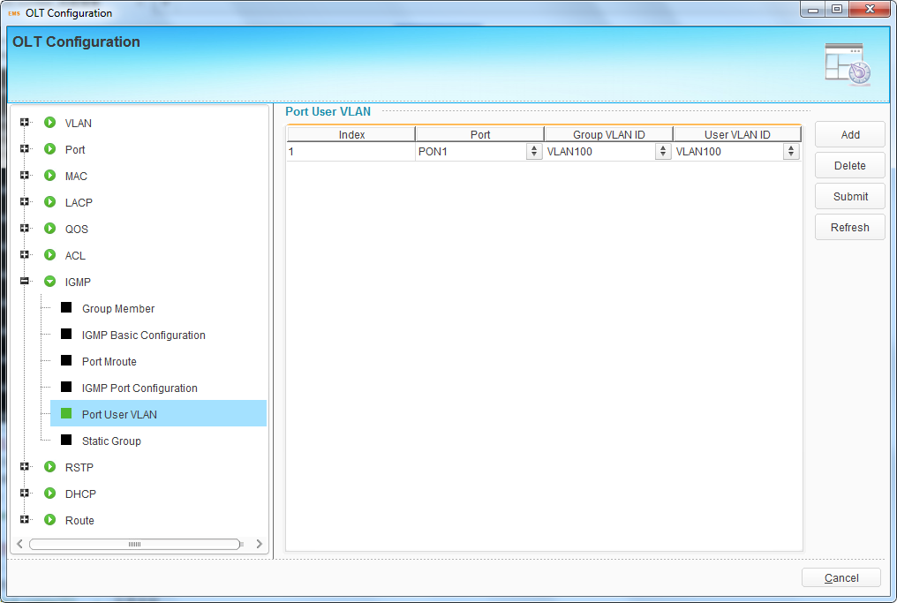
Figure 6-42 IGMP VLAN Configuration

6.3.7.7 Static Group
This configuration is used to bind multicast IP address and VLAN ID.
Click “Add” button, select a port and correct multicast VLAN, fill in multicast IP address, then click “Submit” button to apply the configurations.
Select an index and click “Delete” button to delete it.
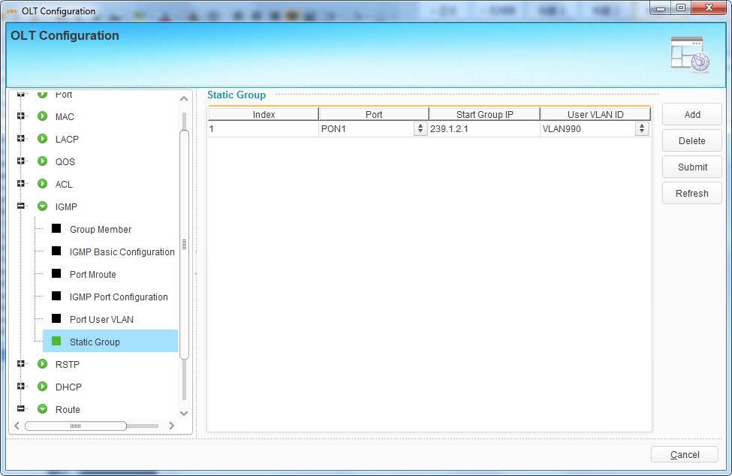
Figure 6-43 Static Group Configuration

6.3.8 RSTP Configuration
Spanning Tree Protocol is layer2 protocol, which is used to eliminate network loop by blocking network redundant links selectively. It has the feature of link backup as well.

6.3.8.1 Global Information
Global information mainly displays RSTP parameters of root bridge device.
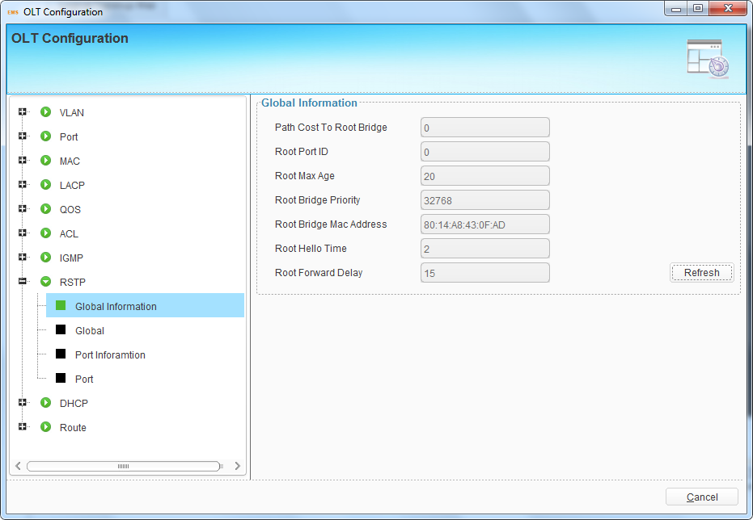
Figure 6-44 RSTP Global Information

6.3.8.2 Global Configuration
This configuration is used to set RSTP parameters of the device, which contains RSTP switch, priority, hello time, max age, forward delay and MAC address.
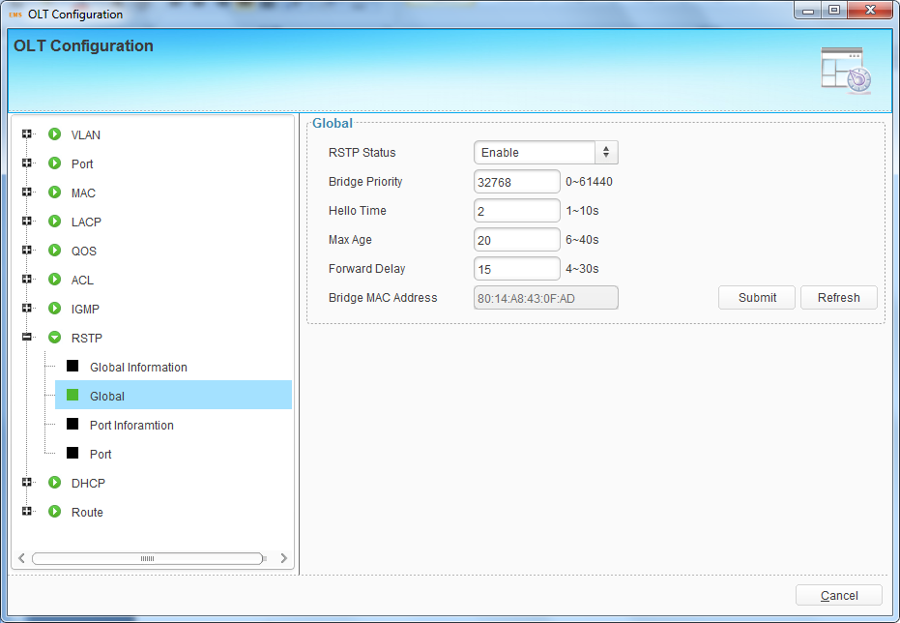
Figure 6-45 RSTP Global Configuration

6.3.8.3 Port Information
Port information displays the status and RSTP parameters of all active ports.
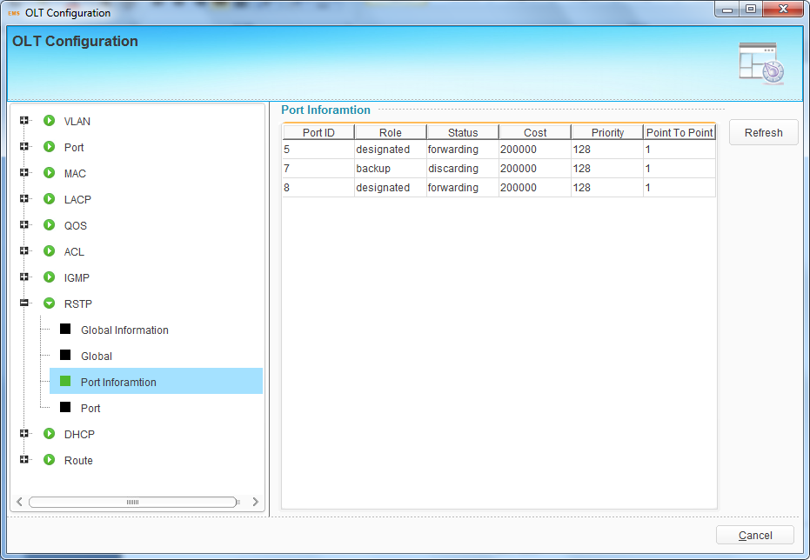
Figure 6-46 RSTP Port Information

6.3.8.4 Port Configuration
This user interface is used to set port RSTP parameters which contain RSTP switch, priority, cost, edge port and p2p port.
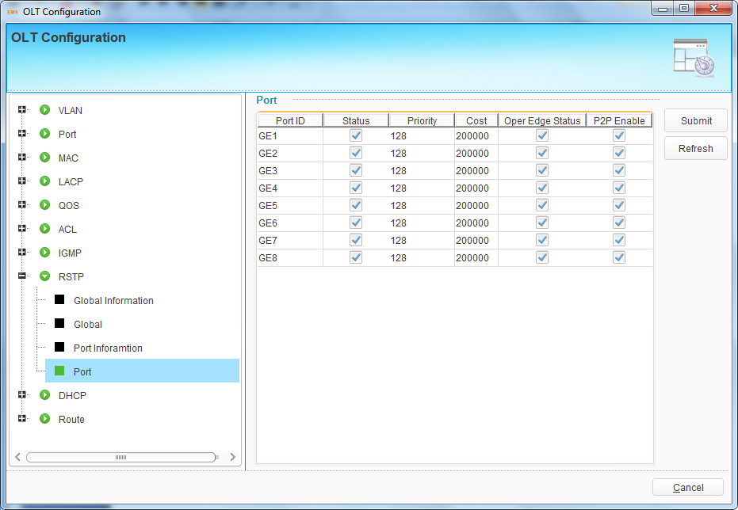
Figure 6-47 RSTP Port Configuration

6.3.9 DHCP Configuration
OLT can support the following DHCP functions.
- DHCP Server
- DHCP Relay
- DHCP Snooping

6.3.9.1 Server Configuration
Sometimes the devices need dynamic IP addresses, but there is no special DHCP server in network. These configurations can solve the problem. OLT will be a DHCP server in network and assign IP addresses to other devices.
Before enabling DHCP server, you must configure IP address for the VLAN.
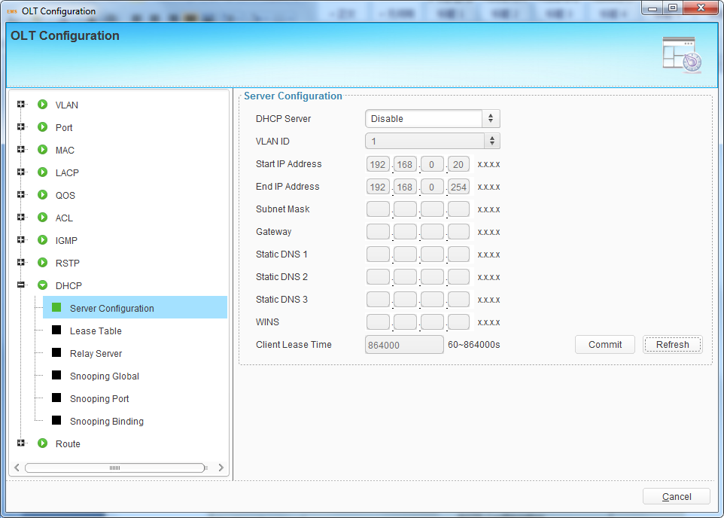
Figure 6-48 DHCP Server Configuration

6.3.9.2 Lease Table
This table displays IP addresses assigned and their MAC addresses, lease time.
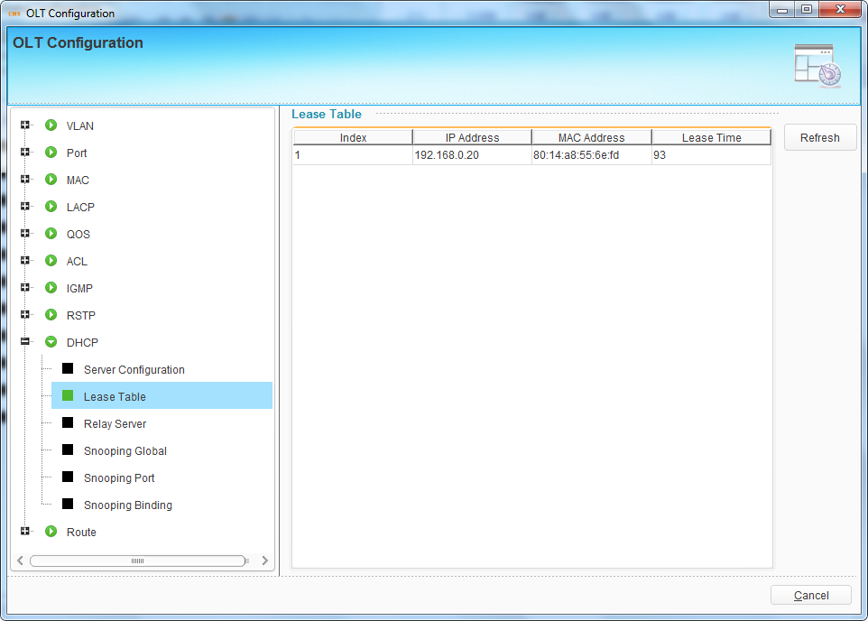
Figure 6-49 DHCP Lease Table

6.3.9.3 Relay Server
Because the DHCP service exists in one broadcast domain, the server and the client are usually in the same network segment. DHCP relay can solve the issue that DHCP server and client do not exist in the same network segment.
Click “Add” button, select a VLAN and fill in DHCP server IP address, then click “Submit” button to apply configurations.
Select an item and click “Delete” button to delete it.
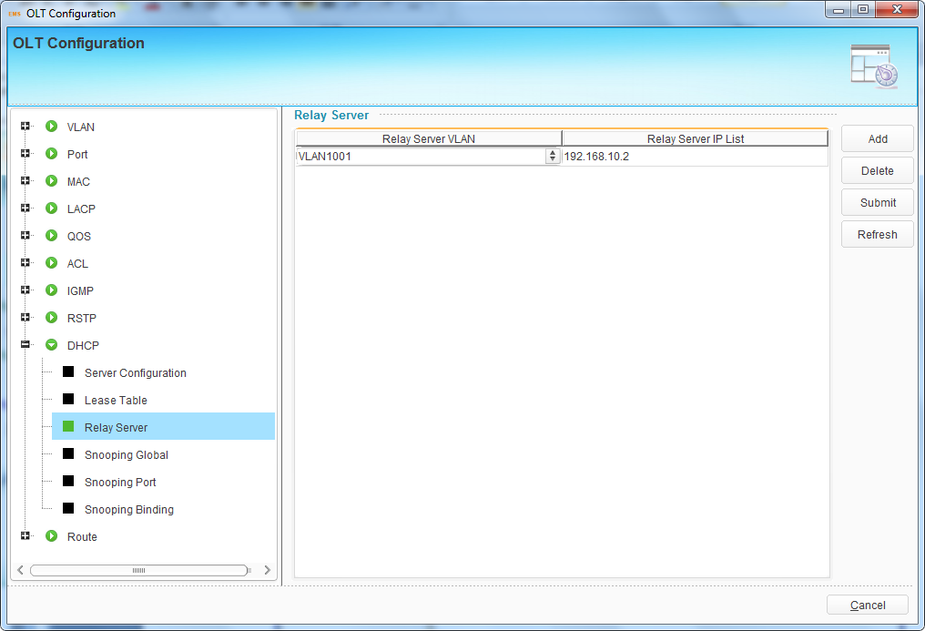
Figure 6-50 DHCP Relay Configuration

6.3.9.4 Snooping Global
DHCP Snooping is used to prevent the DHCP message attacking and guarantee network to get a correct IP address.
DHCP snooping global configuration mainly contains option 82 settings, DHCP traffic rate limit and snooping VLAN.
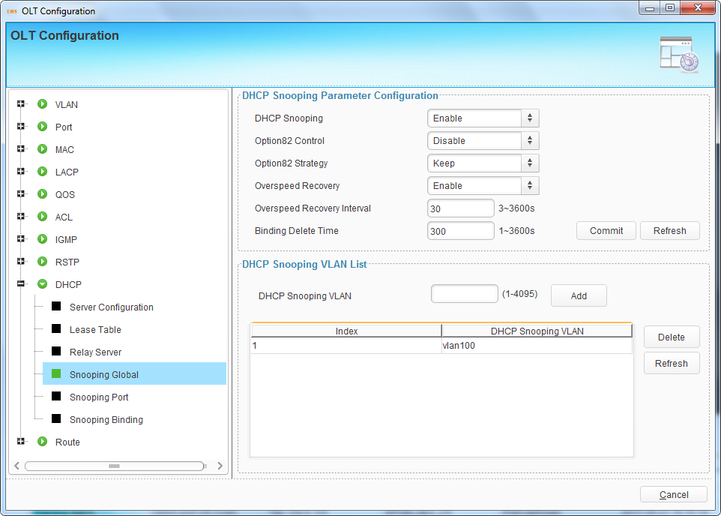
Figure 6-51 DHCP Snooping Global Configuration

6.3.9.5 Snooping Port
This user interface is used to configure DHCP snooping parameters of ports which contain port type, option 82 parameters and rate limit.
All the ports are untrust ports by default. Option82 parameters, “Option 82 Circuit ID” and “Option 82 Remate ID”, are effective for untrust ports. “Limit Rate” is the ports’ max speed of receiving DHCP packets.
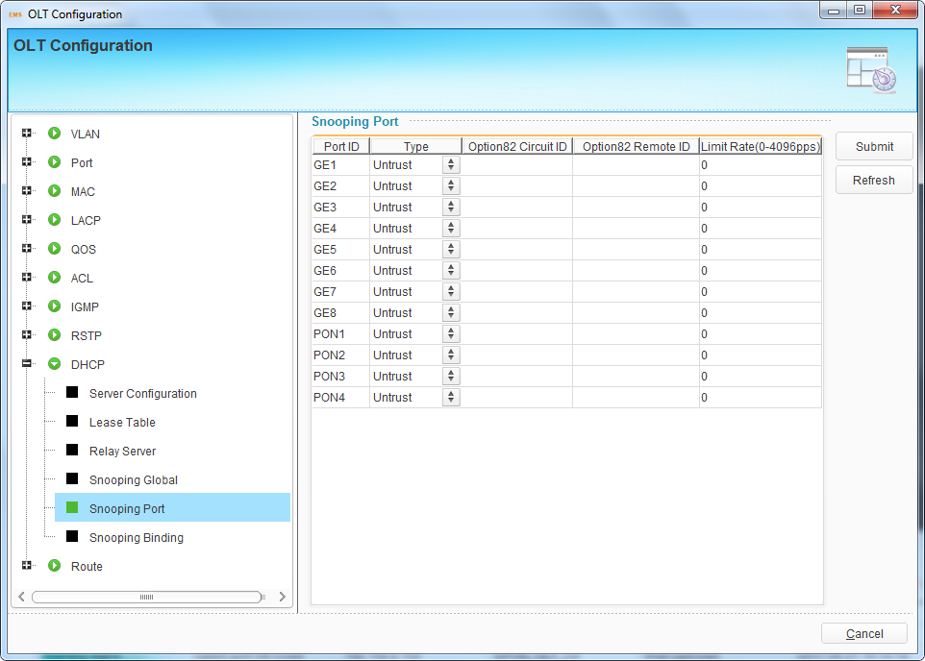
Figure 6-52 DHCP Snooping Port Configuration

6.3.9.6 Snooping Binding
DHCP snooping binding is useful when a host needs a fixed IP address assigned by DHCP server from the specific port.
Click “Add” button to open a pop-up dialog box, fill in all the parameters, select ports and click “OK” button to apply configurations.
Select an item and click “Delete” button to delete it.
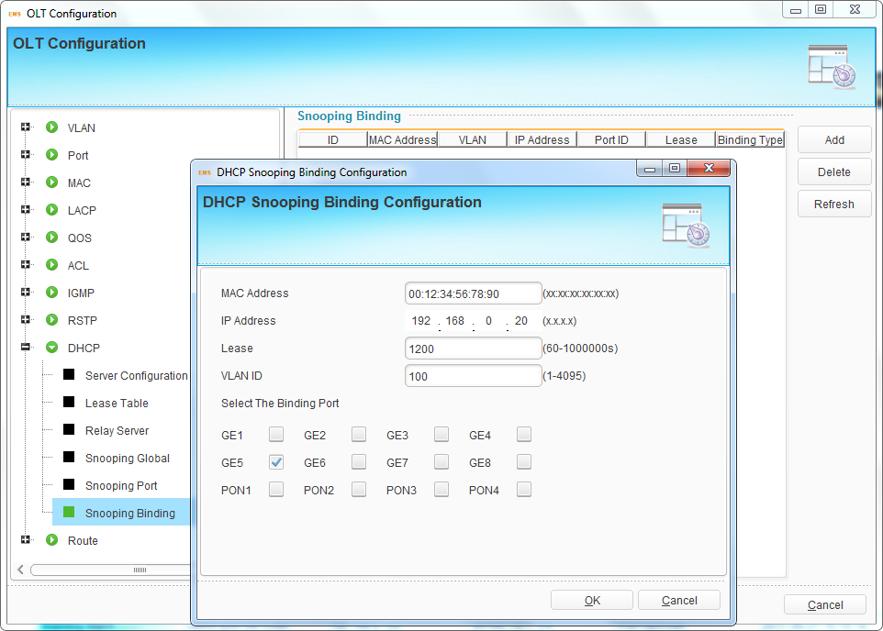
Figure 6-53 DHCP Snooping Binding

6.3.10 Route Configuration

6.3.10.1 VLAN IP
This configuration is used to configure IP address for VLAN. When the VLAN is added to a port, you can access OLT by the IP address from the port.
Click “Add” button, select a VLAN and fill in IP address and mask, then click “Submit” button to apply configurations.
Select an item and click “Delete” button to delete it.
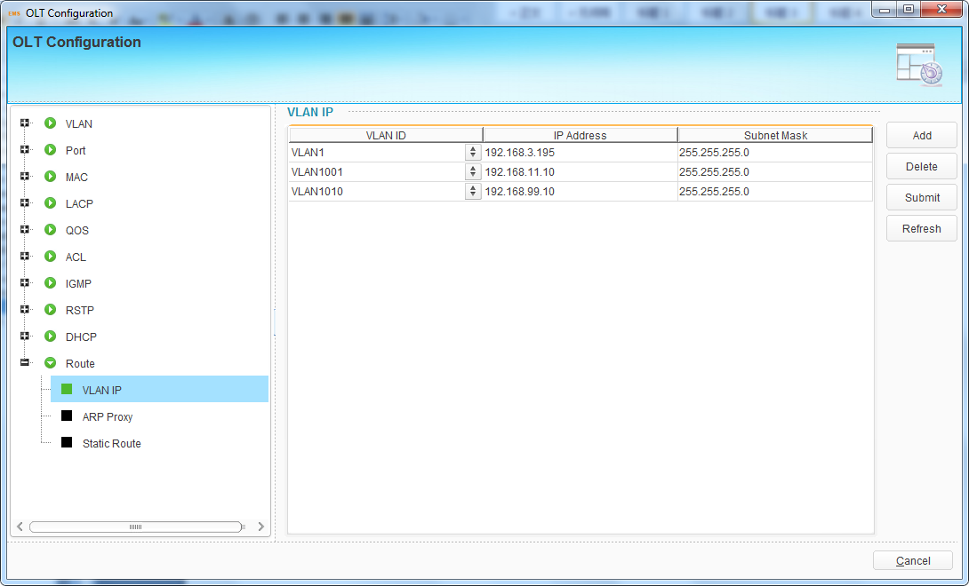
Figure 6-54 VLAN IP Configuration

6.3.10.2 ARP Proxy
ARP Proxy is a technique by which a device on a given network answers the ARP queries for a network address that is not on that network. The ARP Proxy is aware of the location of the traffic's destination, and offers its own MAC address as (ostensibly final) destination. The "captured" traffic is then typically routed by the Proxy to the intended destination via another interface or via a tunnel.
The process which results in the node responding with its own MAC address to an ARP request for a different IP address for proxying purposes is sometimes referred to as 'publishing'.
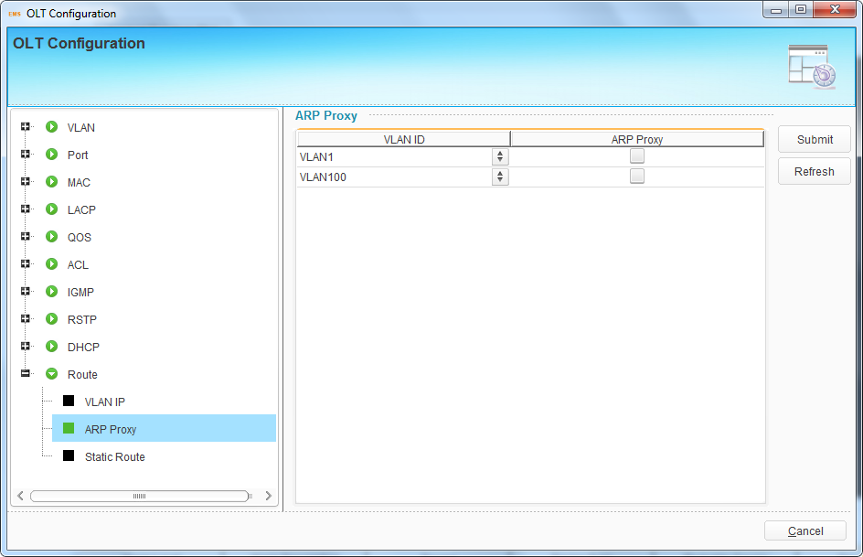
Figure 6-55 ARP Proxy

6.3.10.3 Static Route
Static route is a form of routing that a router uses a manually-configured routing entry. In many cases, static routes are manually configured by a network administrator. Unlike dynamic routing, static routes are fixed and do not change if the network is changed or reconfigured.
The OLT only supports static route. After configured VLAN IP address, add static routes to make the network on the different network segment communicate with each other.
Click “Add” button, fill in destination network address, mask, and gateway, then click “Submit” button to apply configurations.
Select an item and click “Delete” button to delete it.
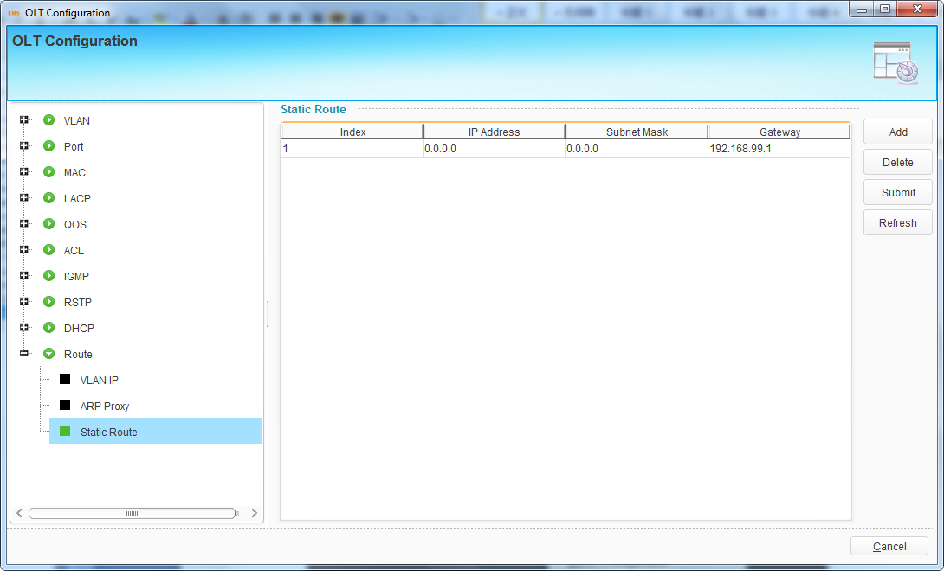
Figure 6-56 Static Route

6.4 OLT Maintenance Management

6.4.1 Save Device Config
When configurations are completed or changed, you should save them to flash so that they will not get lost after OLT restart or power off.
Right click OLT icon, choose "Maintenance Management" > "Save Device Config" to open a pop-up dialog box.
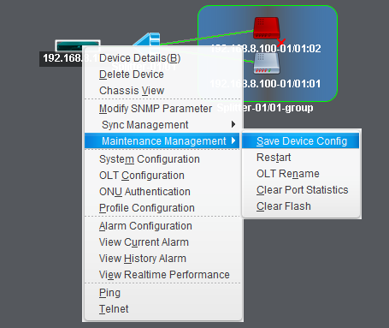
Figure 6-57 Save Device Configurations
Click "Yes" button to save the current device configuration.
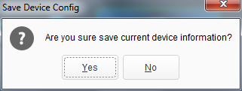
Figure 6-58 Save Configurations Dialog Box

6.4.2 Restart
This command is used to restart OLT. It will cause all services interruption, be careful to execute.
Right click OLT icon, choose " Maintenance Management" >" Restart" to open a pop-up dialog box.
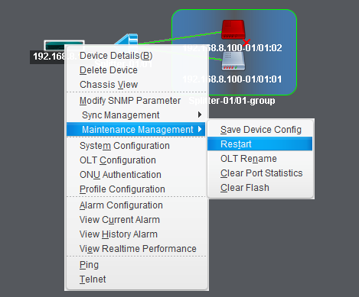
Figure 6-59 Restart Device
Click "Yes" button to restart OLT.
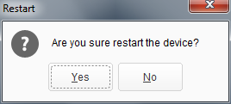
Figure 6-60 Restart Device Dialog Box

6.4.3 OLT Rename
You can change OLT name so that it is easily to be recognized when there are many devices in EMS.
Right click OLT icon, choose " Maintenance Management" >" OLT Rename" to open a pop-up dialog box.
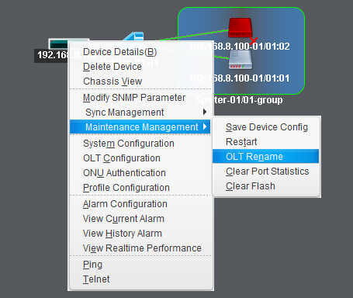
Figure 6-61 OLT Rename
Fill in OLT name and click “OK” button to apply.
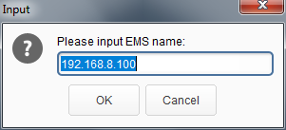
Figure 6-62 OLT Rename dialog Box

6.4.4 Clear Port Statistics
This command is used to clear statistics of all OLT ports.
Right click OLT icon, choose " Maintenance Management" >" Clear Port Statistics" to open a pop-up dialog box.
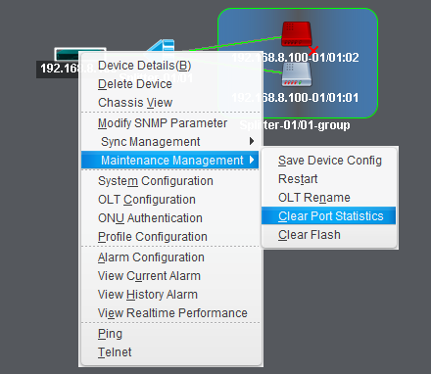
Figure 6-63 Clear Port Statistics
Click “Yes” button to clear statistics of all ports.
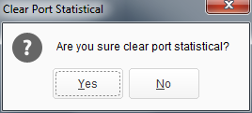
Figure 6-64 Clear Port Statistics Dialog Box

6.4.5 Clear Flash
This command is used to clear OLT configurations that have saved in flash. It will make OLT restore to factory default settings. OLT will restart automatically after configurations are cleared.
Right click OLT icon, choose " Maintenance Management" >" Clear Flash" to open a pop-up dialog box.
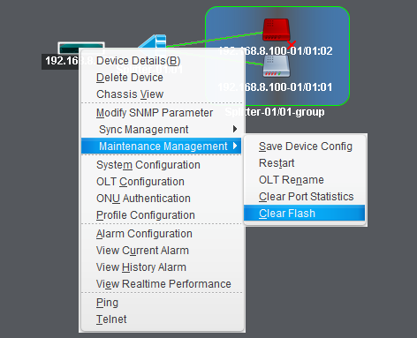
Figure 6-65 Clear Flash
Click “Yes” button to clear flash.
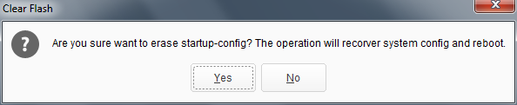
Figure 6-66 Clear Flash Dialog Box

7. ONU Authentication--EPON
This chapter mainly introduces ONU authentication.
Right click OLT icon, choose “ONU Authentication” to open the authentication configuration interface.
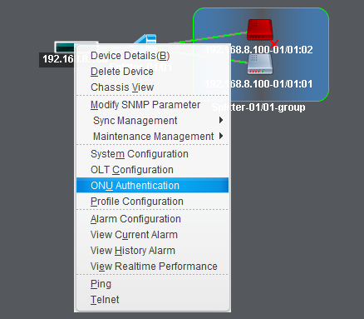
Figure 7-1 ONU Authentication

7.1 ONU Authentication

7.1.1 Authentication Mode
Authentication mode contains MAC, LOID, Hybrid mode and None. If don’t want unkown ONU to register, you should select MAC, LOID or Hybrid mode. In this case, ONU must be added into white list.
You must add MAC white list when using MAC authentication mode while add LOID white list when using LOID authentication mode. Add either MAC or LOID white list when using hybrid authentication mode.
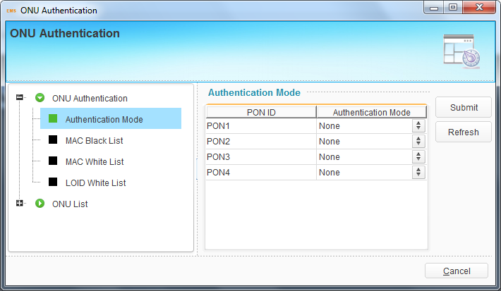
Figure 7-2 Authentication Mode

7.1.2 MAC Black List
MAC black list is used to block ONU to be authenticated even it has been added into white list. The MAC black list is also effective for LOID authentication mode and none authentication mode.
Click “Add” button, fill in MAC address, then click “Submit” button to apply the configurations.
Select an item and click “Delete” button to delete it.
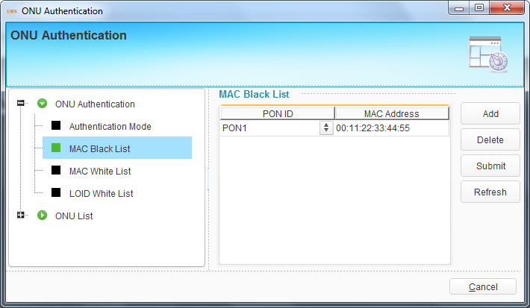
Figure 7-3 MAC Black List

7.1.3 MAC White List
When using MAC or hybrid authentication mode, the ONUs in MAC white list can be authenticated.
Click “Add” button, fill in MAC address, then click “Submit” button to apply the configurations.
Select an item and click “Delete” button to delete it.
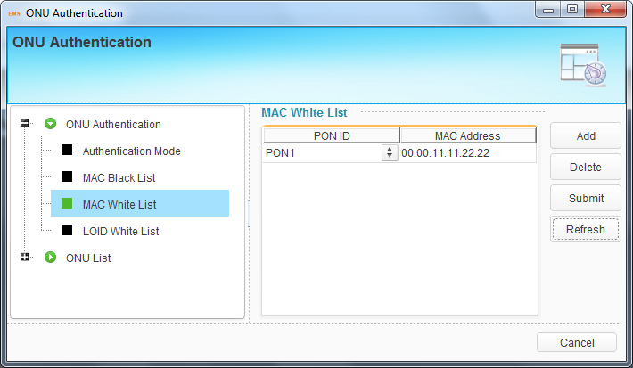
Figure 7-4 MAC White List

7.1.4 LOID White List
When using LOID or hybrid authentication mode, the ONUs in LOID white list can be authenticated. Both LOID and password are required, but OLT will not check if there is only LOID configured in ONU. Otherwise, OLT will check both.
Click “Add” button, fill in LOID and password, then click “Submit” button to apply the configurations.
Select an item and click “Delete” button to delete it.
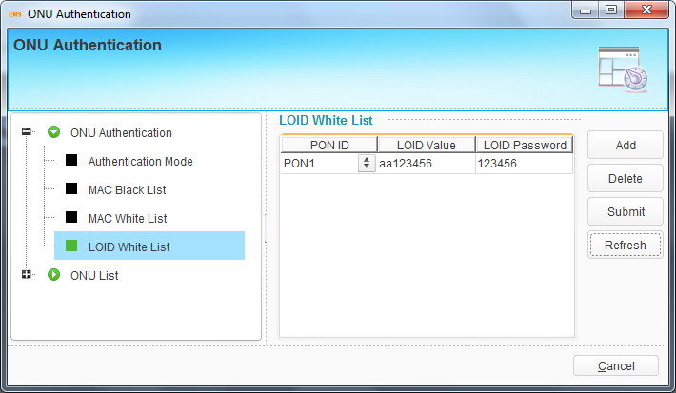
Figure 7-5 LOID White List

7.2 ONU List

7.2.1 Authenticated ONU
All ONUs which are authenticated successful will be displayed in this interface.
You can do some operations, such as reset, reregister or unauthenticate, to all ONUs that connect to the PON port.
Reset is to make all ONUs under the port restart. Reregister is to make all ONUs register again. UnAuth is to remove all ONUs from OLT.
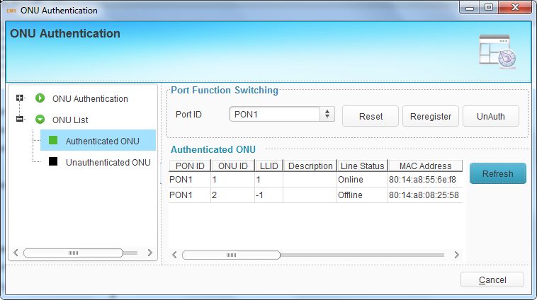
Figure 7-6 Authenticated ONU

7.2.2 Unauthenticated ONU
All ONUs which are authenticated failed or not authenticated will be displayed in this interface.
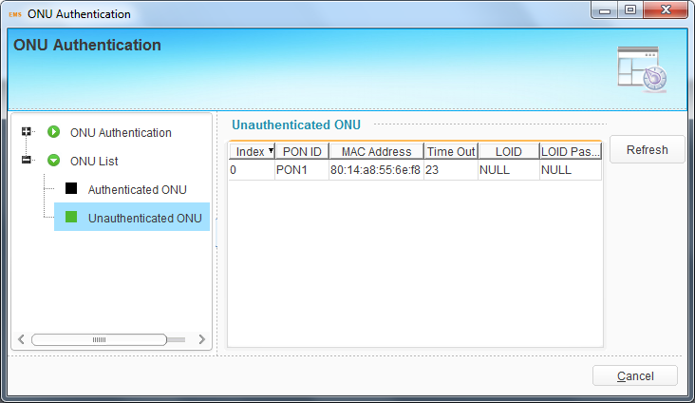
Figure 7-7 Unauthenticated ONU

8 Profile Configuration--EPON
This chapter introduces profile configuration of ONU. According to the characteristics of multiple services (data, voice, alarm) integrated in an ONU, and there would be huge quantity terminals but their configurations are similar, it is necessary to configure these similar configurations in a profile and bind it to ONU.
OLT supports the following profile:
- DBA profile
- Service profile
- VoIP profile
- Alarm profile
Right click OLT icon, choose “Profile Configuration” to open the configuration interface.
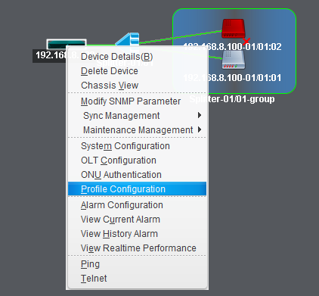
Figure 8-1 Profile Configuration

8.1 Profile Configuration

8.1.1 DBA Profile
DBA is a bandwidth allocation strategy that changes uplink bandwidth assigned to each ONU in real time according to the instant service status of each ONU.
Click “Add” button to create profile ID, then select a profile ID and fill in bandwidth parameters. Click “Submit” button to apply the configurations. If the profile has been bound to ONU and DBA parameters are changed, you need to click “Commit” button to take effect.
The upstream WRR weight will be used to compute the remaining bandwidth allocation after fixed rate of each ONU has been guaranteed. The downstream WRR weight will reference to the global 16 PON weights and only work when the ONU egress shaper is disabled.
When need to delete DBA profile, select the profile ID and click “Delete” button.
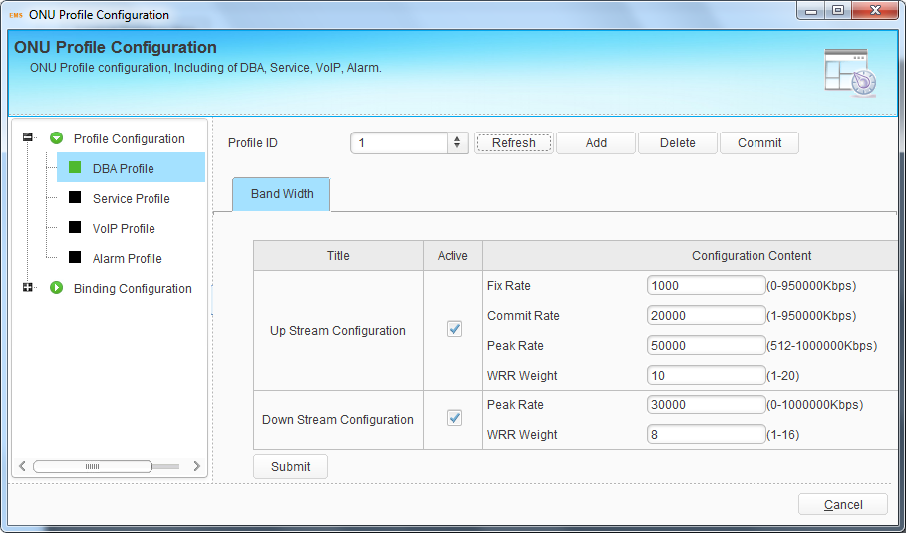
Figure 8-2 DBA Profile

8.1.2 Service Profile
It can be configured most data services of ONU by service profile. Service profile applies to configurations of a batch of ONU which have similar data service configurations.
Click “Add” button to create profile ID, select a profile ID and configure service parameters of the profile. Click “Submit” button to apply the configurations. If the profile has been bound to ONU and service parameters are changed, you need to click “Commit” button to take effect.
The sections below will introduce service configurations related to ONU port, QoS, IGMP, WAN connection, WIFI and so on.

8.1.2.1 LAN Count
This configuration specifies the number of ONU LAN port. It must be configured before configuring other parameters related to LAN port.
Fill in the LAN count and click “Submit” button to apply configuration.
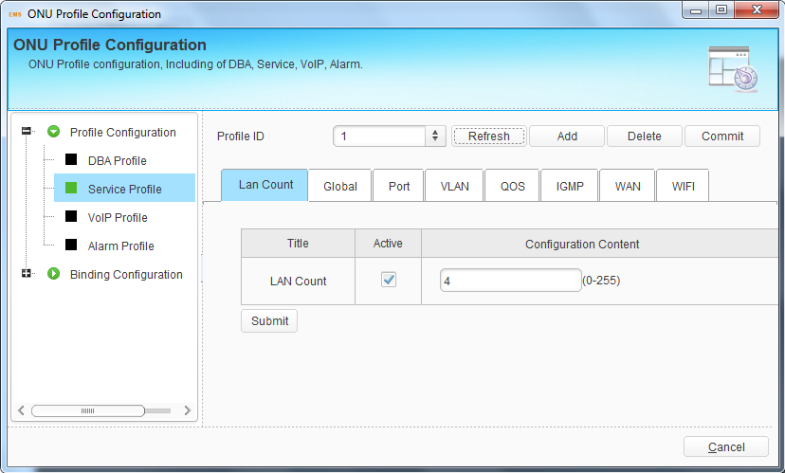
Figure 8-3 LAN Count Configuration
LAN count must be configured before configuring other parameters related to LAN port.

8.1.2.2 Global
This configuration is used to configure ONU global parameters.
Fill in the aging time and click “Submit” button to apply configuration.
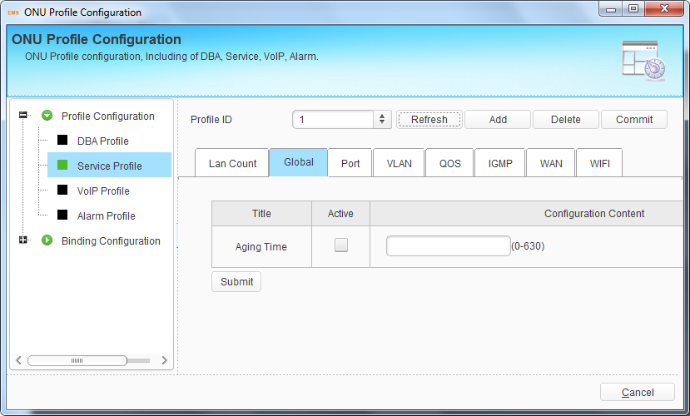
Figure 8-4 Global Configuration

8.1.2.3 Port
Port configuration is mainly used to configure Ethernet port attributes. These configurations contain administration status, flow control, loop, auto-negotiation and rate.
Select one port or all, activate the option which needs to configure. Click “Submit” button to apply configurations.
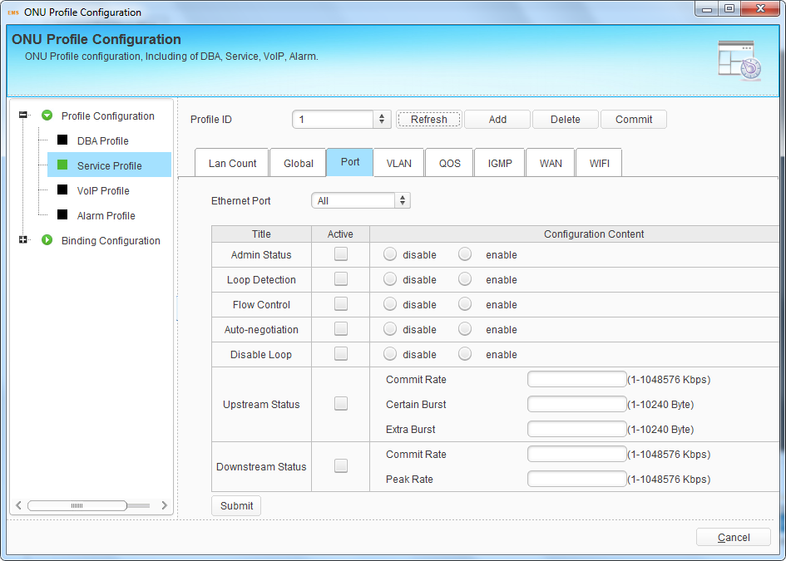
Figure 8-5 Port Configuration

8.1.2.4 VLAN
This is VLAN profile for ONU LAN port. There are transparent, tag, translation, aggregation and trunk mode. Maximum eight VLAN rules can be configured for each port when choosing translation, aggregation and trunk mode.
Select one port or all, activate VLAN option and configure VLAN mode and VLAN ID. Click “Submit” button to apply configurations.
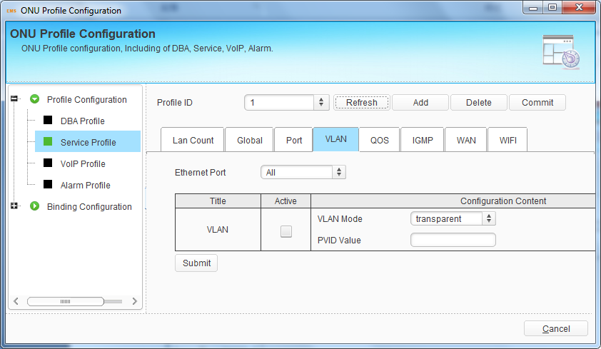
Figure 8-6 VLAN Configuration

8.1.2.5 QoS
This is QoS profile for ONU LAN port. When matches the conditions that have been configured, the data traffic will be set with new priority and mapped to the queue. When bandwidth is not enough or there is congestion, QoS configurations can make sure high priority data traffic passes through the device firstly. The conditions include MAC address, IP address, VLAN, Ethernet type, TCP/UDP port, etc. You can select one or more options to configure.
Click “Submit” button to apply the configurations. QoS rules will display in the table at the bottom of the interface.
Select QoS rule in the table and click “Delete” to delete it.
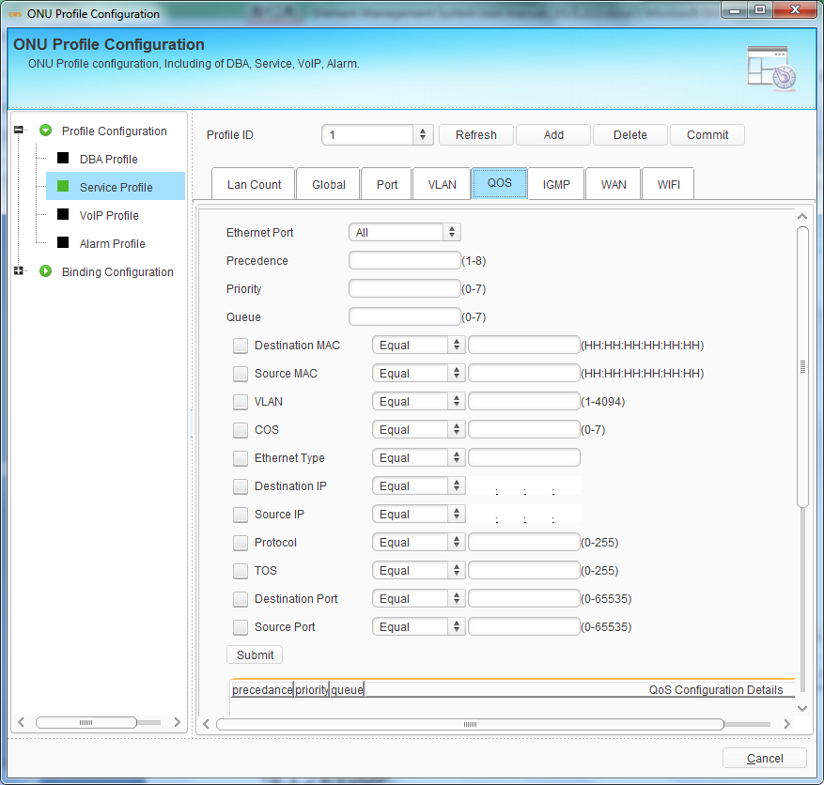
Figure 8-7 QoS Configuration

8.1.2.6 IGMP
This is IGMP profile for ONU. When the ONU is used for IPTV service, IGMP configurations are required. IGMP global configurations contain fast leave mode and multicast mode. IGMP port configurations contain multicast VLAN and maximum group. Maximum eight VLAN rules can be configured for each port.
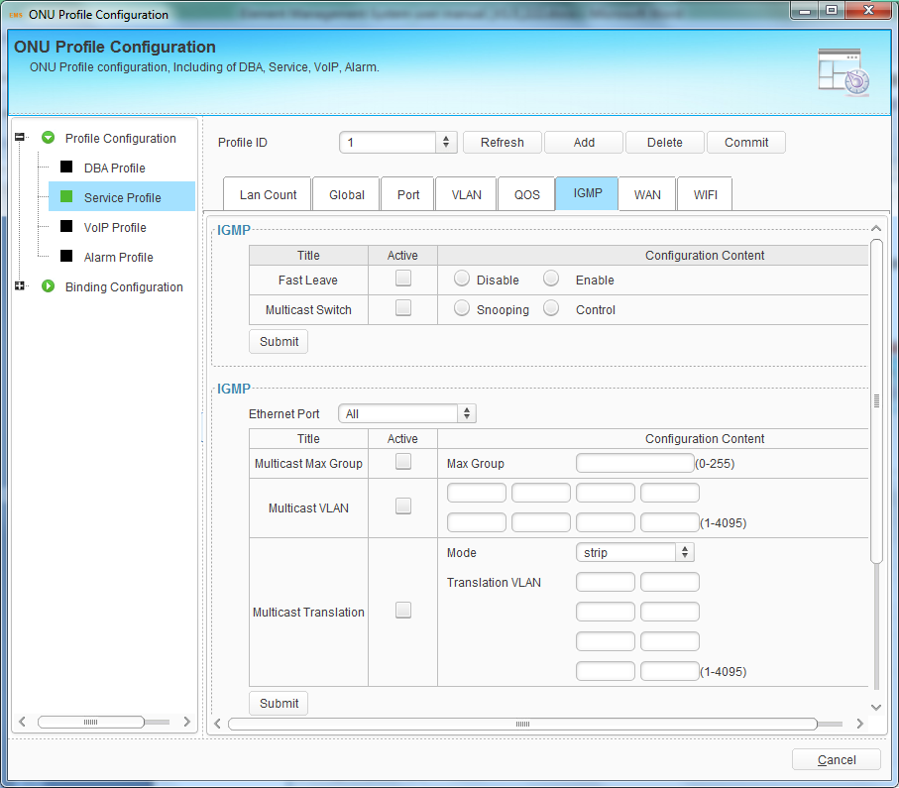
Figure 8-8 IGMP Configuration

8.1.2.7 WAN
This is WAN profile for HGU. You should add a bridge mode or router mode WAN connection firstly, and then configure other parameters of the WAN connection. It doesn’t apply to a batch of ONU when using static IP address.
The WAN connections will display in the table at the bottom of the interface. Select WAN connection in the table and click “Delete” to delete it.
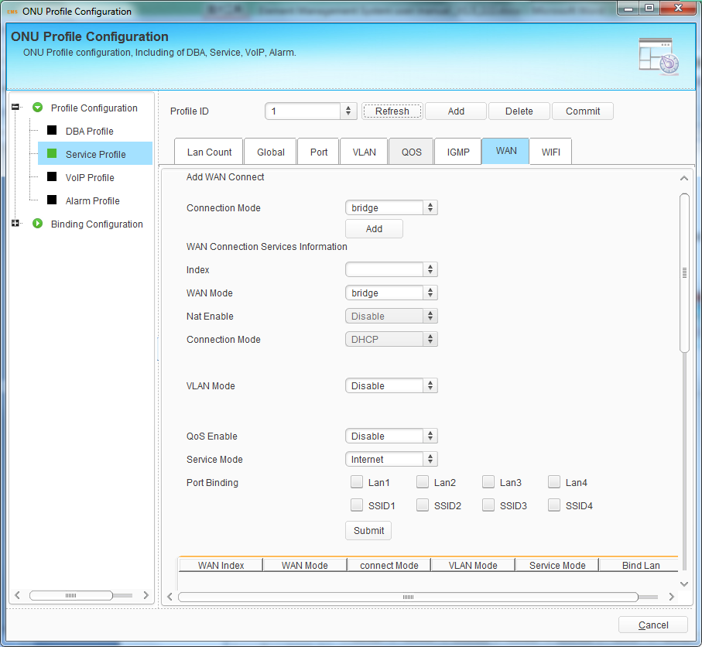
Figure 8-9 WAN Configuration

8.1.2.8 WIFI
This is WIFI profile for ONU. WIFI switch configuration mainly contains WIFI administration status, country, standard, channel and transmit power. WIFI SSID configuration mainly contains SSID name and encryption for each SSID.
Configurations of each SSID will display in the table at the bottom of the interface. Select SSID in the table and click “Delete” to delete it.
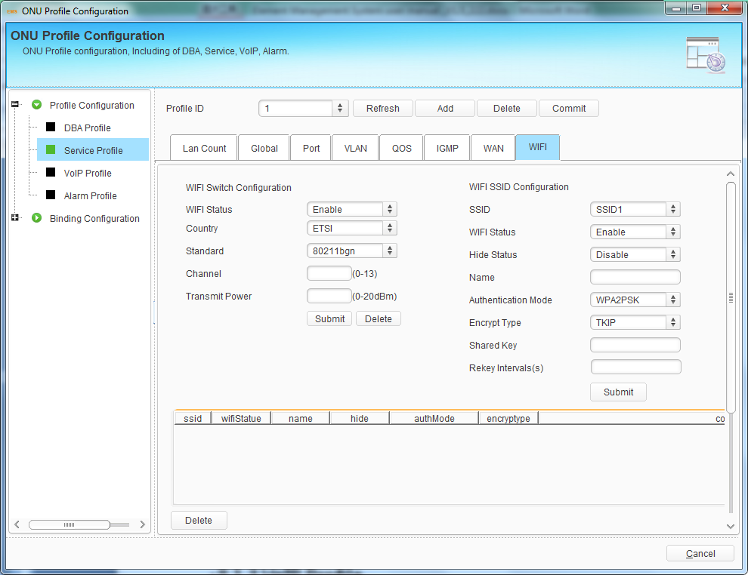
Figure 8-10 WIFI Configuration

8.1.3 VoIP Profile
VoIP profile applies to configuration of a batch ONU which have similar VoIP configurations.
Click “Add” button to create profile ID, select a profile ID and configure VoIP parameters of the profile. Click “Submit” button to apply the configurations. If the profile has been bound to ONU and VoIP parameters are changed, you need to click “Commit” button to take effect.
The sections below will introduce VoIP configurations. The parameters of profile except POTS count are optional configurations.

8.1.3.1 POTS Count
This configuration specifies the number of ONU POTS port. It must be configured before configuring other VoIP parameters related to POTS port.
Fill in the POTS count and click “Submit” button to apply configuration.
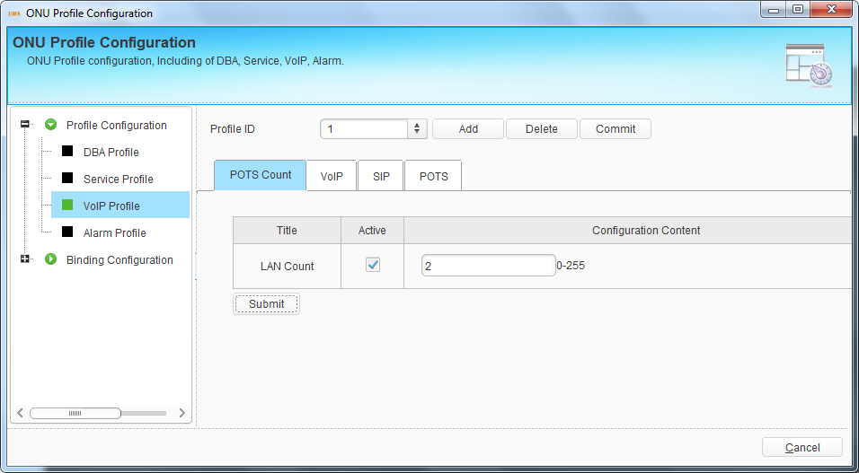
Figure 8-11 POTS Count Configuration
POTS count must be configured before configuring other VoIP parameters related to POTS port.

8.1.3.2 VoIP
This interface is used to configure VoIP global parameters. It mainly contains IP address, VLAN and fax mode. It doesn’t apply to a batch of ONU when using static IP address.
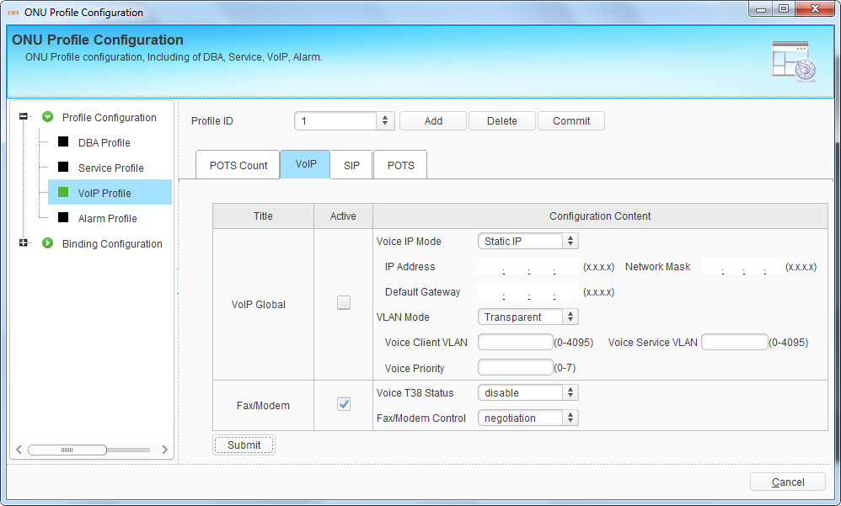
Figure 8-12 VoIP Global Configuration

8.1.3.3 SIP
This interface is used to configure SIP global parameters such as SIP server, proxy server, port, heartbeat, digit map and so on.
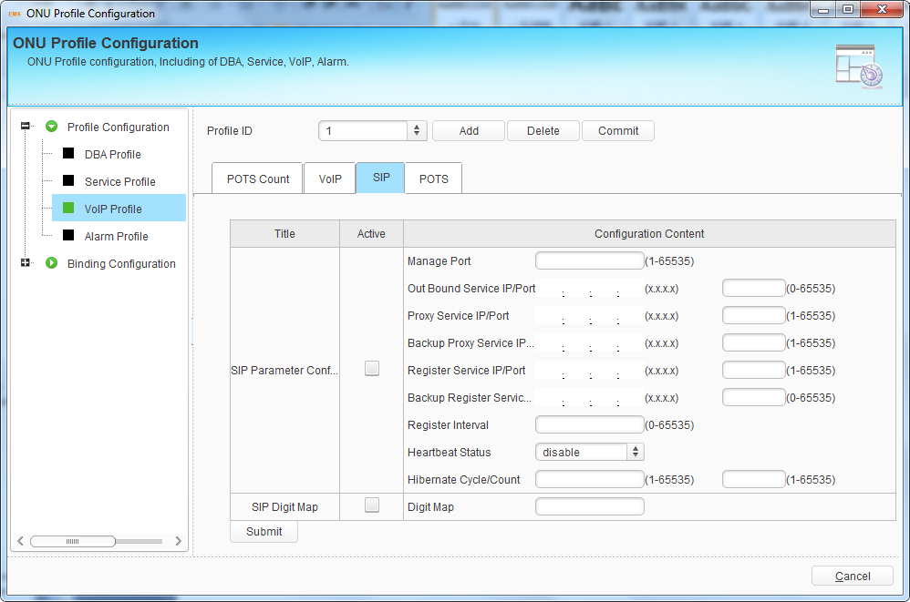
Figure 8-13 SIP Configuration

8.1.3.4 POTS
This interface is used to configure ONU POTS port. The configurations contain POTS port administration status and VoIP account. Because each POTS port has its own VoIP account, POTS profile doesn’t apply to a batch of ONU.
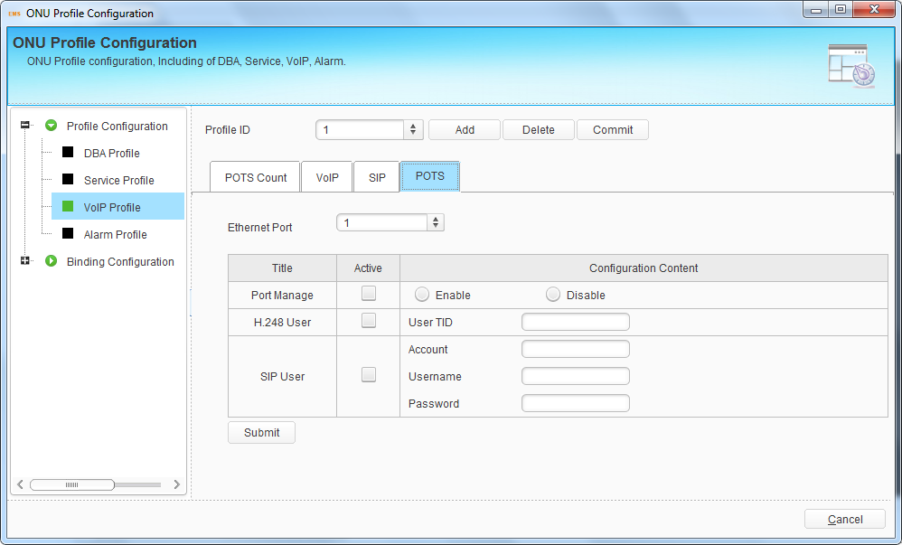
Figure 8-14 POTS Configuration

8.1.4 Alarm Profile
Alarm profile is used to configure all kinds of ONU alarm.
Click “Add” button to create profile ID, select a profile ID and configure alarm of the profile. Click “Submit” button to apply the configurations. If the profile has been bound to ONU and alarm configurations are changed, you need to click “Commit” button to take effect.
The sections below will introduce alarm configurations.

8.1.4.1 ONU Alarm
This interface is used to configure alarms of ONU. Activate alarm type, select enable or disable, or input alarm threshold if needed and click “Submit” button to apply the configurations.
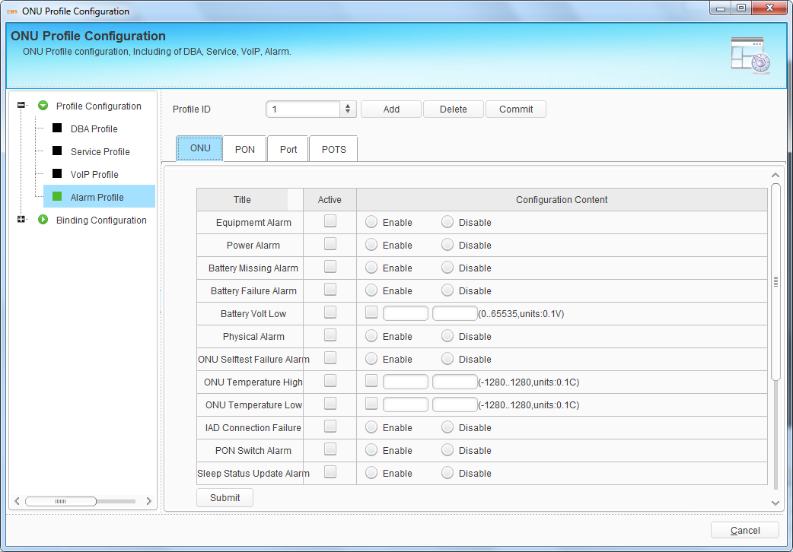
Figure 8-15 ONU Alarm

8.1.4.2 PON Alarm
This interface is used to configure alarms of ONU PON port. Activate alarm type, input alarm threshold and click “Submit” button to apply the configurations.
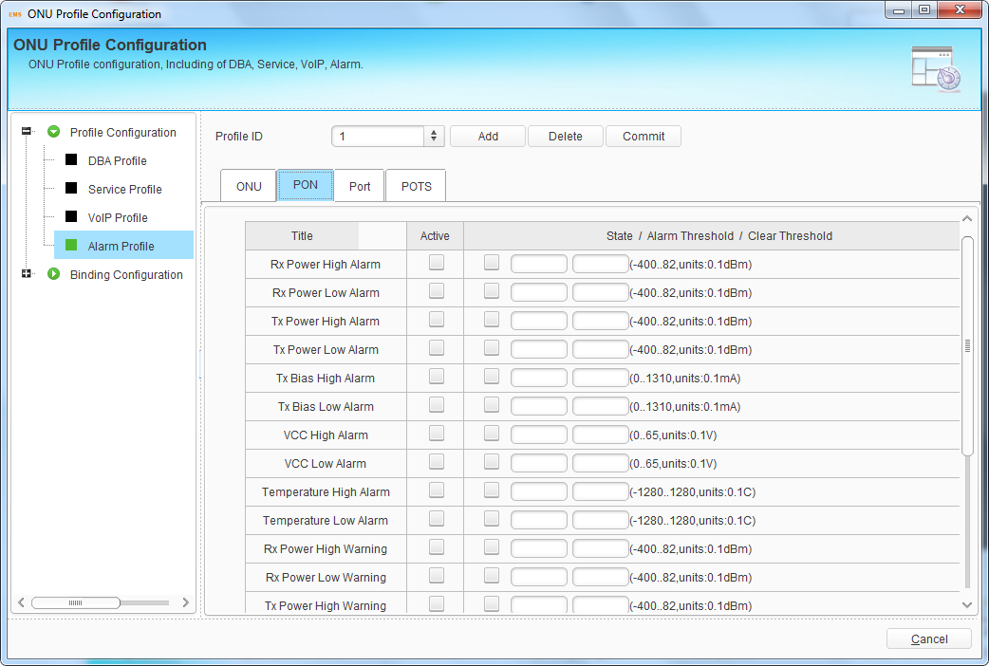
Figure 8-16 ONU PON Alarm

8.1.4.3 Port Alarm
This interface is used to configure alarms of ONU LAN port. Input LAN port number, activate alarm type, and select enable or disable, then click “Submit” button to apply the configurations.
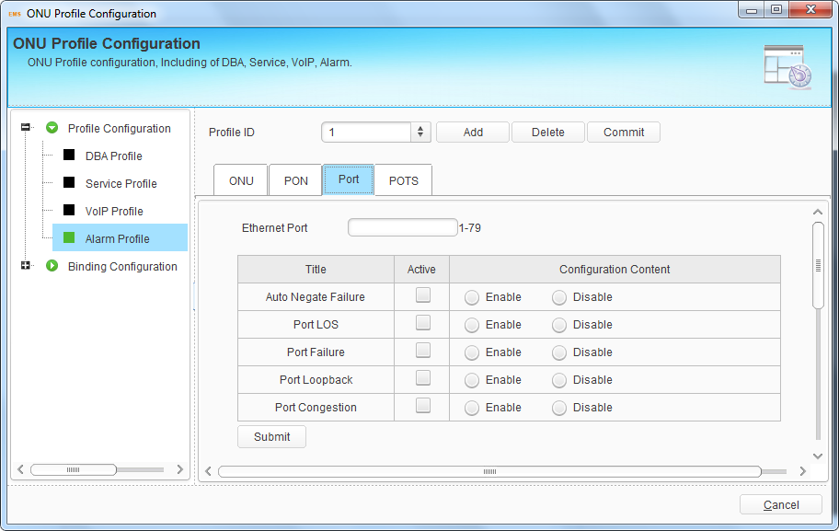
Figure 8-17 ONU Port Alarm

8.1.4.4 POTS Alarm
This interface is used to configure alarms of ONU. Input POTS port number, activate alarm type, and select enable or disable, then click “Submit” button to apply the configurations.
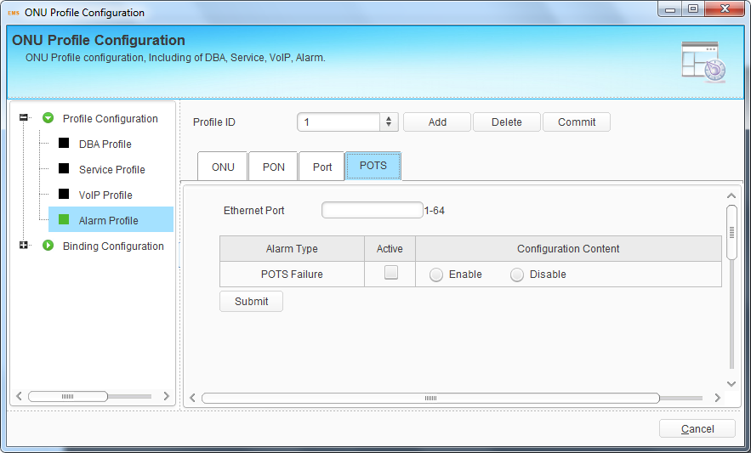
Figure 8-18 ONU POTS Alarm

8.2 Binding Configuration
After profile is configured, it is necessary to bind it to ONU.
Click “Select” button to open a pop-up dialog box, find out the ONU you want to bind and then click “OK” button, the ONU will list in the binding table.
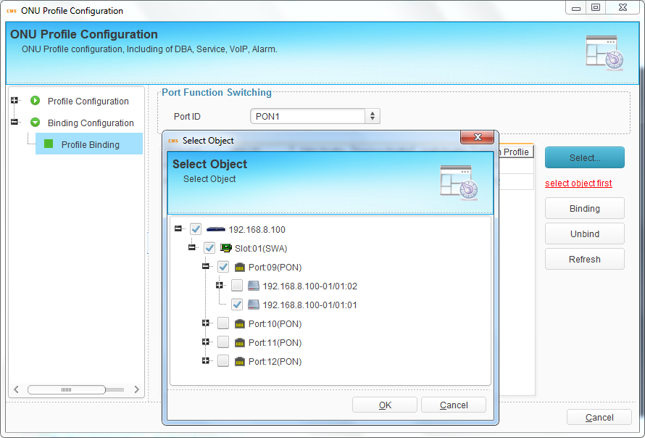
Figure 8-19 Select ONU
Select one or more ONUs in the table, click “Binding” button and select the profile ID, then click “OK” button to apply the configurations. Each ONU can only bind one profile with the same type.
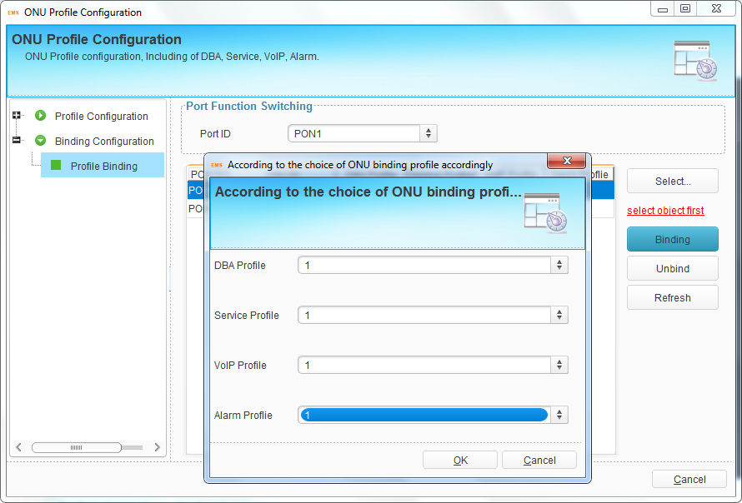
Figure 8-20 Profile Binding
Select one or more ONUs in the table and click “Unbind” button, all profiles will be unbound. If want to unbind part of profiles, you need to unbind them at binding dialog box.

9 ONU Management--EPON
This chapter mainly introduces ONU management function of EMS. ONU management includes ONU system operation and ONU service configuration.

9.1 ONU Basic Information
Choose ONU icon and open right-click menu; click “ONU Detail” to display ONU basic information and ONU user information.
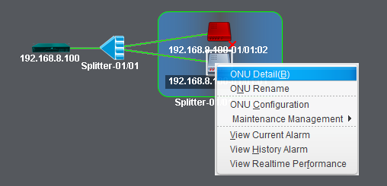
Figure 9-1 Open ONU Device Detail
You can configure ONU description at basic information interface. Click “Submit” button to apply the description and click “View CAP1/2/3” button to display ONU capabilities which are reported by CTC OAM.
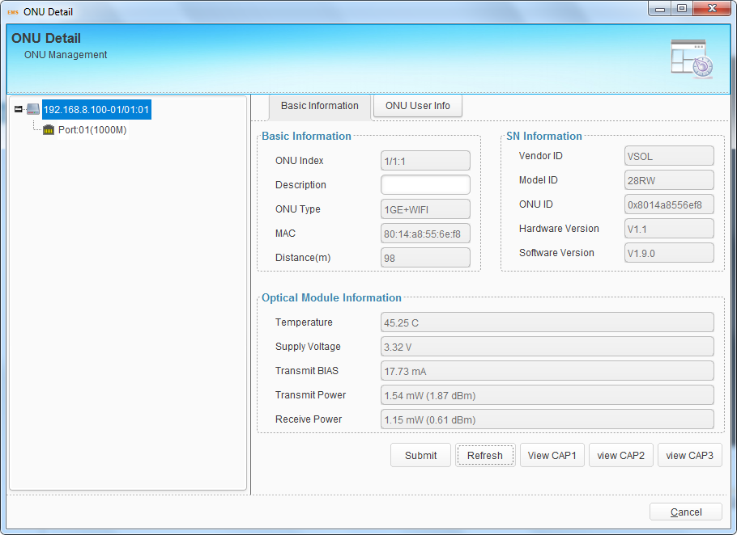
Figure 9-2 ONU Basic Information
ONU user information is used to record address, phone and other information of the ONU user. It is convenient to know where the ONU is installed and contacts of the user.
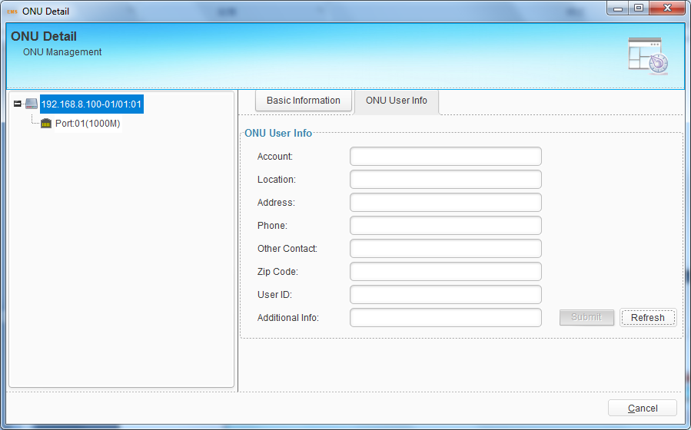
Figure 9-3 ONU User Information

9.2 ONU Maintenance Management

9.2.1 ONU Rename
This operation is used to set or modify ONU’s name. The name will not be saved in device, but be saved in EMS database.
Choose ONU icon and open right-click menu; choose "ONU Rename" to open a pop-up dialog box.
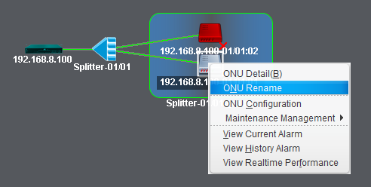
Figure 9-4 ONU Rename
Fill in the ONU new name and click "OK" button to apply.
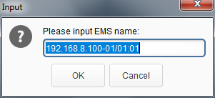
Figure 9-5 Set ONU Rename

9.2.2 Reregister ONU
This operation is used to force ONU to register again. When ONU reregister successful, rolling log bar will display the prompt message.
Right click ONU icon and choose “Maintenance Management" > “Reregister ONU", then click “Yes” button on confirmation dialog box. It will carry out ONU reregister action.
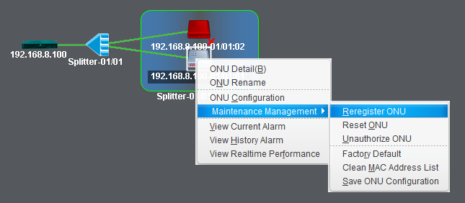
Figure 9-6 Reregister ONU
Caution! The operation will cause user services interruption.

9.2.3 Reset ONU
This operation is used to restart ONU. Rolling log will display the prompt message when the ONU reset successfully.
Right click ONU icon and choose "Maintenance Management" > "Reset ONU", then click "Yes" button on confirmation dialog box to reset it. It will carry out ONU reset action.
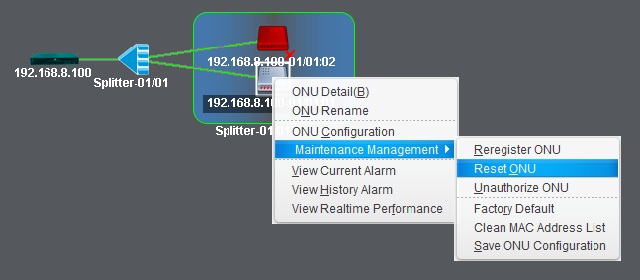
Figure 9-7 Reset ONU
Caution! The operation will cause user services interruption.

9.2.4 Unauthorize ONU
This operation is used to remove ONU from ONU authentication list. All the information related to the ONU will get lost.
Right click ONU icon and choose "Maintenance Management" > "Unauthorize ONU", then click “Yes” button on confirmation dialog box to remove it.
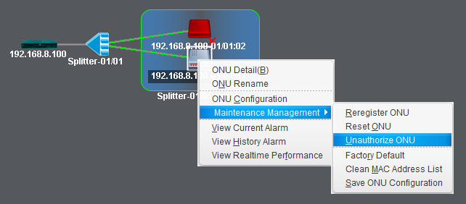
Figure 9-8 Unauthorize ONU
Caution! All information related to the ONU will get lost after executed this operation.

9.2.5 Load Factory Default
This operation is used to load ONU settings to factory default. It is implemented by private OAM.
Right click ONU icon and choose “Maintenance Management" > "Load Factory Default", then click “Yes” button on confirmation dialog box.
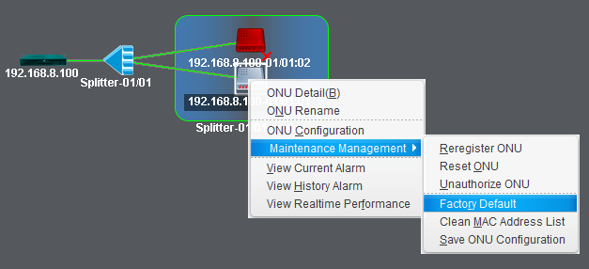
Figure 9-9 Load Factory Default

9.2.6 Clean MAC Address List
This operation is used to clean MAC addresses which the ONU has learnt. It is implemented by private OAM.
Right click ONU icon and choose “Maintenance Management" > "Clean MAC address List", then click “Yes” button on confirmation dialog box.
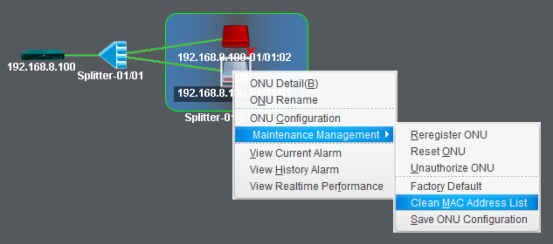
Figure 9-10 Clean MAC Address List

9.2.7 Save ONU Configuration
This operation is used to save ONU configurations to its flash memory. It is implemented by private OAM.
Right click ONU icon and choose “Maintenance Management" > "Save ONU Configurations", then click “Yes” button on confirmation dialog box.
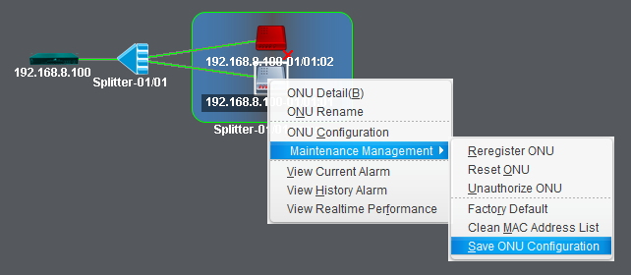
Figure 9-11 Save ONU Configuration

9.3 ONU Configuration
This section mainly introduces ONU service configurations. Different type ONU has different configuration options. OLT can identify what functions the ONU supports and EMS will display the corresponding configuration options in this interface.
Right-click ONU icon, choose “ONU Configuration” to enter ONU configuration interface.
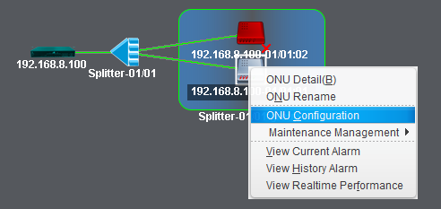
Figure 9-12 Enter ONU Configuration

9.3.1 Information
This interface is the same as ONU detail interface, which displays ONU information. You can also set ONU description and check its capability that reported by CTC OAM.
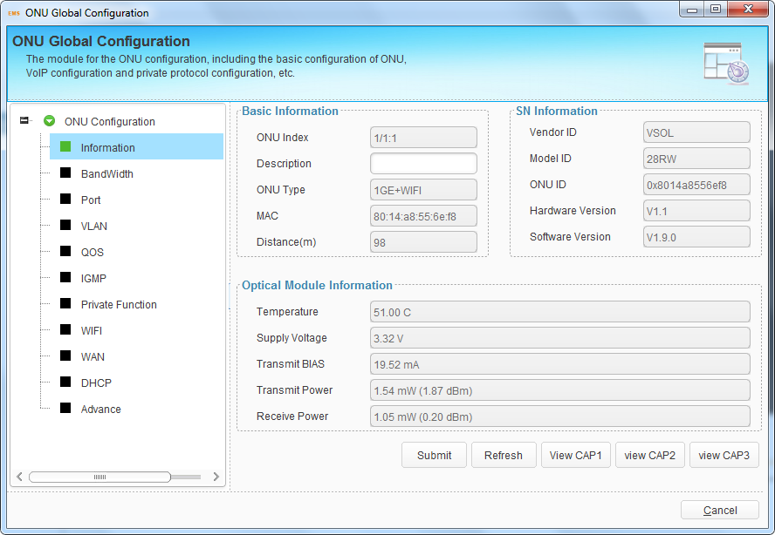
Figure 9-13 ONU Information

9.3.2 Bandwidth
This configuration is used to limit upstream and downstream bandwidth of ONU. It is DBA that changes uplink bandwidth assigned to each ONU in real time according to the instant service status of each ONU.
The upstream WRR weight will be used to compute the remaining bandwidth allocation after fixed rate of each ONU has been guaranteed. The downstream WRR weight will reference to the global 16 PON weights and only work when the ONU egress shaper is disabled.
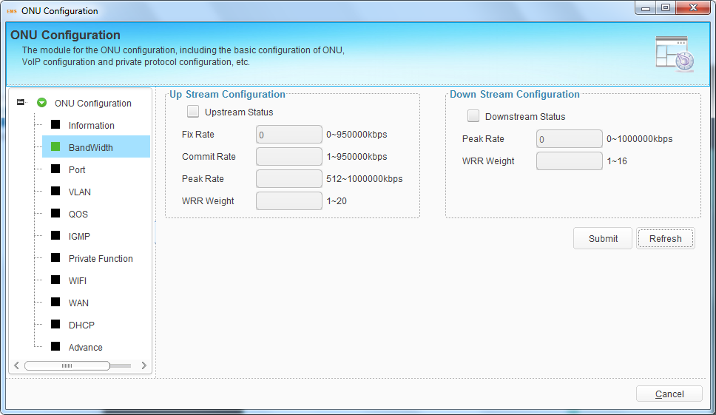
Figure 9-14 ONU Bandwidth Configuration

9.3.3 Port
Port configuration is mainly used to configure functions and characteristic parameters of Ethernet port. These configurations contain administration status, flow control, loop, auto-negotiation and rate.
Choose one port, select the port attributes or fill in rate value; click “Submit” button to apply the configurations.
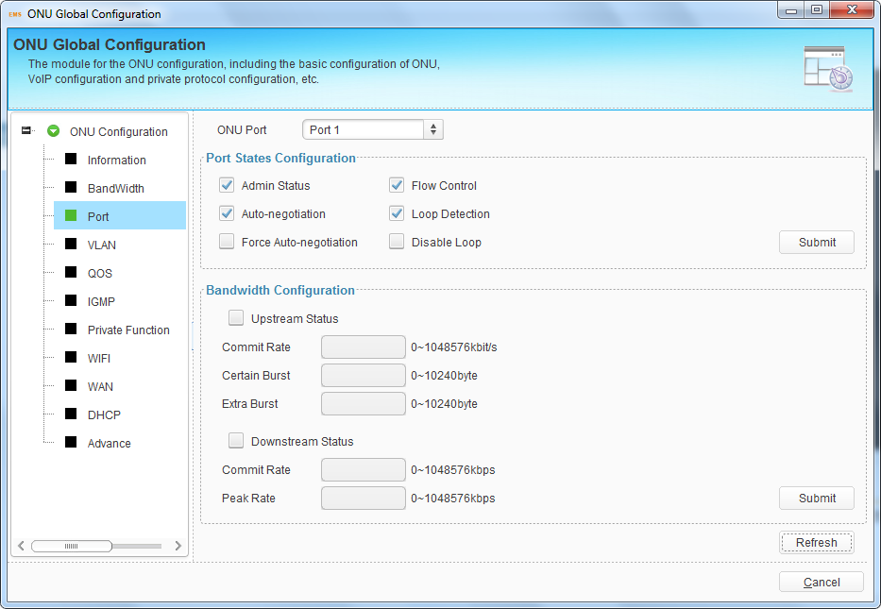
Figure 9-15 ONU Port Configuration
Illustrations of each parameter:
Parameters | Illustration
Admin Status | Enable or disable administration status of the port.
Auto-negotiation | Enable or disable auto negotiation of the port. After enable, the port will negotiate with the connected port to reach the largest possible transmission rate.
Force Auto-negotiation | Force port to auto-negotiate again.
Flow Control | Enable or disable flow control function of the port in order to control congestion. It is disabled by default.
Loop Detection | Enable or disable port loop detection function.
Disable Loop | Disable the port in the loop.
Upstream/Downstream Status | Enable or disable upstream/downstream bandwidth limitation of the port.
Commit Rate | Committed Information Rate of the port.
Certain Burst | Committed Burst Size.
Extra Burst | Extra Burst Size.
Peak Rate | Peak Information Rate.

9.3.4 VLAN
This configuration is used to configure ONU port VLAN. There are transparent, tag, translation, aggregation and trunk mode. Maximum eight VLAN rules can be configured for each port when choosing translation, aggregation and trunk mode.
Select one port, VLAN mode, and fill in VLAN ID. Click “Submit” button to apply configurations.

9.3.4.1 Transparent Mode
In this mode, upstream or downstream Ethernet packet will get through this port directly.
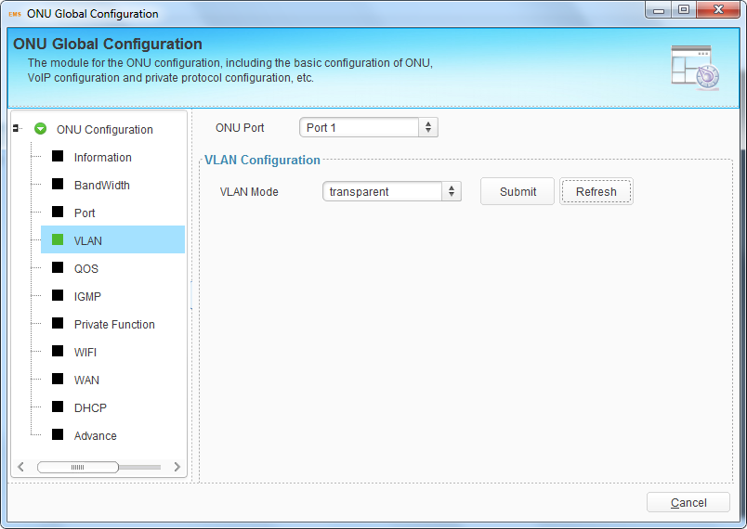
Figure 9-16 ONU port VLAN Transparent Mode

9.3.4.2 Tag Mode
In this mode, PVID is required. PVID is default VLAN of the port. The method of an ONU port with tag mode processing Ethernet packet is shown in the following table.
Direction | VLAN tag | Operation
Upstream | Yes | Discard the packet.
 | No | Add default VLAN tag to the packet.
Downstream | Yes | If VID is not equal to default VID, discard the packet; otherwise strip the VLAN tag of the packet.
 | No | Discard the packet.
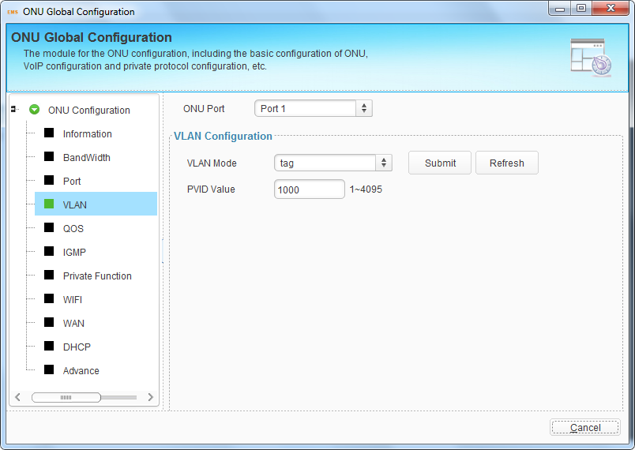
Figure 9-17 ONU Port VLAN Tag Mode

9.3.4.3 Trunk Mode
Trunk mode allows the port forward multiple VLANs at the same time. In this mode, PVID is also required. The method of an ONU port with trunk mode processing Ethernet packet is shown in the following table.
Direction | VLAN tag | Operation
Upstream | Yes | If the packet’s VID exists in the VLAN Trunk list or is equal to the port default VID, forward this packet, otherwise discard this packet.
 | No | Add default VLAN tag to the packet and forward it.
Downstream | Yes | If the packet’s VID is equal to the port default VID, strip the VLAN tag of the packet and forward the packet.  If the packet’s VID is not equal to the port default VID but exists in the VLAN Trunk list, forward the packet.  If the packet’s VID is not equal to the port default VID and doesn’t exist in the VLAN Trunk list, discard the packet.
 | No | Discard this packet.
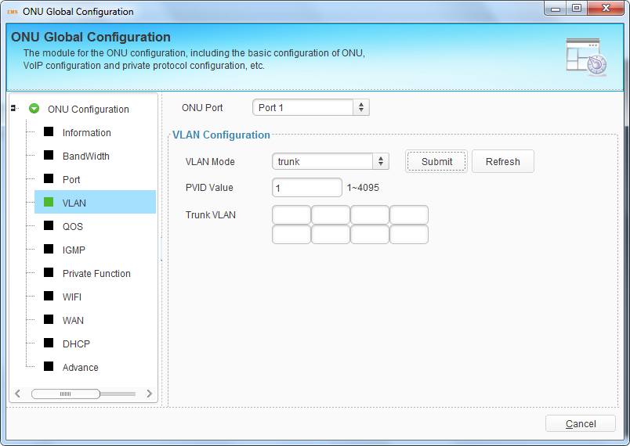
Figure 9-18 ONU Port VLAN Trunk Mode

9.3.4.4 Translation Mode
Translation mode allows the port overwrites VLAN tag. In this mode, PVID is also required. The method of an ONU port with translation mode processing Ethernet packet is shown in the following table.
Direction | VLAN tag | Operation
Upstream | Yes | If the VID of the packet is equal to the CVLAN of a certain translation entry, overwrite the packet’s VID with this entry’s SVLAN and forward the packet.  If the VID of the packet is not equal to any translation entry’s CVLAN, discard the packet.
 | No | Add default VLAN tag to the packet and forward it.
Downstream | Yes | If the VID of the packet is equal to the SVLAN of a certain translation entry, overwrite the packet’s VID with this entry’s CVLAN and forward the packet.  If the VID of the packet is not equal to any translation entry’s SVLAN, discard the packet.
 | No | Discard the packet.
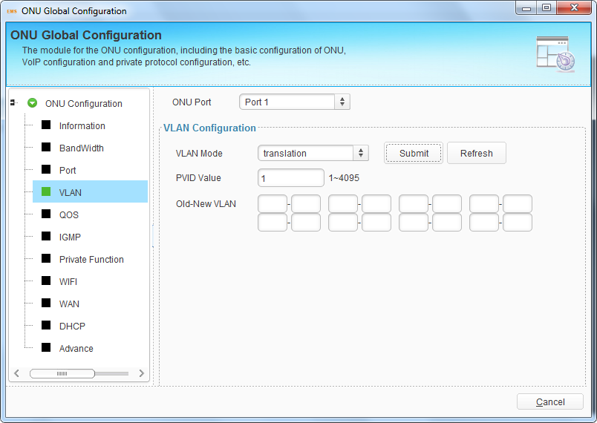
Figure 9-19 ONU Port VLAN Translation Mode

9.3.4.5 Aggregation Mode
Aggregation mode allows multiple VLAN to be overwritten by a same VLAN tag. In this mode, PVID is also required. The method of an ONU port with aggregation mode processing Ethernet packet is shown in the following table.
Direction | VLAN tag | Operation
Upstream | Yes | If the VID of the packet is equal to the CVLAN of a certain VLAN entry, overwrite the packet’s VID with this entry’s SVLAN and forward the packet.  If the VID of the packet is not equal to any VLAN entry’s CVLAN, discard the packet.
 | No | Add default VLAN tag to the packet and forward it.
Downstream | Yes | If the VID of the packet is equal to the SVLAN of a certain translation entry, overwrite the packet’s VID with this entry’s CVLAN and forward this packet.  If the VID of the packet is not equal to any translation entry’s SVLAN, discard the packet.
 | No | Discard the packet.
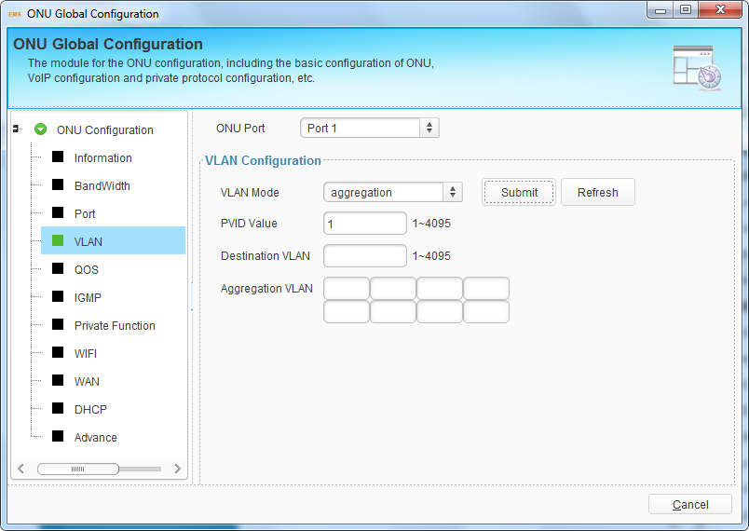
Figure 9-20 ONU Port VLAN Aggregation Mode

9.3.5 QoS
This is QoS configuration for ONU LAN port. QoS function includes data stream classification and mark. Customers can mark different streams by priority according to different rules. When matches the conditions that have been configured, the data traffic will be set with new priority and mapped to the queue. When bandwidth is not enough or there is congestion, QoS configurations can make sure high priority data traffic passes through the device firstly. The conditions include MAC address, IP address, VLAN, Ethernet type, TCP/UDP port, etc. You can select one or more options to configure.
Select a port, click “Add” button to open a pop-up dialog box, check conditions and fill in the value, click “OK” button to apply the configurations.
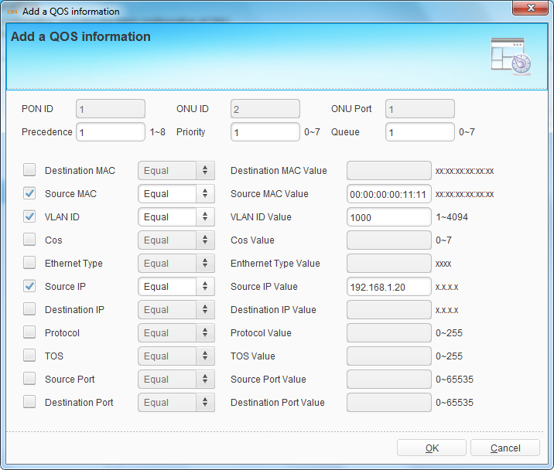
Figure 9-21 Add ONU Port QoS Rule
After added, QoS rules will display in the table. You can click “Details” button to see the detail configurations. Select the QoS rule in the table and click “Delete” to delete it.
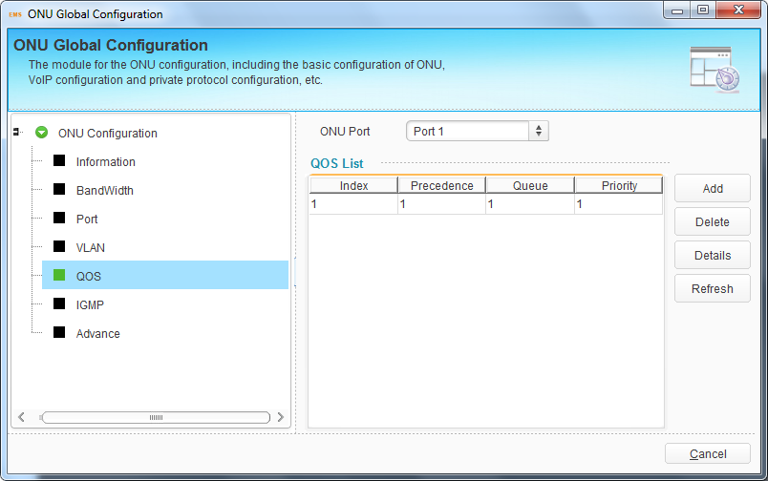
Figure 9-22 ONU Port QoS Rule

9.3.6 IGMP
This is IGMP configuration for ONU LAN port. When the ONU is used for IPTV service, IGMP configurations are required. IGMP port configurations contain multicast VLAN and maximum group.
Multicast max group is used to configure how many multicast groups this port can join in at the same time.
Maximum eight multicast VLAN can be configured for each port. Multicast VLAN translation can be configured only when choosing VLAN Translate.
Select one port, and fill in multicast VLAN, then click “Submit” button to apply the configurations.
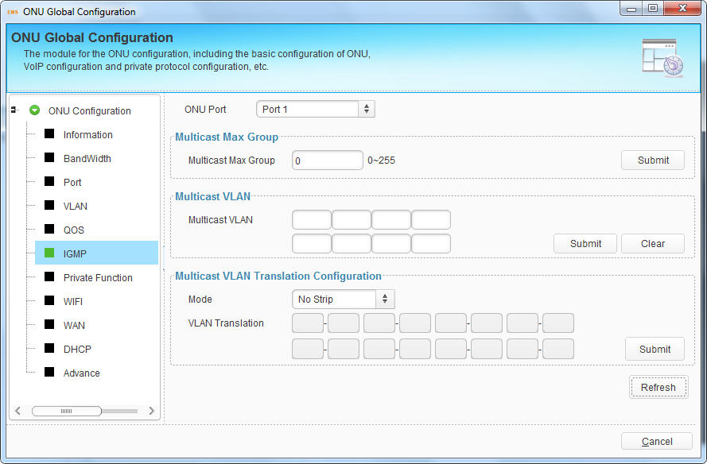
Figure 9-23 ONU Port IGMP Configuration
The method of an ONU port with different mode processing multicast packet is shown in the following table.
Mode | Operation
strip | Multicast stream sent out from the port does not contain any multicast VLAN tag.
No strip | Multicast stream sent out from this port keeps multicast VLAN tag.
Translate | Multicast VLAN of multicast stream sent out from this port will be changed to user VLAN.

9.3.7 VoIP
This interface is mainly used to configure VoIP global configurations, which contain IP address and VLAN, and fax mode, execute IAD operations as well.
Select VLAN mode and IP mode, fill in correct parameters, and click “Submit” button to apply VoIP global configurations.
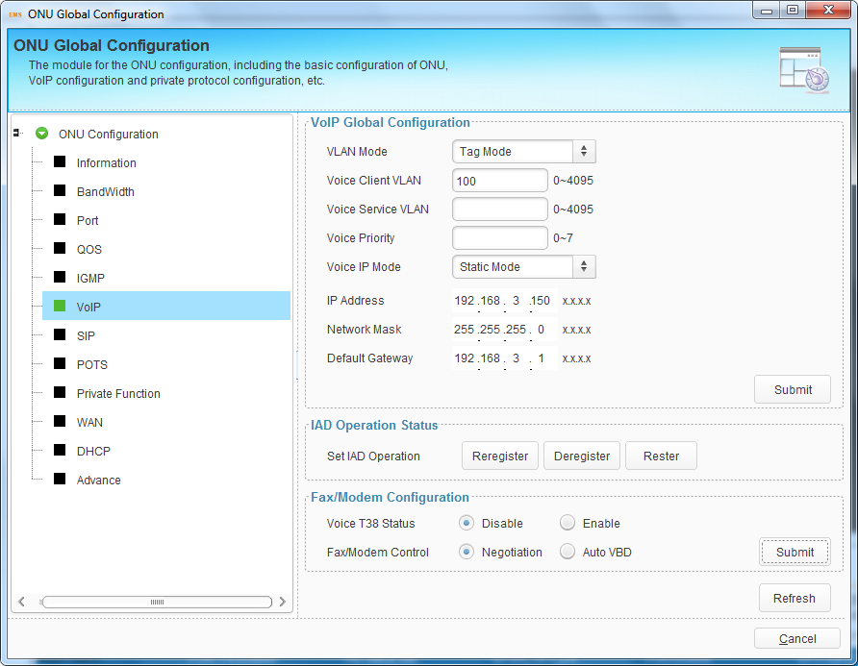
Figure 9-24 Voice Configuration
IAD operation includes reregister, deregister and restart. Reregister is used to force VoIP accounts to register again. Deregister is used to deregister VoIP accounts. Restart it used to restart IAD module.
Fax/Modem Configuration is used to set fax mode. When Voice T38 Status is disabled, the fax mode is T30 mode.

9.3.8 SIP
SIP parameters mainly contain proxy server, register server, backup server, server port, register interval, heartbeat and digit map. Digit map defines the rules of dialing phone number.
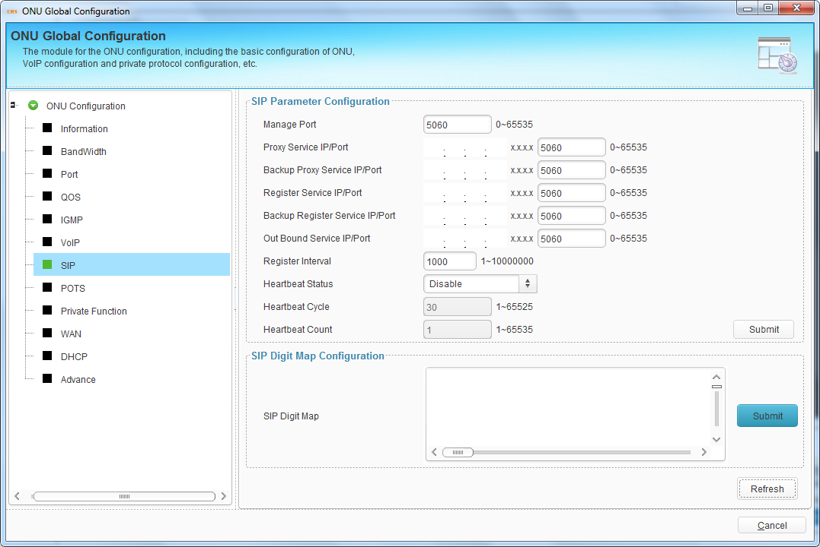
Figure 9-25 SIP Parameter Configuration

9.3.9 POTS
This interface is mainly used to configure POTS active status, SIP accounts and display POTS status and so on.
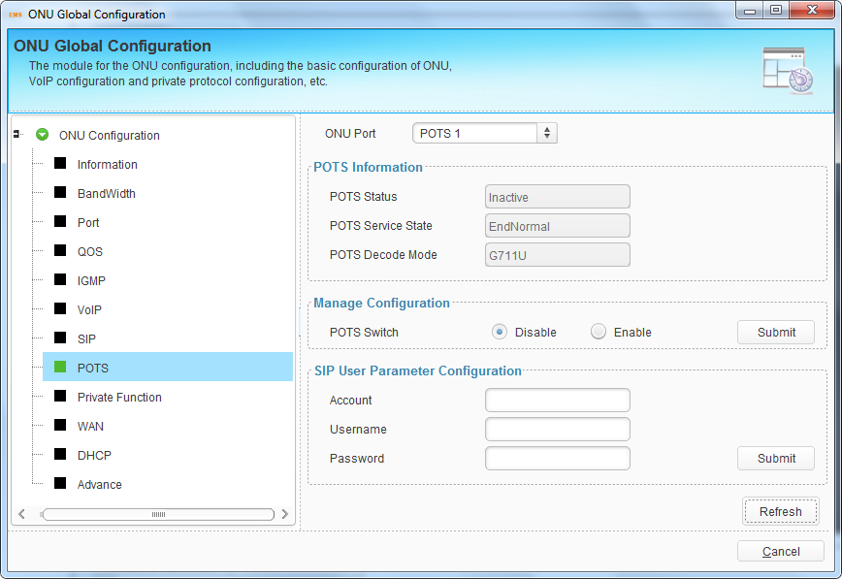
Figure 9-26 POTS Configuration

9.3.10 Private Function
Private function is used to enable or disable some functions of ONU by private OAM. It includes IGMP status, CTC OAM status and port isolate status.
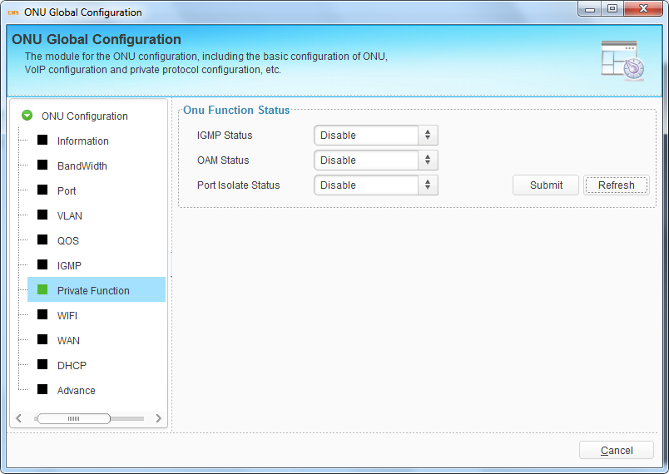
Figure 9-27 ONU Private Function

9.3.11 WIFI
This interface is used to configure ONU WIFI parameters. WIFI switch configuration mainly contains WIFI status, country, standard, channel and transmit power. WIFI SSID configuration mainly contains SSID name and encryption for each SSID. These configurations are implemented by private OAM.
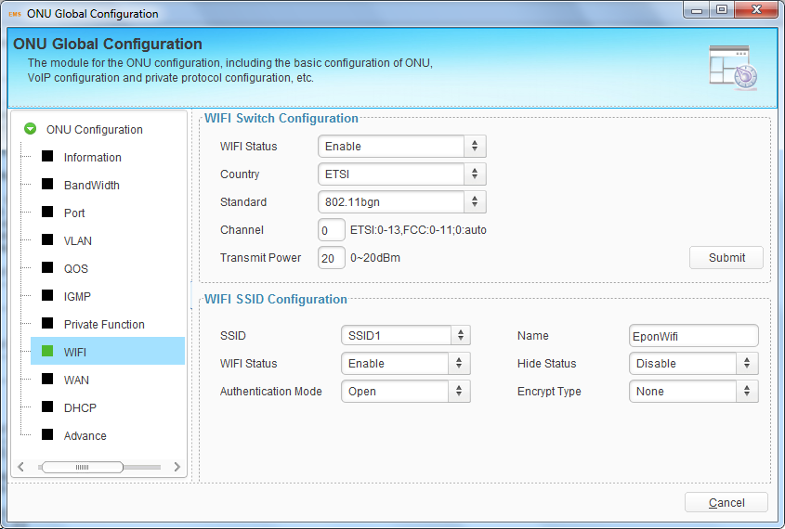
Figure 9-28 ONU WIFI Configuration

9.3.12 WAN
This interface is used to configure HGU WAN connection. These configurations are implemented by private OAM.
Click “Add” button to open a pop-up dialog box, select WAN mode and other parameters, then click “OK” button to apply the configurations. WAN connections will display in the table.
Select one WAN connection, click “Modify” button to modify its parameters, or click “Delete” button to delete it.
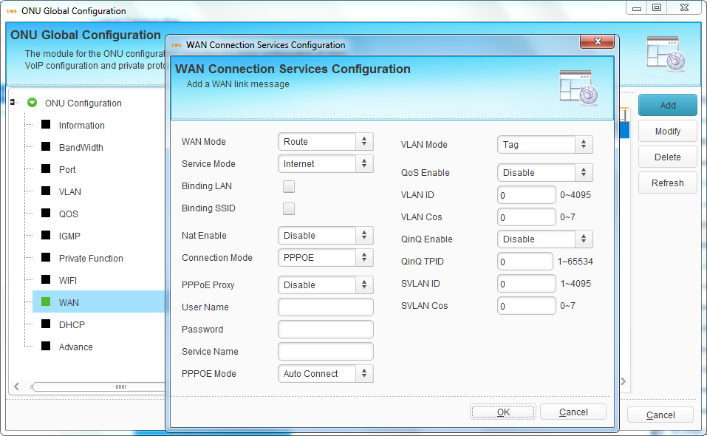
Figure 9-29 Add ONU WAN Connection

9.3.13 DHCP
This interface is used to configure ONU DHCP function. These configurations are implemented by private OAM.
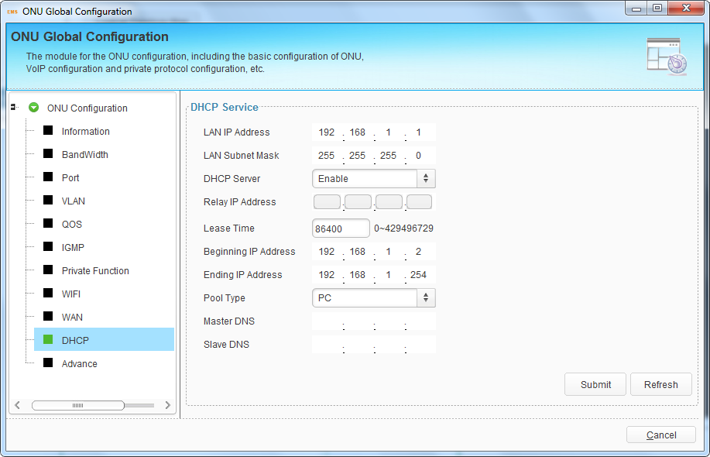
Figure 9-30 ONU DHCP Configuration

9.3.14 Advance
This interface is used to configure ONU management IP and MAC aging time.
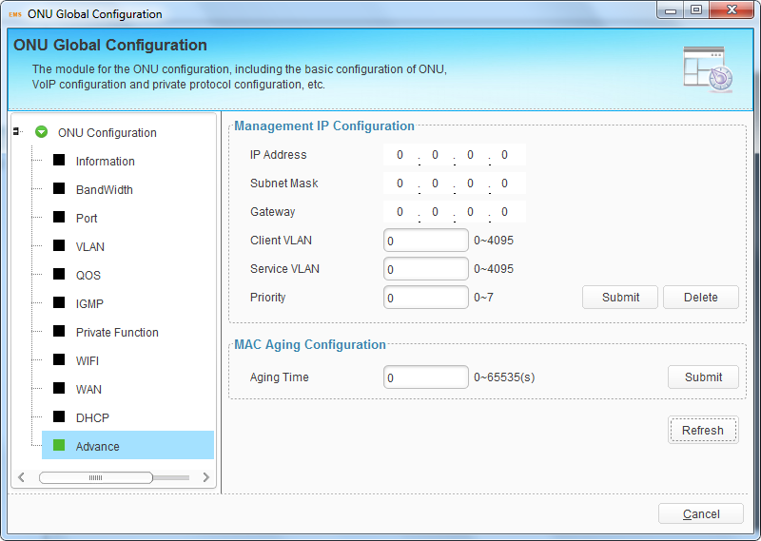
Figure 9-31 ONU Advance Configuration

10. ONU Authentication--GPON
This chapter mainly introduces ONU authentication.
Right click OLT icon, choose “ONU Authentication” to open the authentication configuration interface.
Figure 10-1 ONU Authentication

10.1 ONU AuthList

10.1.1 ONU List
All ONUs which are authenticated successful will be displayed in this interface.
You can do reset, delete to all ONUs that connect to the PON port.
Reset is to make all ONUs under the port restart.
Delete is to remove all ONUs under the port.
You can check PON/ONU/Admin State/OMCC State/Phase State/ONU profile/Auth mode/Auth Info in onu authentication Info window.
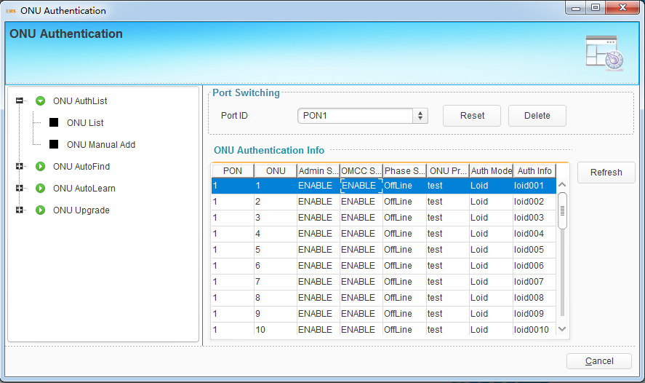
Figure 10-2 ONU List

10.1.2 ONU manual add
ONU can be added manually by this operation.
Step1. Select PON number. For V1600G1, it’s PON1 to PON8.
Step2. Enter the ONU number, it should not be conflict with the others under the same PON port.
Step3. Select the onu profile.
Step4. Select the authentication mode.
Step5. The authentication information, it depends on the step4 selection.
Step6. Click the submit button.
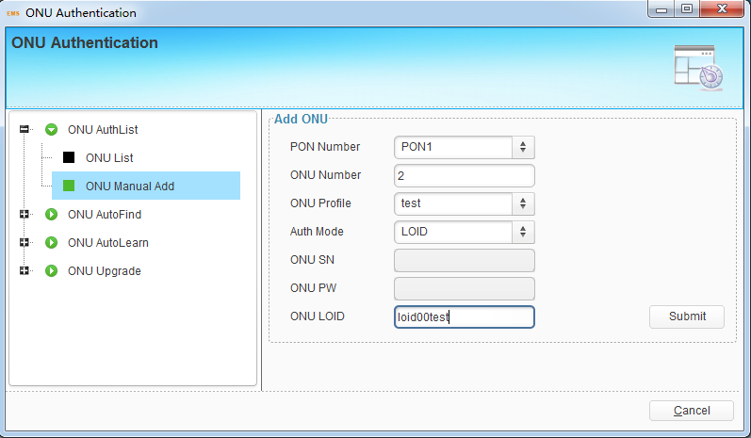
Figure 10-3 ONU manual add

10.2 ONU AutoFind

10.2.1 Discover ONU
After selecting PON port number, all ONUs which are authenticated failed or not authenticated will be displayed in this interface. You can check the serial number of ONUs.
More information will be show under the ONU Detail menu.
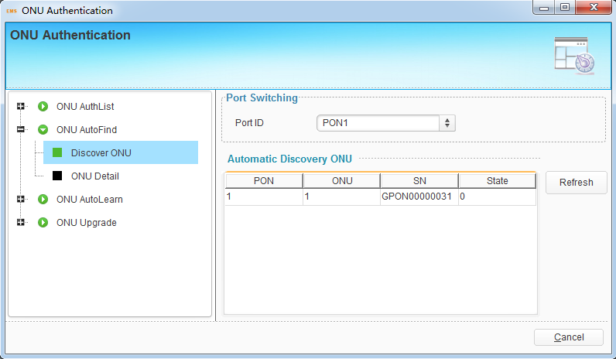
Figure 10-4 Discover ONU

10.2.2 ONU Detail
The detail information will be show in Discovery ONU Detail window, include the serial number, hardware password, LOID, LOID password, Model string, Version string.
The selected ONU can be added manually by clicking the ‘Add’ button on the right side. And the ONU profile should be selected first before adding, or the ‘default’ profile will be used.
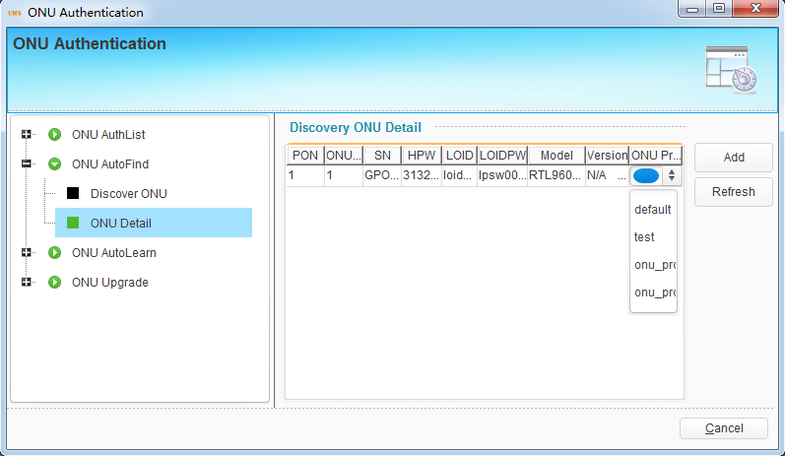
Figure 10-5 ONU Detail

10.3 ONU AutoLearn

10.3.1 Automatic Learn
ONU can be auto authenticated after enabling PON port automatic learning.
Step1. Select ‘status’ checkbox
Step2. Select onu profile or ‘default’ profile will be used.
Step3. Click the submit button.
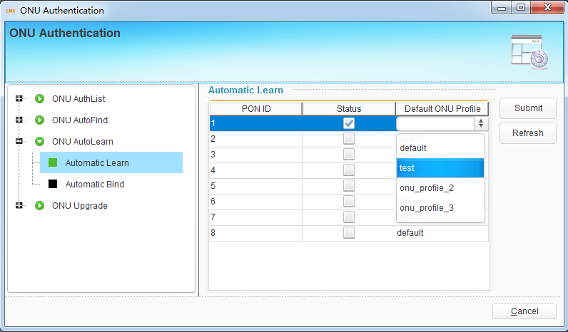
Figure 10-6 Automatic Learn

10.3.2 Automatic Bind
The onu’s equipment ID is the key information for onu auto binding. It can be found by showing the onu’s detail information, see xxx. We can exactly set the onu profile by checking the onu’s equipment ID when onu auto authenticating.
Also, the line profile, srv profile and alarm profile can be auto set.
Step1. Enter the equipment ID
Step2. Select onu profile.
Step3. Select line profile, it’s not required.
Step4. Select srv profile, it’s not required.
Step5. Select alarm profile, it’s not required.
Step6. Click the ‘Add’ button. Check the result in ‘Automatic Bind’ table.
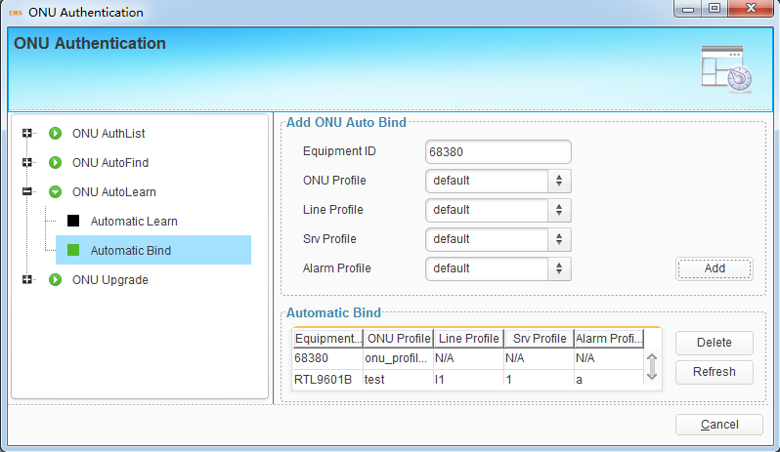
Figure 10-7 Automatic Bind

10.4 ONU Upgrade

10.4.1 Upload Image
First of all, the onu’s firmware should be downloaded from TFTP server to OLT’s RAM.
Step1. Enter the firmware name.
Step2. Enter the TFTP server’s IP
Step3. Click ‘submit’ button.
We will use the firmware in the ‘Upgrade Configuration’ window.
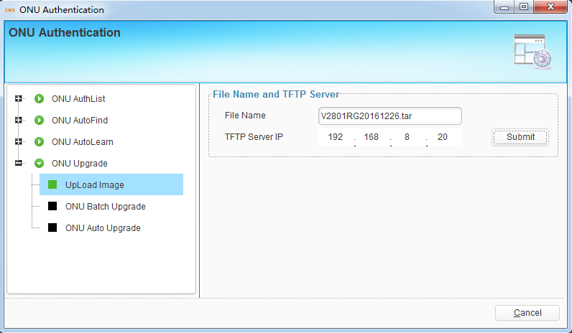
Figure 10-8 UpLoad Image

10.4.2 ONU Batch Upgrade
You can upgrade one or many ONUs at the same time at this interface. But the ONUs need to be updated should be the same device type. You should only select the online ONUs.
Step1. Click the ‘select’ button to pop up the onu select window.
Step2. Select ONU Firmware.
Step3. Select upgrade mode.
Step4. Click start button.
You can click ‘refresh’ to check the upgrade progress.
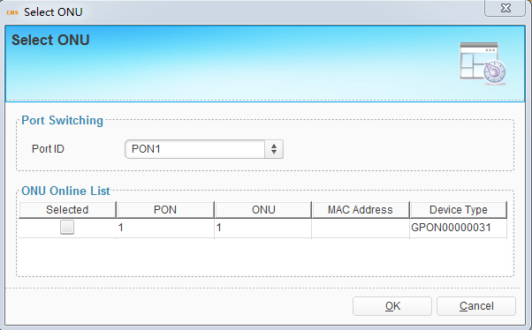
Figure 10-9 select onu
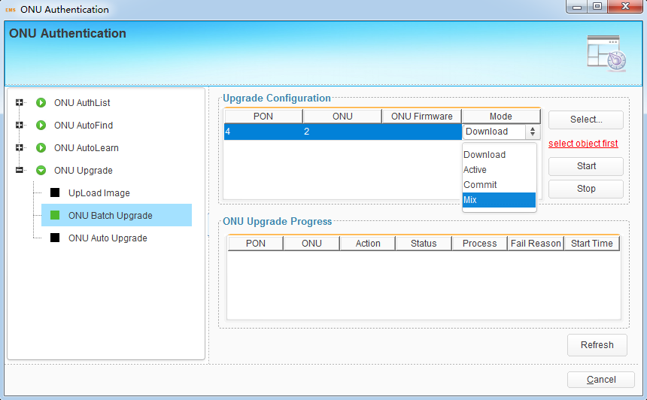
Figure 10-10 ONU Batch Upgrade

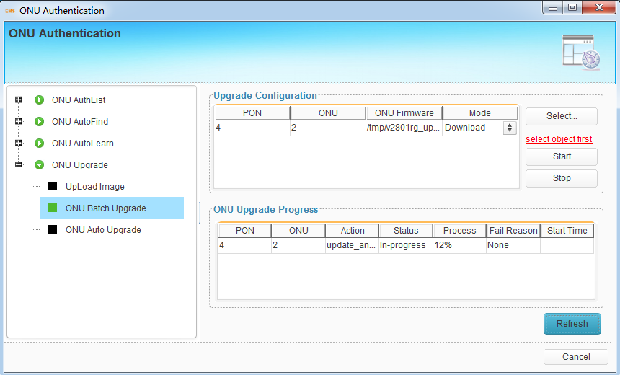
Figure 10-11 Upgrade progress

10.4.3 ONU Auto Upgrade
The specify type of ONU should be upgraded automatically.
Step1. Enter the equipment ID.
Step2. Enter software version.
Step3. Select onu firmware.
Step4. Click ‘submit’ button.

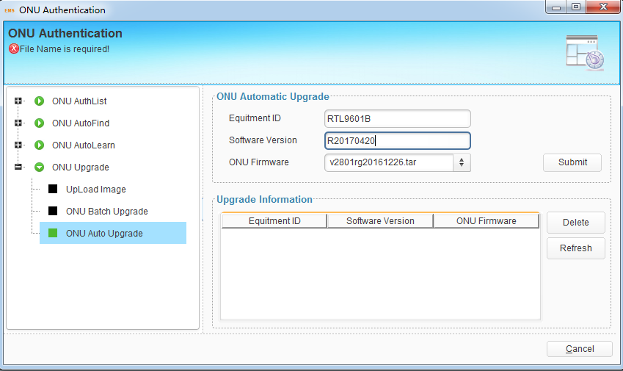
Figure 10-12 ONU auto upgrade

11 Profile Configuration--GPON
This chapter introduces profile configuration of ONU. According to the characteristics of multiple services (data, voice, alarm) integrated in an ONU, and there would be huge quantity terminals but their configurations are similar, it is necessary to configure these similar configurations in a profile and bind it to ONU.
OLT supports the following profile:
- ONU profile
- DBA profile
- Traffic profile
- Line profile
- Service profile
- Alarm profile
Right click OLT icon, choose “Profile Configuration” to open the configuration interface.
Figure 11-1 Profile Configuration

11.1 Profile Configuration

11.1.1 ONU Profile
The Onu profile is used for onu authorization, and each ONU must specify only one ONU profile when authorizated. The ONU profile specifies the capability of this ONU.
Check onu profile in profile list window, click ‘add’ button to add a new onu profile, click ‘delete’ button to remove a profile.
Step1. Modify profile name or let it as auto generated.
Step2. Modify description string.
Step3. Modify max t-cont number, default value is 8.
Step4. Modify max gem-port number, default value is 32.
Step5. Modify max Ethernet number, default value is 1. For some hgu, it should be set to 0.
Step6. Modify max POTS number, default value is 0.
Step7. Modify max Iphost number, default value is 2.
Step8. Modify max VEIP number, default value is 0. For hgu, it shouldn’t be 0.
Step9. The others configuration are modified by professional user, or just set it default value.
Step9. Click ‘OK’ button.
Step10. Click ‘commit’ button.
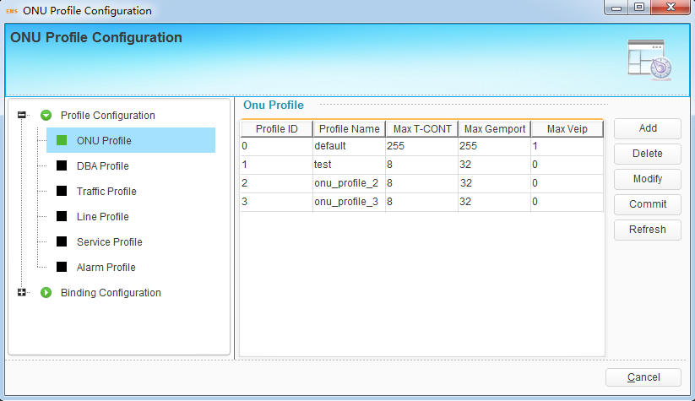
Figure 11-2 onu profile list
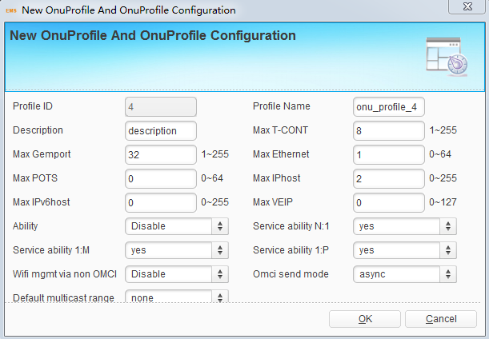
Figure 11-3 add onu profile

11.1.2 DBA Profile
DBA is a bandwidth allocation strategy that changes uplink bandwidth assigned to each T-CONT in real time according to the instant service status of each ONU. There are five BW types supported and make sure that fix<=assure<=max.
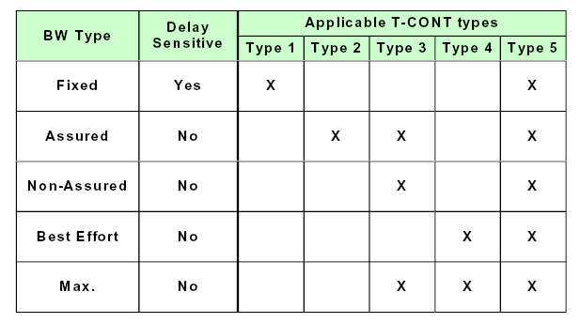
Step1. Select BW type.
Step2. Enter profile name.
Step3. Enter the BW value, it depends on the step1.
Step4. Click ‘submit’ to add a new dba profile.
When need to delete DBA profile, select it and click “Delete” button and it can be modify by click ‘modify’ button.
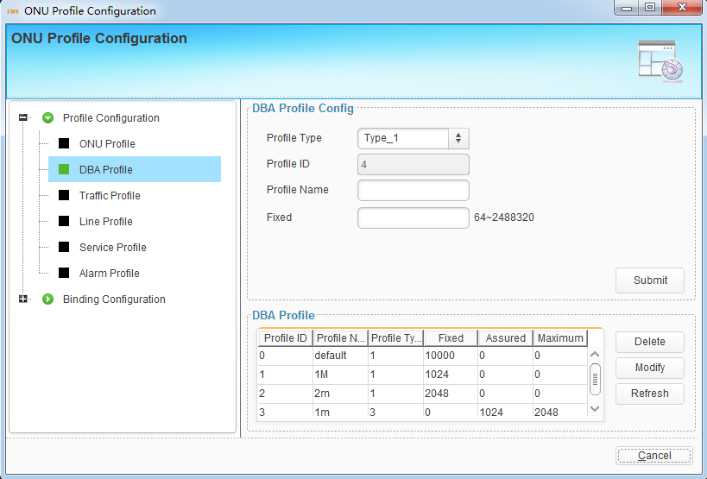
Figure 11-4 DBA Profile

11.1.3 Traffic Profile
Traffic profile is used by Gemport to specify the upstream/downstream bandwidth.
Step1. Enter the profile name.
Step2. Enter the sir value.
Step3. Enter the pir value, the pir >= sir.
Step4. cbs and pbs are not required.
Step5. Click ‘submit’ button to add new traffic profile.
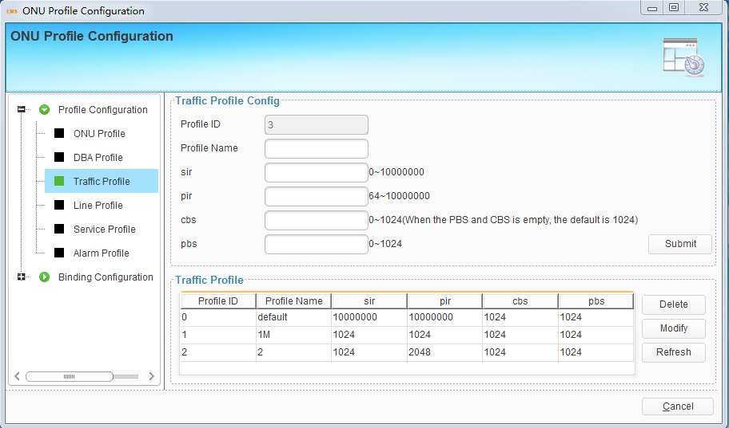
Figure 11-5 Traffic Profile

11.1.4 Line Profile
Line profile is used to configure the ANI side services of onu, such as t-cont, gem-port, service-port and so on.
Click ‘add’ button to add a new line profile. Enter profile name in the add window.
Click ‘delete’ button to remove a line profile.
Click ‘modify’ button to modify a line profile.
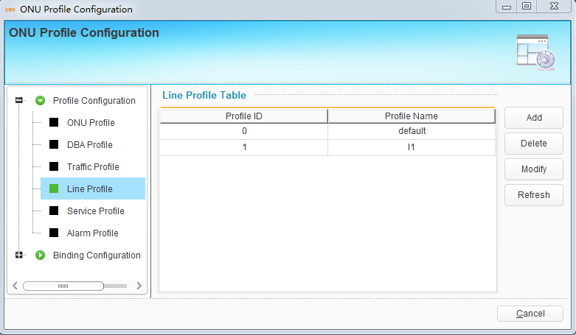
Figure 11-6 line Profile
Enter T-cont ID, T-cont name, select DBA profile and click ‘add’ button to add a new T-cont. select t-cont and click ‘delete’ button to removed it.
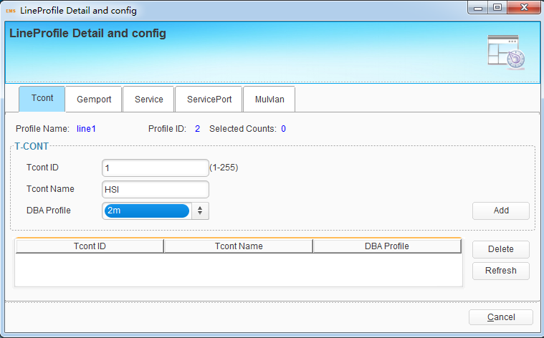
Figure 11-7 T-cont
Enter gemport ID, select Tcont ID, enter gemport name, select Up/down Stream traffic profile and click ‘add’ button to add a new gemport. The others configuration are not required. select gemport and click ‘delete’ button to removed it.
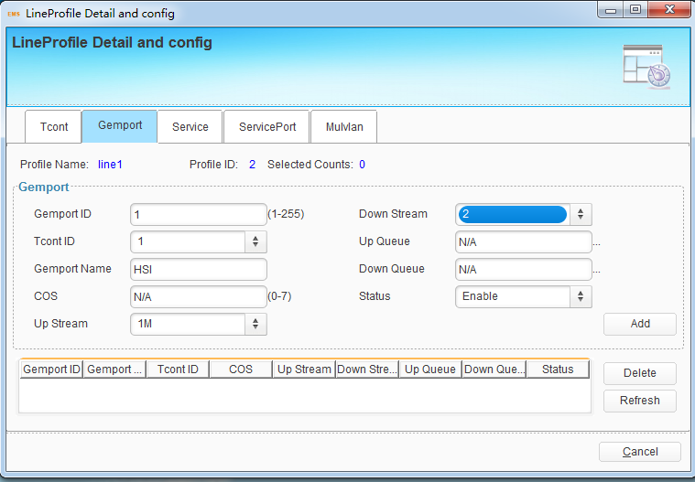
Figure 11-7 gemport
Enter service name, select gemport ID, enter vlan list and click ‘add’ button to add a new service. The others configuration are not required. select service and click ‘delete’ button to removed it.
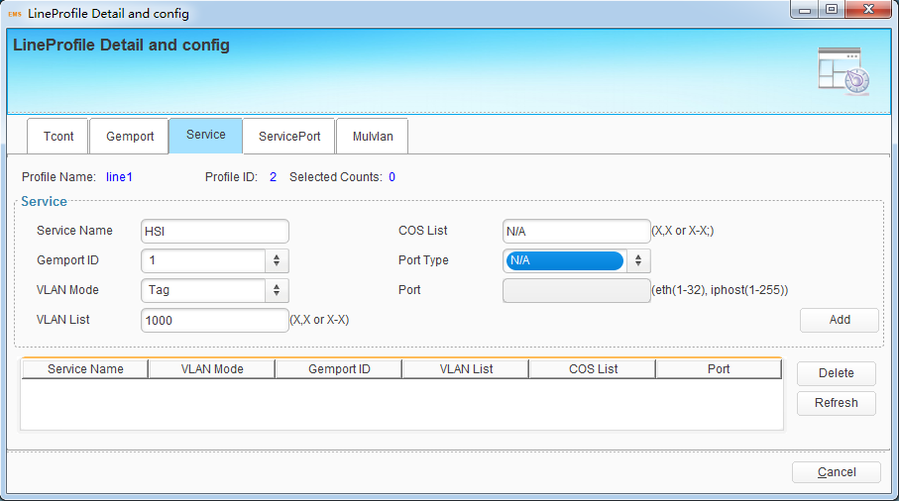
Figure 11-8 service
Enter service port ID, select gemport ID, enter user vlan, enter vlan and click ‘Add’ button to add a new service-port. The others configuration are not required. select service port and click ‘delete’ button to removed it.
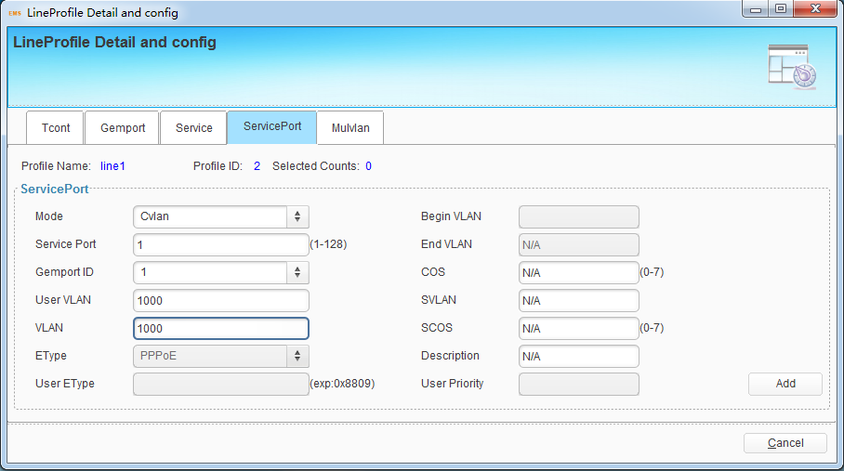
Figure 11-9 service port

Enter multicast vlan list and click ‘Add’ button to add it. Max 12 multicast vlan id supported.
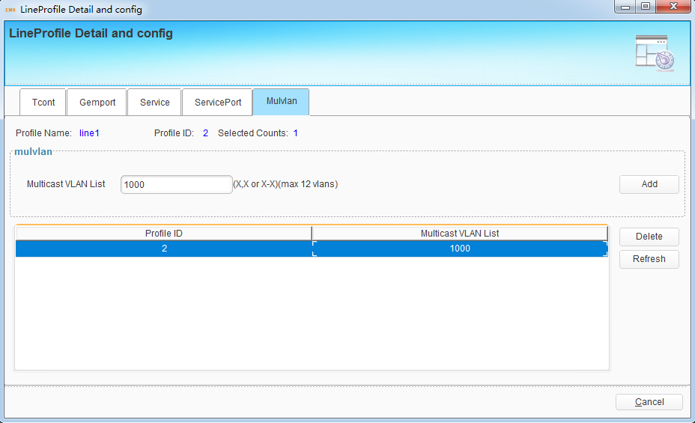
Figure 11-10 multicast vlan

11.1.5 Service Profile
service profile is used to configure the UNI side services of onu, such as Ethernet port, wifi, veip and so on.
Click ‘add’ button to add a new service profile. Enter profile name in the add window.
Click ‘delete’ button to remove a service profile.
Click ‘modify’ button to modify a sercive profile.
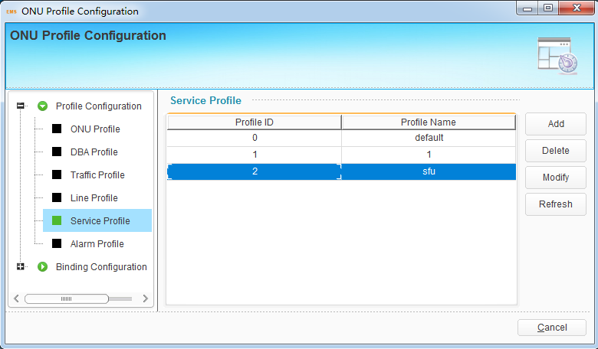
Figure 11-11 service profile
Select vlan type, select port type, enter port id, vlan list and click ‘Add’ button to add a new portVlan service.
Vlan type include: Transparent, Trunk, Tag, Hybrid, Translate
Port type include: Eth, Wifi, Veip
Select port vlan service and click ‘delete’ button to remove it.
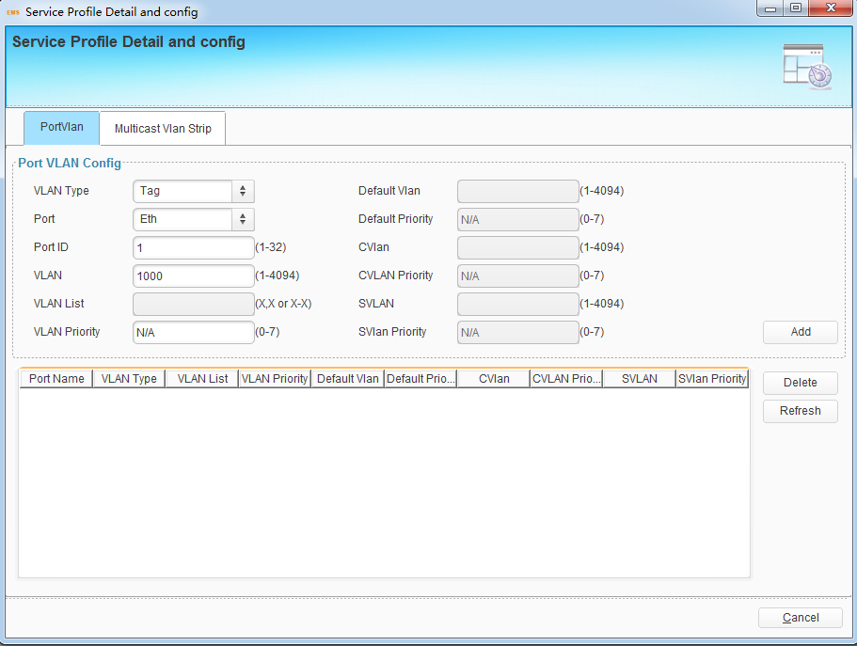
Figure 11-12 port vlan
Sometimes, multicast vlan tag strip function should be set to the Ethernet Port. It depends on the onu’s process.
Enter Ethernet Port number and click ‘Add’ button to enable multicast vlan tag strip function.
Select the multicast vlan strip service and click ‘delete’ to remove it.
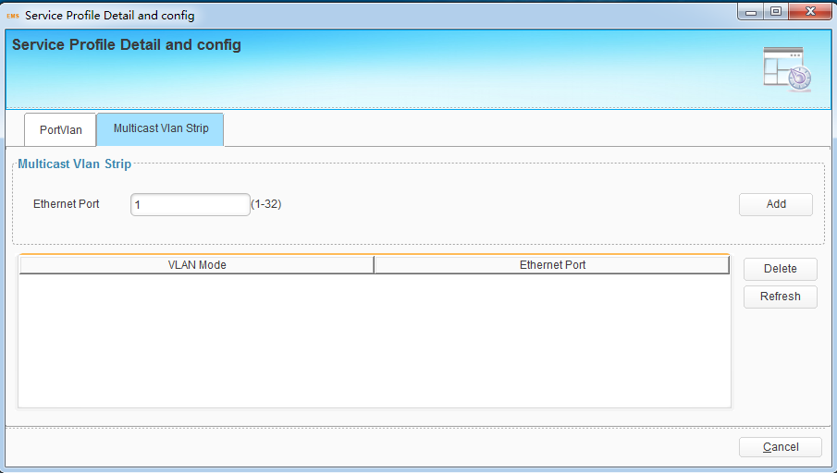
Figure 11-13 multicast vlan strip

11.1.6 Alarm Profile
alarm profile is used to configure the pon parameters of onu.
Click ‘add’ button to add a new alarm profile.
Click ‘delete’ button to remove a service profile.
Click ‘modify’ button to modify a sercive profile.
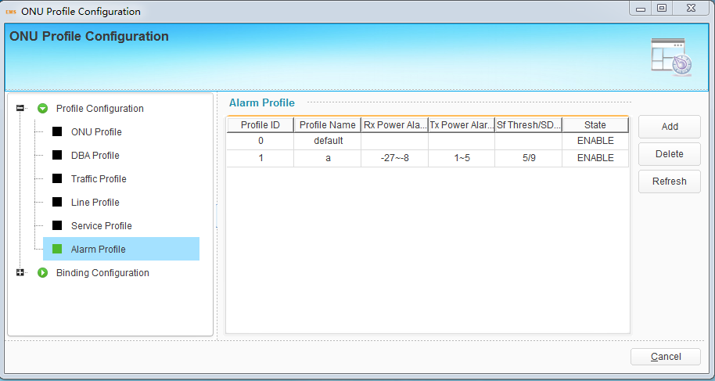
Figure 11-14 alarm profile
Step1. Enter alarm profile name.
Step2. Select state, enable/disable.
Step3. Enter Rx low power threshold.
Step4. Enter Rx high power threshold.
Step5. Enter Tx low power threshold.
Step6. Enter Tx high power threshold.
Step7. Enter SF threshold.
Step8. Enter SD threshold.
Step9. Click ‘Add’ button.
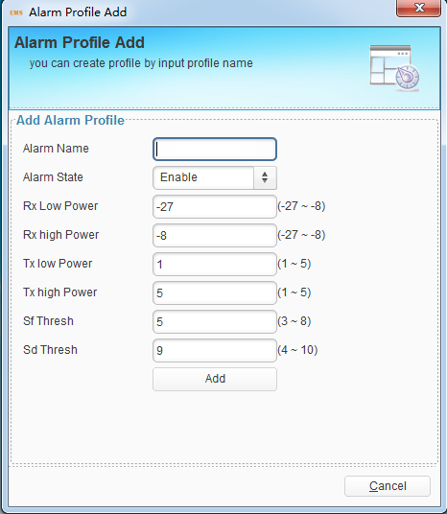
Figure 11-15 alarm profile

11.2 Binding Configuration
After profile is configured, it is necessary to bind it to ONU.
Select PON port ID, then select onu and click “binding” button to open a pop-up dialog box.
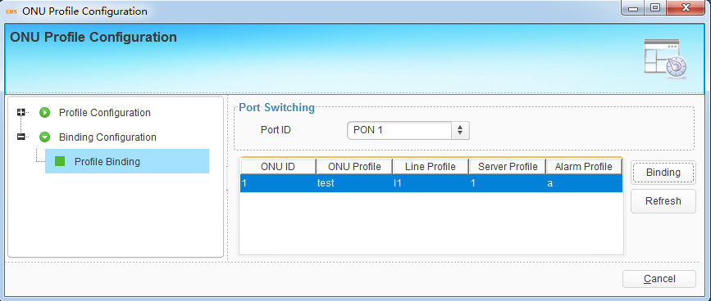
Figure 11-16
Select line profile, service profile, alarm profile on the binding window. And click ‘OK’ button to commit.
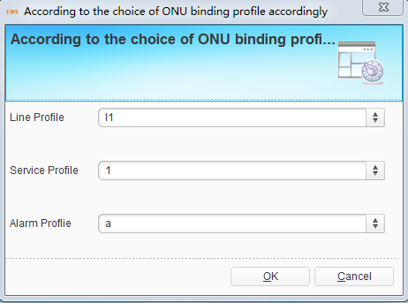
Figure 11-17 Profile Binding

12 ONU Management--GPON
This chapter mainly introduces ONU management function of EMS. ONU management includes ONU configuration, rename, reset, delete, view alarm. Choose ONU icon and open right-click menu.
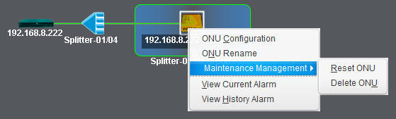
Figure 12-1 onu management

12.1 ONU Configuration
This section mainly introduces ONU service configurations. Different type ONU has different configuration options. OLT can identify what functions the ONU supports and EMS will display the corresponding configuration options in this interface.
Right-click ONU icon, choose “ONU Configuration” to enter ONU configuration interface.

12.1 .1 ONU Information

12.1 .1 .1 Detail Info
We can check the onu detail information in detail info window.
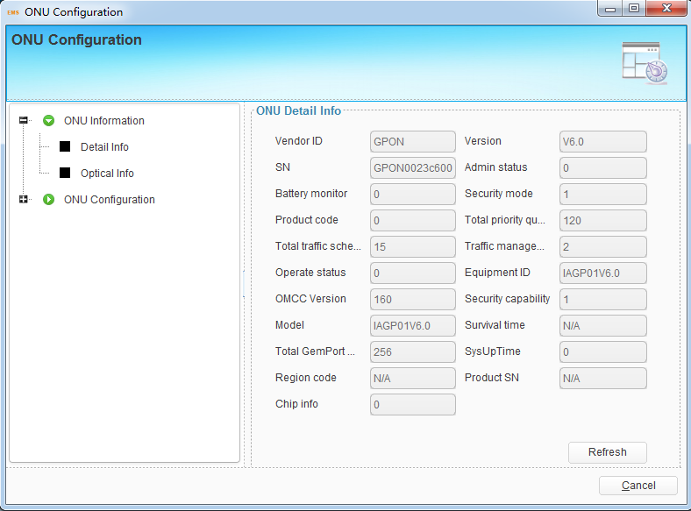
Figure 12-2 onu detail information

12.1 .1 .2 Optical Info
We can check the onu’s pon port parameters.
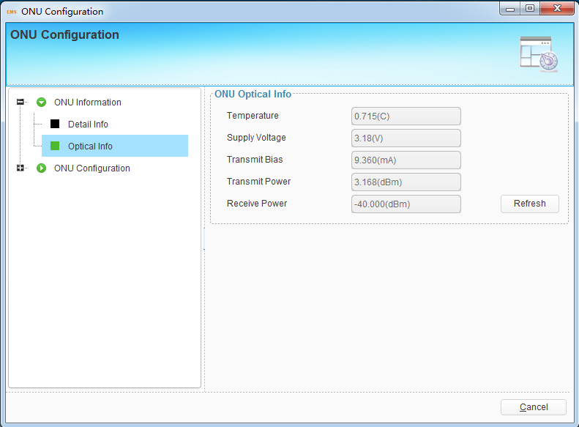
Figure 12-3 onu optical information

12.1.2 ONU Configuration
Onu configuration includes t-cont, gemport, service, service port, port vlan, multicast vlan, multicast vlan strip.

12.1 .2 .1 T-CONT
Enter Tcont ID, select DBA profile and click ‘Add’ button to add a new tcont to ONU. Select Tcont and click ‘Delete’ to remove it.
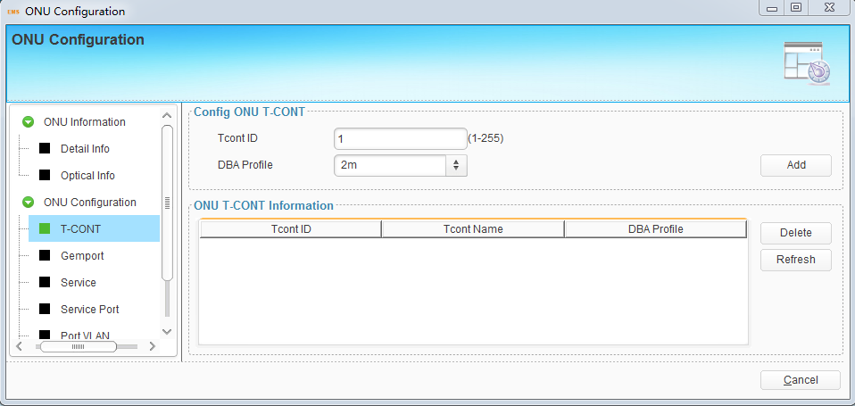
Figure 12-4 T-CONT configuration

12.1 .2 .2 Gemport
Enter Gemport ID, select Tcont ID, select Upstream/Downstream Traffic and click ‘Add’ button to add a new gemport to ONU. Select gemport and click ‘Delete’ to remove it.
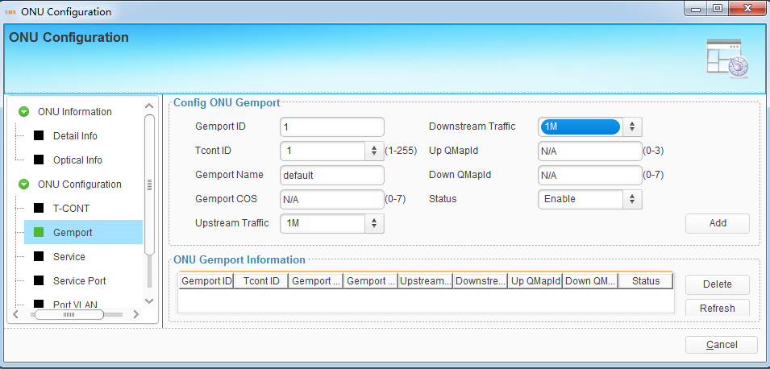
Figure 12-5 Gemport configuration

12.1 .2 .3 Service
Enter Service name, select Gemport ID, enter vlan list and click ‘Add’ button to add a new service to ONU. Select service and click ‘Delete’ to remove it.
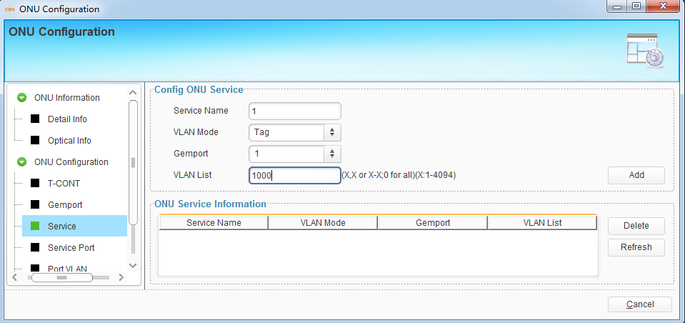
Figure 12-6 Service configuration

12.1 .2 .4 Service Port
Enter Service port ID, select Gemport ID, enter user vlan, enter translate vlan and click ‘Add’ button to add a new service port for ONU. Select service port and click ‘Delete’ to remove it.
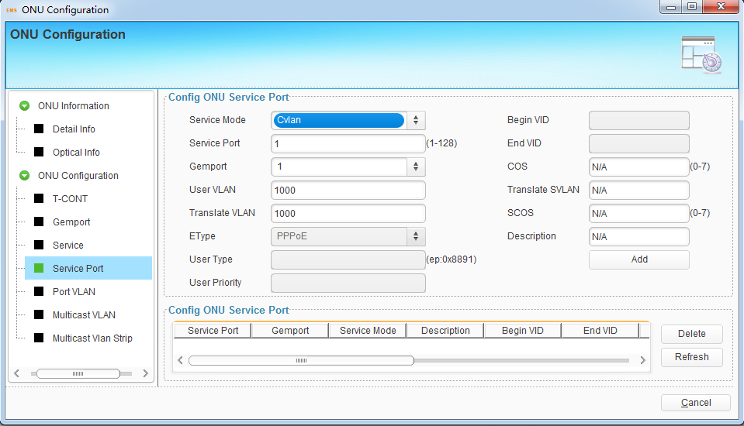
Figure 12-7 Service port configuration

12.1 .2 .5 Port vlan
select server mode, enter port ID, enter vlan and click ‘Add’ button to add a new port vlan for ONU. Select port vlan and click ‘Delete’ to remove it.
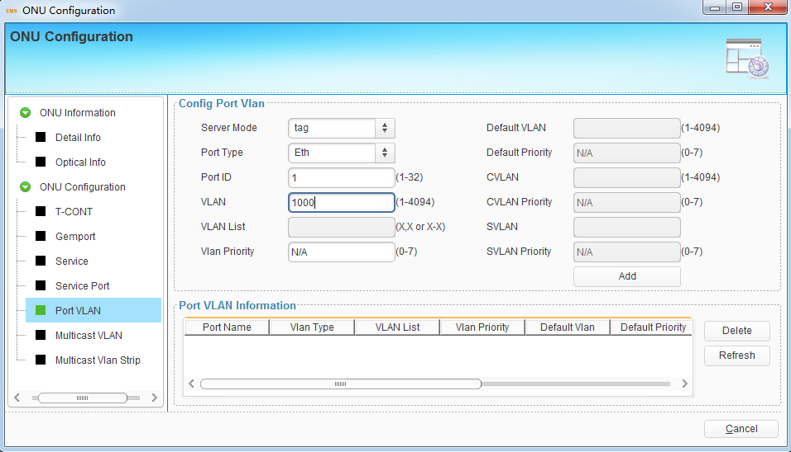
Figure 12-7 port vlan configuration

12.1 .2 .6 Multicast vlan
Enter vlan list and click ‘Add’ button to add multicast vlan.
Select vlan list and click ‘Delete’ button to remove it.
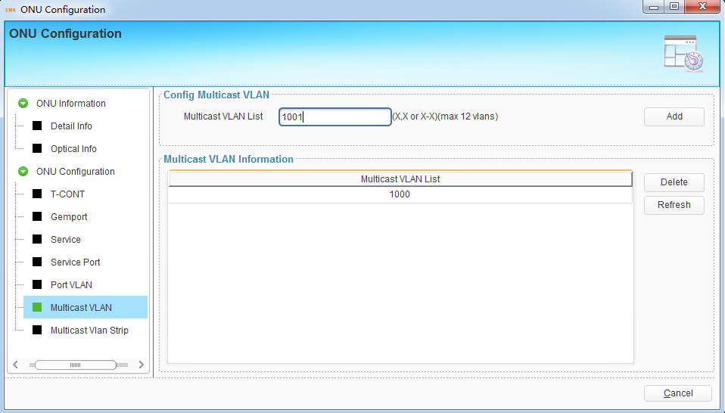
Figure 12-8 multicast vlan configuration

12.1 .2 .7 Multicast vlan strip
Enter port number and click ‘Add’ button to add multicast vlan strip, this operation just for Ethernet port.
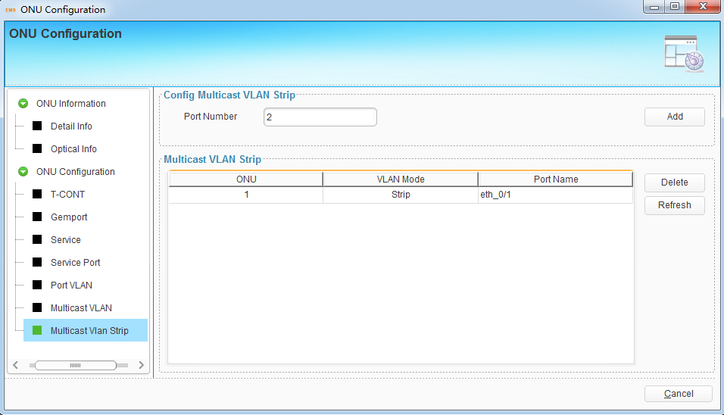
Figure 12-9 multicast vlan configuration

12.2 ONU Rename
This operation is used to set or modify ONU’s name. The name will not be saved in device, but be saved in EMS database.
Choose ONU icon and open right-click menu; choose "ONU Rename" to open a pop-up dialog box.
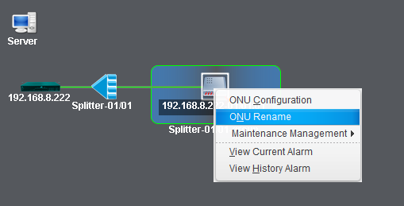
Figure 12-4 ONU Rename
Fill in the ONU new name and click "OK" button to apply.
Figure 12-5 Set ONU Rename

12.3. Maintenance Management

12.3.1 Reset ONU
This operation is used to restart ONU. Rolling log will display the prompt message when the ONU reset successfully.
Right click ONU icon and choose "Maintenance Management" > "Reset ONU", then click "Yes" button on confirmation dialog box to reset it. It will carry out ONU reset action.
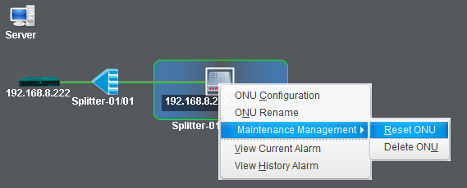
Figure 12-7 Reset ONU
Caution! The operation will cause user services interruption.

12.3.2 Delete ONU
This operation is used to remove ONU from ONU authentication list. All the information related to the ONU will get lost.
Right click ONU icon and choose "Maintenance Management" > "Unauthorize ONU", then click “Yes” button on confirmation dialog box to remove it.
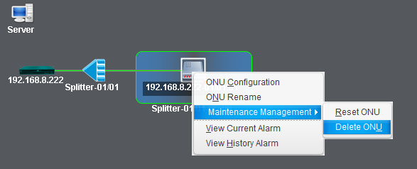
Figure 12-8 Delete ONU
Caution! All information related to the ONU will get lost after executed this operation.

13 Alarm Management
This chapter introduces alarms and events query and configurations. In order to receive alarms normally by EMS, you must add trap server to OLT. The trap server is the IP address of the computer where the EMS server installed.
Right-click OLT icon, choose “Device Details” and open a pop-up dialog box. Click “Add Trap Server” button to add current EMS server to OLT. There will be a prompt which says successfully.
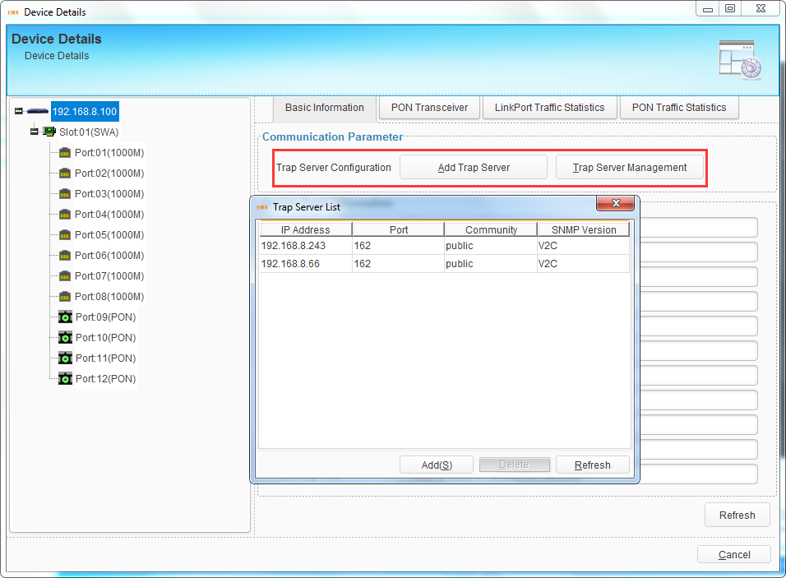
Figure 13-1 Trap Server Configuration
Click “Trap Server Management” button to view the trap servers. Trap server can also be added or deleted in this dialog box. When add a trap server, fill in the IP address, UDP port, community and select SNMP version. Usually, UDP port is 162, SNMP version is V2C, community is default read community public.
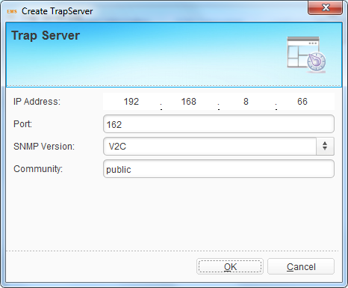
Figure 13-2 Add Trap Server
Trap server must be added to OLT so that EMS can receive alarms.

13.1 Alarm Configuration
This section introduces alarm process rules configuration and alarm sound configuration.

13.1.1 Alarm Process Rule
There may be are many kinds of alarms occur when the PON system is working, but not every alarm we need to care about or the important ones we must know. In this case, alarm shield rule and Email send rule are useful.
Click menu “Alarm Management” > “Alarm Process Rule”, open a dialog box, and choose Alarm Process Rule, create a rule, add alarms which need to be shielded. If the rule is active, the alarms in the rule will not occur any more.
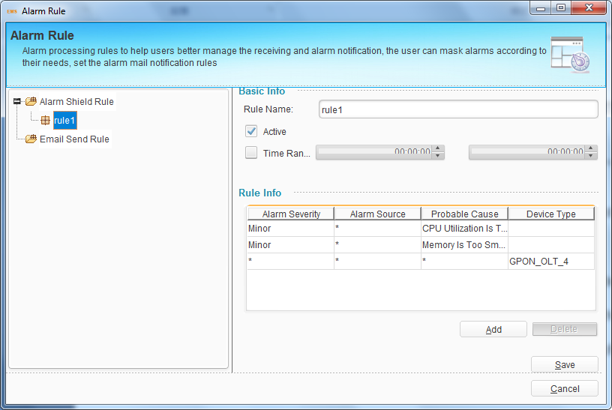
Figure 13-3 Alarm Shield Rule
Click Email Send Rule, create a rule, fill in alarm receive Email and add alarms which need to be sent by Email. If the rule is active, the alarms in the rule will be sent by Email.
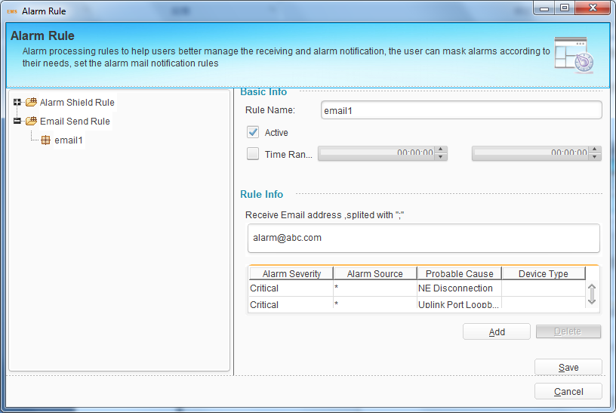
Figure 13-4 Alarm Email Send Rule
Alarm shield rule and Email send rule are still under development.

13.1.2 Alarm Sound
Alarm sound is used to remind network administrator that there is alarm occurred. Different sound can be chosen for different severity level alarm.
Click menu “Alarm Management” > “Alarm Sound”, select alarm sound for each severity level alarm.
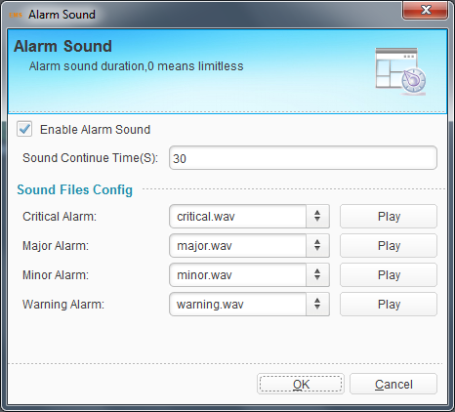
Figure 13-5 Alarm Sound

13.2 Alarm and Event Query
There may be many alarms and events occur when the system is working. Some of them are happening and some have already cleared or been cleared. If want to know what alarms or events occurred, you can use the alarm and event query function.
Click menu “Alarm Management” > “Alarm and Event Query”, open query dialog box. You can query event, current alarm or history alarm, which can be chosen on the upper-left of the dialog box. Select alarm source device on the left of the box and query conditions, add alarm types to the right of the box, click “Query” button to query alarms. You can also save the query conditions as a template.
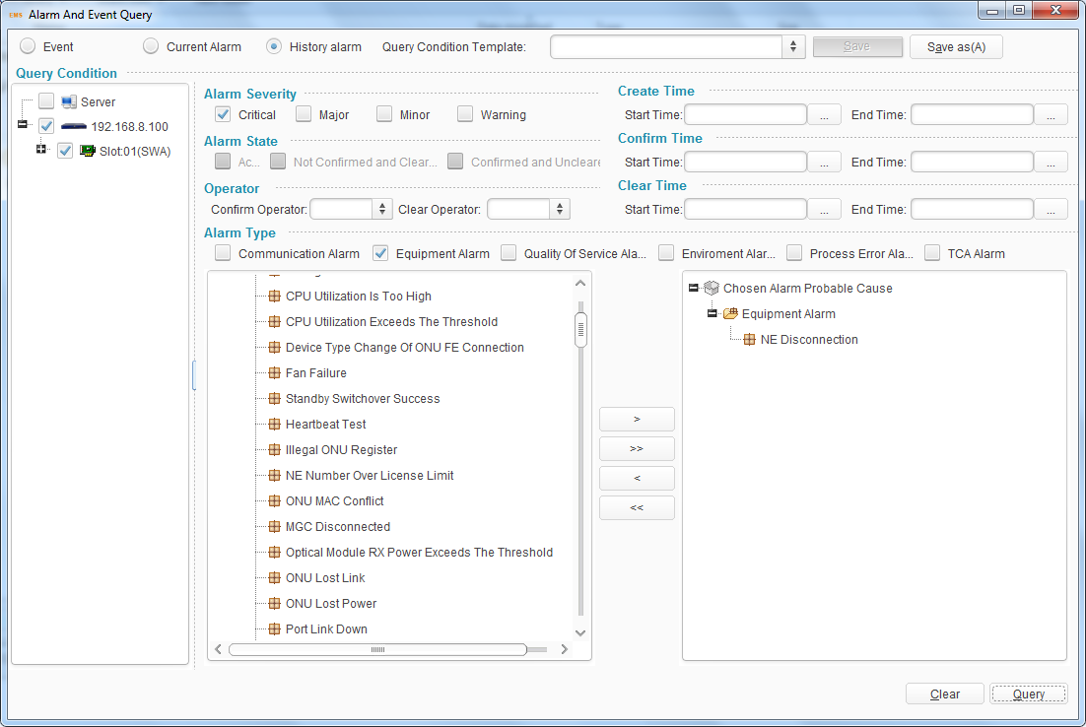
Figure 13-6 Alarm Query Configuration
Choose one alarm in the query result table; you can do some operations to the alarm, such as locate the source device in the topology, confirm or clear alarm, delete alarm, export and view the alarm details. Confirm and clear operation are available for current alarms and delete operation is available for history alarms.
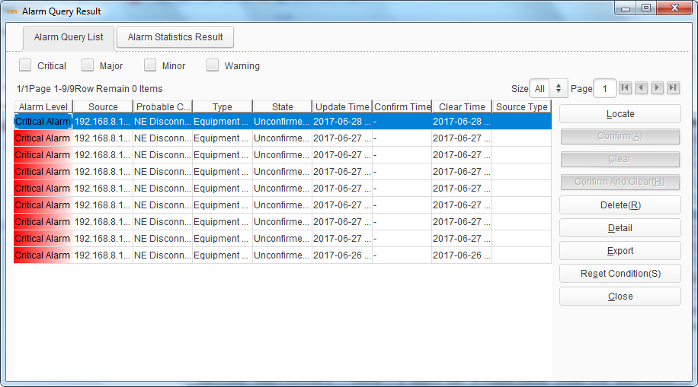
Figure 13-7 Alarm Query Result

13.3 Real Time Alarm
At the bottom of EMS main interface, real time alarm/event window will display all current alarms/events of OLT and ONU devices.
Real time alarm list contains alarm level, description, alarm source, device type, probable cause, alarms create time and EMS receive time. Different severity level is marked by different color. The color also displays on the alarm source. You can confirm, clear, shield the alarms or view alarm details by right-clicking.
Real time event list contains event name, event source, source type, events create time and event type. You can delete events or view event details by right-clicking.
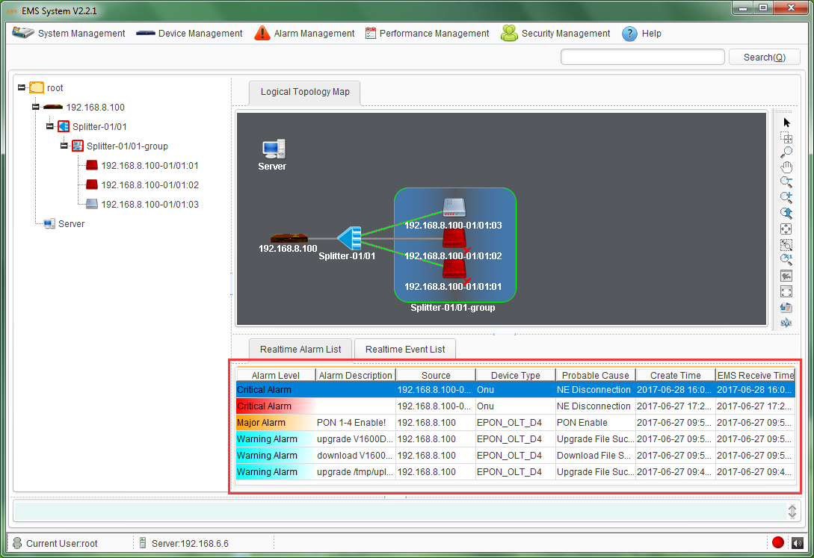
Figure 13-8 Real Time Alarm
When OLT is disconnected with EMS, EMS will display a red “X” at the OLT icon in the topology map. When ONU is disconnected with OLT and OLT is still connecting with EMS, EMS will display a red “X” at the ONU icon in the topology map. The cross mark “X” will disappear after the connection is established.

13.4 OLT Alarm Management
This section introduces OLT alarm configuration and view.

13.4.1 OLT Alarm Configuration
OLT alarm configuration contains PON alarm, alarm control and threshold alarm.
Right click OLT icon, choose "Alarm Configuration" to enter OLT alarm configuration interface.
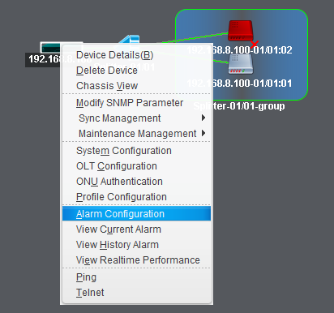
Figure 13-9 Enter OLT Alarm Configuration

13.4.1.1 OLT PON alarm
OLT PON alarm contains transmit power, Vcc, bias current and temperature alarm of PON module.
Select PON port, active status and fill in threshold. For high alarm, alarm threshold must be bigger than clear threshold; oppositely, for low alarm, alarm threshold must be smaller than clear threshold.
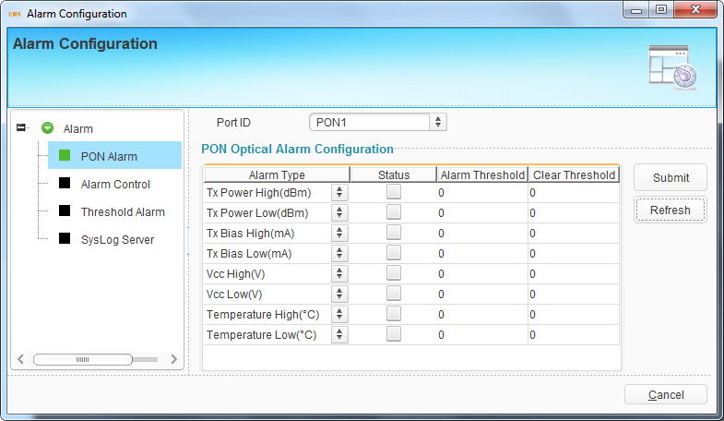
Figure 13-10 OLT PON Alarm Configuration

13.4.1.2 Alarm Control
These configurations are used to control whether the alarms display on EMS, system log or other devices. There are four options for each alarm, which are print, record, trap and remote. The meaning of each option is shown bellow.
- Print: print alarm information on console port.
- Record: record alarm information in system log.
- Trap: display alarm information on EMS.
- Remote: send alarm information to remoter server.
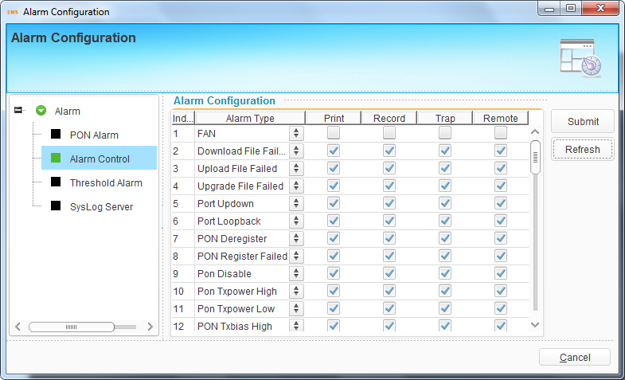
Figure 13-11 Alarm control configuration
The alarm control configuration contains all alarms of the PON system. It is only used to control whether the alarms display or not, but not to control whether the alarms report or not.

13.4.1.3 Threshold Alarm
These configurations are used to configure OLT system alarm, such as temperature alarm, CPU usage alarm and memory usage alarm. You need to select alarm display mode and set threshold.
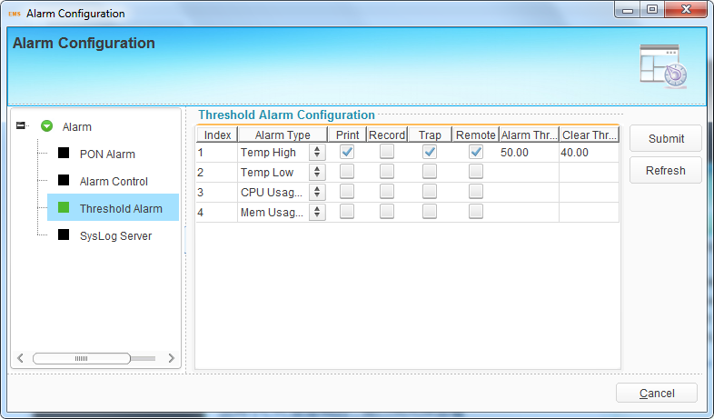
Figure 13-12 Threshold Alarm Configuration

13.4.1.4 System Log Server
This configuration is used to configure server address and monitor UDP port for receiving system log. When enabled Remote in the alarm settings, the alarms will send to the server.
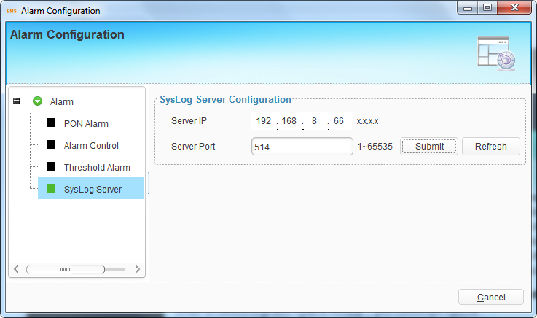
Figure 13-13 Syslog Server Configuration

13.4.2 View OLT Alarm
Except querying alarms and viewing real time alarms described above, there is another frequently-used ways to view OLT alarms.

13.4.2.1 View Current Alarm
Right-click OLT icon, choose “View Current Alarm”, and open current alarms dialog box. You can choose alarm list or alarm statistics to view.
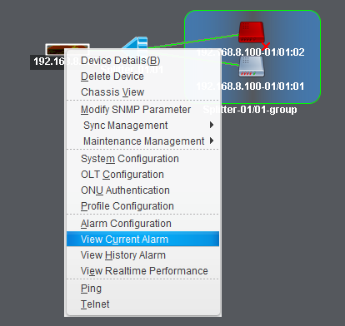
Figure 13-14 View OLT Current Alarm
In alarm list interface, you can choose which severity level alarms can be displayed and confirm or clear the alarms, view alarm details and export the alarms.
In alarm statistics interface, you can choose which kind of methods to display the alarms. The methods contain pie graph, bar graph and statistics table.
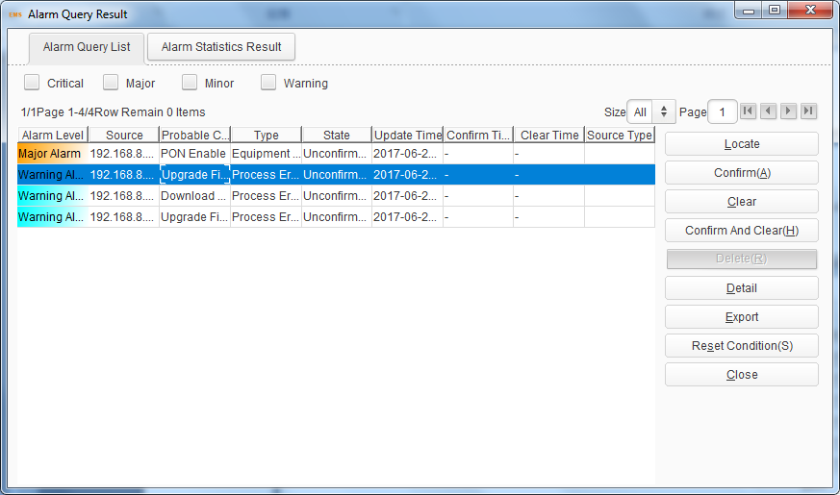
Figure 13-15 OLT Current Alarm List
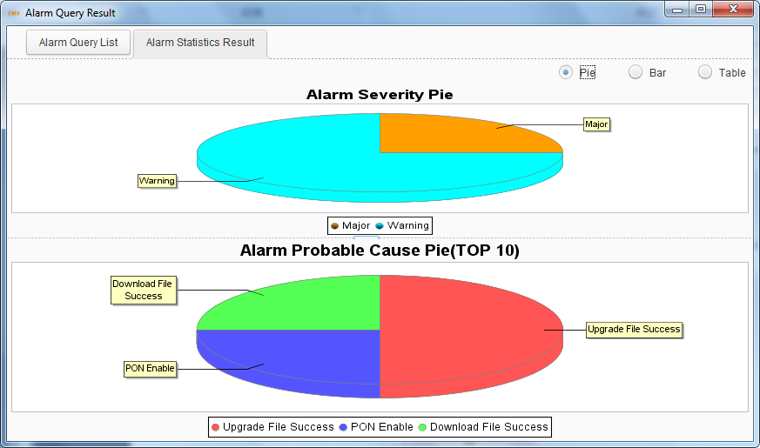
Figure 13-16 OLT Current Alarm Statistics

13.4.2.2 View History Alarm
Right-click OLT icon, choose “View History Alarm”, and open history alarms dialog box. You can choose alarm list or alarm statistics to view.
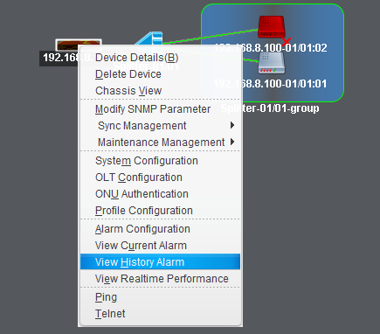
Figure 13-17 View OLT History Alarm
In alarm list interface, you can choose which severity level alarms can be displayed and delete the alarms, view alarm details and export the alarms.
In alarm statistics interface, you can choose which kind of methods to display the alarms. The methods contain pie graph, bar graph and statistics table.
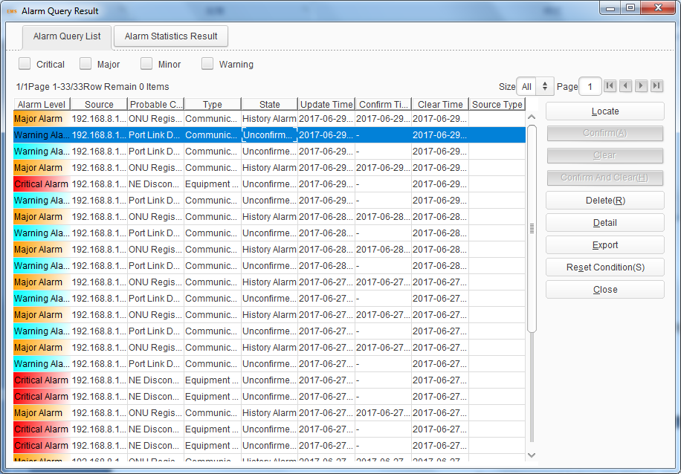
Figure 13-18 OLT History Alarm List
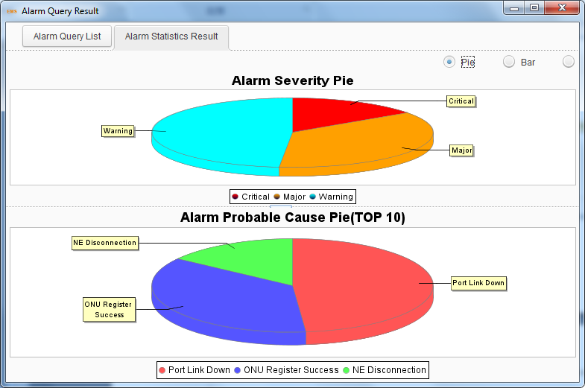
Figure 13-19 OLT History Alarm Statistics

13.5 ONU Alarm Manangement
This section mainly introduces ONU alarm configuration and view.

13.5.1 ONU Alarm Configuration
ONU alarm configuration has been introduced in alarm profile configuration and it is the only way to configure ONU alarm. If want to configure ONU alarm, please refer to alarm profile configuration.

13.5.2 View ONU Alarm
Except querying alarms and viewing real time alarms described above, there is another frequently-used ways to view ONU alarms.

13.5.2.1 View Current Alarm
Right-click ONU icon, choose “View Current Alarm”, and open current alarms dialog box. You can choose alarm list or alarm statistics to view.
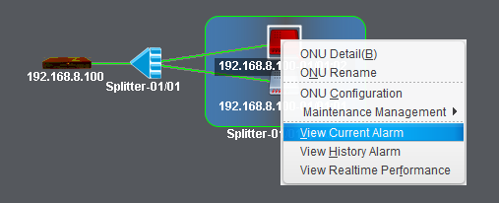
Figure 13-20 View ONU Current Alarm
In alarm list interface, you can choose which severity level alarms can be displayed and confirm or clear the alarms, view alarm details and export the alarms.
In alarm statistics interface, you can choose which kind of methods to display the alarms. The methods contain pie graph, bar graph and statistics table.
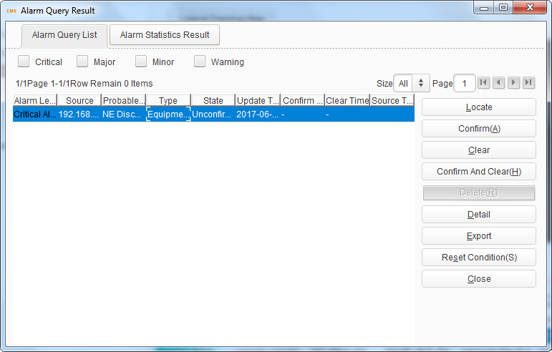
Figure 13-21 ONU Current Alarm List
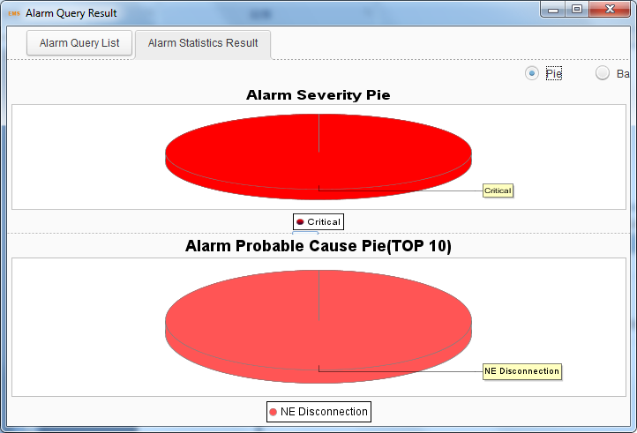
Figure 13-22 ONU Current Alarm Statistics

13.5.2.2 View History Alarm
Right-click ONU icon, choose “View History Alarm”, and open history alarms dialog box. You can choose alarm list or alarm statistics to view.
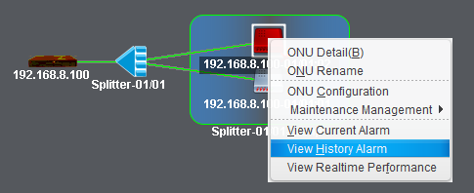
Figure 13-23 View ONU History Alarm
In alarm list interface, you can choose which severity level alarms can be displayed and delete the alarms, view alarm details and export the alarms.
In alarm statistics interface, you can choose which kind of methods to display the alarms. The methods contain pie graph, bar graph and statistics table.
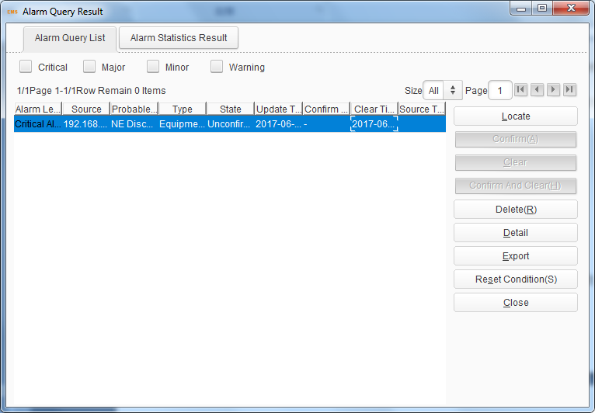
Figure 13-24 ONU History Alarm List
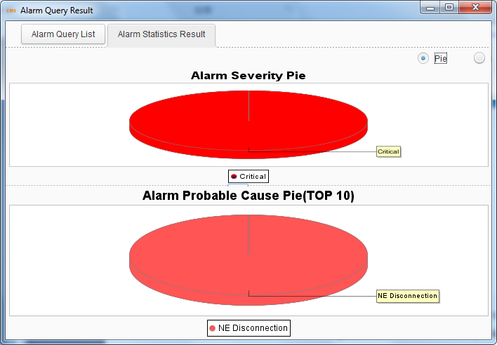
Figure 13-25 ONU History Alarm Statistics

14 Performance Management

14.1 OLT Performance
OLT performance is used to collect OLT real time traffic statistics of a certain time and draw a graph. Traffic statistics can be shown by line graph, area graph, bar graph and table.
Right-click OLT icon, choose “View Realtime Performance”, open performance statistics dialog box.
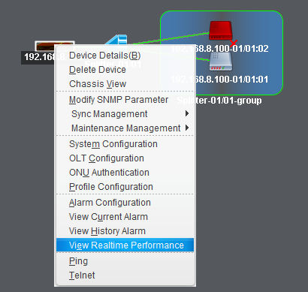
Figure 14-1 Enter OLT Performance Statistics
Select ports and types of traffic and click “Add” button, the traffic of the selected ports will be shown on the interface. You can pause and start collecting traffic at any time. Once stopped, you need to add the traffic types again.
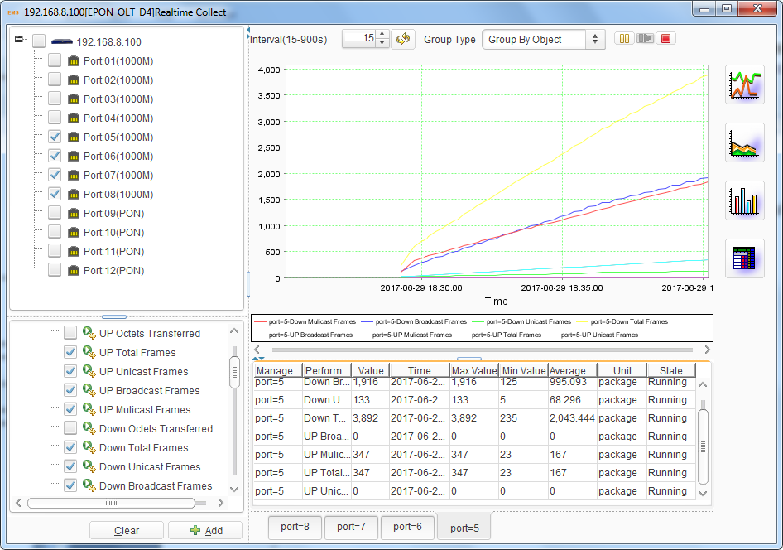
Figure 14-2 OLT Performance Statistics

14.2 ONU performance—EPON
ONU performance is used to collect ONU real time traffic statistics of a certain time and draw a graph. Traffic statistics can be shown by line graph, area graph, bar graph and table.
Right-click ONU icon, choose “View Realtime Performance”, open performance statistics dialog box.
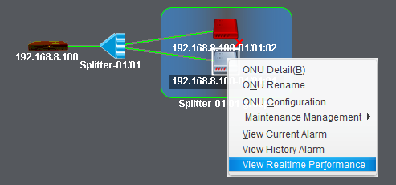
Figure 14-3 Enter ONU Performance Statistics
Select ports and types of traffic and click “Add” button, the traffic of the selected ports will be shown on the interface. You can pause and start collecting traffic at any time. Once stopped, you need to add the traffic types again.
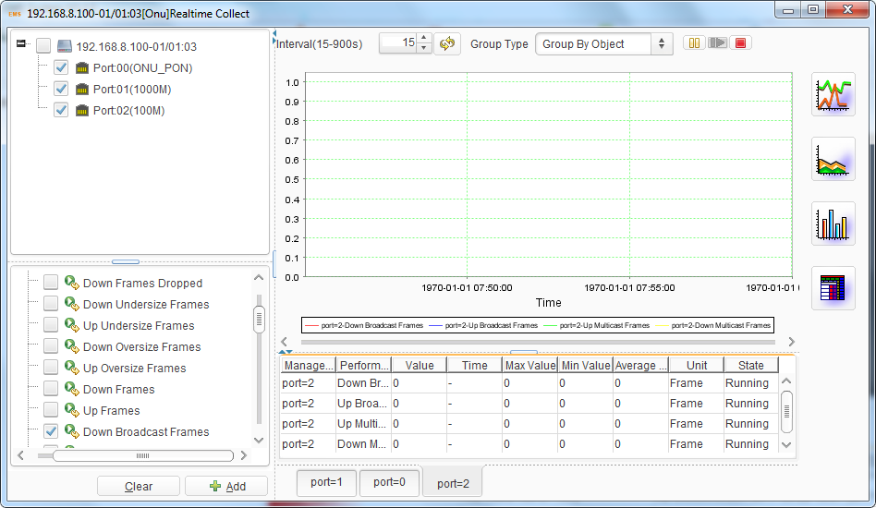
Figure 14-4 ONU Performance Statistics

End of the document.
Thank you

