APPLICATION WHITE PAPER—GPON APP NOTE/EXAMPLE
Version V1.0.1
Release Date :2017-08-08

Z

Contents
DBA profile 3
SFU Authorization 3
Planning Data 3
ONU Manual authorize 4
ONU automatic authorize 6
HGU Authorization 9
Planning Data 9
ONU Manual authorize 9
ONU automatic authorize 11
Automatic Configure the ONU By Profile 14
Planning Data 14
Automatic configure onu 14
Show/Delete the ONU 21
Show the ONU status 21
Delete the ONU status 22
Case 1 SFU Bridge 23
Network Diagram 23
Planning Data 23
Configuring the OLT 24
Configuring the ONU 26
Case 2 SFU Bridge With IPTV 31
Network Diagram 31
Planning Data 31
Configuring the OLT 32
Configuring the ONU 36
Case 4 HGU Router --Internet 41
Network Diagram 41
Planning Data 41
Configuring the OLT 43
Configuring the ONU 44
Case 5 HGU Router --VoIP 53
Network Diagram 53
Planning Data 53
Configuring the OLT 54
Configuring the ONU 56
Case 6 HGU Bridge --IPTV 63
Network Diagram 63
Planning Data 63
Configuring the OLT 64
Configuring the ONU 68

DBA profile
Item | Description | Example
DBA profile | The DBA of ONU | Assured :10M  Maximum :100M

By CLI --------------
gpon-olt(config)# profile dba
gpon-olt(profile-dba:1)# type 3 assured 10000 maximum 100000
gpon-olt(profile-dba:1)# commit

By Web --------------
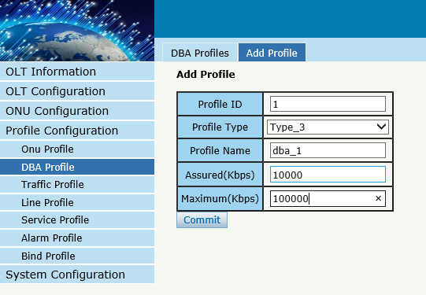

SFU Authorization

Planning Data
Item | Description | Example
ONU Type | The type of onu | V2801ZG
ONU SN | ONU serial number | GPON00000015
OLT PON | The PON port of OLT | GPON 0/1
Equipid | The Equipment id of ONU | V2801ZGV8.0

ONU Manual authorize
By CLI --------------

gpon-olt(config)# profile onu name V2801ZG
gpon-olt(profile-onu:3)# port-num eth 1
gpon-olt(profile-onu:3)# commit
gpon-olt(profile-onu:3)# exit
gpon-olt(config)# show onu auto-find
gpon-olt(config)# interface gpon 0/1
gpon-olt(config-pon-0/1)# onu add 1 profile V2801ZG sn GPON00000015

By Web --------------
1、Create ONU profile for 1GE ONU

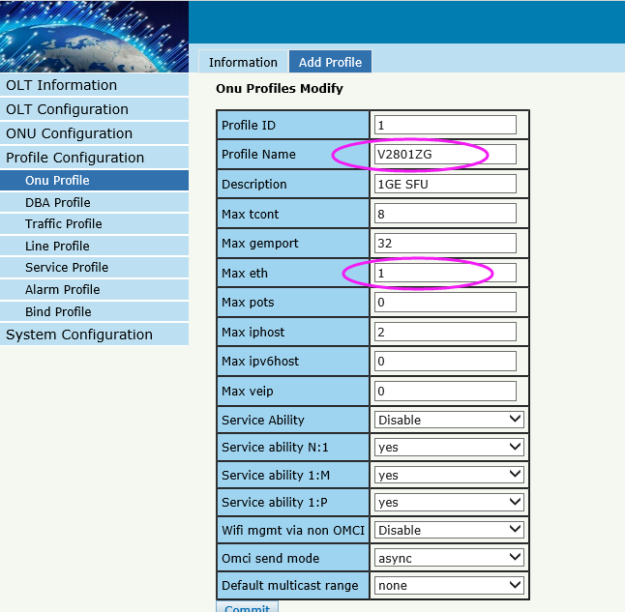
2, Find the ONU of Autofind lists and perform authorization operations on it
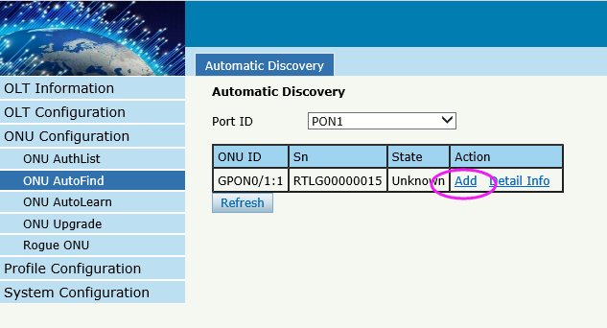
3, Select the 1GE ONU template
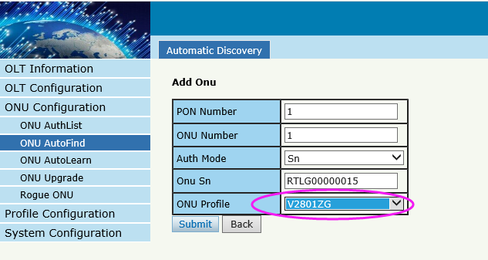
If ONU is successfully registered, working will be shown here
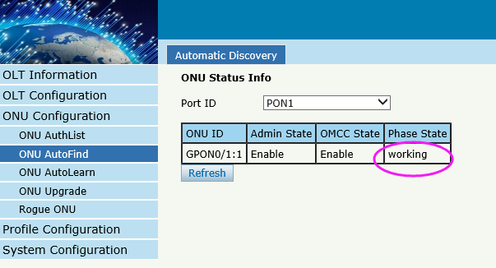

ONU automatic authorize
By CLI --------------
gpon-olt(config)# profile onu name V2801ZG
gpon-olt(profile-onu:3)# port-num eth 1
gpon-olt(profile-onu:3)# commit
gpon-olt(profile-onu:3)# exit
gpon-olt(config)# show onu auto-find detail-info
gpon-olt(config)# onu auto-learn bind onu-profile V2801ZGV8.0 V2801ZG
gpon-olt(config)# interface gpon 0/1
gpon-olt(config-pon-0/1)# onu auto-learn
By Web --------------
1、Create ONU profile for 1GE ONU

2, Equipment ID binding ONU profile

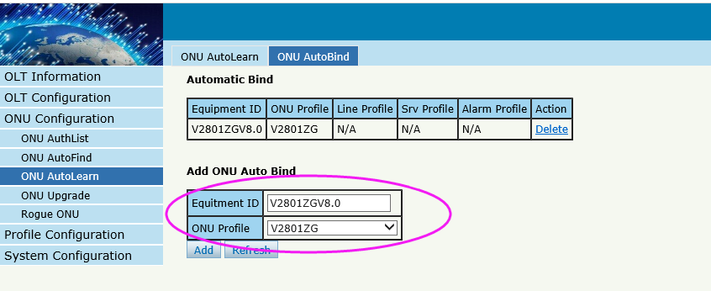
3, enable automatic learn mode of PON port
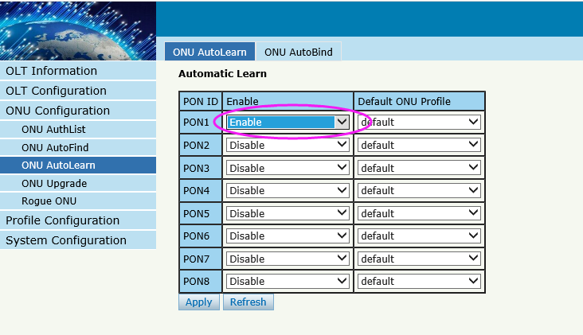
If ONU is successfully registered, working will be shown here

HGU Authorization

Planning Data
Item | Description | Example
ONU Type | The type of onu | HG326RGW
ONU SN | ONU serial number | GPON000010E0
OLT PON | The PON port of OLT | GPON 0/1
Equipid | The Equipment id of ONU | IGD

ONU Manual authorize
By CLI --------------
gpon-olt(config)# profile onu name HG326RGW
gpon-olt(profile-onu:3)# port-num veip 1
gpon-olt(profile-onu:3)# commit
gpon-olt(profile-onu:3)# exit
gpon-olt(config)# show onu auto-find
gpon-olt(config)# interface gpon 0/1
gpon-olt(config-pon-0/1)# onu add 1 profile HG326RGW sn GPON000010E0

By Web --------------
1、Create ONU profile for 4GE HGU
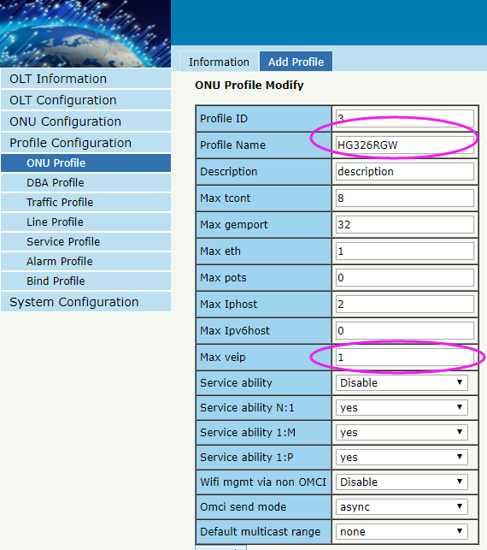

2, Find the ONU of Autofind lists and perform authorization operations on it
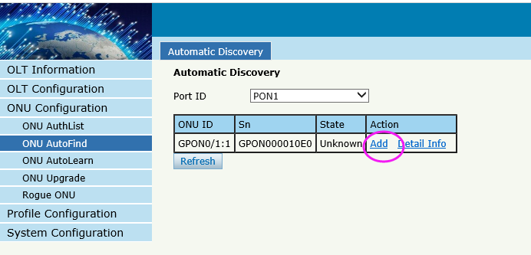
3, Select the ONU template
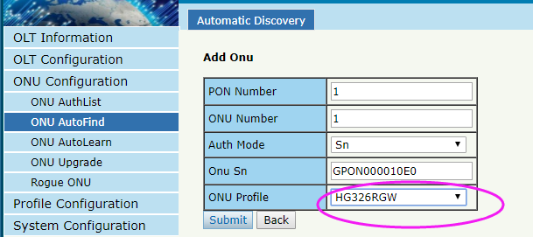

If ONU is successfully registered, working will be shown here

ONU automatic authorize
By CLI --------------
gpon-olt(config)# profile onu name HG326RGW
gpon-olt(profile-onu:3)# port-num veip 1
gpon-olt(profile-onu:3)# commit
gpon-olt(profile-onu:3)# exit
gpon-olt(config)# show onu auto-find detail-info
gpon-olt(config)# onu auto-learn bind onu-profile IGD HG326RGW
gpon-olt(config)# interface gpon 0/1
gpon-olt(config-pon-0/1)# onu auto-learn

By Web --------------
1、Create ONU profile for 4GE HGU

2, Equipment ID binding ONU profile
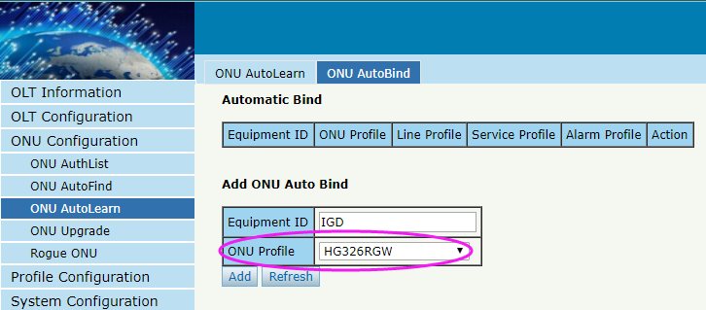

3, enable automatic learn mode
If ONU is successfully registered, working will be shown here

Automatic Configure the ONU By Profile
Create a line profile and srv profile. When the ONU online, it can be bound the corresponding line profile and srvprofile according to the Equipment id.

Planning Data
Item | Description | Example
ONU Type | The type of onu | 2801ZG
ONU SN | ONU serial number | GPON000000C0
OLT PON | The PON port of OLT | GPON 0/1
Equipment id | The Equipment id of ONU | V2801ZGV8.0
Tcont | Tcont | 1
Gemport | Gemport | 1
Service | The onu Service | Vlan 100
Service-port | The onu service-port | Vlan 100  Mode tag

Automatic configure onu
By CLI --------------
gpon-olt(config)# profile onu name V2801ZG
gpon-olt(profile-onu:3)# port-num eth 1
gpon-olt(profile-onu:3)# commit
gpon-olt(profile-onu:3)# exit
gpon-olt(config)# profile dba name dba_1
gpon-olt(profile-dba:4)# type 3 assured 10000 maximum 100000
gpon-olt(profile-dba:4)# exit
gpon-olt(profile-dba:4)# commit
gpon-olt(config)# profile line name line1
gpon-olt(profile-line:1)# tcont 1 dba dba_1
gpon-olt(profile-line:1)# gemport 1 tcont 1
gpon-olt(profile-line:1)# service 1 gemport 1 vlan 100
gpon-olt(profile-line:1)# service-port 1 gemport 1 uservlan 100 vlan 100
gpon-olt(profile-line:1)# commit
gpon-olt(profile-line:1)# exit
pon-olt(config)# profile srv name srv1
gpon-olt(profile-srv:1)# portvlan eth 1 mode hybrid def_vlan 100
gpon-olt(profile-srv:1)# commit
gpon-olt(profile-srv:1)# exit
gpon-olt(config)# onu auto-learn bind onu-profile V2801ZG8.0 V2801ZG
gpon-olt(config)# onu auto-learn bind line-profile V2801ZGV8.0 line1
gpon-olt(config)# onu auto-learn bind srv-profile V2801ZGV8.0 srv1
gpon-olt(config)# interface gpon 0/1
gpon-olt(config-pon-0/1)# onu auto-learn
gpon-olt(config-pon-0/1)#exit

By Web --------------
1、Create ONU profile for 1GE ONU
2, Equipment ID bind ONU profile

3, create line profile
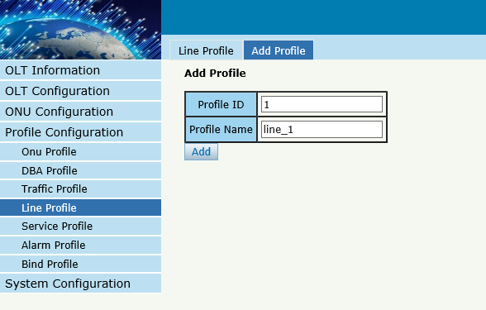
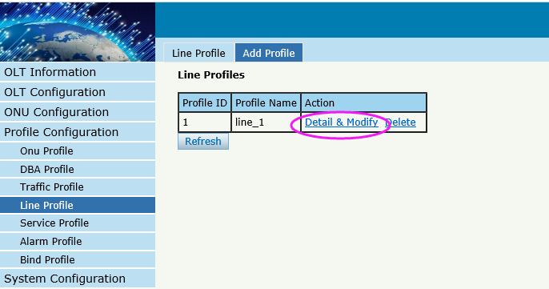
4, create tcont
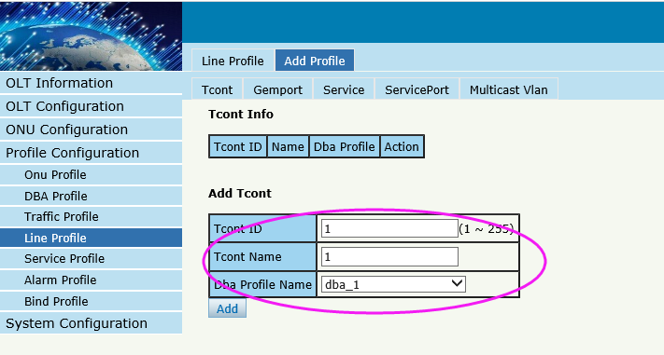
5, create gemport
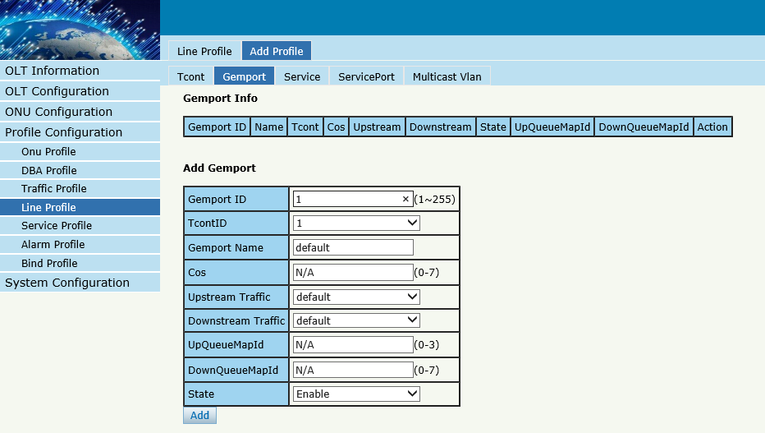
6 create service
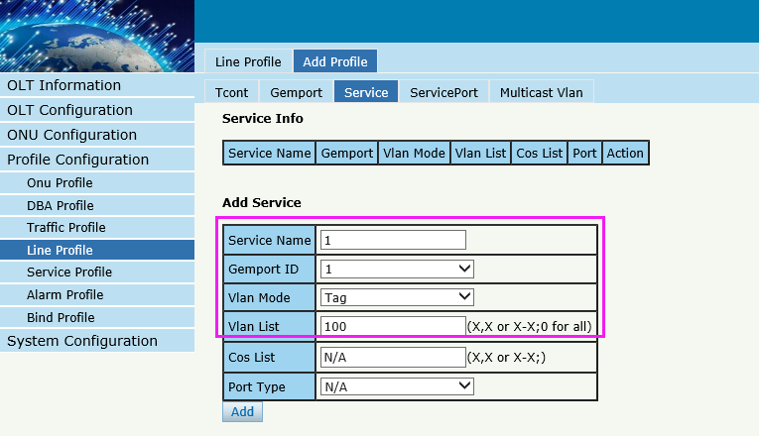

7、create service-port
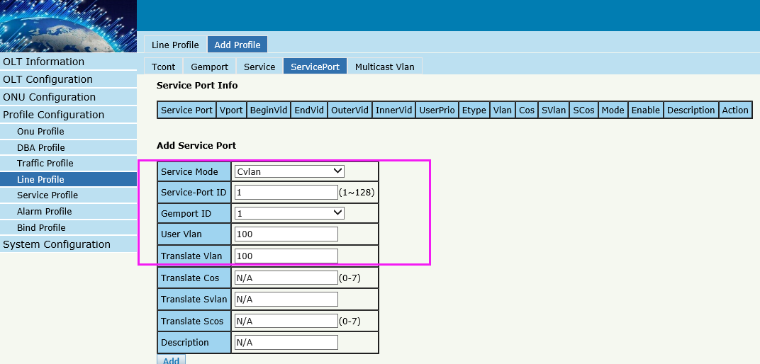

8、create service profile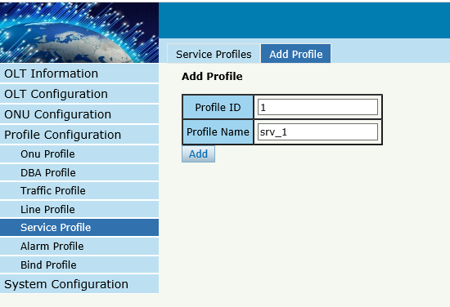
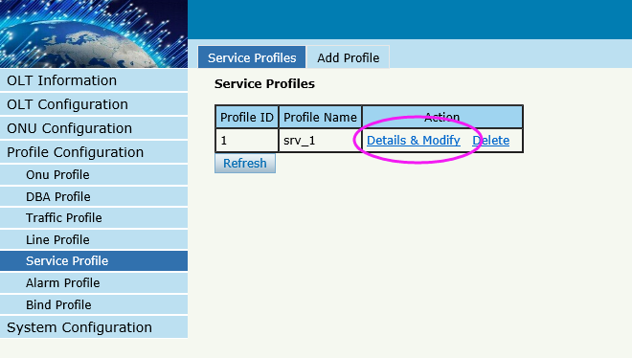
9、create service profile
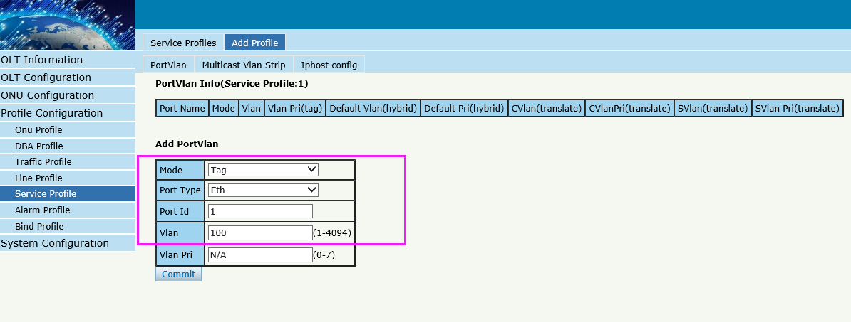
10、bind profile
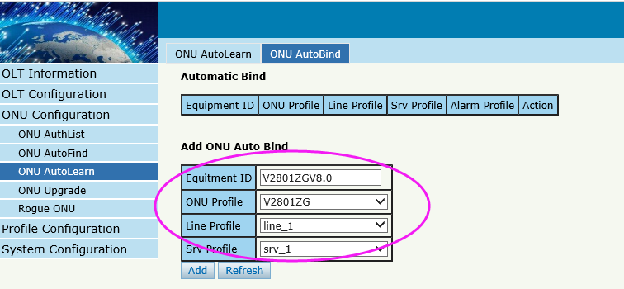

11, enable automatic learn mode

Show/Delete the ONU

Show the ONU status
By CLI --------------
gpon-olt(config-pon-0/1)# show onu state
OnuIndex Admin State OMCC State Phase State Config State Channel
---------------------------------------------------------------------------------------------------------------------------
1/1/1:1 enable enable working succeeded 1(GPON)
By Web --------------
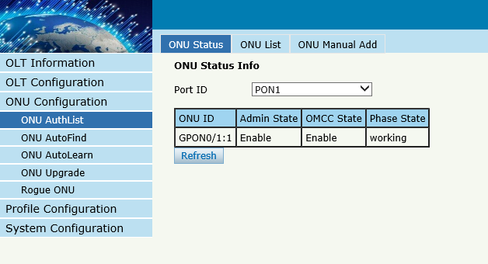

Delete the ONU status
By CLI --------------
gpon-olt(config-pon-0/1)# no onu 1

By Web --------------
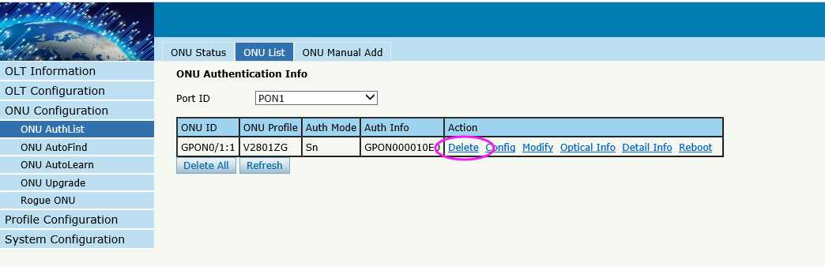

Case 1 SFU Bridge

Network Diagram
DHCP/PPPoE/Static
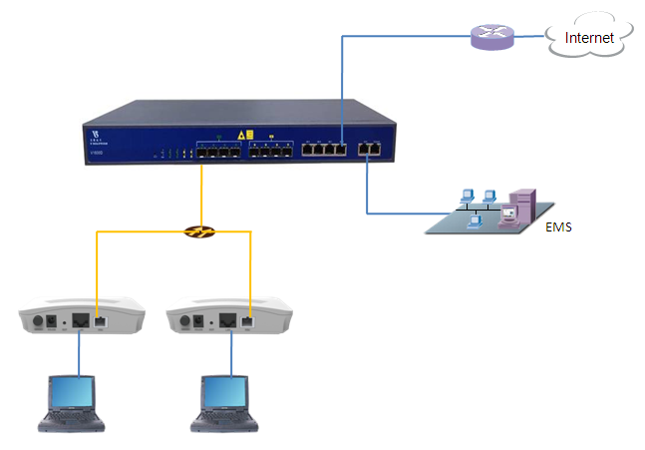
10.1.1.1/24

Planning Data
Item |  | Description | Example
ONU Information | Slot No. | The number of the slot actually used. | 0
 | PON No. | The number of the actually used PON port. | 1
 | ONU Auth No. | Configure according to the network planning of the operator. | 1
 | ONU Type | The type of the ONU. | 2801ZG
 | ONU SN | ONU serial number | GPON000000C0
 | OLT PON | The PON port of OLT | GPON 0/1
 | Equipid | The Equipment id of ONU | V2801ZGV8.0
OLT | Service Uplink VLAN | The VLAN ID of the uplink port service. | VLAN mode = UNTAG  PVID = 100
 | Service Uplink port | Configure according to the number of the actually  used uplink port. | GE8
ONU | Service LAN port | The number of the actually used ONU port. | LAN1
 | Tcont | The onu Tcont | Tcont=1
 | Gemport | The onu Gemport | Gemport=1
 | Dba | The ONU dba profile | Dba name= dba_1  Dba type = 3
 | Service vlan | The vlan of ONU service. | Service Vlan = 100
 | Service-port uservlan | The vlan of onu service-port | Service-port vlan =100
 | Portvlan | The vlan of onu port | Portvlan=100  Mode=hybrid
 | If DHCP mode | The router use DHCP assign ip to PC. | Gateway = 10.1.1.1  IP Range 10.1.1.2-10.1.1.254  IP Mask = 255.255.255.0  DNS = 8.8.8.8
PC | If PPPoE  mode | The router use PPPoE assign ip to PC. | IP Range 10.1.1.2-10.1.1.254  IP Mask = 255.255.255.0  User name = test  Password = test
 | If Static  mode | The router use Static assign ip to PC. | Gateway = 10.1.1.1  IP = 10.1.1.100  IP Mask = 255.255.255.0  DNS = 8.8.8.8

Configuring the OLT
By CLI --------------
gpon-olt(config)# vlan 100
gpon-olt(config-vlan-100)# exit
gpon-olt(config)# interface gigabitethernet 0/8
gpon-olt(config-if-ge0/8)# switchport hybrid vlan 100 untagged
gpon-olt(config-if-ge0/8)# switchport hybrid pvid vlan 100
gpon-olt(config-if-ge0/8)# exit
By Web --------------
1, Create a new VLAN
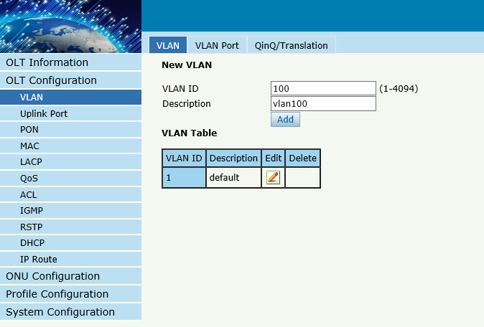
2. Configure GE port VLAN mode
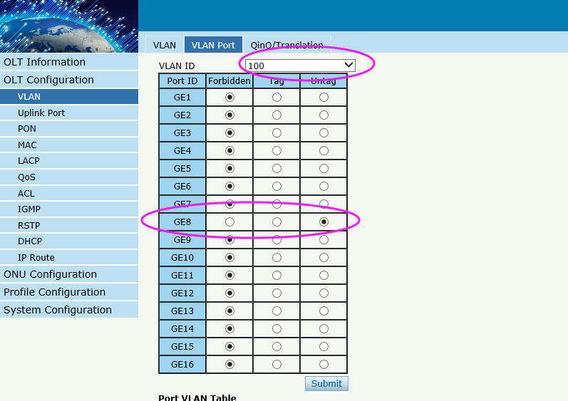
3, Configure GE port PVID
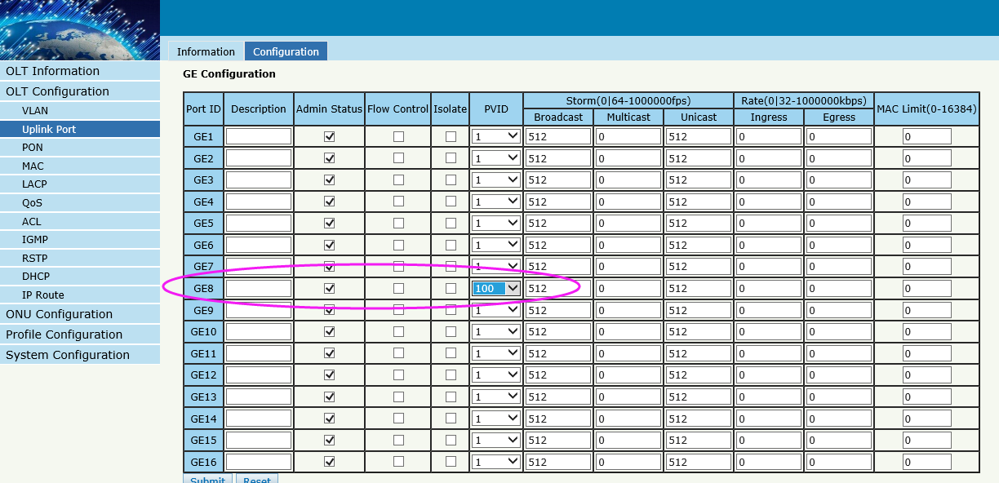

Configuring the ONU
By CLI --------------
gpon-olt(config)#profile dba name dba_1
gpon-olt(profile-dba:1)# type 3 assured 10000 maximum 1000000
gpon-olt(profile-dba:1)# commit
gpon-olt(profile-dba:1)# exit
gpon-olt(config)# interface gpon 0/1
gpon-olt(config-pon-0/1)# onu 1 tcont 1 dba dba_1
gpon-olt(config-pon-0/1)# onu 1 gemport 1 tcont 1
gpon-olt(config-pon-0/1)# onu 1 service 1 gemport 1 vlan 100
gpon-olt(config-pon-0/1)#onu 1 service-port 1 gemport 1 uservlan 100 vlan 100
gpon-olt(config-pon-0/1)#onu 1 portvlan eth 1 mode hybrid def_vlan 100

By Web --------------
1, create DBA profile
2,Create ONU profile for 1GE ONU

3,Authorize ONU
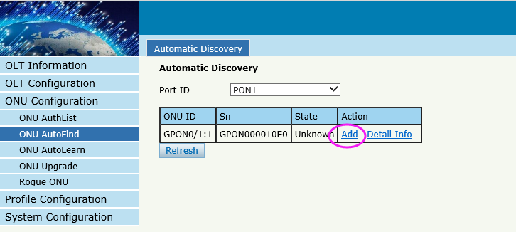
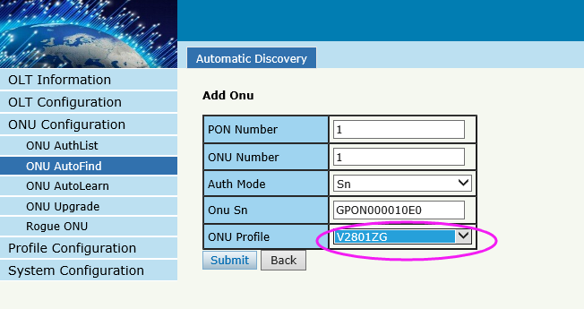
4, Configure ONU
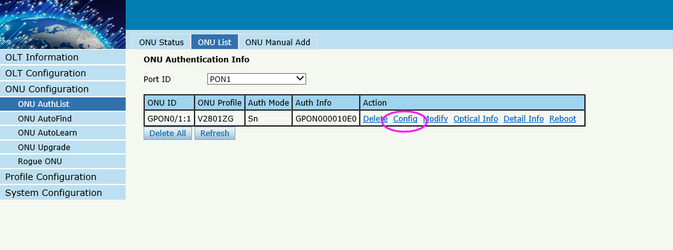
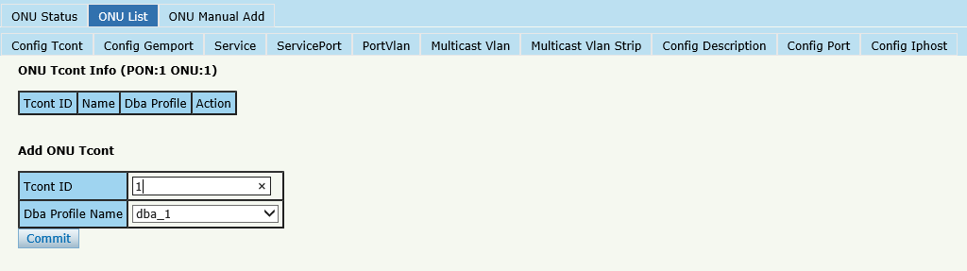
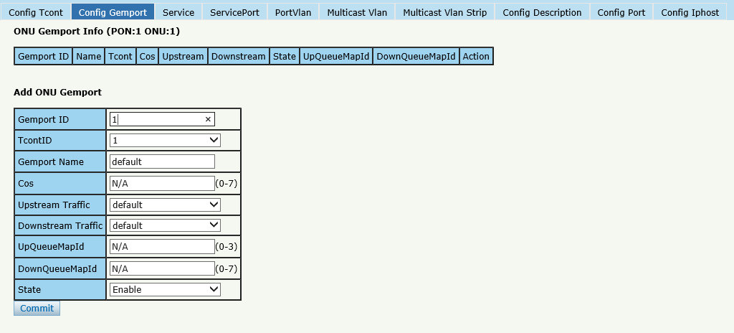
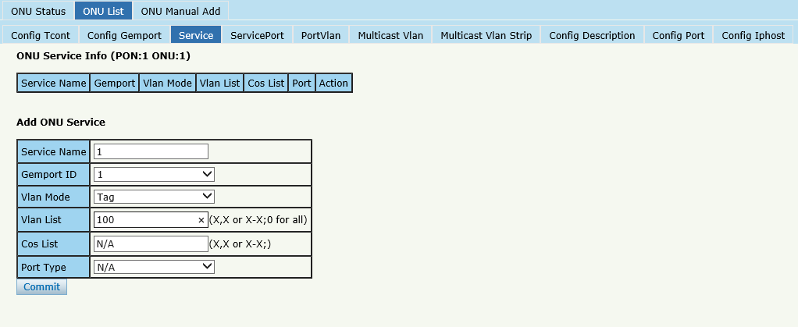
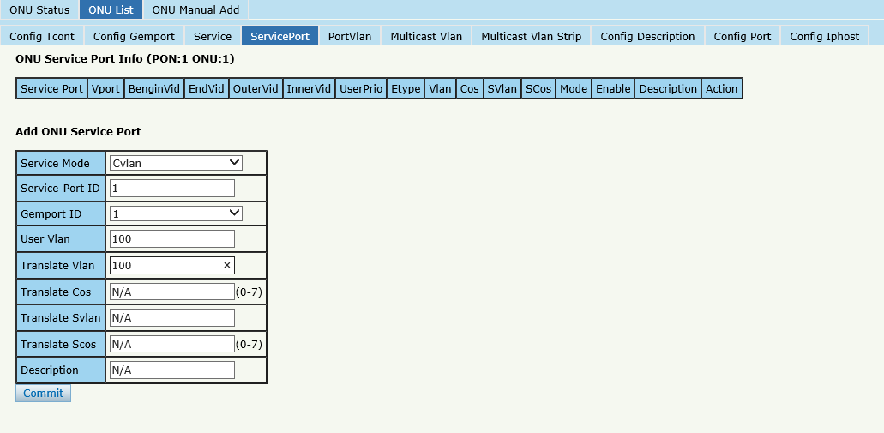
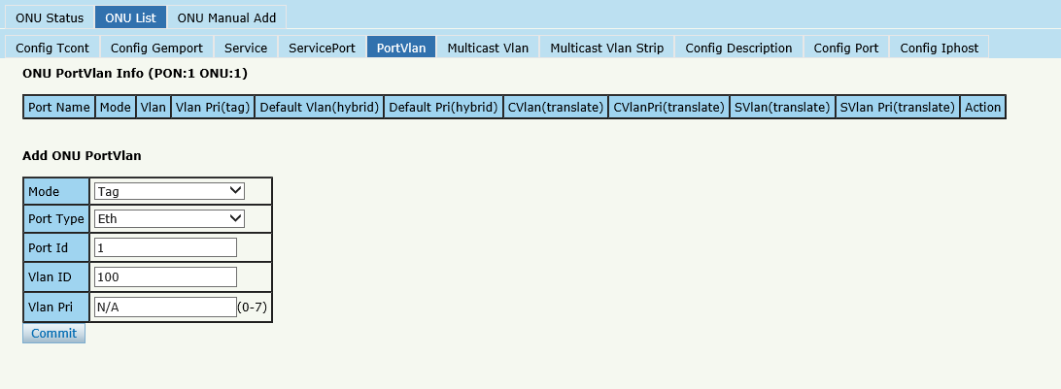

Case 2 SFU Bridge With IPTV

Network Diagram
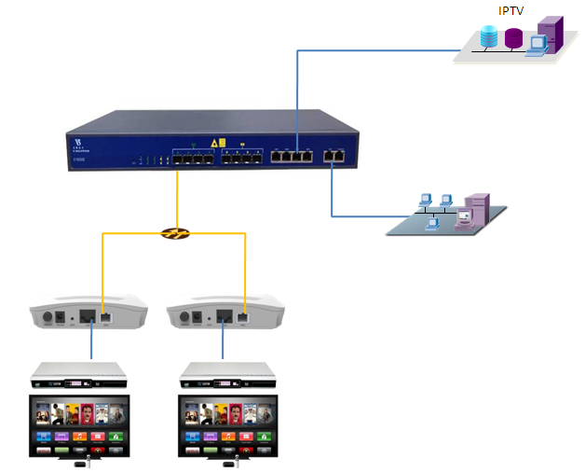

Planning Data
Item |  | Description | Example
ONU Information | Slot No. | The number of the slot actually used. | 0
 | PON No. | The number of the actually used PON port. | 1
 | ONU Auth No. | Configure according to the network planning of the operator. | 1
 | ONU Type | The type of the ONU. | 2801ZG
 | ONU SN | ONU serial number | GPON000000C0
 | OLT PON | The PON port of OLT | GPON 0/1
 | Equipid | The Equipment id of ONU | V2801ZGV8.0
 | Service PON port | Configure according to the number of the actually used PON port. | PON1
ONU | Service LAN port | The number of the actually used ONU port. | LAN1
 | Tcont | The onu Tcont | Tcont=1
 | Gemport | The onu Gemport | Gemport=1
 | Dba | The ONU dba profile | Dba name=dba_1  Dba type = 3
 | Service vlan | The vlan of ONU service. | Service Vlan = 300
 | Service-port uservlan | The vlan of onu service-port | Service-port vlan =300
 | Portvlan | The vlan of onu port | Portvlan=300  Mode=hybrid
IGMP | IGMP Group | The IP of IGMP source | IP = 239.0.0.1

Configuring the OLT
CLI
gpon-olt(config)# vlan 300
gpon-olt(config-vlan-300)# exit
gpon-olt(config)# interface gigabitethernet 0/7
gpon-olt(config-if-ge0/7)# switchport hybrid vlan 300 untagged
gpon-olt(config-if-ge0/7)# switchport hybrid pvid vlan 300
gpon-olt(config-if-ge0/7)# exit
gpon-olt(config)# ip igmp snooping enable
gpon-olt(config)# ip igmp snooping general-query-packet enable
gpon-olt(config)# ip igmp snooping mrouter vlan 300 interface gigabitethernet 0/7
gpon-olt(config)#ip igmp snooping mvlan 300 unknown-multicast drop igmp trap-to-cpu
gpon-olt(config)# interface gpon 0/1
gpon-olt(config-pon-0/1)# ip igmp snooping user-vlan 300 group-vlan 300 tagged
gpon-olt(config-pon-0/1)# exit
1,create a new VLAN for IGMP
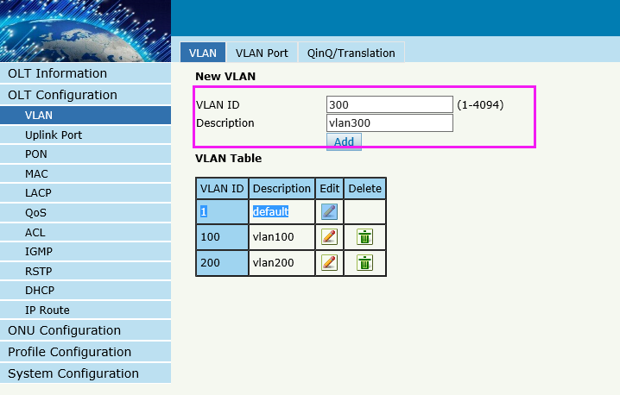
2, configure VLAN mode
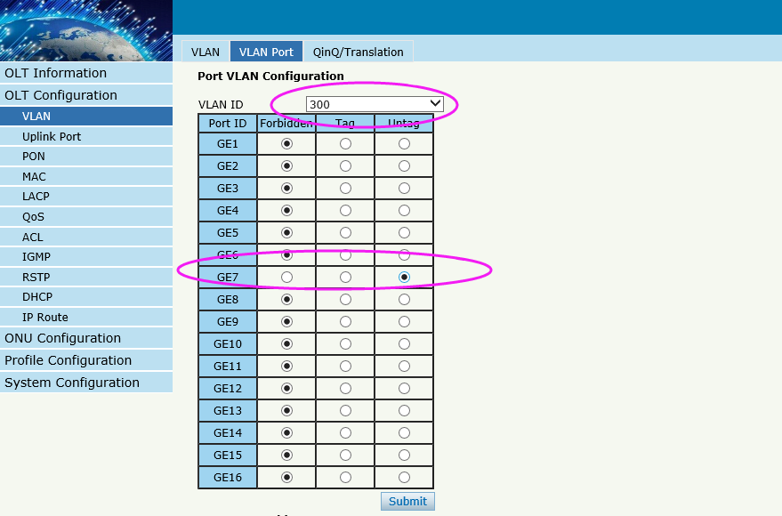
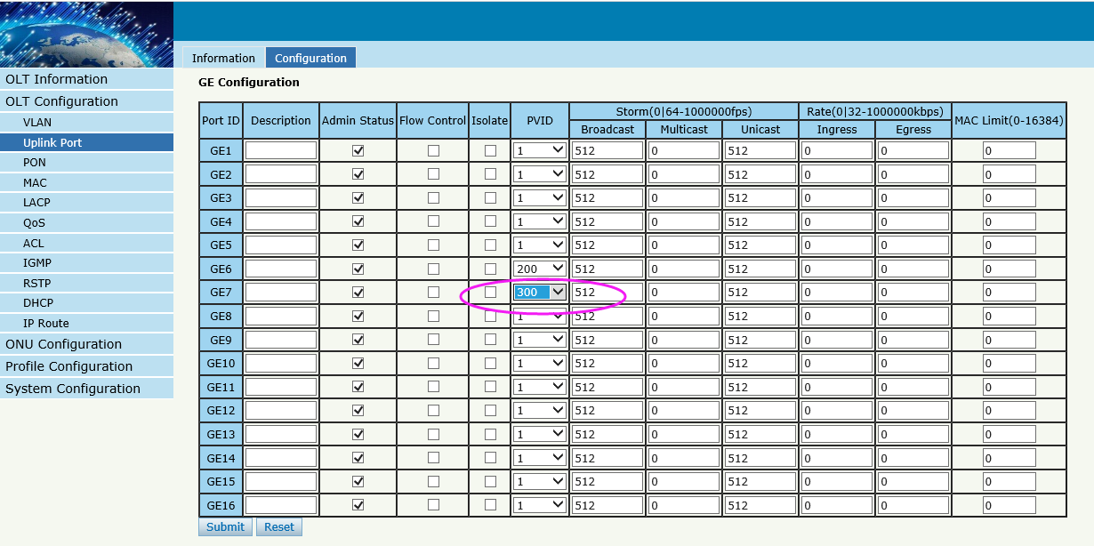

3,enable IGMP snooping function
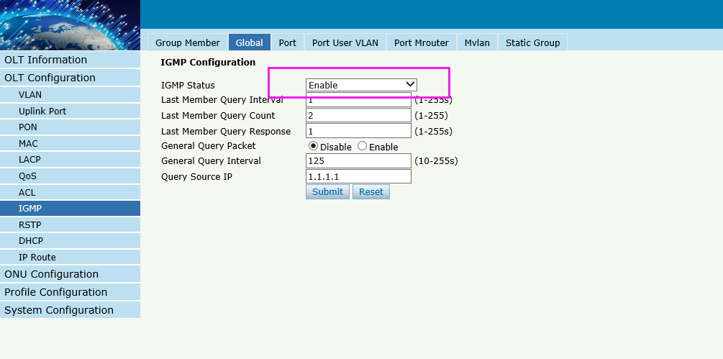
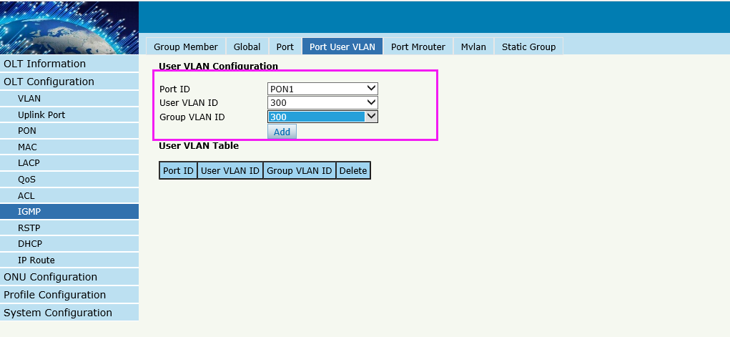
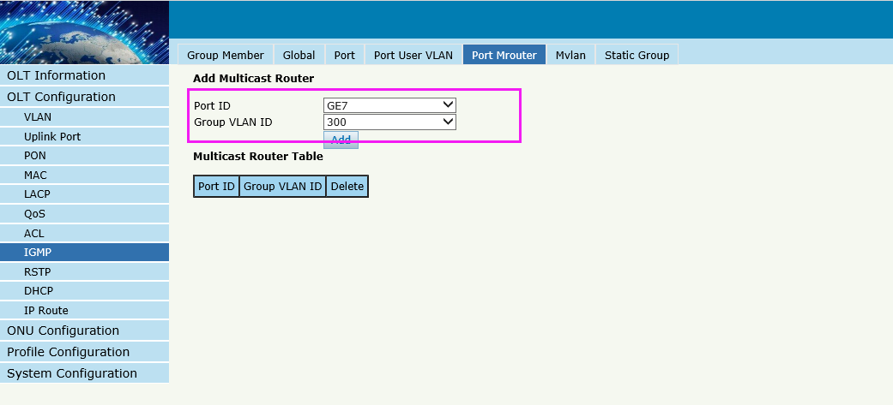
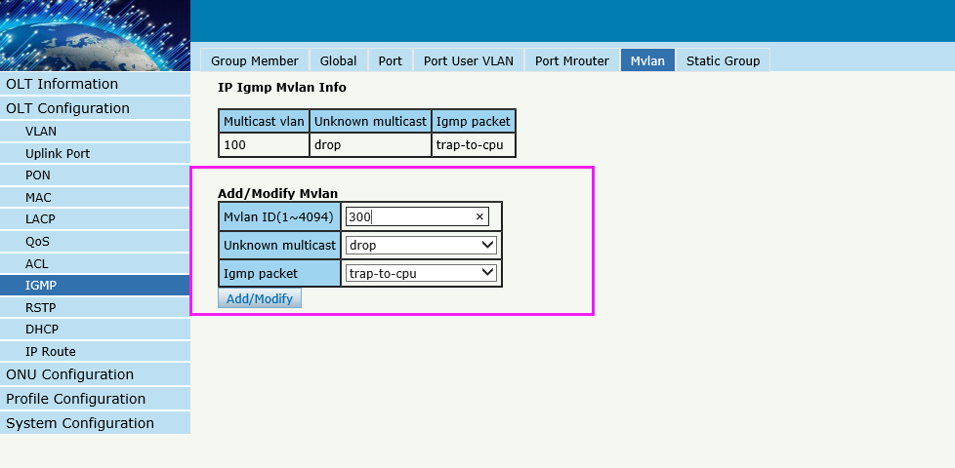

Configuring the ONU
CLI
pon-olt(config)# interface gpon 0/1
gpon-olt(config-pon-0/1)# onu 1 tcont 1 dba dba_1
gpon-olt(config-pon-0/1)# onu 1 gemport 3 tcont 1
gpon-olt(config-pon-0/1)# onu 1 service 1 gemport 3 vlan 300
gpon-olt(config-pon-0/1)#onu 1 service-port 1 gemport 3 uservlan 300 vlan 300
gpon-olt(config-pon-0/1)#onu 1 portvlan eth 1 mode hybrid def_vlan 300
gpon-olt(config-pon-0/1)# onu 1 mvlan 300
gpon-olt(config-pon-0/1)# onu 1 mvlan tag-strip eth 1
gpon-olt(config-pon-0/1)# exit
create DBA profile
2, Create ONU profile for 1GE ONU

3,Authorize ONU
4,Configure ONU
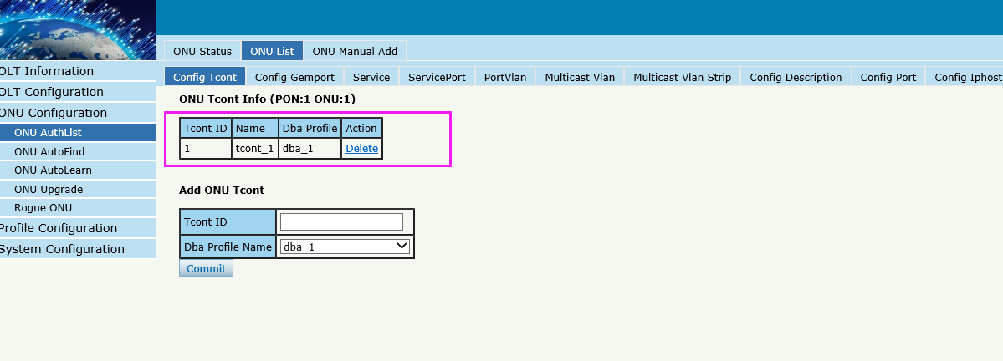

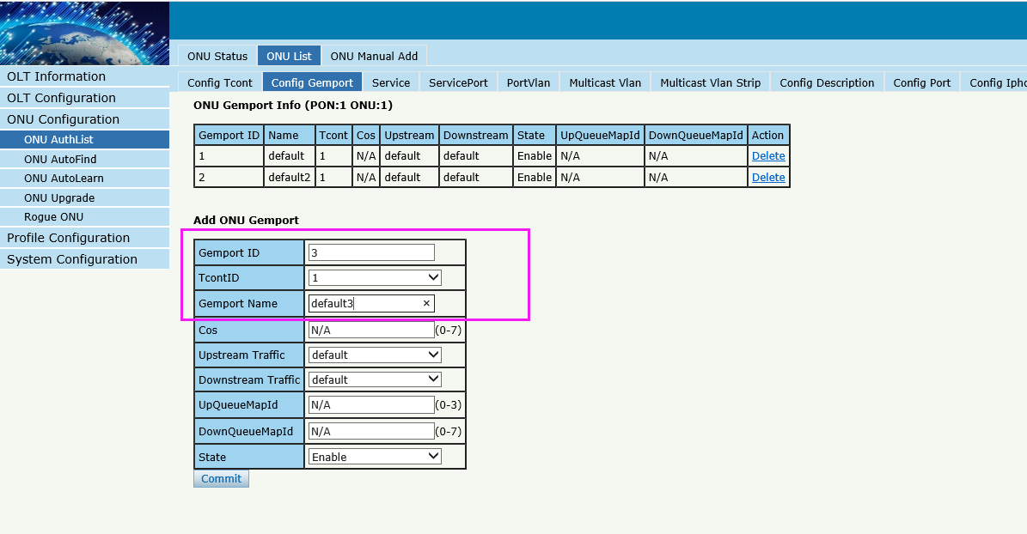
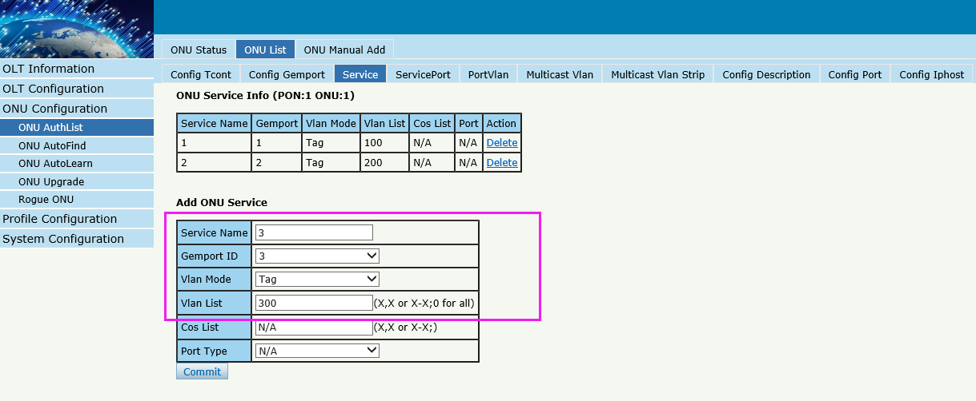
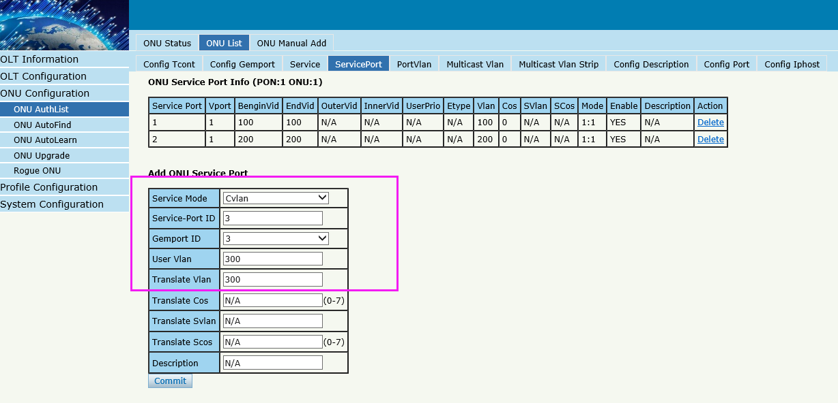

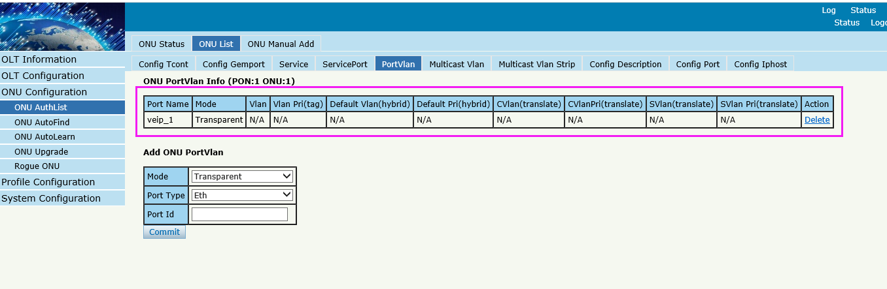
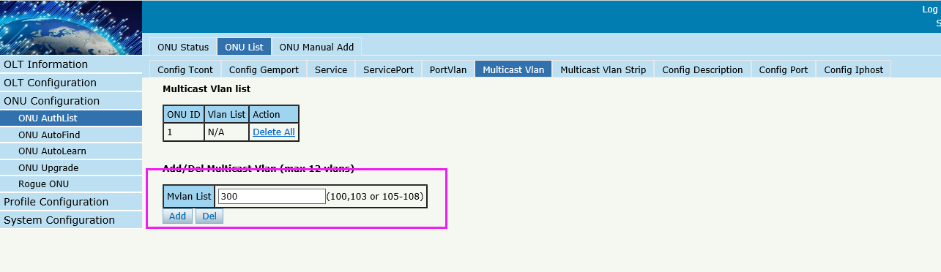
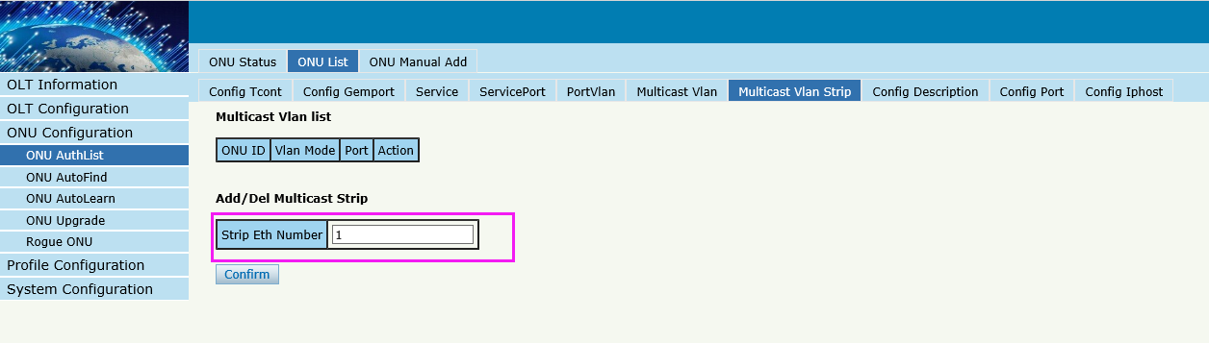

Case 4 HGU Router --Internet

Network Diagram
DHCP/PPPoE/Static
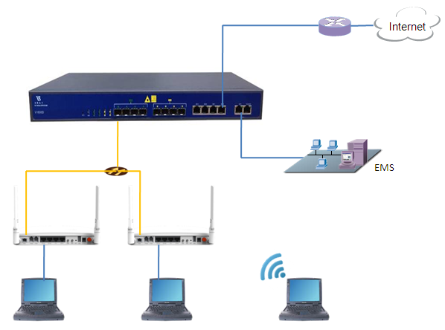
10.1.1.1/24

Planning Data
Item |  | Description | Example
ONU Information | Slot No. | The number of the slot actually used. | 0
 | PON No. | The number of the actually used PON port. | 1
 | ONU Auth No. | Configure according to the network planning of theoperator. | 1
 | ONU Type | The type of the ONU. | HG326RGW
OLT | Service Uplink VLAN | The VLAN ID of the uplink port service. | VLAN mode = UNTAG  PVID = 100
 | Service Uplink port | Configure according to the number of the actuallyused uplink port. | GE8
 | Service PON VLAN | The VLAN ID of the PON port service. | VLAN mode = TAG  VLAN ID = 100
 | Service PON port | Configure according to the number of the actuallyused PON port. | PON1
ONU | Service LAN  VLAN | The VLAN ID of the LAN port service. | Default  No VLAN
 | Service LAN port | The number of the actually used ONU port. | LAN1
 | Service LAN VLAN | The VLAN ID of the LAN port service. | VLAN mode = TAG  PVID = 100
 | Service LAN port | The number of the actually used ONU port. | LAN1
 | Tcont | The onu Tcont | Tcont=1
 | Gemport | The onu Gemport | Gemport=1
 | Dba | The ONU dba profile | Dba name=dba_1  Dba type = 3
 | Service vlan | The vlan of ONU service. | Service Vlan = 100
 | Service-port uservlan | The vlan of onu service-port | Service-port vlan =100
 | WiFi | Wireless’s SSID name,Security. | SSID1 name = SSID-1  Security method = WAP2 Mixed  WPA Encryption = TKIP  WPA2 Encryption = AES  KEY = 12345678
 | Service WAN  VLAN | The VLAN ID of the PON(WAN) port service. | VLAN ID = 100
 | If WAN use DHCP mode | The router use DHCP assign ip to terminal user. | Gateway = 10.1.1.1  IP Range 10.1.1.2-10.1.1.254  IP Mask = 255.255.255.0  DNS = 8.8.8.8
 | If WAN use PPPoE  mode | The router use PPPoE assign ip to terminal user. | IP Range 10.1.1.2-10.1.1.254  IP Mask = 255.255.255.0  User name = test  Password = test
 | If WAN use Static  mode | The router use Static assign ip to terminal user. | Gateway = 10.1.1.1  IP = 10.1.1.100  IP Mask = 255.255.255.0  DNS = 8.8.8.8
PC | DHCP mode | The ONU use DHCP assign ip to PC. | Gateway = 192.168.1.1  IP = 192.168.1.2  IP Mask = 255.255.255.0  DNS = 192.168.1.1

Configuring the OLT
By CLI --------------
gpon-olt(config)# vlan 100
gpon-olt(config-vlan-100)# exit
gpon-olt(config)# interface gigabitethernet 0/8
gpon-olt(config-if-ge0/8)# switchport hybrid vlan 100 untagged
gpon-olt(config-if-ge0/8)# switchport hybrid pvid vlan 100
gpon-olt(config-if-ge0/8)# exit

By web --------------
1,Create a new VLAN
2. configure GE port VLAN mode
3, configure GE port PVID

Configuring the ONU
By CLI --------------
gpon-olt(config)# interface gpon 0/1
gpon-olt(config-pon-0/1)# onu 1 tcont 1 dba dba_1
gpon-olt(config-pon-0/1)# onu 1 gemport 1 tcont 1
gpon-olt(config-pon-0/1)# onu 1 service 1 gemport 1 vlan 100
gpon-olt(config-pon-0/1)# onu 1 service-port 1 gemport 1 uservlan 100 vlan 100
gpon-olt(config-pon-0/1)# onu 1 portvlan veip 1 mode transparent

1, Create ONU profile for 4GE HGU

By web --------------

2, Find the ONU of Autofind lists and perform authorization operations on it
3, Select the 1GE ONU template

4, Configure ONU
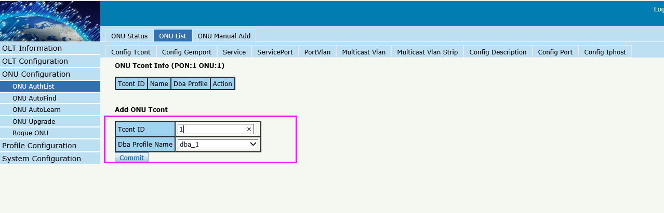
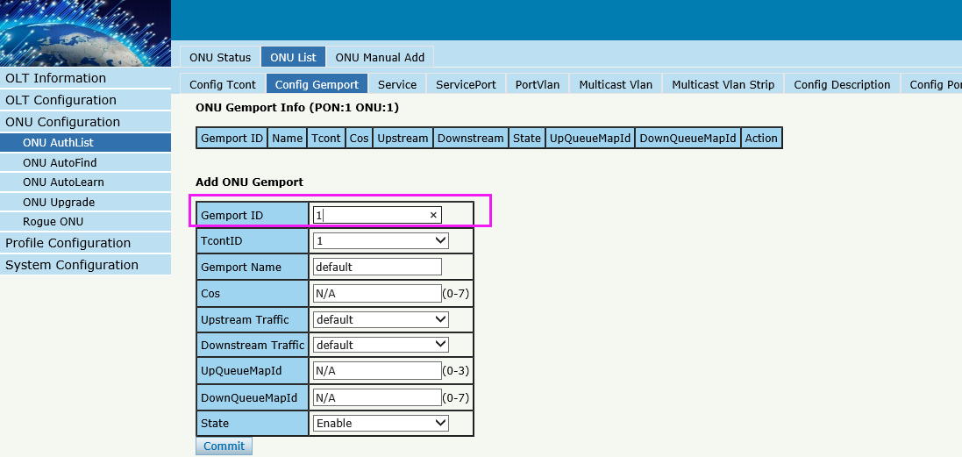
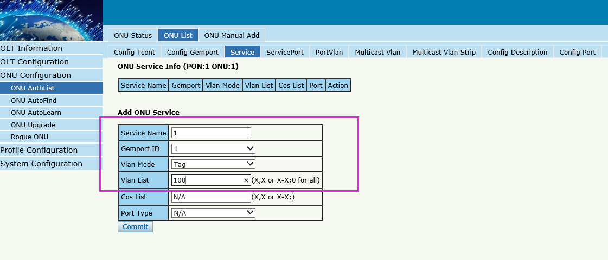
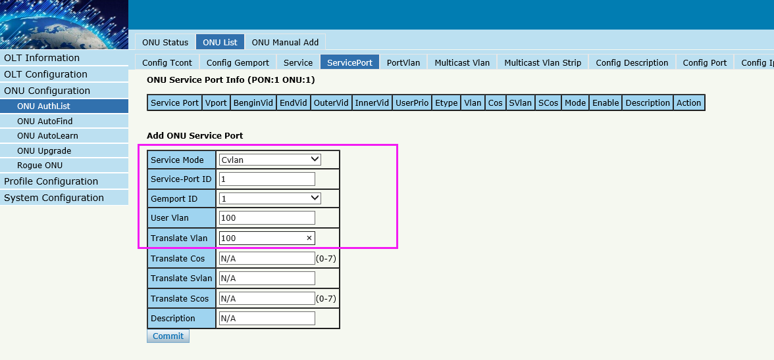
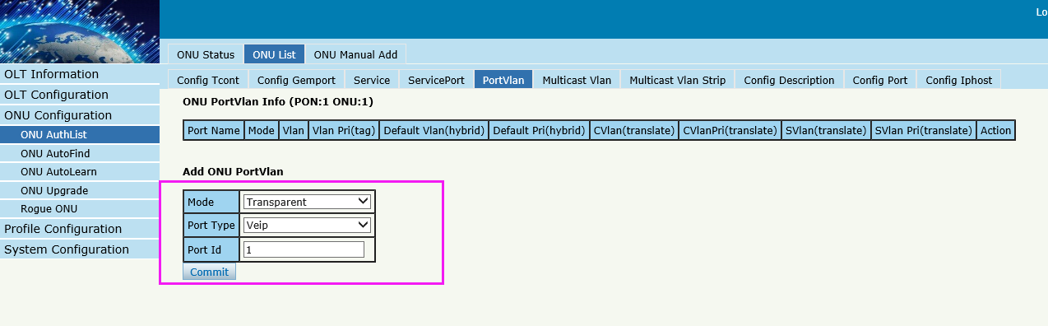

By ONU web --------------
If DHCP mode
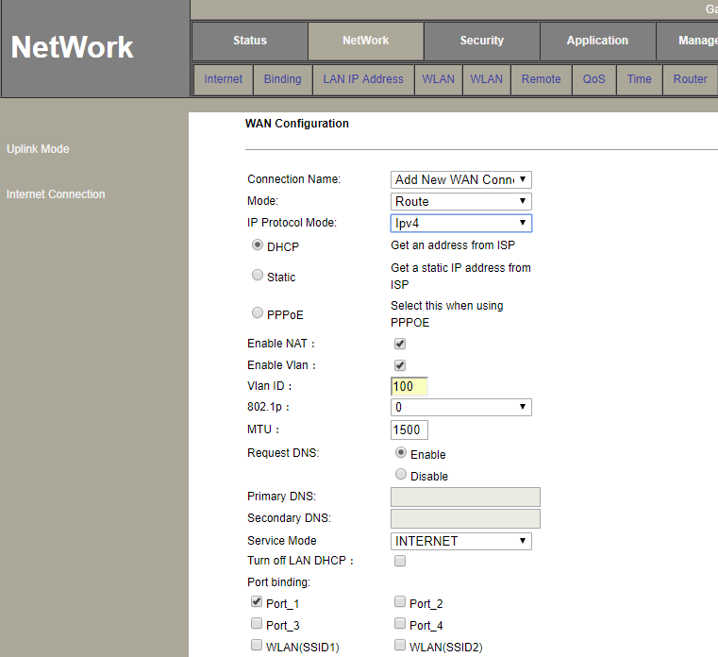
The connection status
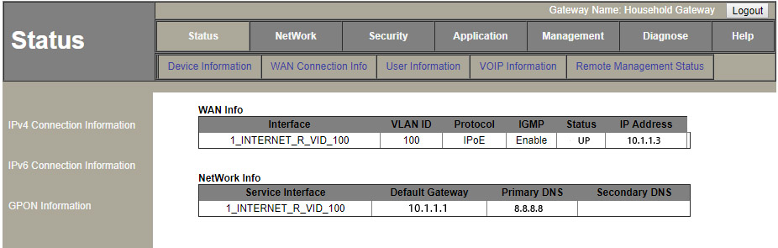

If PPPoE mode
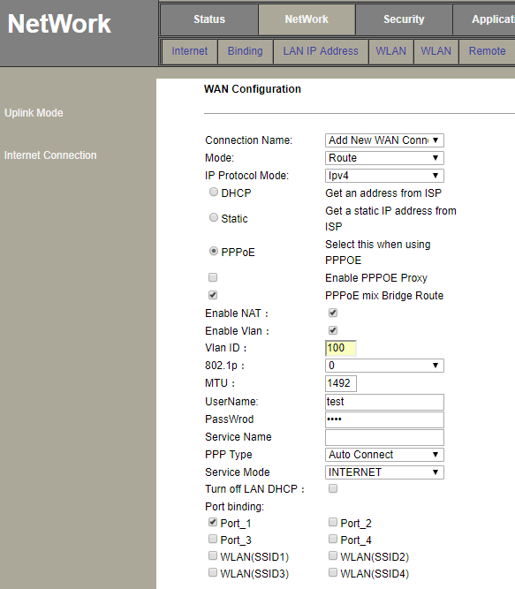

The connection status

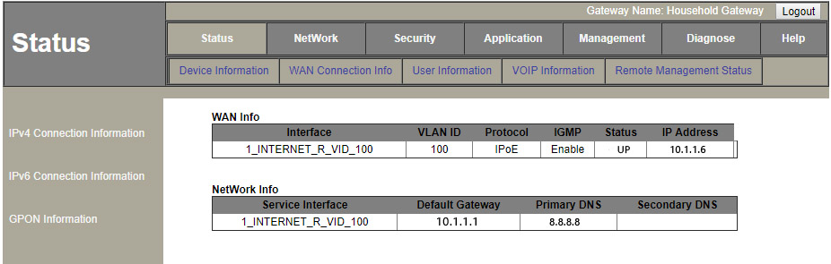
If Static mode
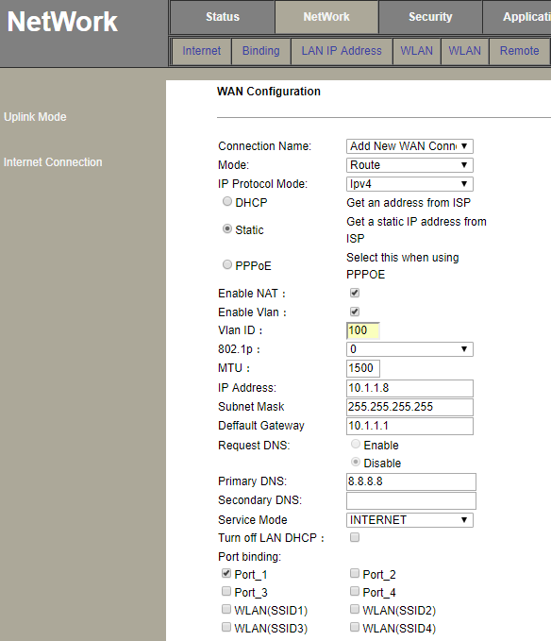
The connection status
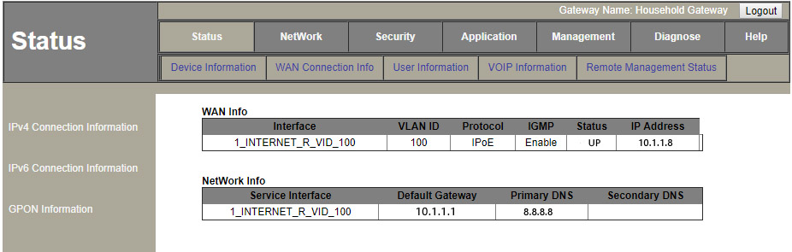
WiFi
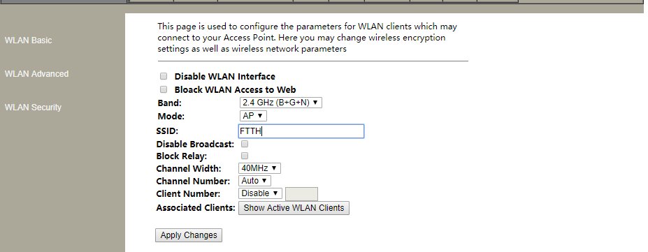
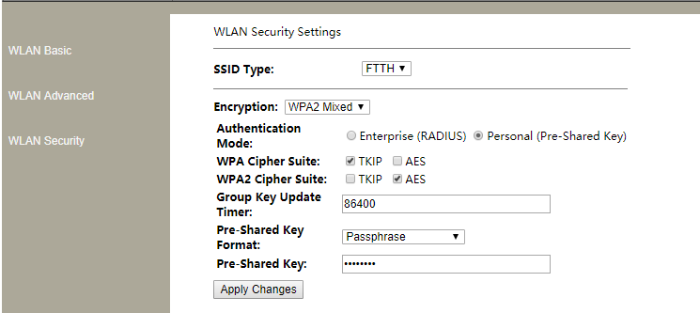

Case 5 HGU Router --VoIP

Network Diagram
DHCP/PPPoE/Static
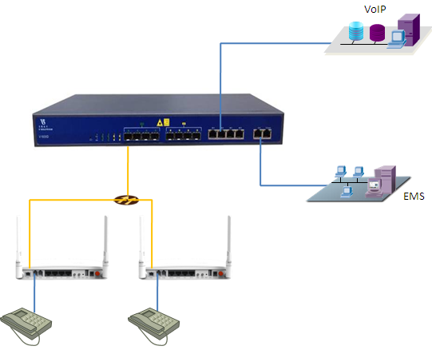
10.1.2.1/24

Planning Data
Item |  | Description | Example
ONU Information | Slot No. | The number of the slot actually used. | 0
 | PON No. | The number of the actually used PON port. | 1
 | ONU Auth No. | Configure according to the network planning of theoperator. | 1
 | ONU Type | The type of the ONU. | HG326RGW
OLT | Service Uplink VLAN | The VLAN ID of the uplink port service. | VLAN mode = UNTAG  PVID = 200
 | Service Uplink port | Configure according to the number of the actuallyused uplink port. | GE6
 | Service PON VLAN | The VLAN ID of the PON port service. | VLAN mode = TAG  VLAN ID = 200
 | Service PON port | Configure according to the number of the actuallyused PON port. | PON1
ONU | Service WAN  VLAN | The VLAN ID of the PON(WAN) port service. | VLAN ID = 200
 | Service POTS port | The number of the actually used ONU port. | POTS1
 | Tcont | The onu Tcont | Tcont=1
 | Gemport | The onu Gemport | Gemport=1
 | Dba | The ONU dba profile | Dba name=dba_1  Dba type = 3
 | Service vlan | The vlan of ONU service. | Service Vlan = 200
 | Service-port uservlan | The vlan of onu service-port | Service-port vlan =200
 | If WAN use DHCP mode | The router use DHCP assign ip to ONU. | Gateway = 10.1.2.1  IP Range 10.1.2.2-10.1.2.254  IP Mask = 255.255.255.0  DNS = 8.8.8.8
 | If WAN use PPPoE  mode | The router use PPPoE assign ip to ONU. | IP Range 10.1.2.2-10.1.2.254  IP Mask = 255.255.255.0  User name = test1  Password = test1
 | If WAN use Static  mode | The router use Static assign ip to ONU. | Gateway = 10.1.2.1  IP = 10.1.2.100  IP Mask = 255.255.255.0  DNS = 8.8.8.8

Configuring the OLT
By CLI --------------
gpon-olt(config)# vlan 200
gpon-olt(config-vlan-200)# exit
gpon-olt(config)# interface gigabitethernet 0/6
gpon-olt(config-if-ge0/6)# switchport hybrid vlan 200 untagged
gpon-olt(config-if-ge0/6)# switchport hybrid pvid vlan 200
gpon-olt(config-if-ge0/6)# exit

By Web --------------
1, create a new VLAN
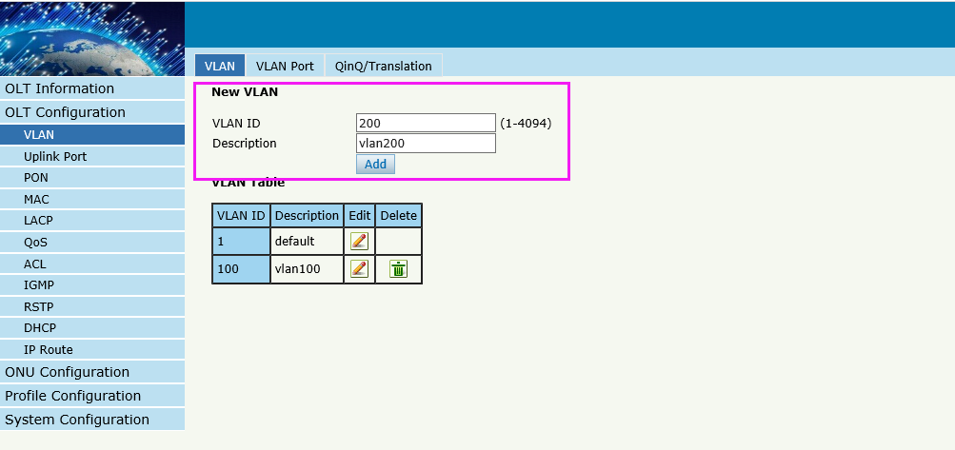
2.configure GE VLAN mode
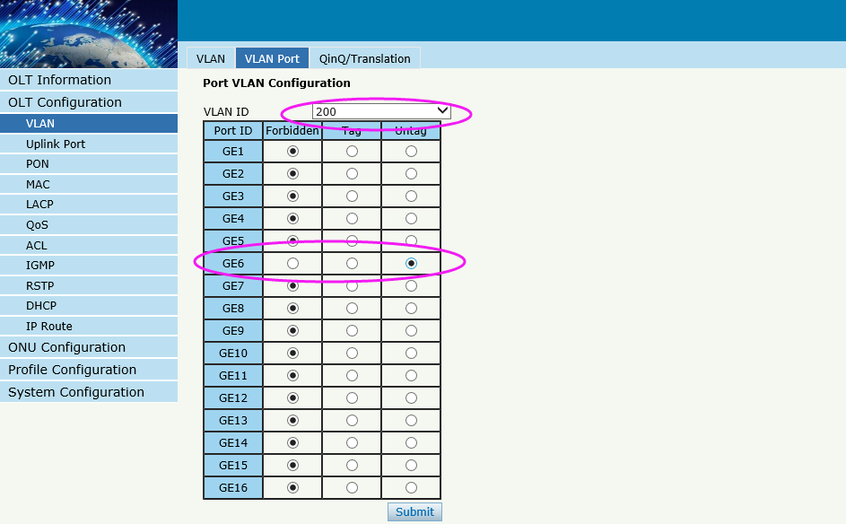
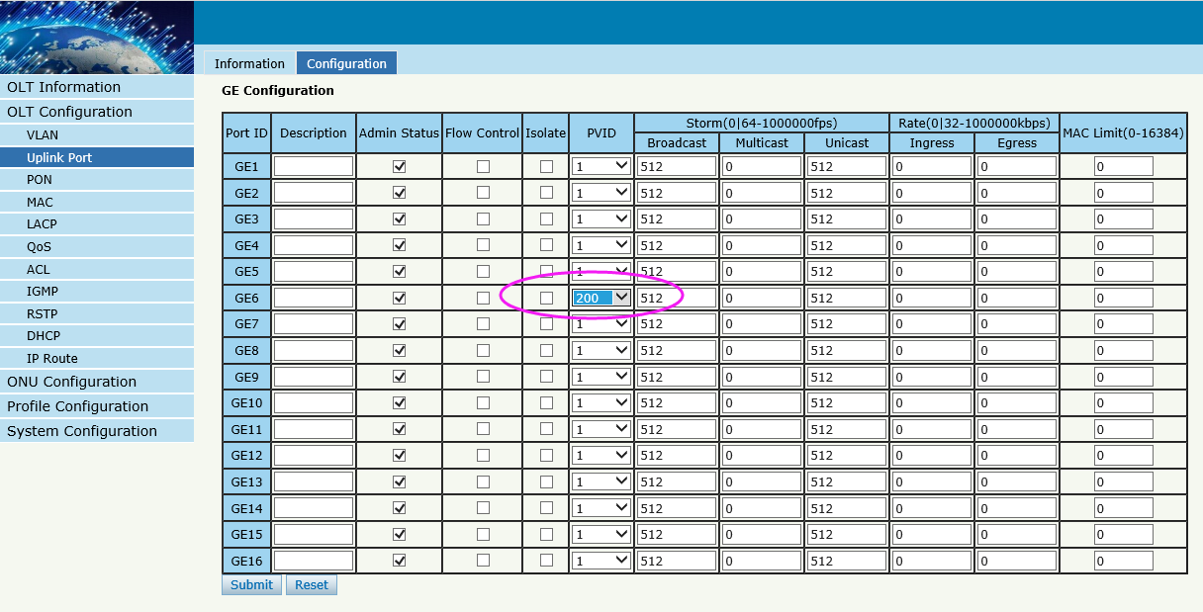

Configuring the ONU
By CLI --------------
gpon-olt(config-pon-0/1)# onu 1 tcont 1 dba dba_1
gpon-olt(config-pon-0/1)# onu 1 gemport 2 tcont 1
gpon-olt(config-pon-0/1)# onu 1 service 1 gemport 2 vlan 200
gpon-olt(config-pon-0/1)# onu 1 service-port 1 gemport 2 uservlan 200 to 200 transparent

By web --------------
Configure ONU
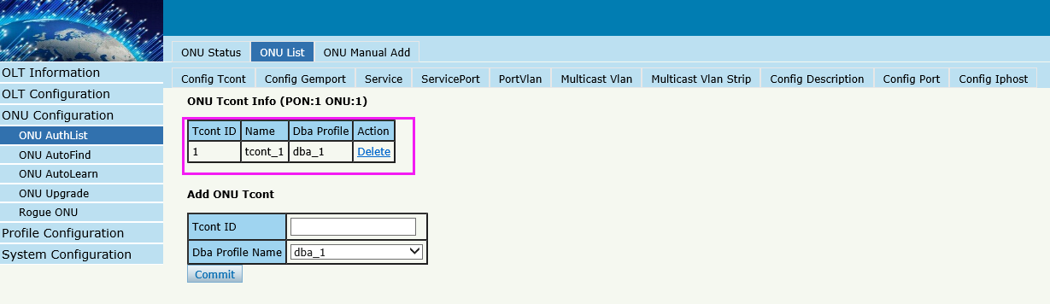

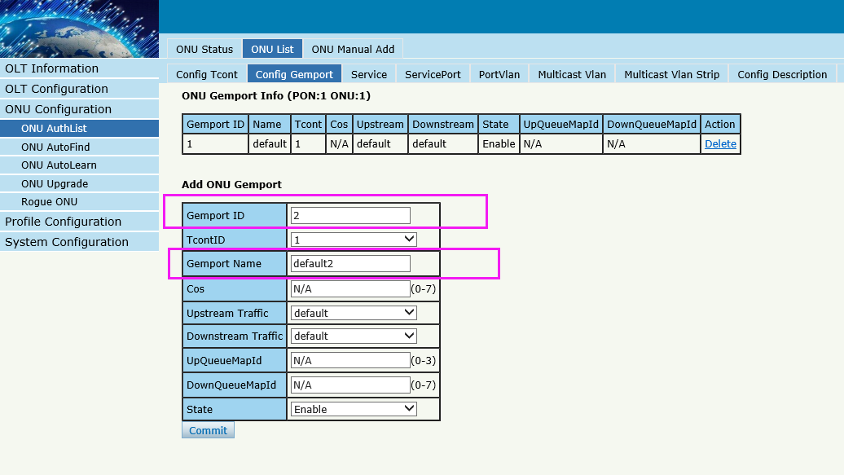
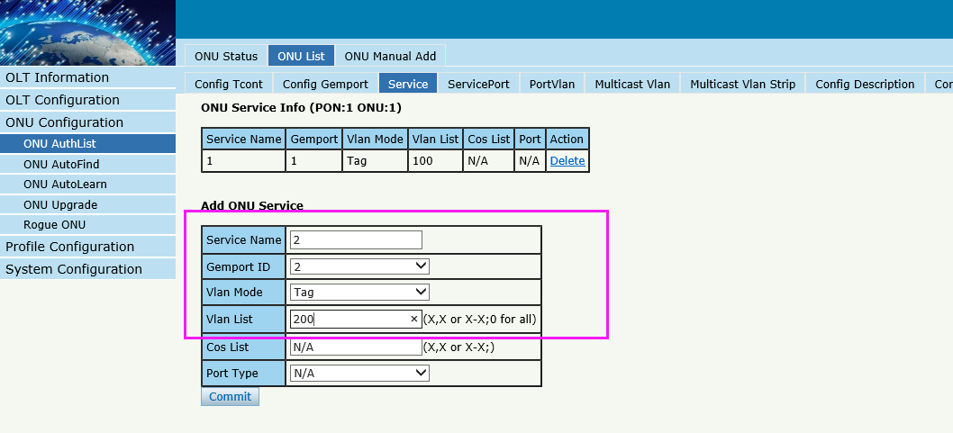
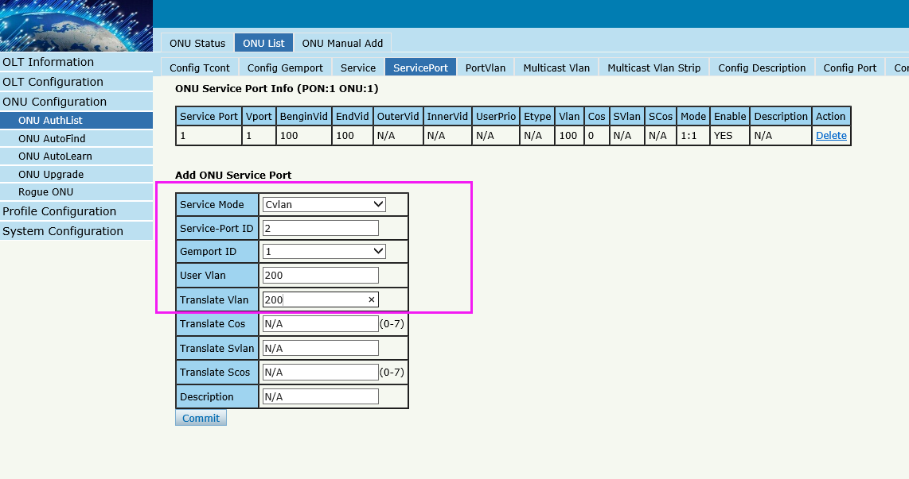
By ONU web --------------
If DHCP mode
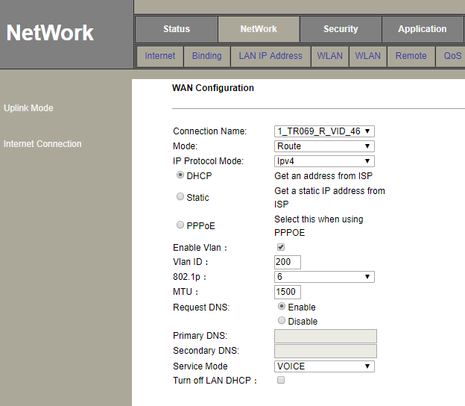
The connection status
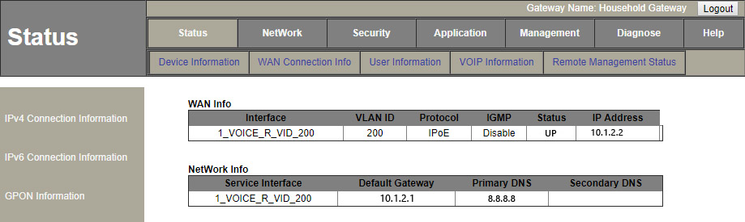

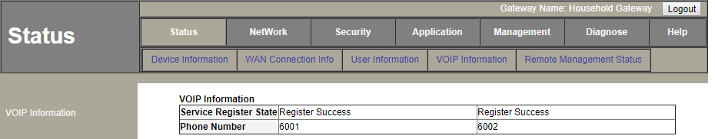
If PPPoE mode
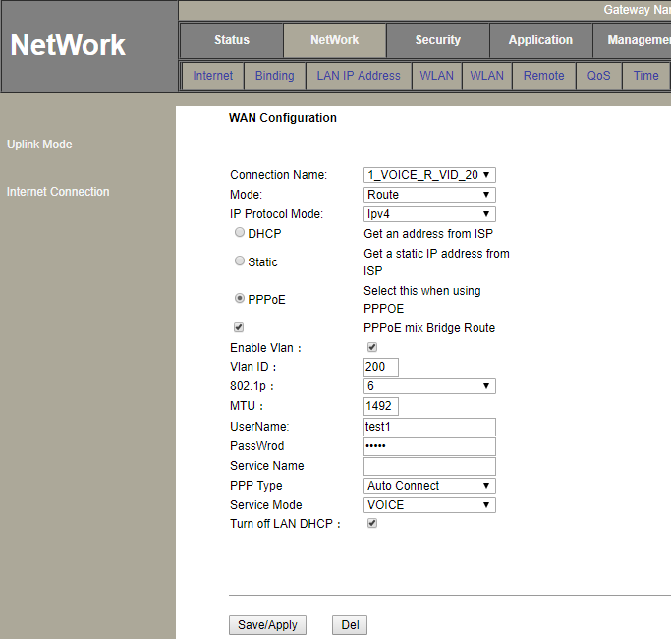
The connection status
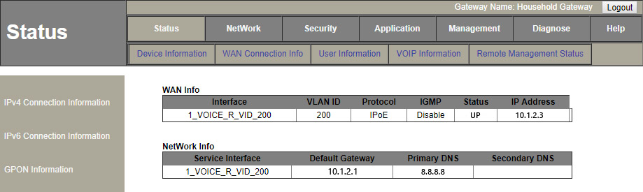

If Static mode
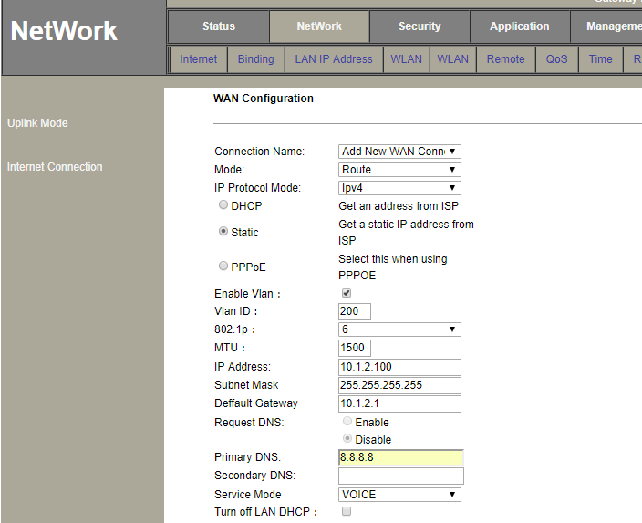
The connection status
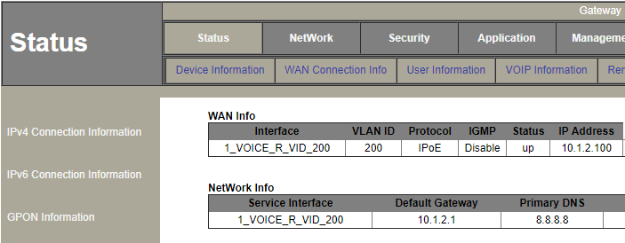
VoIP
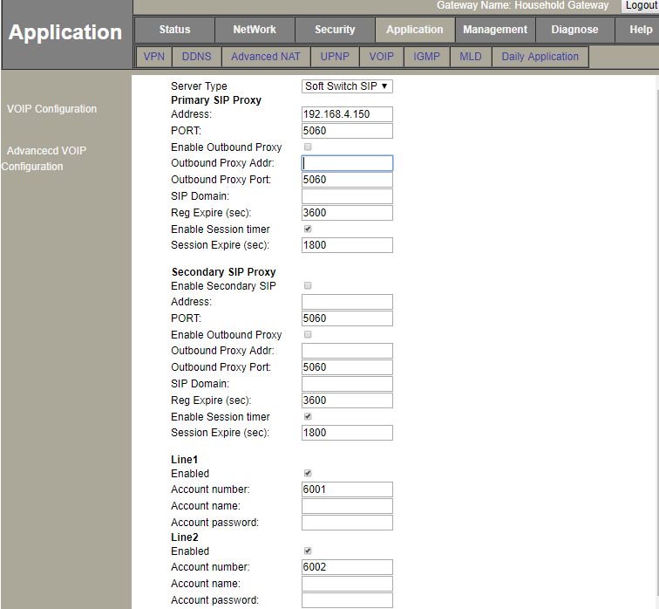

Case 6 HGU Bridge --IPTV

Network Diagram
DHCP/PPPoE/Static
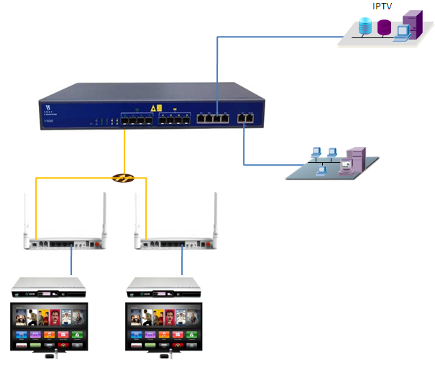
10.1.3.1/24

Planning Data
Item |  | Description | Example
ONU Information | Slot No. | The number of the slot actually used. | 0
 | PON No. | The number of the actually used PON port. | 1
 | ONU Auth No. | Configure according to the network planning of theoperator. | 1
 | ONU Type | The type of the ONU. | HG326RGW
OLT | Service Uplink VLAN | The VLAN ID of the uplink port service. | VLAN mode = UNTAG  PVID = 300
 | Service Uplink port | Configure according to the number of the actuallyused uplink port. | GE7
 | Service PON VLAN | The VLAN ID of the PON port service. | VLAN mode = TAG  VLAN ID = 300
 | Service PON port | Configure according to the number of the actuallyused PON port. | PON1
ONU | Service  WAN  VLAN | The VLAN ID of the PON(WAN) port service. | VLAN mode= Transparent
 | Service  LAN  VLAN | The VLAN ID of the LAN port service. | VLAN mode = UNTAG  LAN VLAN ID = 300  Multicast VLAN ID = 300
 | Service LAN port | The number of the actually used ONU port. | LAN4
 | Tcont | The onu Tcont | Tcont=1
 | Gemport | The onu Gemport | Gemport=1
 | Dba | The ONU dba profile | Dba name=dba_1  Dba type = 3
 | Service vlan | The vlan of ONU service. | Service Vlan = 100
 | Service-port uservlan | The vlan of onu service-port | Service-port vlan =100
STB | Management IP | The IP for STB. | Gateway = 10.1.3.1  IP = 10.1.3.100  IP Mask = 255.255.255.0

Configuring the OLT
By CLI --------------
gpon-olt(config)# vlan 300
gpon-olt(config-vlan-100)# exit
gpon-olt(config)# interface gigabitethernet 0/7
gpon-olt(config-if-ge0/7)# switchport hybrid vlan 300 untagged
gpon-olt(config-if-ge0/7)# switchport hybrid pvid vlan 300
gpon-olt(config-if-ge0/7)# exit
gpon-olt(config)# ip igmp snooping enable
gpon-olt(config)# ip igmp snooping general-query-packet enable
gpon-olt(config)# ip igmp snooping mrouter vlan 300 interface gigabitethernet 0/7
gpon-olt(config)#ip igmp snooping mvlan 300 unknown-multicast drop igmp trap-to-cpu
gpon-olt(config)# interface gpon 0/1
gpon-olt(config-pon-0/1)# ip igmp snooping user-vlan 300 group-vlan 300 tagged
gpon-olt(config-pon-0/1)# exit

By web --------------
1\create a new VLAN for IGMP
2, configure VLAN mode

3,enable IGMP snooping function

Configuring the ONU
By CLI --------------
pon-olt(config)# interface gpon 0/1
gpon-olt(config-pon-0/1)# onu 1 tcont 1 dba dba_1
gpon-olt(config-pon-0/1)# onu 1 gemport 3 tcont 1
gpon-olt(config-pon-0/1)# onu 1 service 1 gemport 3 vlan 300
gpon-olt(config-pon-0/1)# onu 1 service-port 1 gemport 3 uservlan 300 to 300 transparent
gpon-olt(config-pon-0/1)# onu 1 mvlan 300
gpon-olt(config-pon-0/1)# onu 1 mvlan tag-strip eth 1
gpon-olt(config-pon-0/1)# exit
By web --------------
Configure ONU

By ONU web --------------
