VSOLUTION PON APPLICATION WHITE PAPER—EPON APP NOTE/EXAMPLE
Version V1.0.1
Release Date 2016-06-13

Guangzhou V-SOLUTION Technology Co., Ltd
Contents
Case 1 SFU Bridge Without VLAN 4
Network Diagram 4
Planning Data 4
Configuring the OLT 5
Configuring the ONU 5
Case 2 SFU Bridge With VLAN 6
Network Diagram 6
Planning Data 6
Configuring the OLT 7
Configuring the ONU 9
Case 3 SFU Bridge With VLAN--IPTV 11
Network Diagram 11
Planning Data 11
Configuring the OLT 12
Configuring the ONU 15
Case 4 SFU Route Without VLAN 18
Network Diagram 18
Planning Data 18
Configuring the OLT 20
Configuring the ONU 20
Case 5 SFU Router With VLAN 25
Network Diagram 25
Planning Data 25
Configuring the OLT 27
Configuring the ONU 29
Case 6 HGU Router With VLAN--Internet 34
Network Diagram 34
Planning Data 34
Configuring the OLT 36
Configuring the ONU 37
Case 7 HGU Router With VLAN--VoIP 42
Network Diagram 42
Planning Data 42
Configuring the OLT 43
Configuring the ONU 45
Case 8 HGU Bridge With VLAN--IPTV 50
Network Diagram 50
Planning Data 50
Configuring the OLT 51
Configuring the ONU 55
Case 9 HGU Router/Bridge With VLAN Internet--VoIP--IPTV 57
Network Diagram 57
Planning Data 57
Configuring the OLT 60
Configuring the ONU 60

Case 1 SFU Bridge Without VLAN

Network Diagram
DHCP/PPPoE/Static
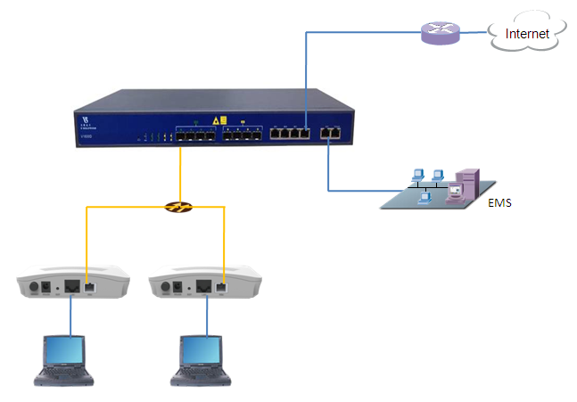
10.1.1.1/24

Planning Data
Item |  | Description | Example
ONU Information | Slot No. | The number of the slot actually used. | 0
 | PON No. | The number of the actually used PON port. | 1
 | ONU Auth No. | Configure according to the network planning of the operator. | 1
 | ONU Type | The type of the ONU. | 2801HE
OLT | Service Uplink VLAN | The VLAN ID of the uplink port service. | Default  (VLAN = 1 UNTAG  PVID = 1)
 | Service Uplink port | Configure according to the number of the actually  used uplink port. | GE8
 | Service PON VLAN | The VLAN ID of the PON port service. | Default  (VLAN = 1 UNTAG  PVID = 1)
 | Service PON port | Configure according to the number of the actually used PON port. | PON1
ONU | Service  LAN  VLAN | The VLAN ID of the LAN port service. | Default  (VLAN mode = TRANSPARENT)
 | Service LAN port | The number of the actually used ONU port. | LAN1
PC | If DHCP mode | The router use DHCP assign ip to PC. | Gateway = 10.1.1.1  IP Range 10.1.1.2-10.1.1.254  IP Mask = 255.255.255.0  DNS = 8.8.8.8
 | If PPPoE  mode | The router use PPPoE assign ip to PC. | IP Range 10.1.1.2-10.1.1.254  IP Mask = 255.255.255.0  User name = test  Password = test
 | If Static  mode | The router use Static assign ip to PC. | Gateway = 10.1.1.1  IP = 10.1.1.100  IP Mask = 255.255.255.0  DNS = 8.8.8.8

Configuring the OLT
Default Configuration

Configuring the ONU
Default Configuration

Case 2 SFU Bridge With VLAN

Network Diagram
DHCP/PPPoE/Static
10.1.1.1/24

Planning Data
Item |  | Description | Example
ONU Information | Slot No. | The number of the slot actually used. | 0
 | PON No. | The number of the actually used PON port. | 1
 | ONU Auth No. | Configure according to the network planning of the operator. | 1
 | ONU Type | The type of the ONU. | 2801HE
OLT | Service Uplink VLAN | The VLAN ID of the uplink port service. | VLAN mode = UNTAG  PVID = 100
 | Service Uplink port | Configure according to the number of the actually  used uplink port. | GE8
 | Service PON VLAN | The VLAN ID of the PON port service. | VLAN mode = TAG  VLAN ID = 100
 | Service PON port | Configure according to the number of the actually used PON port. | PON1
ONU | Service LAN VLAN | The VLAN ID of the LAN port service.(CTC VLAN mode) | VLAN mode = TAG  PVID = 100
 | Service LAN port | The number of the actually used ONU port. | LAN1
PC | If DHCP mode | The router use DHCP assign ip to PC. | Gateway = 10.1.1.1  IP Range 10.1.1.2-10.1.1.254  IP Mask = 255.255.255.0  DNS = 8.8.8.8
 | If PPPoE  mode | The router use PPPoE assign ip to PC. | IP Range 10.1.1.2-10.1.1.254  IP Mask = 255.255.255.0  User name = test  Password = test
 | If Static  mode | The router use Static assign ip to PC. | Gateway = 10.1.1.1  IP = 10.1.1.100  IP Mask = 255.255.255.0  DNS = 8.8.8.8

Configuring the OLT
CLI
epon-olt(config)# vlan 100
epon-olt(config-vlan-100)# exit
epon-olt(config)# interface gigabitethernet 0/8
epon-olt(config-if-ge0/8)# switchport hybrid vlan 100 untagged
epon-olt(config-if-ge0/8)# switchport hybrid pvid vlan 100
epon-olt(config-if-ge0/8)# exit
epon-olt(config)# interface epon 0/1
epon-olt(config-pon-0/1)# switchport hybrid vlan 100 tagged
epon-olt(config-pon-0/1)# exit

EMS
1. Right-click the OLT icon and select Configuration->VLAN Configuration
2. Click the Add button, configure according to the planning data.
3. Click the commit button to complete the configuration.
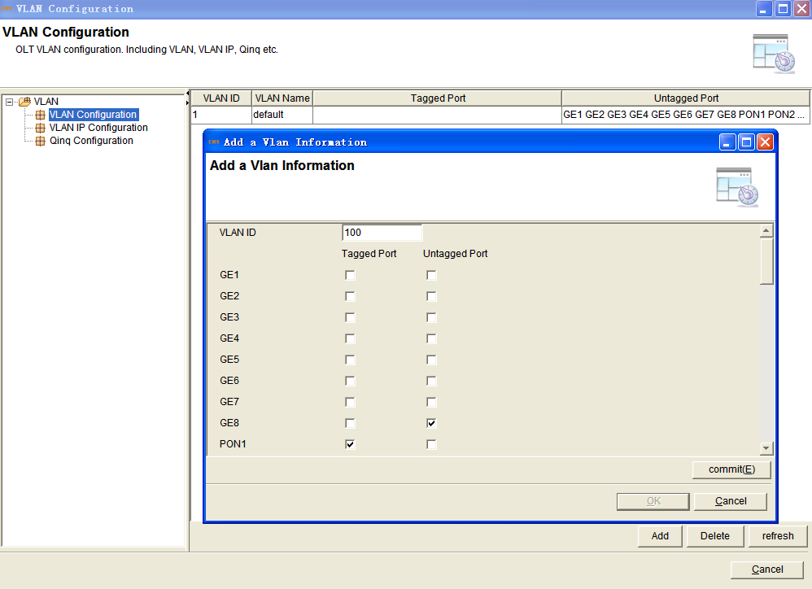
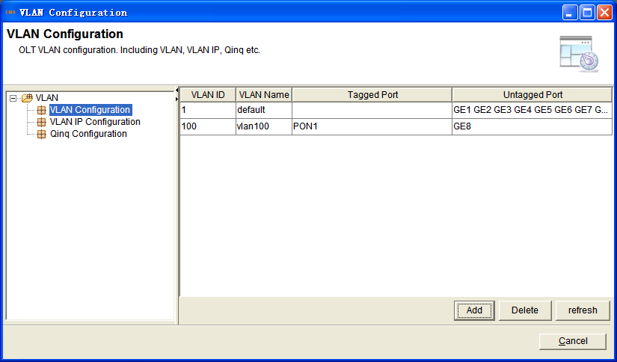
4. Right-click the OLT icon and select Configuration->Port Configuration
Configure according to the planning data.
5. Click the Apply button to complete the configuration.
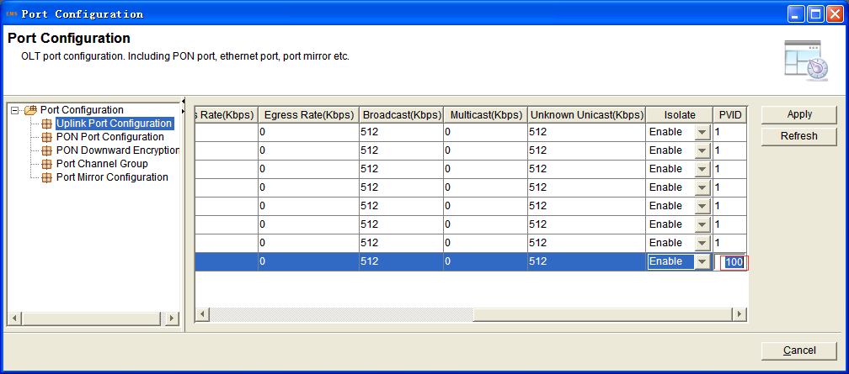

Configuring the ONU
CLI
epon-olt(config)# interface epon 0/1
epon-olt(config-pon-0/1)# onu 1 ctc eth 1 vlan mode tag
epon-olt(config-pon-0/1)# onu 1 ctc eth 1 vlan pvid 100 pri 3
epon-olt(config-pon-0/1)# exit

EMS
1. Right-click the ONU icon and select Configuration->ONU Port Configuration
2. Choose VLAN Configuration->port 1, configure according to the planning data.
3. Click the Save button to complete the configuration.
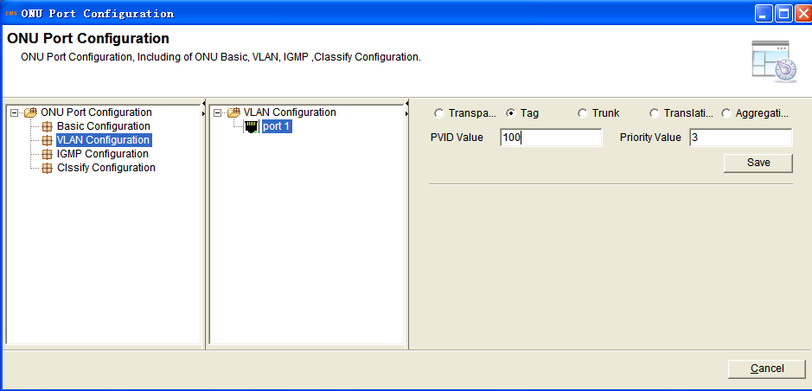

Case 3 SFU Bridge With VLAN--IPTV

Network Diagram
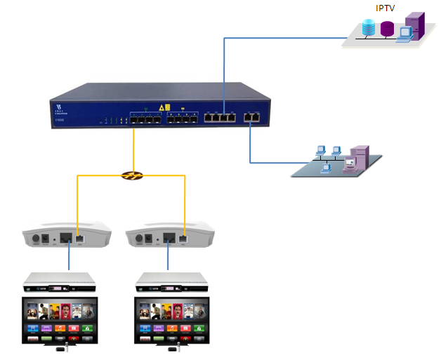
10.1.3.1/24
DHCP/PPPoE/Static

Planning Data
Item |  | Description | Example
ONU Information | Slot No. | The number of the slot actually used. | 0
 | PON No. | The number of the actually used PON port. | 1
 | ONU Auth No. | Configure according to the network planning of the operator. | 1
 | ONU Type | The type of the ONU. | 2801HE
OLT | Service Uplink VLAN | The VLAN ID of the uplink port service. | VLAN mode = UNTAG  PVID = 100
 | Service Uplink port | Configure according to the number of the actually  used uplink port. | GE8
 | Service PON VLAN | The VLAN ID of the PON port service. | VLAN mode = TAG  VLAN ID = 100
 | Service PON port | Configure according to the number of the actually used PON port. | PON1
ONU | Service LAN VLAN | The VLAN ID of the LAN port service.(CTC VLAN mode) | VLAN mode = TAG  PVID = 100
 | Service LAN port | The number of the actually used ONU port. | LAN1
STB | Management IP | The IP for STB. | Gateway = 10.1.3.1  IP = 10.1.3.100  IP Mask = 255.255.255.0

Configuring the OLT
CLI
epon-olt(config)# vlan 100
epon-olt(config-vlan-100)# exit
epon-olt(config)# interface gigabitethernet 0/8
epon-olt(config-if-ge0/8)# switchport hybrid vlan 100 untagged
epon-olt(config-if-ge0/8)# switchport hybrid pvid vlan 100
epon-olt(config-if-ge0/8)# exit
epon-olt(config)# interface epon 0/1
epon-olt(config-pon-0/1)# switchport hybrid vlan 100 tagged
epon-olt(config-pon-0/1)# exit
epon-olt(config)# ip igmp snooping enable
epon-olt(config)# ip igmp snooping general-query-packet enable
epon-olt(config)# ip igmp snooping mrouter vlan 100 interface gigabitethernet 0/8
epon-olt(config)# interface epon 0/1
epon-olt(config-pon-0/1)# ip igmp snooping user-vlan 100 group-vlan 100 tagged
epon-olt(config-pon-0/1)# exit

EMS
1. Right-click the OLT icon and select Configuration->VLAN Configuration
2. Click the Add button, configure according to the planning data.
3. Click the commit button to complete the configuration.
4. Right-click the OLT icon and select Configuration->Port Configuration
Configure according to the planning data.
5. Click the Apply button to complete the configuration.
6. Right-click the OLT icon and select Configuration->IGMP Configuration
configure according to the planning data.
7. Choose Basic Configuration, tick the IGMP Snooping and General Query Packet , click the Apply button to complete the configuration.
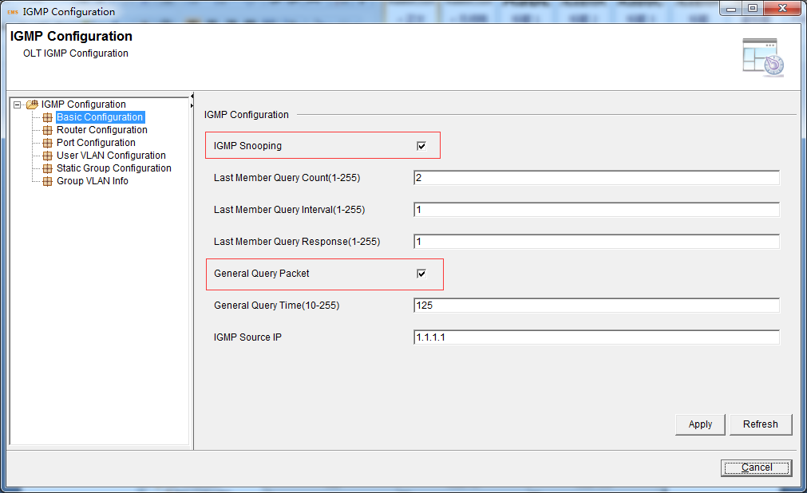

8. Choose Router Configuration, click the Add button to create a item, then modify the parameters according to the planning data.
Click the Save button to complete the configuration.
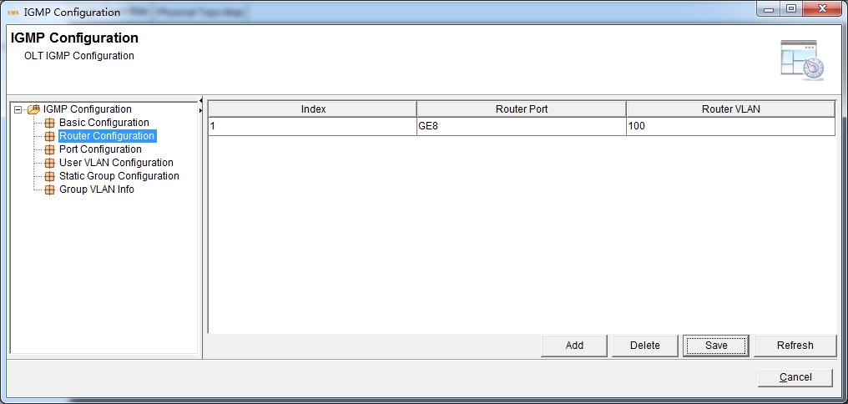

9. Choose User Vlan Configuration, click the Add button to create a item, then modify the parameters according to the planning data.
Click the Save button to complete the configuration.
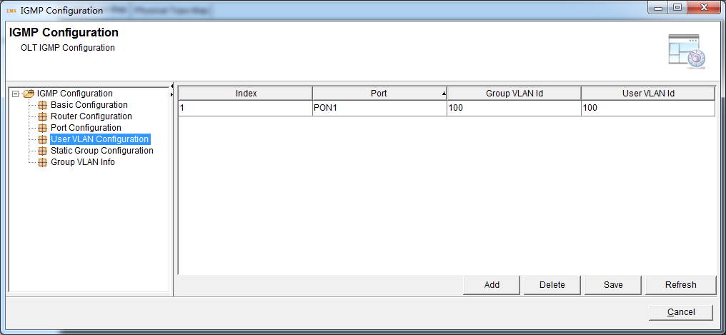

Configuring the ONU
CLI
epon-olt (config)# inter epon 0/1
epon-olt (config-pon-0/1)# onu 1 ctc eth 1 vlan mode tag
epon-olt (config-pon-0/1)# onu 1 ctc eth 1 vlan pvid 100 pri 0
epon-olt (config-pon-0/1)# onu 1 ctc eth 1 mc_vlan add 100
epon-olt (config-pon-0/1)# onu 1 ctc eth 1 mc_tagstrip enable

EMS
1. Right-click the ONU icon and select Configuration->ONU Port Configuration
2. Choose VLAN Configuration->port 1, configure according to the planning data.
3. Click the Save button to complete the configuration.
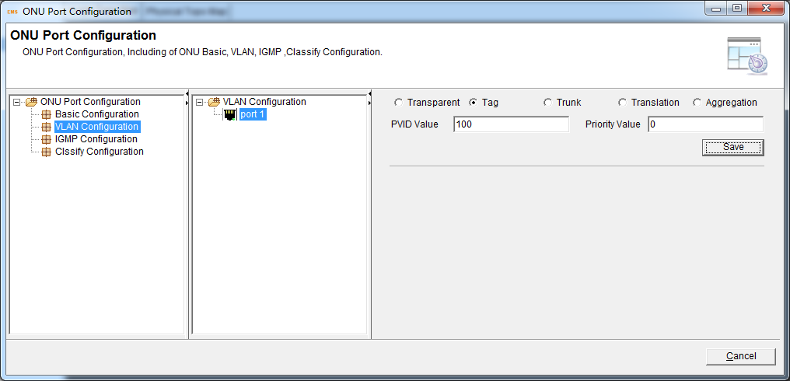

4. Choose IGMP Configuration->IGMP VLAN Configuration->port 1,click Add, configure according to the planning data.
5. Click the Save button to complete the configuration.

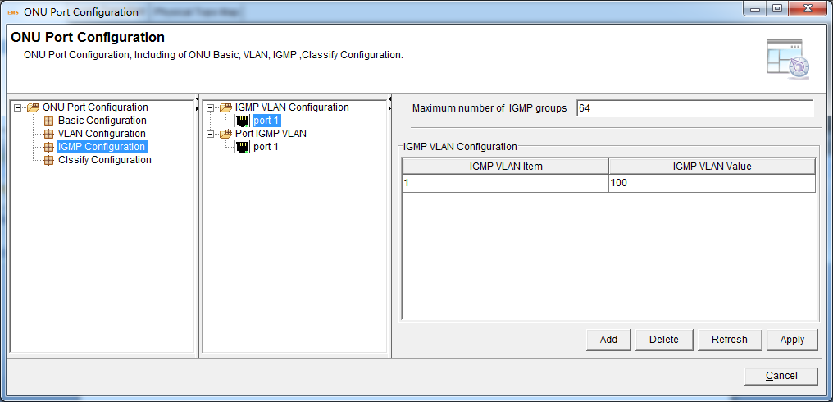

6. Choose Port IGMP VLAN ->port 1,click Add, configure according to the planning data.
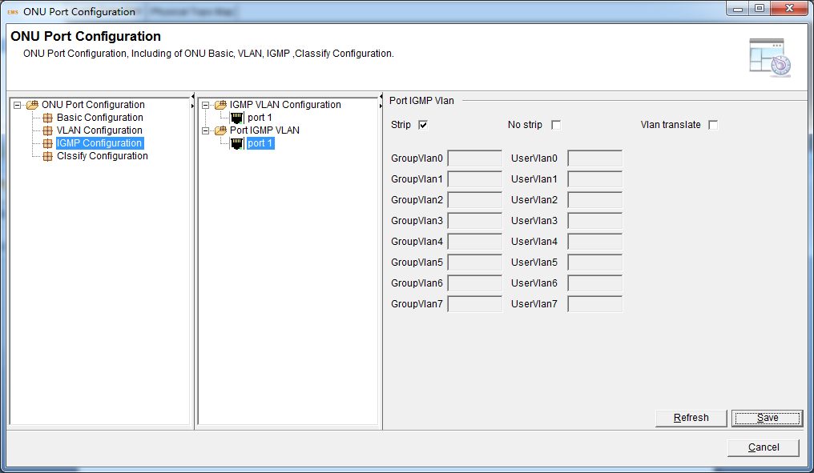

Case 4 SFU Route Without VLAN

Network Diagram
DHCP/PPPoE/Static
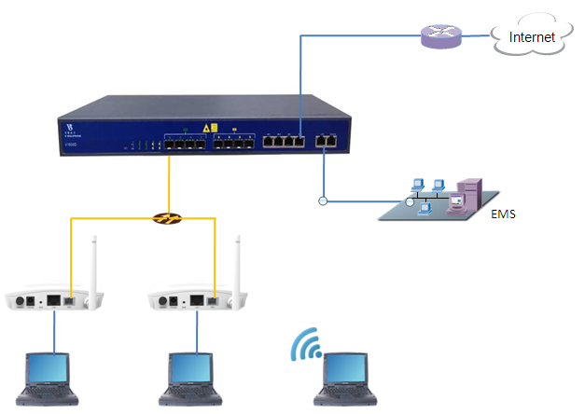
10.1.1.1/24

Planning Data
Item |  | Description | Example
ONU Information | Slot No. | The number of the slot actually used. | 0
 | PON No. | The number of the actually used PON port. | 1
 | ONU Auth No. | Configure according to the network planning of the operator. | 1
 | ONU Type | The type of the ONU. | 2801HW
OLT | Service Uplink VLAN | The VLAN ID of the uplink port service. | Default  (VLAN = 1 UNTAG  PVID = 1)
 | Service Uplink port | Configure according to the number of the actually used uplink port. | GE8
 | Service PON VLAN | The VLAN ID of the PON port service. | Default  (VLAN = 1 UNTAG  PVID = 1)
 | Service PON port | Configure according to the number of the actually used PON port. | PON1
ONU | Service LAN VLAN | The VLAN ID of the LAN port service. | Default  No VLAN
 | Service LAN port | The number of the actually used ONU port. | LAN1
 | WiFi | Wireless’s SSID name,Security. | SSID1 name = SSID-1  Security method = WAP2 Mixed  WPA Encryption = TKIP  WPA2 Encryption = AES  KEY = 12345678
 | Service WAN  VLAN | The VLAN ID of the PON(WAN) port service. | Default  No VLAN
 | If WAN use DHCP mode | The router use DHCP assign ip to ONU. | Gateway = 10.1.1.1  IP Range 10.1.1.2-10.1.1.254  IP Mask = 255.255.255.0  DNS = 8.8.8.8
 | If WAN use PPPoE  mode | The router use PPPoE assign ip to ONU. | IP Range 10.1.1.2-10.1.1.254  IP Mask = 255.255.255.0  User name = test  Password = test
 | If WAN use Static  mode | The router use Static assign ip to ONU. | Gateway = 10.1.1.1  IP = 10.1.1.100  IP Mask = 255.255.255.0  DNS = 8.8.8.8
PC | DHCP mode | The ONU use DHCP assign ip to PC. | Gateway = 192.168.1.1  IP = 192.168.1.40  IP Mask = 255.255.255.0  DNS = 192.168.1.1

Configuring the OLT
Default Configuration

Configuring the ONU
ONU WEB
If DHCP mode
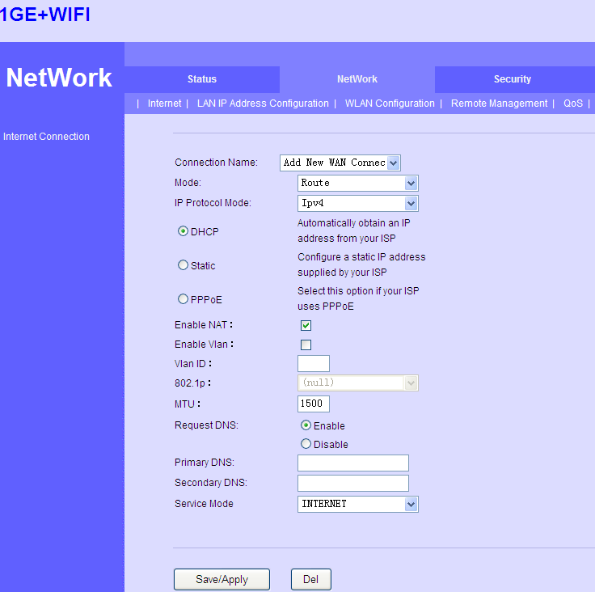

The connection status
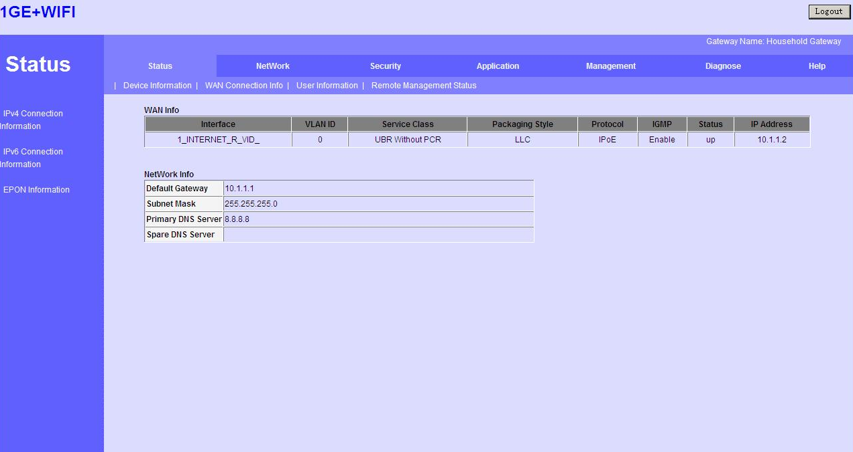
If PPPoE mode
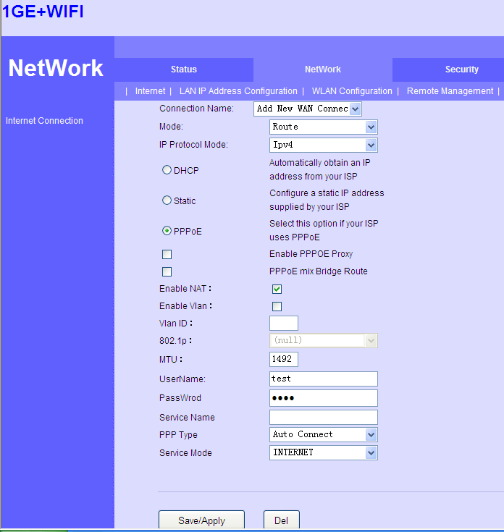

The connection status
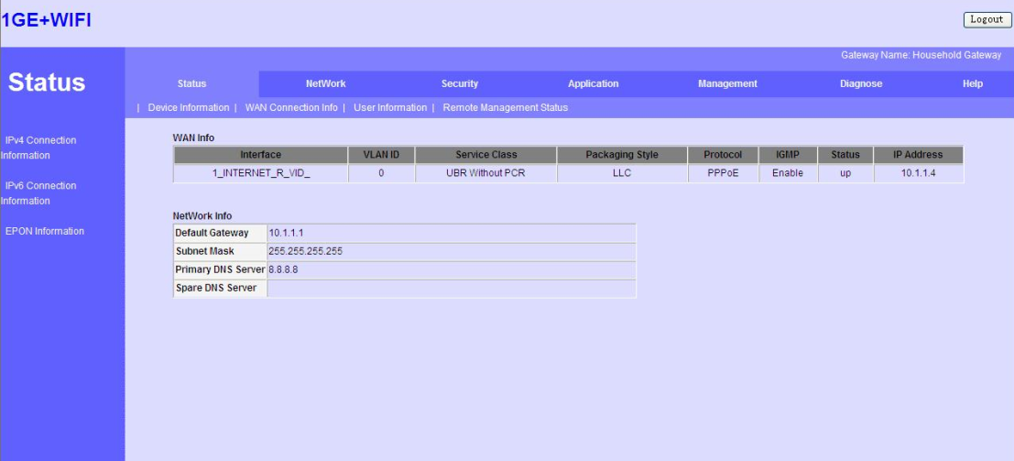
If Static mode
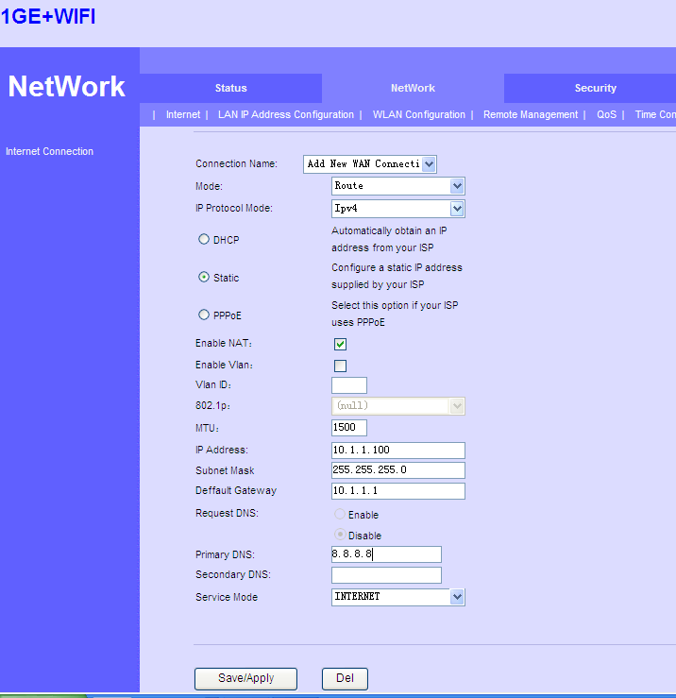

The connection status
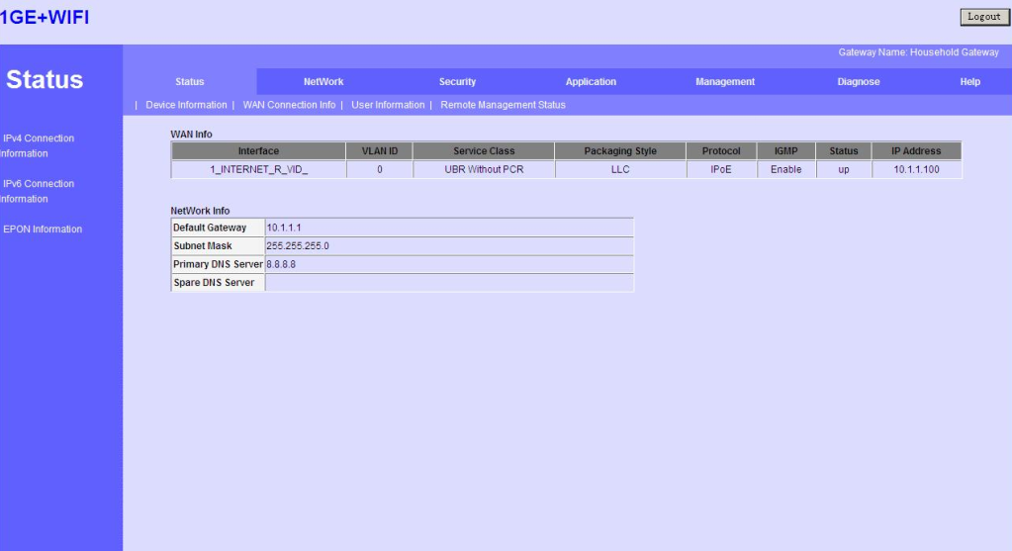
WiFi
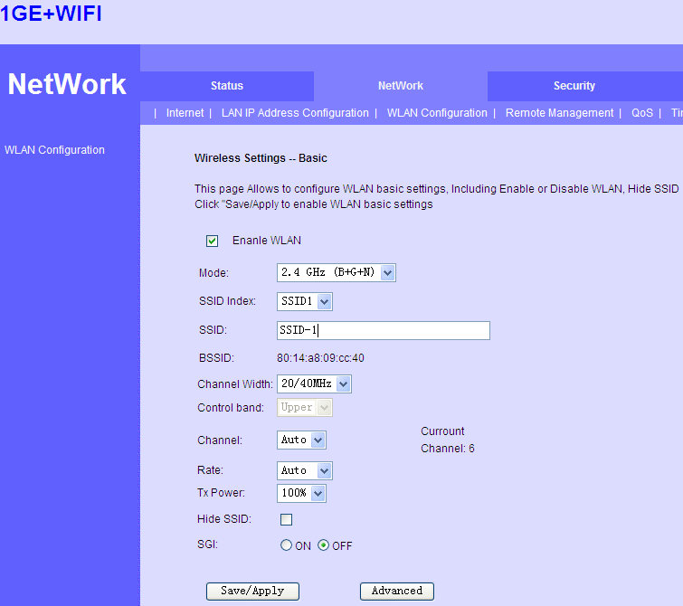
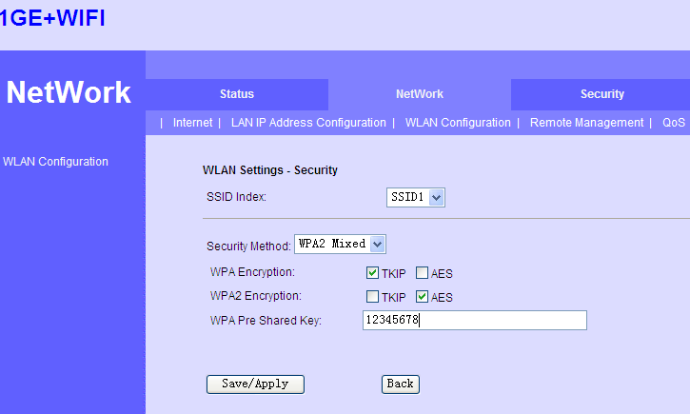

Case 5 SFU Router With VLAN

Network Diagram
DHCP/PPPoE/Static
10.1.1.1/24

Planning Data
Item |  | Description | Example
ONU Information | Slot No. | The number of the slot actually used. | 0
 | PON No. | The number of the actually used PON port. | 1
 | ONU Auth No. | Configure according to the network planning of the operator. | 1
 | ONU Type | The type of the ONU. | 2801HW
OLT | Service Uplink VLAN | The VLAN ID of the uplink port service. | VLAN mode = UNTAG  PVID = 100
 | Service Uplink port | Configure according to the number of the actually  used uplink port. | GE8
 | Service PON VLAN | The VLAN ID of the PON port service. | VLAN mode = TAG  VLAN ID = 100
 | Service PON port | Configure according to the number of the actually used PON port. | PON1
ONU | Service LAN  VLAN | The VLAN ID of the LAN port service. | Default  No VLAN
 | Service LAN port | The number of the actually used ONU port. | LAN1
 | WiFi | Wireless’s SSID name,Security. | SSID1 name = SSID-1  Security method = WAP2 Mixed  WPA Encryption = TKIP  WPA2 Encryption = AES  KEY = 12345678
 | Service WAN  VLAN | The VLAN ID of the PON(WAN) port service. | VLAN ID = 100
 | If WAN use DHCP mode | The router use DHCP assign ip to ONU. | Gateway = 10.1.1.1  IP Range 10.1.1.2-10.1.1.254  IP Mask = 255.255.255.0  DNS = 8.8.8.8
 | If WAN use PPPoE  mode | The router use PPPoE assign ip to ONU. | IP Range 10.1.1.2-10.1.1.254  IP Mask = 255.255.255.0  User name = test  Password = test
 | If WAN use Static  mode | The router use Static assign ip to ONU. | Gateway = 10.1.1.1  IP = 10.1.1.100  IP Mask = 255.255.255.0  DNS = 8.8.8.8
PC | DHCP mode | The ONU use DHCP assign ip to PC. | Gateway = 192.168.1.1  IP = 192.168.1.40  IP Mask = 255.255.255.0  DNS = 192.168.1.1

Configuring the OLT
CLI
epon-olt(config)# vlan 100
epon-olt(config-vlan-100)# exit
epon-olt(config)# interface gigabitethernet 0/8
epon-olt(config-if-ge0/8)# switchport hybrid vlan 100 untagged
epon-olt(config-if-ge0/8)# switchport hybrid pvid vlan 100
epon-olt(config-if-ge0/8)# exit
epon-olt(config)# interface epon 0/1
epon-olt(config-pon-0/1)# switchport hybrid vlan 100 tagged
epon-olt(config-pon-0/1)# exit

EMS
1. Right-click the OLT icon and select Configuration->VLAN Configuration
2. Click the Add button, configure according to the planning data.
3. Click the commit button to complete the configuration.
4. Right-click the OLT icon and select Configuration->Port Configuration
configure according to the planning data.
5. Click the Apply button to complete the configuration.

Configuring the ONU
ONU WEB
If DHCP mode
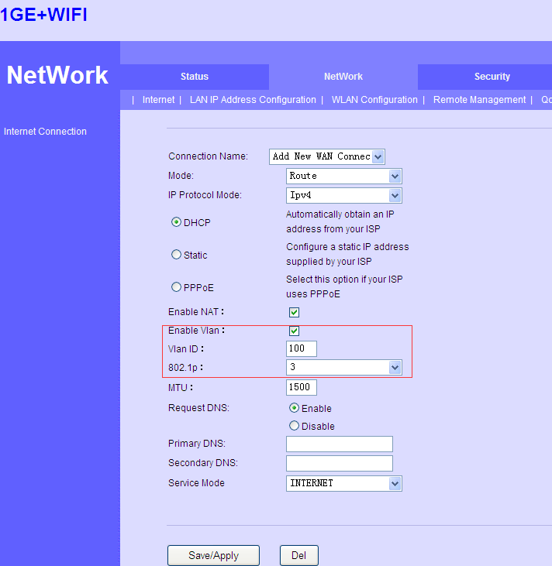
The connection status
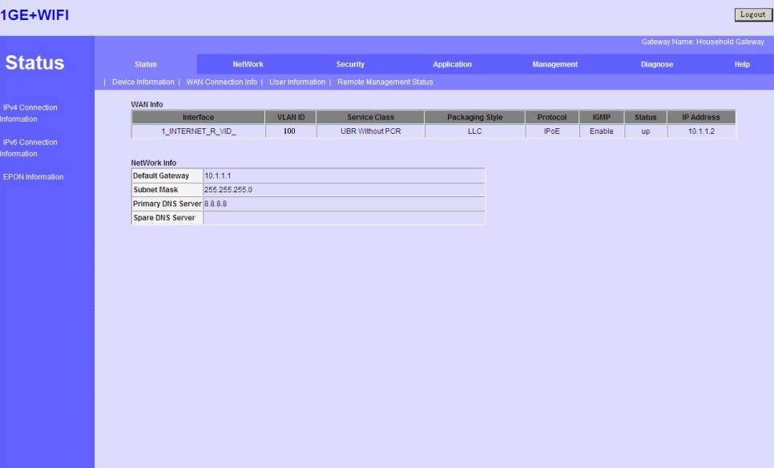
If PPPoE mode
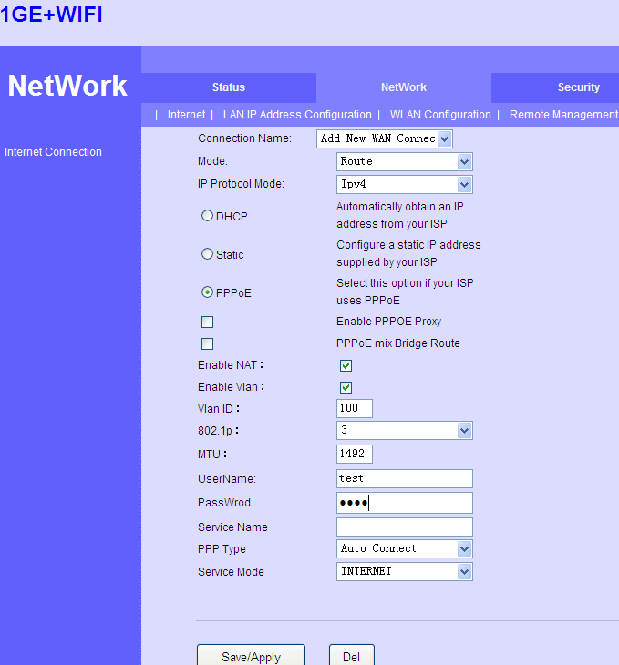

The connection status
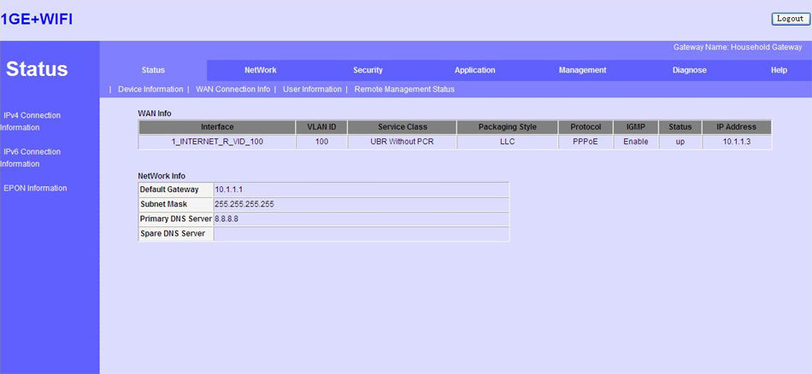
If Static mode
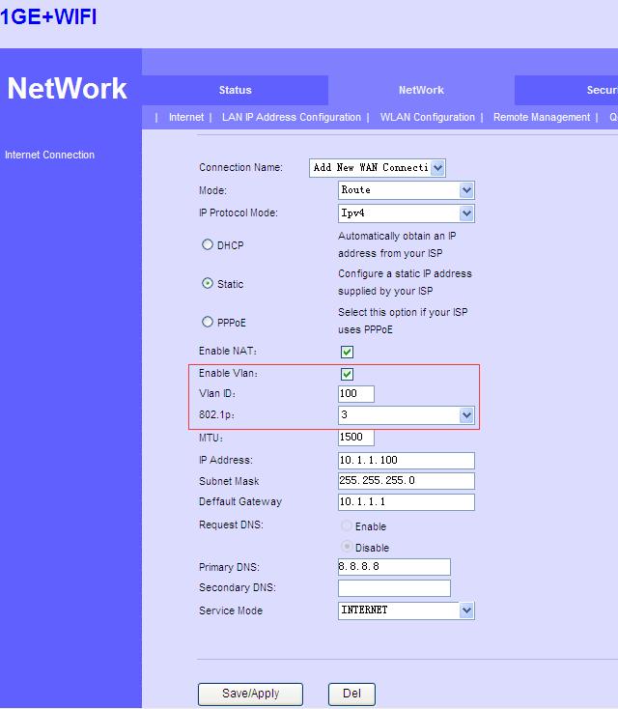

The connection status
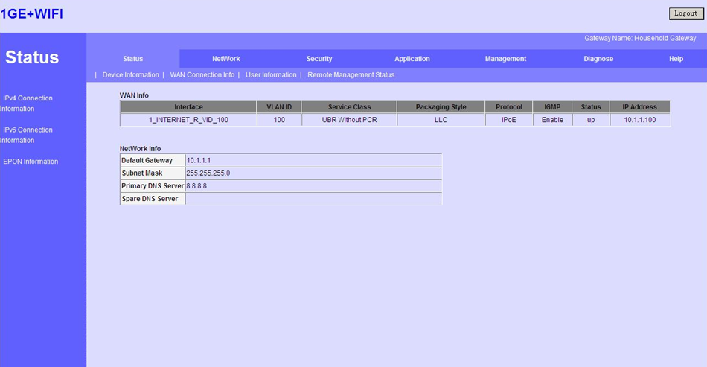
WiFi

Case 6 HGU Router With VLAN--Internet

Network Diagram
DHCP/PPPoE/Static
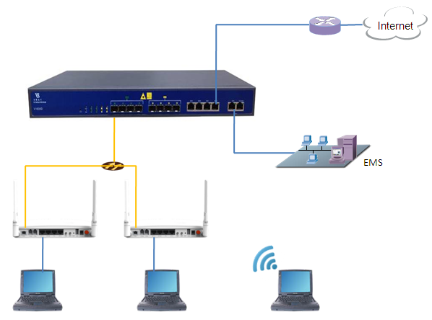
10.1.1.1/24

Planning Data
Item |  | Description | Example
ONU Information | Slot No. | The number of the slot actually used. | 0
 | PON No. | The number of the actually used PON port. | 1
 | ONU Auth No. | Configure according to the network planning of the operator. | 1
 | ONU Type | The type of the ONU. | HG326UEG
OLT | Service Uplink VLAN | The VLAN ID of the uplink port service. | VLAN mode = UNTAG  PVID = 100
 | Service Uplink port | Configure according to the number of the actually used uplink port. | GE8
 | Service PON VLAN | The VLAN ID of the PON port service. | VLAN mode = TAG  VLAN ID = 100
 | Service PON port | Configure according to the number of the actually used PON port. | PON1
ONU | Service LAN  VLAN | The VLAN ID of the LAN port service. | Default  No VLAN
 | Service LAN port | The number of the actually used ONU port. | LAN1
 | WiFi | Wireless’s SSID name,Security. | SSID1 name = SSID-1  Security method = WAP2 Mixed  WPA Encryption = TKIP  WPA2 Encryption = AES  KEY = 12345678
 | Service WAN  VLAN | The VLAN ID of the PON(WAN) port service. | VLAN ID = 100
 | If WAN use DHCP mode | The router use DHCP assign ip to terminal user. | Gateway = 10.1.1.1  IP Range 10.1.1.2-10.1.1.254  IP Mask = 255.255.255.0  DNS = 8.8.8.8
 | If WAN use PPPoE  mode | The router use PPPoE assign ip to terminal user. | IP Range 10.1.1.2-10.1.1.254  IP Mask = 255.255.255.0  User name = test  Password = test
 | If WAN use Static  mode | The router use Static assign ip to terminal user. | Gateway = 10.1.1.1  IP = 10.1.1.100  IP Mask = 255.255.255.0  DNS = 8.8.8.8
PC | DHCP mode | The ONU use DHCP assign ip to PC. | Gateway = 192.168.1.1  IP = 192.168.1.2  IP Mask = 255.255.255.0  DNS = 192.168.1.1

Configuring the OLT
CLI
epon-olt(config)# vlan 100
epon-olt(config-vlan-100)# exit
epon-olt(config)# interface gigabitethernet 0/8
epon-olt(config-if-ge0/8)# switchport hybrid vlan 100 untagged
epon-olt(config-if-ge0/8)# switchport hybrid pvid vlan 100
epon-olt(config-if-ge0/8)# exit
epon-olt(config)# interface epon 0/1
epon-olt(config-pon-0/1)# switchport hybrid vlan 100 tagged
epon-olt(config-pon-0/1)# exit

EMS
1. Right-click the OLT icon and select Configuration->VLAN Configuration
2. Click the Add button, configure according to the planning data.
3. Click the commit button to complete the configuration.
4. Right-click the OLT icon and select Configuration->Port Configuration
configure according to the planning data.
5. Click the Apply button to complete the configuration.

Configuring the ONU
ONU WEB
If DHCP mode
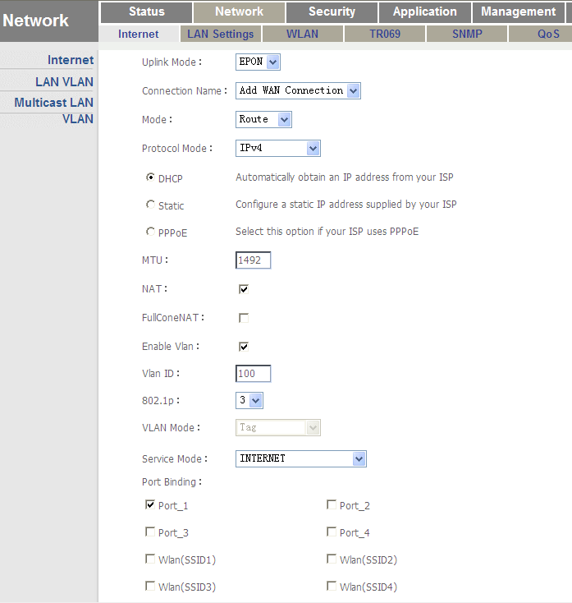
The connection status
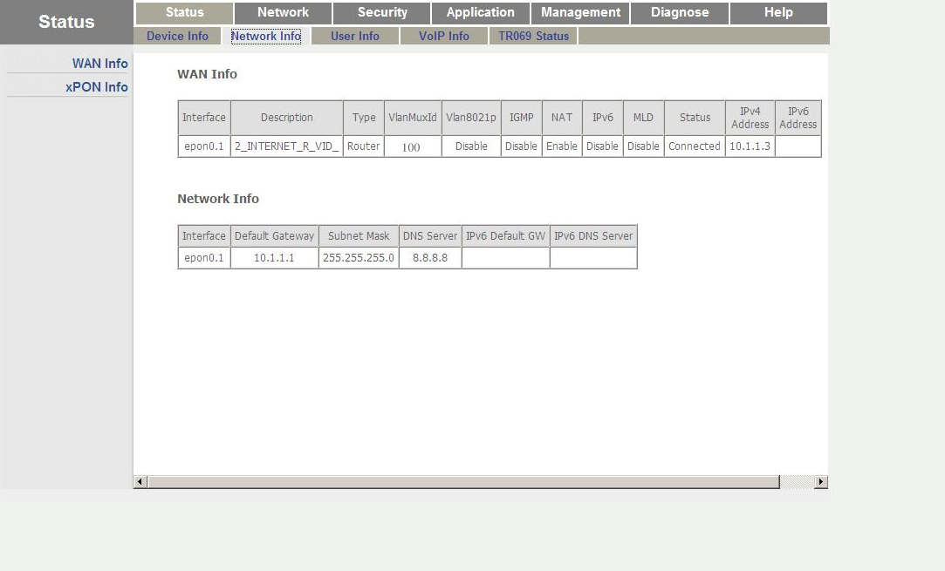

If PPPoE mode
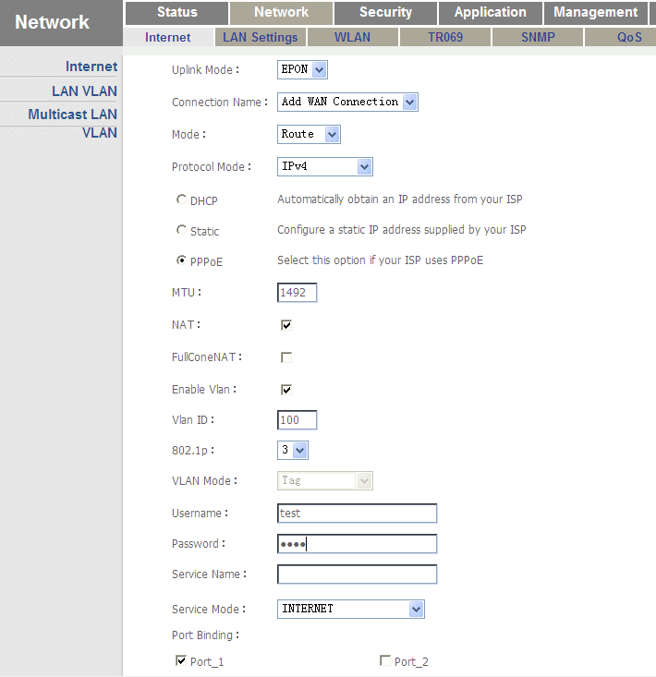
The connection status
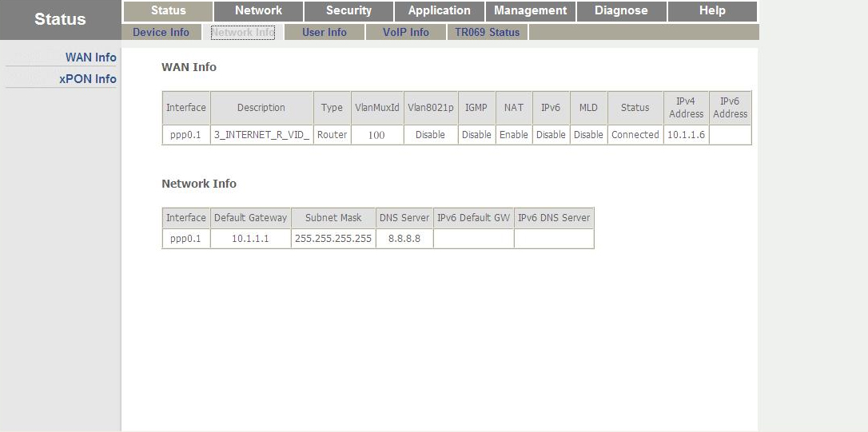

If Static mode
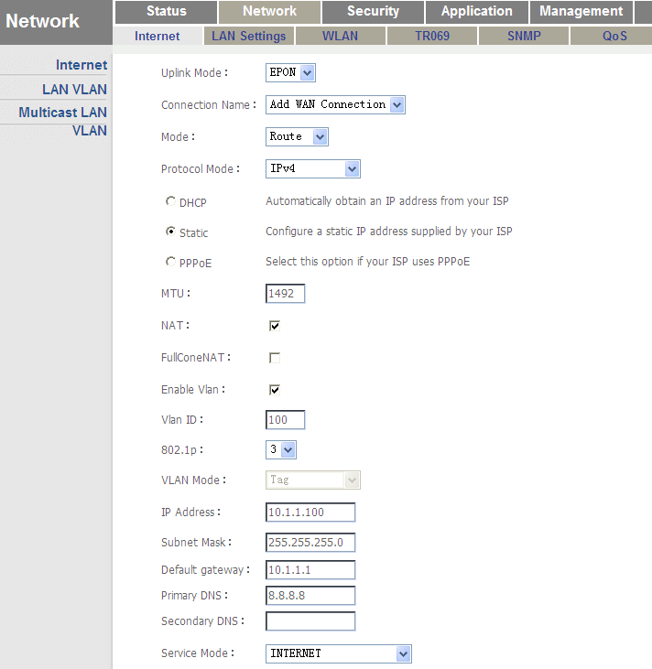
The connection status
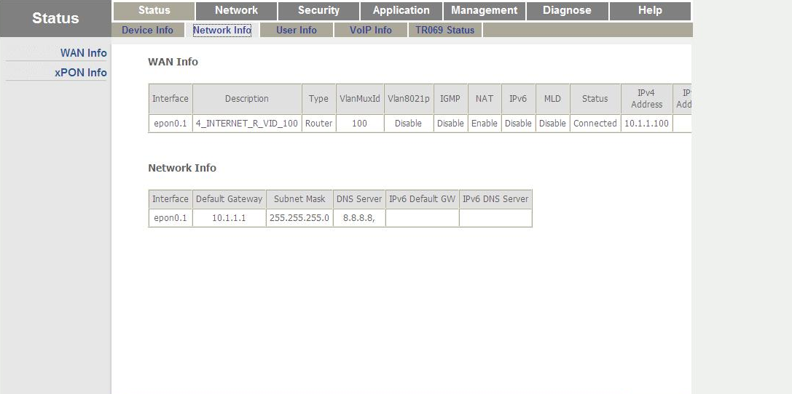

WiFi
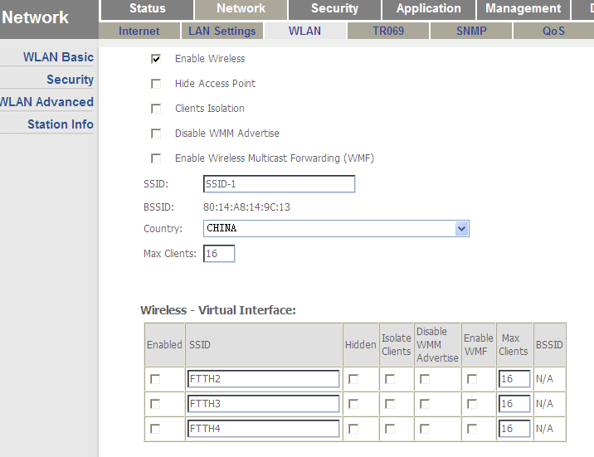
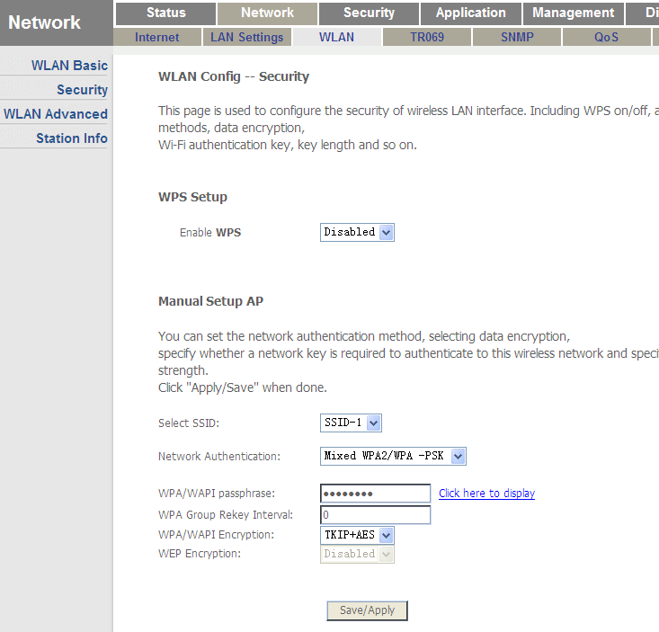

Case 7 HGU Router With VLAN--VoIP

Network Diagram
DHCP/PPPoE/Static
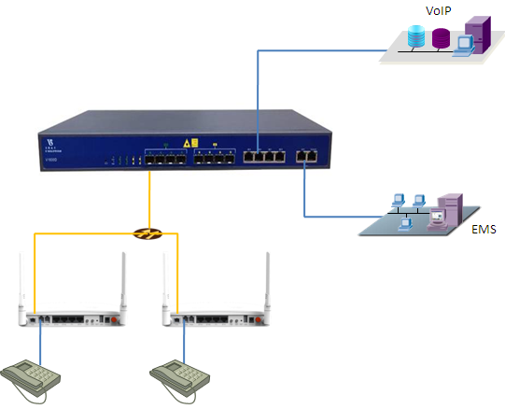
10.1.2.1/24

Planning Data
Item |  | Description | Example
ONU Information | Slot No. | The number of the slot actually used. | 0
 | PON No. | The number of the actually used PON port. | 1
 | ONU Auth No. | Configure according to the network planning of the operator. | 1
 | ONU Type | The type of the ONU. | HG326UEG
OLT | Service Uplink VLAN | The VLAN ID of the uplink port service. | VLAN mode = UNTAG  PVID = 200
 | Service Uplink port | Configure according to the number of the actually used uplink port. | GE6
 | Service PON VLAN | The VLAN ID of the PON port service. | VLAN mode = TAG  VLAN ID = 200
 | Service PON port | Configure according to the number of the actually used PON port. | PON1
ONU | Service WAN  VLAN | The VLAN ID of the PON(WAN) port service. | VLAN ID = 200
 | Service POTS port | The number of the actually used ONU port. | POTS1
 | If WAN use DHCP mode | The router use DHCP assign ip to ONU. | Gateway = 10.1.2.1  IP Range 10.1.2.2-10.1.2.254  IP Mask = 255.255.255.0  DNS = 8.8.8.8
 | If WAN use PPPoE  mode | The router use PPPoE assign ip to ONU. | IP Range 10.1.2.2-10.1.2.254  IP Mask = 255.255.255.0  User name = test1  Password = test1
 | If WAN use Static  mode | The router use Static assign ip to ONU. | Gateway = 10.1.2.1  IP = 10.1.2.100  IP Mask = 255.255.255.0  DNS = 8.8.8.8

Configuring the OLT
CLI
epon-olt(config)# vlan 200
epon-olt(config-vlan-200)# exit
epon-olt(config)# interface gigabitethernet 0/6
epon-olt(config-if-ge0/6)# switchport hybrid vlan 200 untagged
epon-olt(config-if-ge0/6)# switchport hybrid pvid vlan 200
epon-olt(config-if-ge0/6)# exit
epon-olt(config)# interface epon 0/1
epon-olt(config-pon-0/1)# switchport hybrid vlan 200 tagged
epon-olt(config-pon-0/1)# exit

EMS
1. Right-click the OLT icon and select Configuration->VLAN Configuration
2. Click the Add button, configure according to the planning data.
3. Click the commit button to complete the configuration.
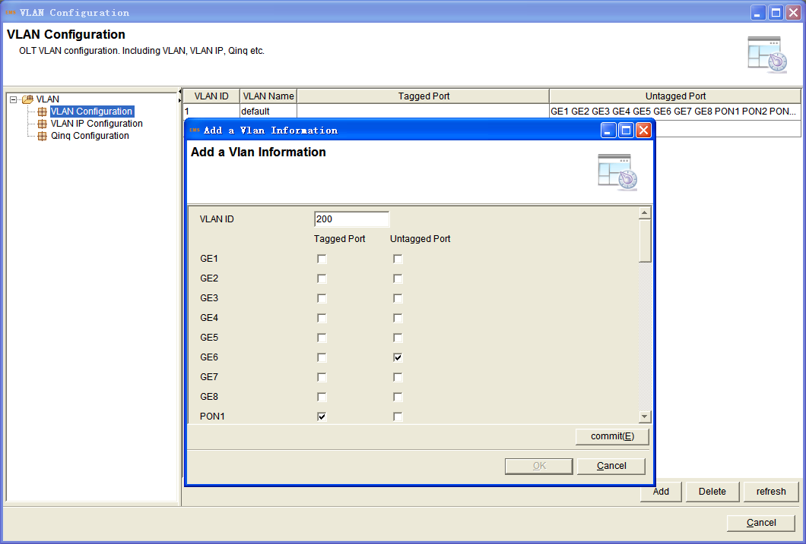
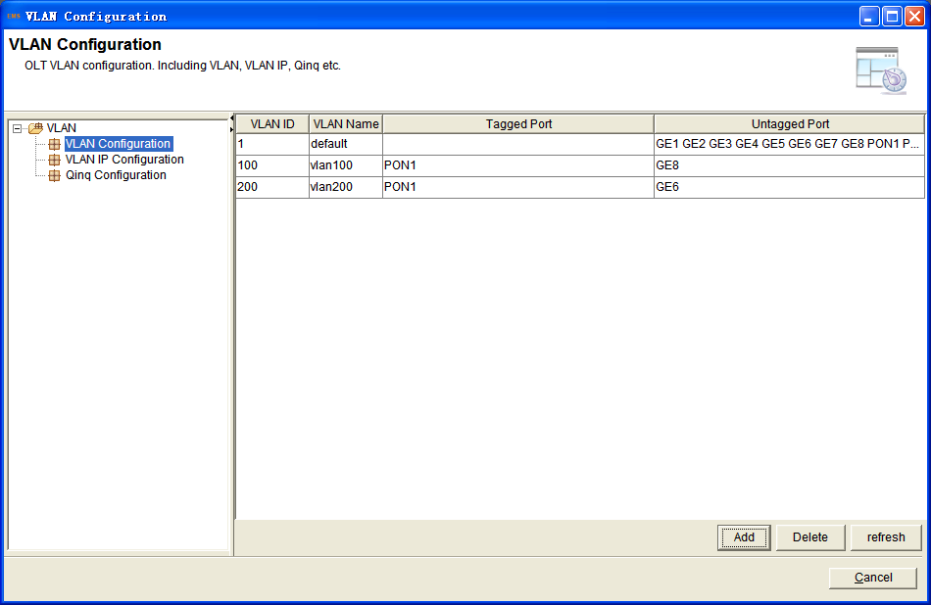
4. Right-click the OLT icon and select Configuration->Port Configuration
configure according to the planning data.
5. Click the Apply button to complete the configuration.
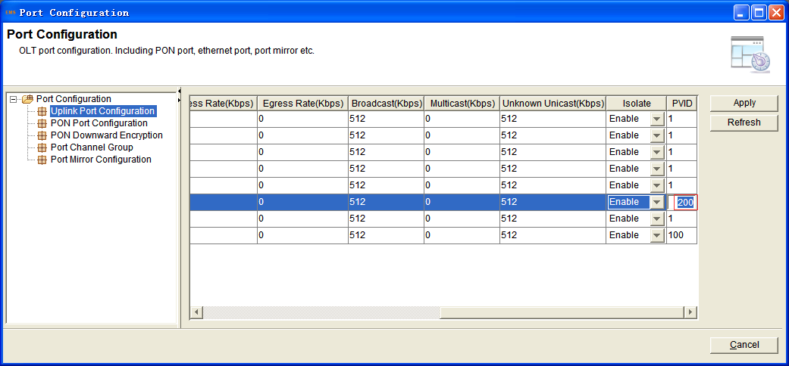

Configuring the ONU
ONU WEB
If DHCP mode
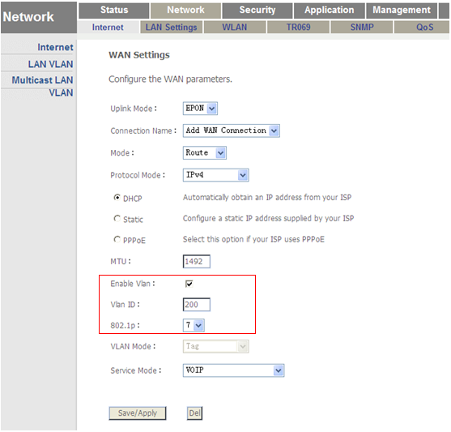
The connection status
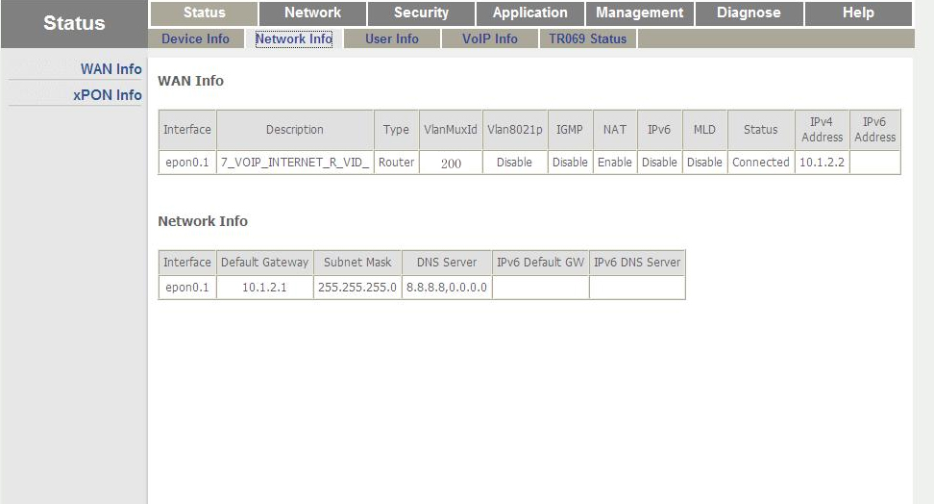
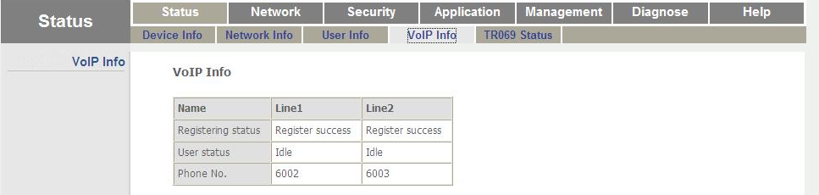
If PPPoE mode
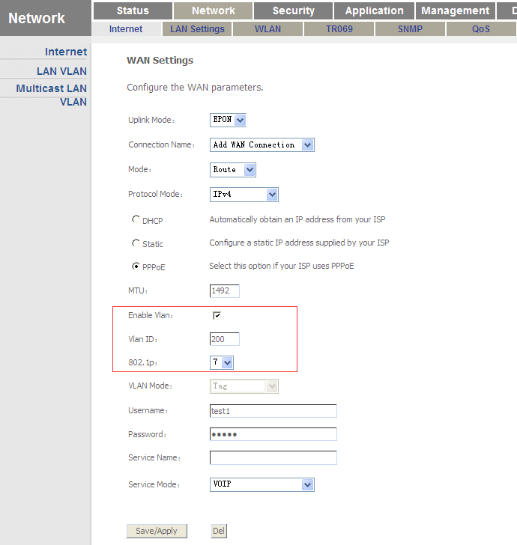
The connection status
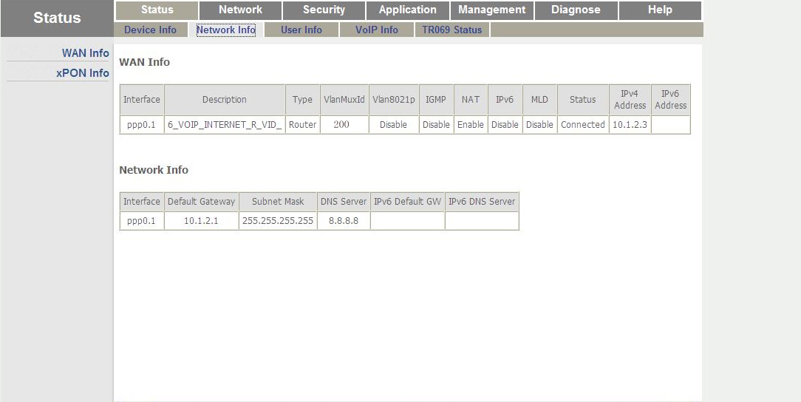
If Static mode
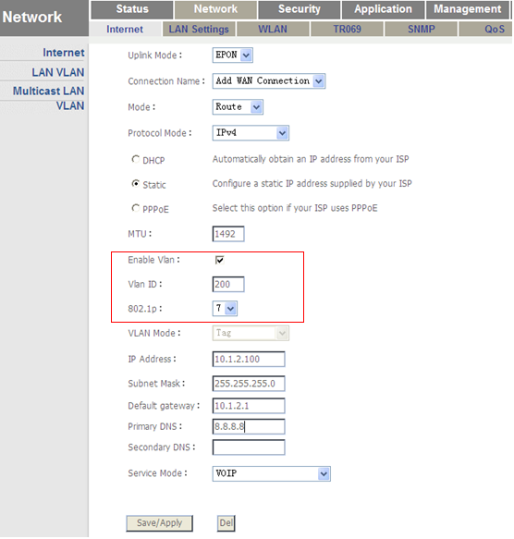
The connection status
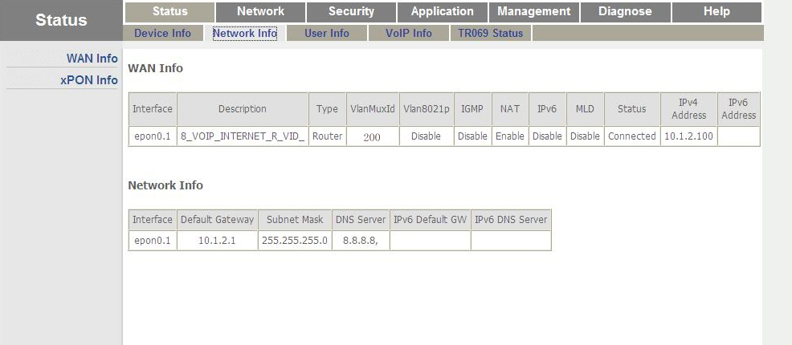
VoIP
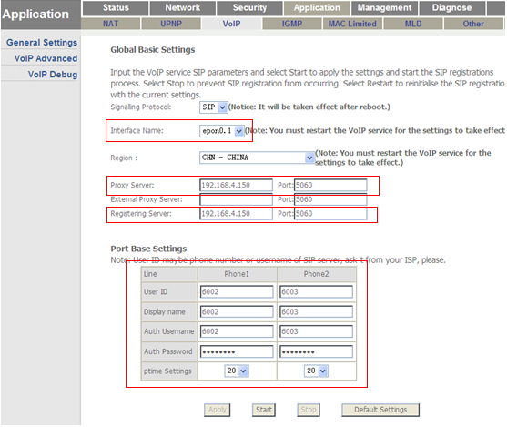

Case 8 HGU Bridge With VLAN--IPTV

Network Diagram
DHCP/PPPoE/Static
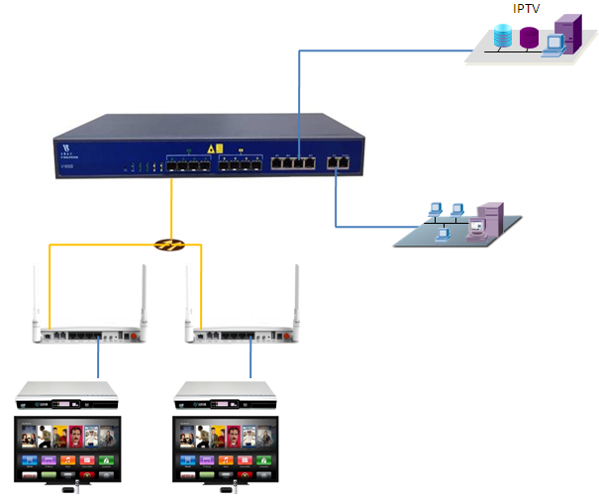
10.1.3.1/24

Planning Data
Item |  | Description | Example
ONU Information | Slot No. | The number of the slot actually used. | 0
 | PON No. | The number of the actually used PON port. | 1
 | ONU Auth No. | Configure according to the network planning of the operator. | 1
 | ONU Type | The type of the ONU. | HG326UEG
OLT | Service Uplink VLAN | The VLAN ID of the uplink port service. | VLAN mode = UNTAG  PVID = 300
 | Service Uplink port | Configure according to the number of the actually used uplink port. | GE7
 | Service PON VLAN | The VLAN ID of the PON port service. | VLAN mode = TAG  VLAN ID = 300
 | Service PON port | Configure according to the number of the actually used PON port. | PON1
ONU | Service  WAN  VLAN | The VLAN ID of the PON(WAN) port service. | VLAN mode= Transparent
 | Service  LAN  VLAN | The VLAN ID of the LAN port service. | VLAN mode = UNTAG  LAN VLAN ID = 300  Multicast VLAN ID = 300
 | Service LAN port | The number of the actually used ONU port. | LAN4
STB | Management IP | The IP for STB. | Gateway = 10.1.3.1  IP = 10.1.3.100  IP Mask = 255.255.255.0

Configuring the OLT
CLI
epon-olt(config)# vlan 300
epon-olt(config-vlan-300)# exit
epon-olt(config)# interface gigabitethernet 0/7
epon-olt(config-if-ge0/7)# switchport hybrid vlan 300 untagged
epon-olt(config-if-ge0/7)# switchport hybrid pvid vlan 300
epon-olt(config-if-ge0/7)# exit
epon-olt(config)# interface epon 0/1
epon-olt(config-pon-0/1)# switchport hybrid vlan 300 tagged
epon-olt(config-pon-0/1)# exit
epon-olt(config)# ip igmp snooping enable
epon-olt(config)# ip igmp snooping general-query-packet enable
epon-olt(config)# ip igmp snooping mrouter vlan 300 interface gigabitethernet 0/7
epon-olt(config)# interface epon 0/1
epon-olt(config-pon-0/1)# ip igmp snooping user-vlan 300 group-vlan 300 tagged
epon-olt(config-pon-0/1)# exit

EMS
1. Right-click the OLT icon and select Configuration->VLAN Configuration
2. Click the Add button, configure according to the planning data.
3. Click the commit button to complete the configuration.
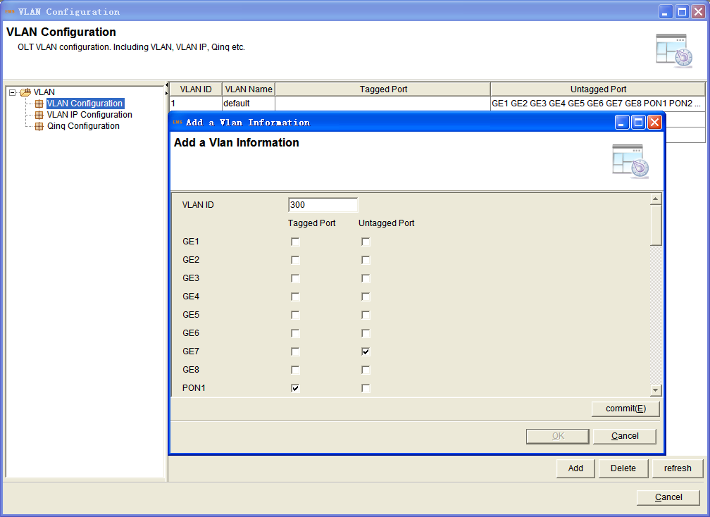
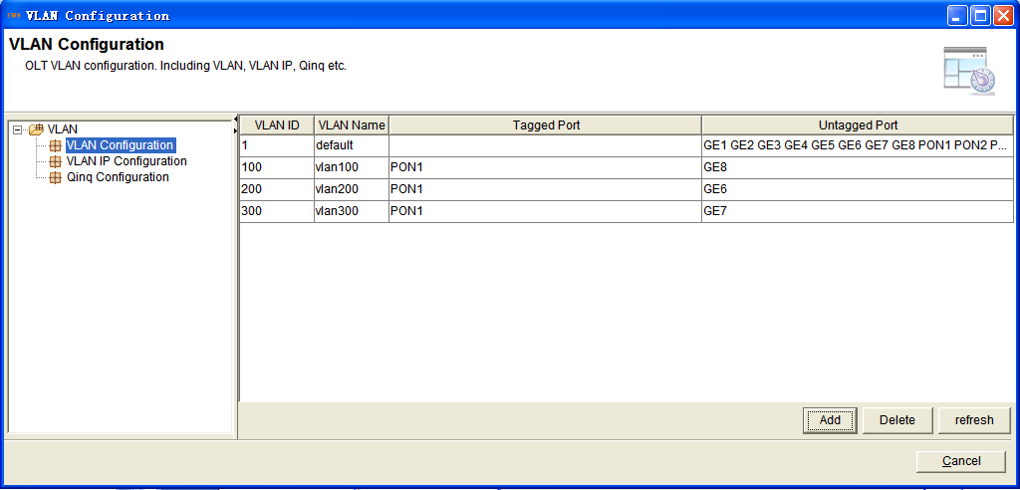
4. Right-click the OLT icon and select Configuration->Port Configuration
configure according to the planning data.
5. Click the Apply button to complete the configuration.
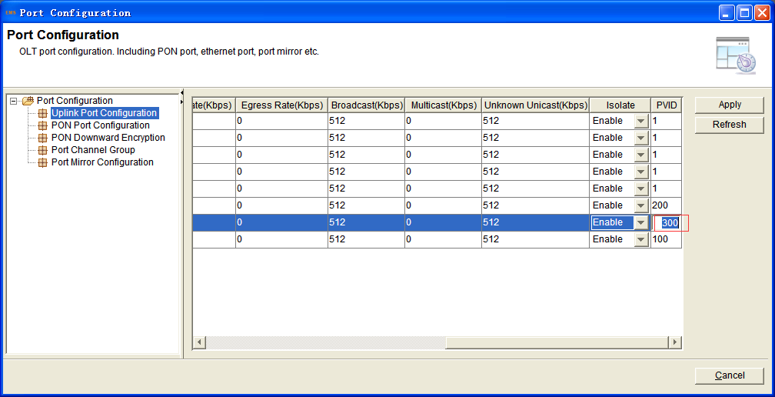

6. Right-click the OLT icon and select Configuration->IGMP Configuration
configure according to the planning data.
7. Choose Basic Configuration, tick the IGMP Snooping and General Query Packet , click the Apply button to complete the configuration.
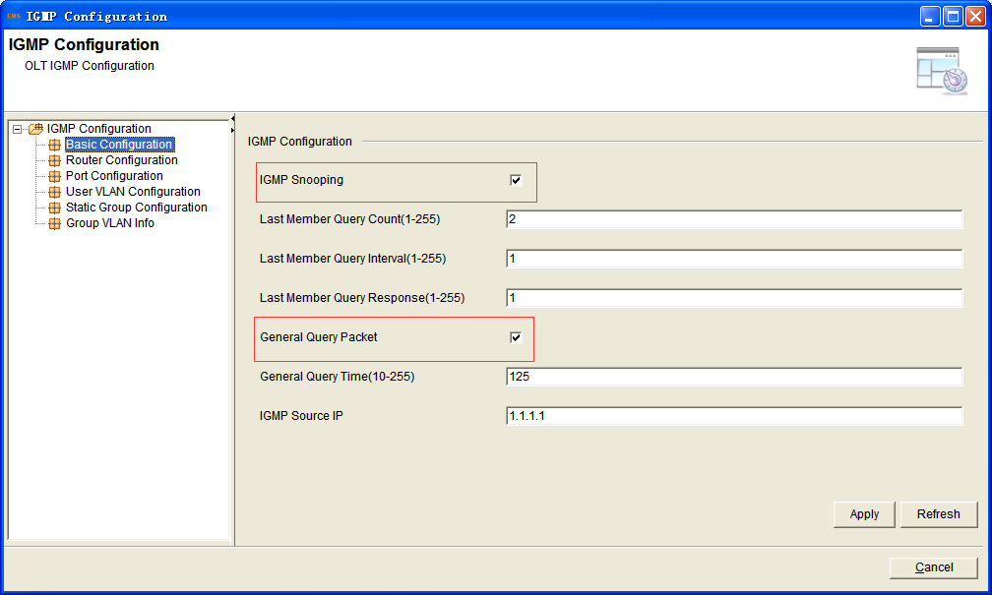

8. Choose Router Configuration, click the Add button to create a item, then modify the parameters according to the planning data.
Click the Save button to complete the configuration.
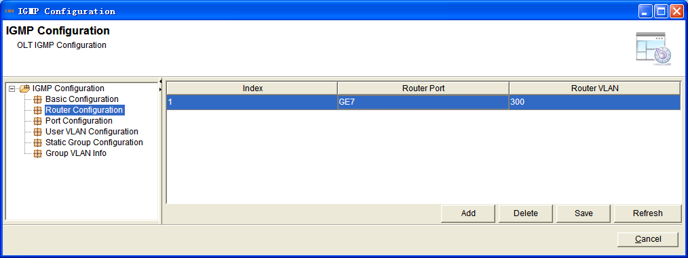

9. Choose User Vlan Configuration, click the Add button to create a item, then modify the parameters according to the planning data.
Click the Save button to complete the configuration.
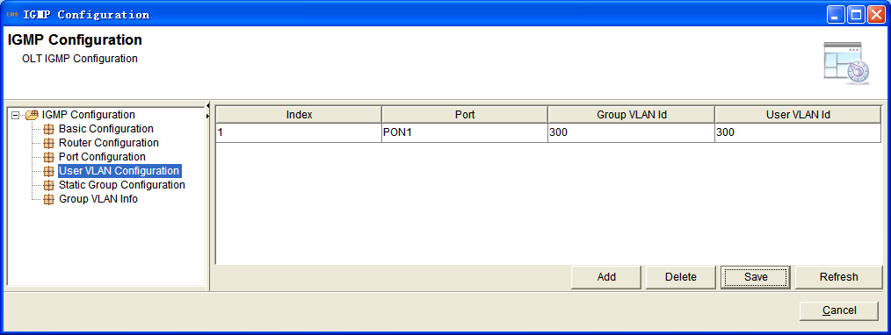

Configuring the ONU
ONU WEB
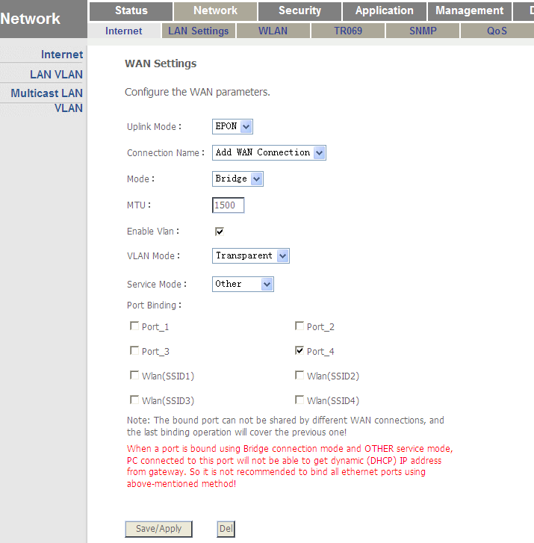
IPTV(LAN and Multicast VLAN)
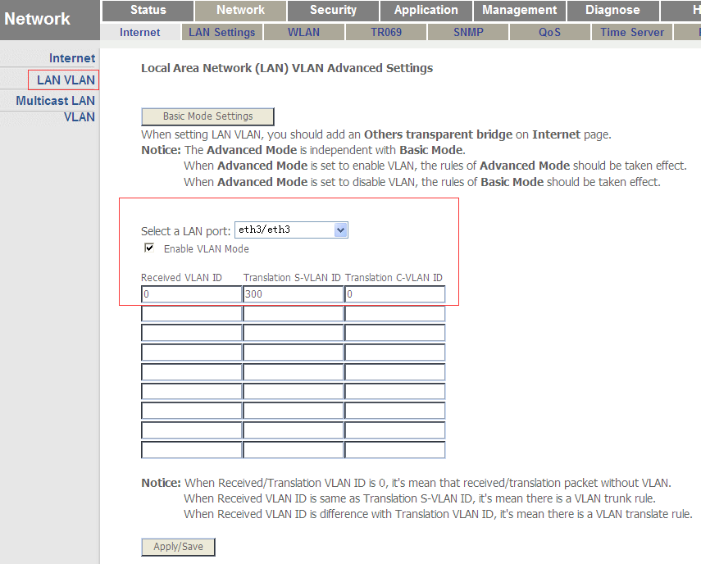
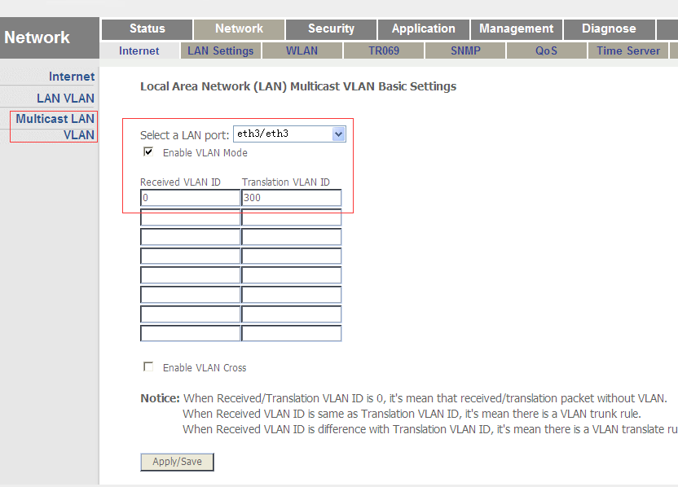

Case 9 HGU Router/Bridge With VLAN Internet--VoIP--IPTV

Network Diagram
10.1.3.1/24
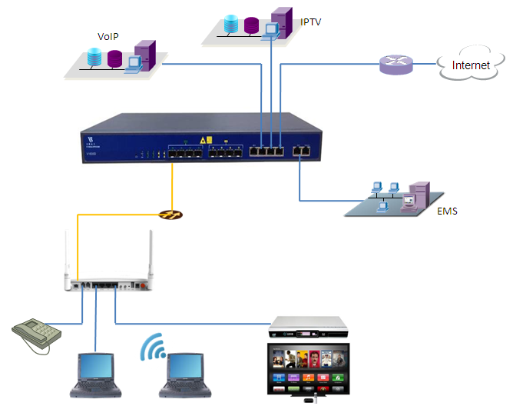
10.1.2.1/24
10.1.1.1/24
DHCP/PPPoE/Static
DHCP/PPPoE/Static

Planning Data
Item |  | Description | Example
ONU Information | Slot No. | The number of the slot actually used. | 0
 | PON No. | The number of the actually used PON port. | 1
 | ONU Auth No. | Configure according to the network planning of the operator. | 1
 | ONU Type | The type of the ONU. | HG326UEG
OLT | Service Uplink VLAN | The VLAN ID of the uplink port service. | VLAN mode = UNTAG  GE7,PVID = 300 for IPTV  GE5,PVID = 200 for VoIP  GE8,PVID = 100 for Internet
 | Service Uplink port | Configure according to the number of the actually used uplink port. | GE7, for IPTV  GE5, for VoIP  GE8, for Internet
 | Service PON VLAN | The VLAN ID of the PON port service. | VLAN mode = TAG  VLAN ID = 300,200,100
 | Service PON port | Configure according to the number of the actually used PON port. | PON1
ONU | Service  WAN  VLAN | The VLAN ID of the PON(WAN) port service. | WAN1(for IPTV):  VLAN mode=  Transparent;  WAN2(for VoIP):  VLAN ID = 200;  WAN3(for Internet):  VLAN ID = 100;
 | Service  LAN  VLAN | The VLAN ID of the LAN port service. | LAN4(for IPTV):  VLAN mode = UNTAG  LAN VLAN ID = 300  Multicast VLAN ID = 300;  LAN1(for Internet):  Default
 | WiFi | Wireless’s SSID name,Security. | SSID1 name = SSID-1  Security method = WAP2 Mixed  WPA Encryption = TKIP  WPA2 Encryption = AES  KEY = 12345678
 | Service POTS port | The number of the actually used ONU port. | POTS1
 | If WAN use DHCP mode | The router use DHCP assign ip to ONU. | Internet:  Gateway = 10.1.1.1  IP Range 10.1.1.2-10.1.1.254  IP Mask = 255.255.255.0  DNS = 8.8.8.8  VoIP:  Gateway = 10.1.2.1  IP Range 10.1.2.2-10.1.1.254  IP Mask = 255.255.255.0  DNS = 8.8.8.8
 | If WAN use PPPoE  mode | The router use PPPoE assign ip to ONU. | Internet:  IP Range 10.1.1.2-10.1.1.254  IP Mask = 255.255.255.0  User name = test  Password = test  VoIP:  IP Range 10.1.2.2-10.1.2.254  IP Mask = 255.255.255.0  User name = test1  Password = test1
 | If WAN use Static  mode | The router use Static assign ip to ONU. | Internet:  Gateway = 10.1.1.1  IP Mask = 255.255.255.0  VoIP:  Gateway = 10.1.2.1  IP Mask = 255.255.255.0
PC | DHCP mode | The ONU use DHCP assign ip to PC. | Gateway = 192.168.1.1  IP = 192.168.1.2  IP Mask = 255.255.255.0  DNS = 192.168.1.1
STB | Management IP | The IP for STB. | Gateway = 10.1.3.1  IP = 10.1.3.100  IP Mask = 255.255.255.0

Configuring the OLT
CLI
As show in Case 5 to 7.
EMS
As show in Case 5 to 7.

Configuring the ONU
ONU WEB
As show in Case 5 to 7.

